Difference between frontend, backend, and full-stack development
Frontend development focuses on the visual and interactive parts of a website — what users see and interact with (HTML, CSS, JavaScript). Backend deals with the server-side logic, database interactions, and APIs. Full-stack developers handle both. Example: In an e-commerce site, frontend is the product page UI, backend handles order processing, and full-stack can build the entire system.

Client-Server Model Diagram
The client-server model works like this: Client (browser) → sends request → Server (hosting website) → processes request → responds back with data → Client displays the result. Example: When you search on Google, your browser (client) sends a request to Google’s server.
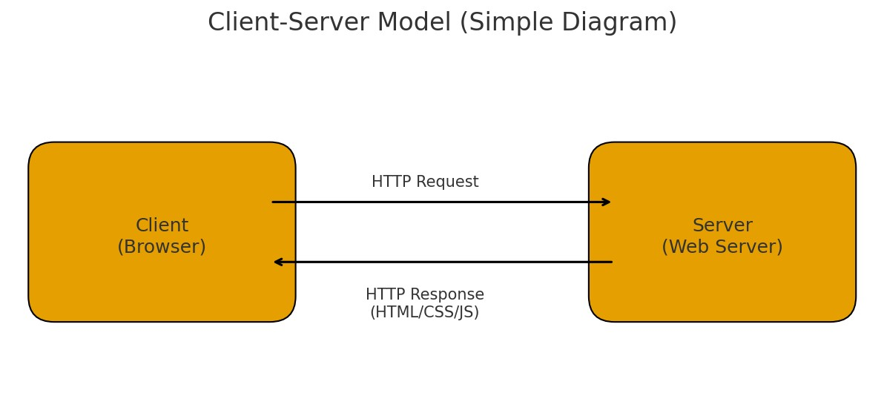

How a browser requests and displays a web page
When you enter a URL, the browser sends an HTTP/HTTPS request to the server. The server processes it and returns HTML, CSS, JS files. The browser parses and renders the page on screen.
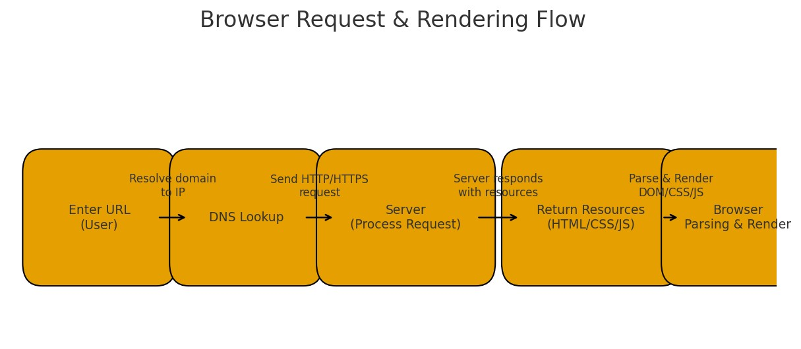

Tools required for web development environment
- Code Editor (VS Code) – for writing code
- Browser (Chrome) – to test 3) Node.js – to run JavaScript
- Git – for version control
- Live Server extension – to preview changes instantly.

What is a Web Server
A web server is software that stores, processes, and delivers web pages to clients. Common examples: Apache, Nginx, Microsoft IIS.

Roles in a web project
Frontend Developer – builds UI using HTML/CSS/JS.
Backend Developer – handles data processing, APIs, and logic.
Database Administrator – manages and maintains the database securely.

Installing VS Code
Install VS Code from official site → Add extensions like Live Server, Prettier → Configure HTML, CSS, JS. 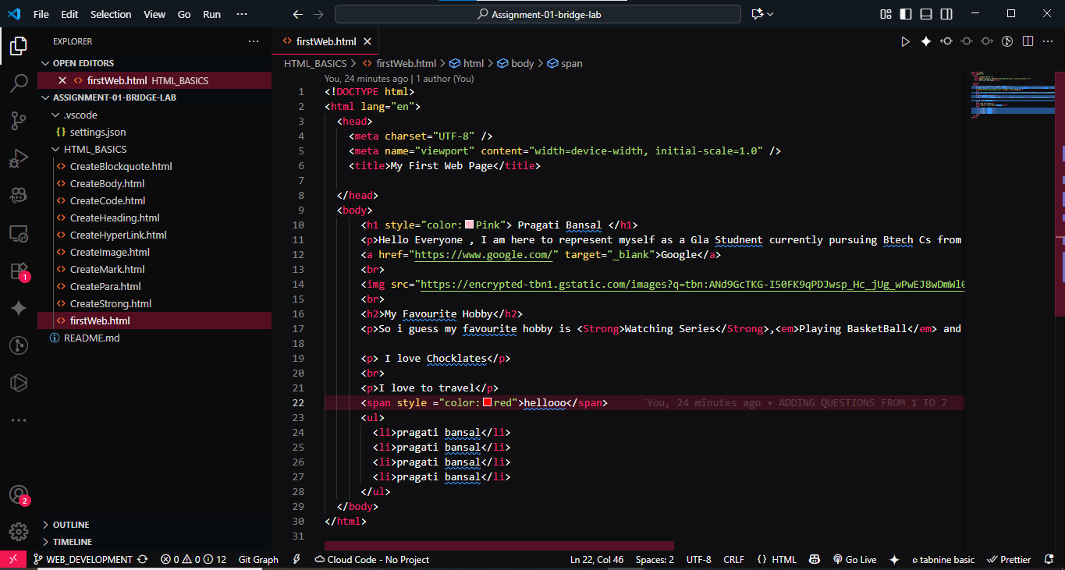

Static vs Dynamic Websites
Static website: content is fixed, same for everyone (e.g., personal portfolio). Dynamic website: content changes based on user or data (e.g., Facebook).

Five Web Browsers and Rendering Engines
- Google Chrome – Blink
- Mozilla Firefox – Gecko
- Safari – WebKit
- Microsoft Edge – Blink
- Opera – Blink
Rendering engines determine how HTML/CSS/JS are parsed and displayed.

Basic Web Architecture Diagram
Client → sends request → Server → interacts with Database via APIs → sends response → Client displays output. This is the basic web flow.
