DSCS Project
Passport Travel Readiness System
Data Science • NLP • Visualization

1. Home Page

home.py
import tkinter as tk
import subprocess
import sys
import os
BASE = os.path.dirname(os.path.abspath(__file__))
VENV_PYTHON = os.path.join(BASE, "venv", "Scripts", "python.exe")
PYTHON = VENV_PYTHON if os.path.exists(VENV_PYTHON) else sys.executable
def run(file):
subprocess.Popen([PYTHON, os.path.join(BASE, file)])
root = tk.Tk()
root.title("Passport Travel Readiness System")
root.geometry("500x520")
root.resizable(False, False)
tk.Label(
root,
text="Passport Travel Readiness\nData Science Case Study",
font=("Arial", 18, "bold"),
pady=20
).pack()
btn = {"font": ("Arial", 12), "width": 30, "height": 2}
tk.Button(root, text="Passenger Entry",
command=lambda: run("registration.py"), **btn).pack(pady=6)
tk.Button(root, text="Feedback Insights",
command=lambda: run("feedback_gui.py"), **btn).pack(pady=6)
tk.Button(root, text="Text Summarization",
command=lambda: run("summary_gui.py"), **btn).pack(pady=6)
tk.Button(root, text="Entity Extraction (NER)",
command=lambda: run("ner_gui.py"), **btn).pack(pady=6)
tk.Button(root, text="Visual Insights",
command=lambda: run("plot_gui.py"), **btn).pack(pady=6)
tk.Button(root, text="Exit", bg="red", fg="white",
command=root.destroy, **btn).pack(pady=20)
root.mainloop()
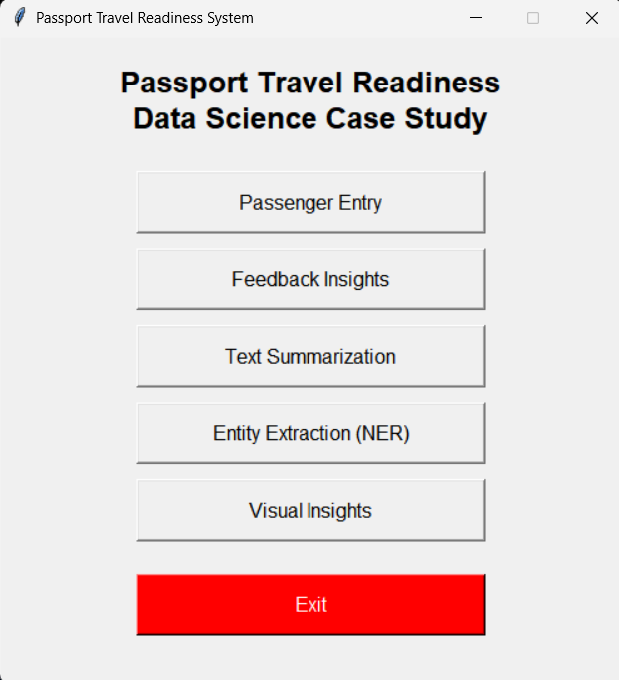

2. Passenger Entry

registration.py
import tkinter as tk
from tkinter import messagebox, ttk
import csv, os
FILE = "passenger_registration.csv"
if not os.path.exists(FILE):
with open(FILE, "w", newline="", encoding="utf-8") as f:
csv.writer(f).writerow([
"Full_Name","Passport_Number","Date_of_Birth","Destination_Country",
"Travel_Purpose","Group_Size","Number_of_Bags",
"Children_Count","Elderly_Count",
"Accessibility_Needs","Medical_Conditions","Dietary_Requirements",
"Language_Preference","First_Time_Traveler","Emergency_Contact",
"Travel_Insurance","Vaccination_Status","Travel_Feedback"
])
def submit():
row = [
name.get(), passport.get(), dob.get(), dest.get(), purpose.get(),
group.get(), bags.get(), children.get(), elderly.get(),
accessibility.get(), medical.get(), dietary.get(),
language.get(), first_time.get(), emergency.get(),
insurance.get(), vaccination.get(),
feedback.get("1.0", tk.END).strip()
]
if not row[0] or not row[1]:
messagebox.showerror("Error", "Name & Passport required")
return
with open(FILE, "a", newline="", encoding="utf-8") as f:
csv.writer(f).writerow(row)
messagebox.showinfo("Saved", "Data saved successfully")
# Clear fields
name.delete(0, tk.END)
passport.delete(0, tk.END)
dob.delete(0, tk.END)
dest.delete(0, tk.END)
group.delete(0, tk.END)
bags.delete(0, tk.END)
children.delete(0, tk.END)
elderly.delete(0, tk.END)
medical.delete(0, tk.END)
dietary.delete(0, tk.END)
emergency.delete(0, tk.END)
feedback.delete("1.0", tk.END)
root = tk.Tk()
root.title("Passport Travel Readiness - Inclusive Entry Form")
root.geometry("600x850")
canvas = tk.Canvas(root)
scrollbar = ttk.Scrollbar(root, orient="vertical", command=canvas.yview)
scrollframe = tk.Frame(canvas)
scrollframe.bind(
"<Configure>",
lambda e: canvas.configure(scrollregion=canvas.bbox("all"))
)
canvas.create_window((0, 0), window=scrollframe, anchor="nw")
canvas.configure(yscrollcommand=scrollbar.set)
canvas.pack(side="left", fill="both", expand=True)
scrollbar.pack(side="right", fill="y")
tk.Label(scrollframe, text="Passport Travel Readiness System", font=("Arial", 16, "bold")).pack(pady=10)
tk.Label(scrollframe, text="Inclusive Travel Information", font=("Arial", 10, "italic"), fg="gray").pack()
def lbl(t): tk.Label(scrollframe, text=t, anchor="w").pack(fill="x", padx=10)
def ent():
e = tk.Entry(scrollframe, width=40)
e.pack(padx=10, pady=3)
return e
# Personal Information
tk.Label(scrollframe, text="━━ PERSONAL INFORMATION ━━", font=("Arial", 11, "bold"), fg="#2c3e50").pack(fill="x", padx=10, pady=8)
lbl("Full Name *"); name = ent()
lbl("Passport Number *"); passport = ent()
lbl("Date of Birth"); dob = ent()
# Destination
tk.Label(scrollframe, text="━━ TRAVEL DETAILS ━━", font=("Arial", 11, "bold"), fg="#2c3e50").pack(fill="x", padx=10, pady=8)
lbl("Destination Country"); dest = ent()
lbl("Travel Purpose")
purpose = tk.StringVar(value="Tourism")
ttk.Combobox(scrollframe, textvariable=purpose,
values=["Tourism","Business","Education","Work","Visit Family"],
width=37).pack(padx=10, pady=3)
lbl("Group Size"); group = ent()
lbl("Number of Bags"); bags = ent()
# Family Info
tk.Label(scrollframe, text="━━ GROUP COMPOSITION ━━", font=("Arial", 11, "bold"), fg="#2c3e50").pack(fill="x", padx=10, pady=8)
lbl("Children Count"); children = ent()
lbl("Elderly Count"); elderly = ent()
# Inclusive & Accessibility
tk.Label(scrollframe, text="━━ ACCESSIBILITY & HEALTH ━━", font=("Arial", 11, "bold"), fg="#2c3e50").pack(fill="x", padx=10, pady=8)
lbl("Accessibility Needs (Wheelchair, Mobility Aid, Visual/Hearing Impairment, etc.)")
accessibility = ent()
lbl("Medical Conditions (if any)")
medical = ent()
lbl("Dietary Requirements (Vegetarian, Vegan, Halal, Kosher, Allergies, etc.)")
dietary = ent()
lbl("Language Preference")
language = tk.StringVar(value="English")
ttk.Combobox(scrollframe, textvariable=language,
values=["English","Spanish","French","Mandarin","Hindi","Arabic","Other"],
width=37).pack(padx=10, pady=3)
# Travel Experience
tk.Label(scrollframe, text="━━ TRAVEL EXPERIENCE ━━", font=("Arial", 11, "bold"), fg="#2c3e50").pack(fill="x", padx=10, pady=8)
lbl("First Time Traveler?")
first_time = tk.StringVar(value="No")
ttk.Combobox(scrollframe, textvariable=first_time,
values=["Yes","No"],
width=37).pack(padx=10, pady=3)
# Important Info
tk.Label(scrollframe, text="━━ IMPORTANT INFO ━━", font=("Arial", 11, "bold"), fg="#2c3e50").pack(fill="x", padx=10, pady=8)
lbl("Emergency Contact (Name & Phone)")
emergency = ent()
lbl("Travel Insurance?")
insurance = tk.StringVar(value="No")
ttk.Combobox(scrollframe, textvariable=insurance,
values=["Yes","No"],
width=37).pack(padx=10, pady=3)
lbl("Vaccination Status")
vaccination = tk.StringVar(value="Complete")
ttk.Combobox(scrollframe, textvariable=vaccination,
values=["Complete","Partial","Not Vaccinated","Prefer Not to Say"],
width=37).pack(padx=10, pady=3)
# Feedback
tk.Label(scrollframe, text="━━ ADDITIONAL FEEDBACK ━━", font=("Arial", 11, "bold"), fg="#2c3e50").pack(fill="x", padx=10, pady=8)
lbl("Travel Feedback/Comments")
feedback = tk.Text(scrollframe, height=4, width=40)
feedback.pack(padx=10, pady=3)
# Submit Button
tk.Button(scrollframe, text="Submit", bg="#27ae60", fg="white",
width=40, font=("Arial", 12, "bold"), command=submit).pack(pady=15)
root.mainloop()
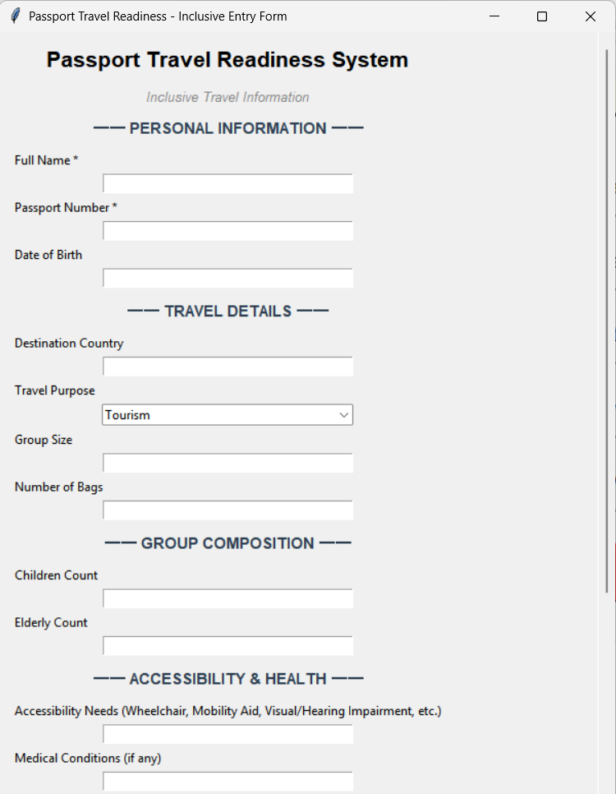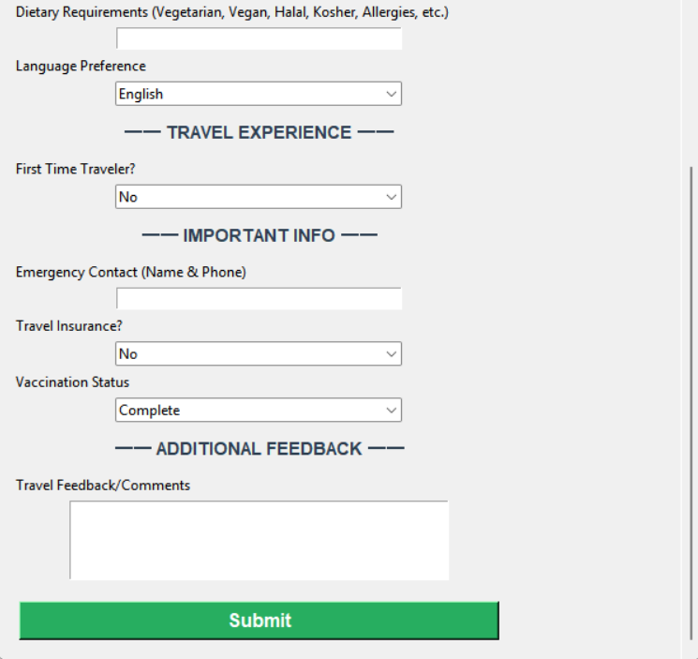

passenger_registration.csv
Full_Name | Passport_Number | Date_of_Birth | Destination_Country | Travel_Purpose | Group_Size | Number_of_Bags | Children_Count | Elderly_Count
Rahul Sharma | P1234567 | 12-04-1995 | France | Tourism | 4 | 5 | 1 | 1
Ananya Verma | P2345678 | 25-08-1998 | Japan | Education | 1 | 2 | 0 | 0
Mohit Khan | P3456789 | 09-06-1992 | UAE | Business | 3 | 4 | 0 | 1
Sneha Kulkarni | P4567890 | 14-02-1996 | Germany | Tourism | 2 | 3 | 0 | 0
Amit Patel | P5678901 | 03-01-1989 | USA | Business | 5 | 6 | 2 | 0
Pooja Nair | P6789012 | 17-11-1997 | Canada | Education | 1 | 2 | 0 | 0
Rohit Mehta | P7890123 | 30-09-1994 | UK | Tourism | 3 | 4 | 1 | 0
Neha Gupta | P8901234 | 11-07-1999 | Australia | Work | 2 | 3 | 0 | 1
Kunal Shah | P9012345 | 21-05-1991 | Singapore | Business | 1 | 1 | 0 | 0
Kavya Iyer | P0123456 | 28-08-1995 | Italy | Tourism | 3 | 4 | 1 | 0

Full_Name | Accessibility_Needs | Medical_Conditions | Dietary_Requirements | Language_Preference | First_Time_Traveler | Travel_Insurance | Vaccination_Status
Rahul Sharma | Wheelchair | Asthma | Vegetarian | English | No | Yes | Complete
Ananya Verma | No Special Needs | Thyroid | Vegan | English | Yes | Yes | Complete
Mohit Khan | Hearing Aid | Diabetes | Halal | Hindi | No | Yes | Complete
Sneha Kulkarni | No Special Needs | Migraine | Vegetarian | English | No | No | Complete
Amit Patel | No Special Needs | Hypertension | Jain | Gujarati | No | Yes | Complete
Pooja Nair | Visual Impairment | Allergy | Gluten-Free | English | Yes | Yes | Complete
Rohit Mehta | No Special Needs | Cholesterol | No Restriction | Hindi | No | No | Complete
Neha Gupta | Mobility Aid | BP Low | Kosher | English | Yes | Yes | Complete
Kunal Shah | No Special Needs | No Conditions | No Restriction | English | No | Yes | Complete
Kavya Iyer | Wheelchair | Allergy | Vegetarian | English | Yes | No | Complete

Full_Name | Travel_Feedback
Rahul Sharma | Travelling with family was smooth but security checks took time.
Ananya Verma | Solo travel experience was well managed and staff was helpful.
Mohit Khan | Business travel was efficient but baggage handling could improve.
Sneha Kulkarni | Couple travel was comfortable and immigration was quick.
Amit Patel | Group travel took longer due to multiple baggage checks.
Pooja Nair | Student travel process was smooth and well guided.
Rohit Mehta | Travelling with a child required extra time at security.
Neha Gupta | Elderly assistance was provided but waiting time was high.
Kunal Shah | Fast check-in and smooth verification process.
Kavya Iyer | Family travel was good but baggage handling was slow.

3. Feedback Analysis

feedback_gui.py
import tkinter as tk
from tkinter import scrolledtext, messagebox
import pandas as pd
from textblob import TextBlob
import os
import time
def sentiment(text):
p = TextBlob(str(text)).sentiment.polarity
if p > 0: return "Positive"
if p < 0: return "Negative"
return "Neutral"
def analyze():
try:
df = pd.read_csv("passenger_registration.csv")
if len(df) == 0:
messagebox.showwarning("No Data", "Please enter travel data first!")
return
df["Sentiment"] = df["Travel_Feedback"].fillna("").apply(sentiment)
# Try to save CSV with retry
max_retries = 3
for attempt in range(max_retries):
try:
if os.path.exists("sentiment_analysis.csv"):
try:
os.remove("sentiment_analysis.csv")
except:
time.sleep(0.5)
df.to_csv("sentiment_analysis.csv", index=False)
break
except PermissionError:
if attempt < max_retries - 1:
time.sleep(0.5)
else:
messagebox.showwarning("File Locked", "Could not save CSV (file locked), but analysis displayed below.")
messagebox.showinfo("Success", "Feedback analysis complete!")
out.delete(1.0, tk.END)
out.insert(tk.END, "━━ FEEDBACK SENTIMENT ANALYSIS ━━\n\n")
for idx, (_, r) in enumerate(df.iterrows(), 1):
feedback = str(r['Travel_Feedback'])[:100] if pd.notna(r['Travel_Feedback']) else "No feedback"
sentiment_val = r['Sentiment']
out.insert(tk.END, f"{idx}. Feedback: {feedback}\n → Sentiment: {sentiment_val}\n\n")
# Summary
sentiment_counts = df['Sentiment'].value_counts()
out.insert(tk.END, "\n━━ SUMMARY ━━\n")
for sentiment_type, count in sentiment_counts.items():
out.insert(tk.END, f"{sentiment_type}: {count}\n")
except FileNotFoundError:
messagebox.showerror("Error", "passenger_registration.csv not found! Enter data first.")
except Exception as e:
messagebox.showerror("Error", f"Error: {str(e)}")
root = tk.Tk()
root.title("Feedback Analysis")
root.geometry("700x500")
tk.Button(root, text="Re-Analyze Feedback", command=analyze, font=("Arial", 12, "bold"),
bg="#27ae60", fg="white", padx=10, pady=8).pack(pady=10)
out = scrolledtext.ScrolledText(root, width=85, height=25, font=("Arial", 10))
out.pack()
root.after(100, analyze)
root.mainloop()
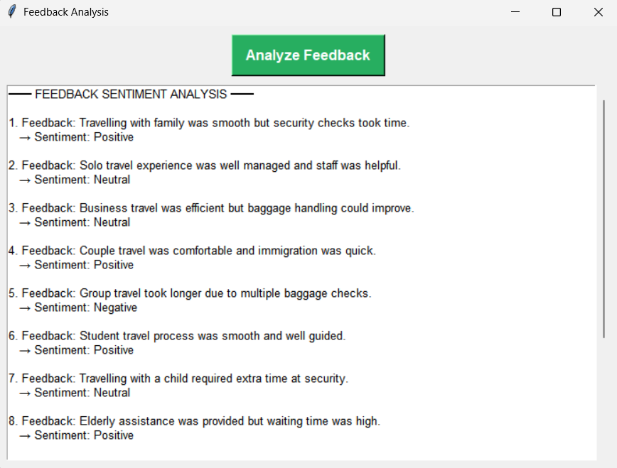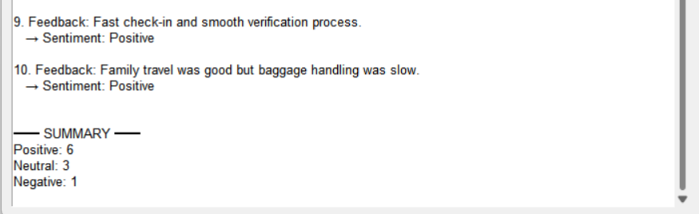

sentiment_analysis.csv
Full_Name | Destination_Country | Travel_Feedback | Sentiment
Rahul Sharma | France | Travelling with family was smooth but security checks took time. | Positive
Ananya Verma | Japan | Solo travel experience was well managed and staff was helpful. | Neutral
Mohit Khan | UAE | Business travel was efficient but baggage handling could improve. | Neutral
Sneha Kulkarni | Germany | Couple travel was comfortable and immigration was quick. | Positive
Amit Patel | USA | Group travel took longer due to multiple baggage checks. | Negative
Pooja Nair | Canada | Student travel process was smooth and well guided. | Positive
Rohit Mehta | UK | Travelling with a child required extra time at security. | Neutral
Neha Gupta | Australia | Elderly assistance was provided but waiting time was high. | Positive
Kunal Shah | Singapore | Fast check-in and smooth verification process. | Positive
Kavya Iyer | Italy | Family travel was good but baggage handling was slow. | Positive

4. Text Summarization

summary_gui.py
import tkinter as tk
from tkinter import scrolledtext
import pandas as pd
keywords = [
"smooth","delay","security","baggage",
"slow","quick","helpful","stressful","waiting"
]
def summarize(text):
text = str(text).lower()
found = [k for k in keywords if k in text]
if not found:
return "General travel experience."
return "Key points: " + ", ".join(found)
def generate():
df = pd.read_csv("passenger_registration.csv")
df["Summary"] = df["Travel_Feedback"].fillna("").apply(summarize)
df.to_csv("feedback_summary.csv", index=False)
out.delete(1.0, tk.END)
for i, r in df.iterrows():
out.insert(tk.END,
f"Original:\n{r['Travel_Feedback']}\n"
f"Summary:\n{r['Summary']}\n\n")
root = tk.Tk()
root.title("Text Summarization")
root.geometry("720x520")
tk.Button(root, text="Re-Generate Summary", command=generate).pack(pady=10)
out = scrolledtext.ScrolledText(root, width=85, height=25)
out.pack()
root.after(100, generate)
root.mainloop()
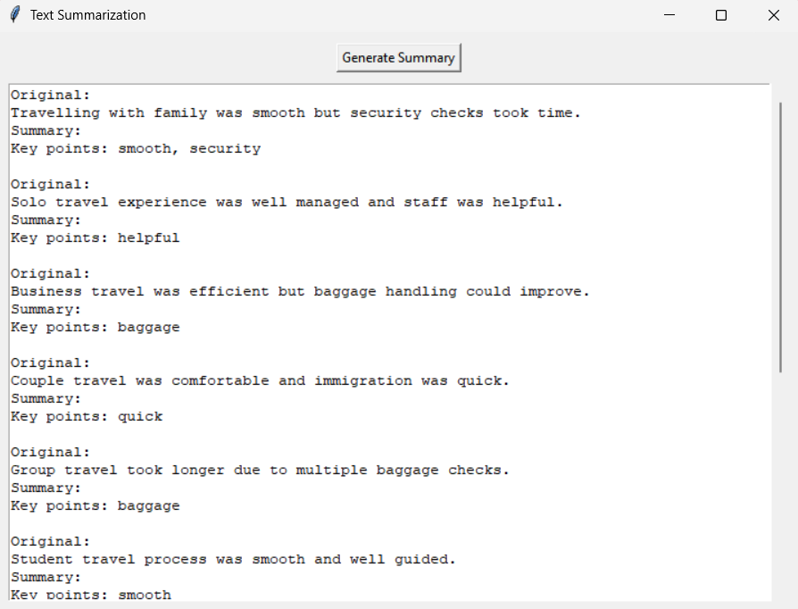

feedback_summary.csv
Full_Name | Destination_Country | Travel_Feedback | Summary
Rahul Sharma | France | Travelling with family was smooth but security checks took time. | Key points: smooth, security
Ananya Verma | Japan | Solo travel experience was well managed and staff was helpful. | Key points: helpful
Mohit Khan | UAE | Business travel was efficient but baggage handling could improve. | Key points: baggage
Sneha Kulkarni | Germany | Couple travel was comfortable and immigration was quick. | Key points: quick
Amit Patel | USA | Group travel took longer due to multiple baggage checks. | Key points: baggage
Pooja Nair | Canada | Student travel process was smooth and well guided. | Key points: smooth
Rohit Mehta | UK | Travelling with a child required extra time at security. | Key points: security
Neha Gupta | Australia | Elderly assistance was provided but waiting time was high. | Key points: waiting
Kunal Shah | Singapore | Fast check-in and smooth verification process. | Key points: smooth
Kavya Iyer | Italy | Family travel was good but baggage handling was slow. | Key points: baggage, slow

5. Entity Extraction (NER)

ner_gui.py
import tkinter as tk
from tkinter import scrolledtext, messagebox
import pandas as pd
import re
try:
import spacy
nlp = spacy.load("en_core_web_sm")
except ImportError:
messagebox.showerror("Error", "Spacy not installed. Install with: pip install spacy")
nlp = None
def run_ner():
try:
if nlp is None:
messagebox.showerror("Error", "Spacy model not loaded. Restart the application.")
return
df = pd.read_csv("passenger_registration.csv")
if len(df) == 0:
messagebox.showwarning("No Data", "Please enter travel data first!")
return
rows = []
for _, r in df.iterrows():
text = f"{r.get('Full_Name', '')} travelled to {r.get('Destination_Country', '')}. {r.get('Travel_Feedback', '')}"
doc = nlp(text)
for e in doc.ents:
rows.append([e.text, e.label_])
if 'Passport_Number' in r and pd.notna(r['Passport_Number']):
for p in re.findall(r"[A-Z0-9]{6,10}", str(r["Passport_Number"])):
rows.append([p, "PASSPORT_NUMBER"])
if not rows:
messagebox.showinfo("Info", "No entities found in the data")
out.delete(1.0, tk.END)
out.insert(tk.END, "No named entities detected in travel data.")
return
ner_df = pd.DataFrame(rows, columns=["Entity", "Type"])
try:
ner_df.to_csv("entity_extraction.csv", index=False)
except:
pass # File might be locked, continue anyway
out.delete(1.0, tk.END)
out.insert(tk.END, "━━ NAMED ENTITY RECOGNITION (NER) RESULTS ━━\n\n")
for e, t in rows:
out.insert(tk.END, f"{e} → {t}\n")
messagebox.showinfo("Success", "NER + Regex completed")
except FileNotFoundError:
messagebox.showerror("Error", "passenger_registration.csv not found!")
except Exception as e:
messagebox.showerror("Error", str(e))
root = tk.Tk()
root.title("NER + Regex")
root.geometry("700x500")
tk.Button(root, text="Re-Run NER + Regex", command=run_ner).pack(pady=10)
out = scrolledtext.ScrolledText(root, width=85, height=25)
out.pack()
root.after(100, run_ner)
root.mainloop()

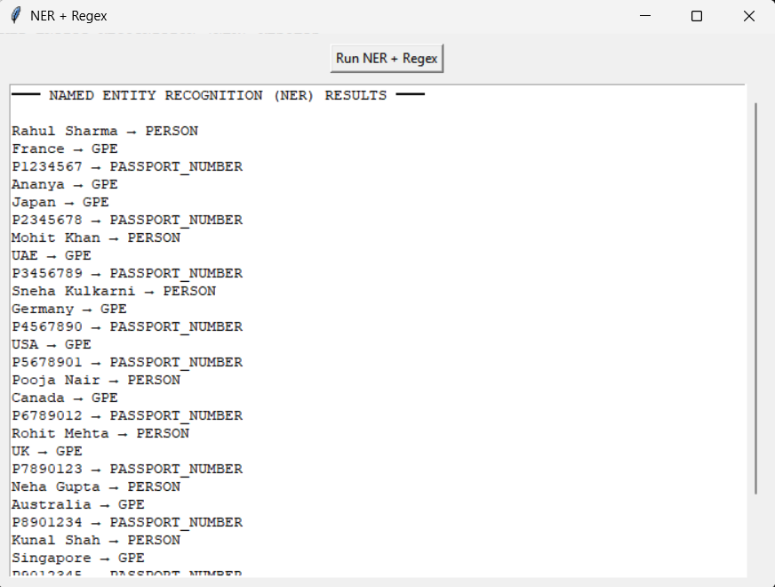

entity_extraction.csv
Entity | Type
Rahul Sharma | PERSON
France | GPE
P1234567 | PASSPORT_NUMBER
Ananya | GPE
Japan | GPE
P2345678 | PASSPORT_NUMBER
Mohit Khan | PERSON
UAE | GPE
P3456789 | PASSPORT_NUMBER
Sneha Kulkarni | PERSON
Germany | GPE
P4567890 | PASSPORT_NUMBER
USA | GPE
P5678901 | PASSPORT_NUMBER
Pooja Nair | PERSON
Canada | GPE
P6789012 | PASSPORT_NUMBER
Rohit Mehta | PERSON
UK | GPE
P7890123 | PASSPORT_NUMBER
Neha Gupta | PERSON
Australia | GPE
P8901234 | PASSPORT_NUMBER
Kunal Shah | PERSON
Singapore | GPE
P9012345 | PASSPORT_NUMBER
Kavya Iyer | PERSON
Italy | GPE
P0123456 | PASSPORT_NUMBER

6. Visual Insights

plot_gui.py
import pandas as pd
import matplotlib.pyplot as plt
import numpy as np
try:
df = pd.read_csv("passenger_registration.csv")
if len(df) == 0:
print("No data found. Please enter travel data first!")
exit()
# Data preprocessing
df['Group_Size'] = pd.to_numeric(df['Group_Size'], errors='coerce').fillna(1).astype(int)
df['Children_Count'] = pd.to_numeric(df['Children_Count'], errors='coerce').fillna(0).astype(int)
df['Elderly_Count'] = pd.to_numeric(df['Elderly_Count'], errors='coerce').fillna(0).astype(int)
df['Number_of_Bags'] = pd.to_numeric(df['Number_of_Bags'], errors='coerce').fillna(0).astype(int)
df['First_Time_Traveler'] = df['First_Time_Traveler'].fillna('No')
df['Accessibility_Needs'] = df['Accessibility_Needs'].fillna('None')
# Create 2x2 subplot grid
fig, ((ax1, ax2), (ax3, ax4)) = plt.subplots(2, 2, figsize=(16, 12))
fig.suptitle("Visualization", fontsize=20, fontweight='bold', y=0.99)
# PLOT 1: TRAVELER COMPOSITION
solo = len(df[df["Group_Size"] == 1])
family = len(df[df["Children_Count"] > 0])
elderly = len(df[df["Elderly_Count"] > 0])
colors1 = ["#3498db", "#e74c3c", "#f39c12"]
ax1.pie(
[solo, family, elderly],
labels=["Solo Travelers", "Families with Children", "Groups with Elderly"],
autopct="%1.1f%%",
colors=colors1,
startangle=90,
textprops={'fontsize': 9, 'weight': 'bold'}
)
ax1.set_title("Traveler Composition", fontsize=12, fontweight='bold', pad=10)
# PLOT 2: GROUP SIZE vs BAGS
ax2.scatter(df["Group_Size"], df["Number_of_Bags"], s=80, alpha=0.6, color='#9b59b6', edgecolors='black', linewidth=1.5)
ax2.set_xlabel("Group Size", fontsize=10, fontweight='bold')
ax2.set_ylabel("Number of Bags", fontsize=10, fontweight='bold')
ax2.set_title("Group Size vs Baggage Load", fontsize=12, fontweight='bold', pad=10)
ax2.set_xticks(sorted(df["Group_Size"].unique()))
ax2.grid(True, alpha=0.3, linestyle='--')
# PLOT 3: FIRST-TIME vs EXPERIENCED TRAVELERS
counts = df["First_Time_Traveler"].value_counts()
colors3 = ['#3498db', '#e67e22'][:len(counts)]
counts.plot(kind="bar", ax=ax3, color=colors3, alpha=0.8, edgecolor='black', linewidth=1.5)
ax3.set_xlabel("Traveler Type", fontsize=10, fontweight='bold')
ax3.set_ylabel("Number of Passengers", fontsize=10, fontweight='bold')
ax3.set_title("First-Time vs Experienced Travelers", fontsize=12, fontweight='bold', pad=10)
ax3.set_xticklabels(ax3.get_xticklabels(), rotation=0, ha='center', fontsize=9)
ax3.grid(True, alpha=0.3, axis='y', linestyle='--')
# PLOT 4: ACCESSIBILITY NEEDS
access = df["Accessibility_Needs"].value_counts().head(8)
ax4.barh(range(len(access)), access.values, color='#e74c3c', alpha=0.8, edgecolor='black', linewidth=1.5)
ax4.set_yticks(range(len(access)))
ax4.set_yticklabels(access.index, fontsize=9)
ax4.set_xlabel("Number of Passengers", fontsize=10, fontweight='bold')
ax4.set_title("Top Accessibility Needs", fontsize=12, fontweight='bold', pad=10)
ax4.grid(True, alpha=0.3, axis='x', linestyle='--')
# Adjust spacing to prevent label overlap
plt.subplots_adjust(top=0.94, bottom=0.08, left=0.08, right=0.96, hspace=0.35, wspace=0.3)
# Remove toolbar for cleaner look
mng = plt.get_current_fig_manager()
if hasattr(mng, 'toolbar'):
mng.toolbar.pack_forget()
plt.show()
except FileNotFoundError:
print("Error: passenger_registration.csv not found!")
except Exception as e:
print(f"Error: {str(e)}")
