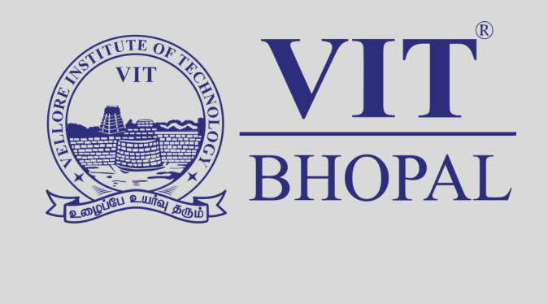
Name: Pragati Sachdeva
Reg. No.- 25BCE10811
Branch: CSE Core
Year: 2025–29
Course Code: CSE0001
Date: 28/03/26

Introduction
This portfolio represents my development as a Student Digital Ambassador, covering five essential areas of digital literacy. In Task 1, I created a visual infographic to explain digital literacy concepts and safe internet practices. In Task 2, I built my professional presence by creating profiles on GitHub, LinkedIn, and Kaggle.

In Task 3, I explored coding and collaboration platforms by solving a coding challenge and creating a Google Form for awareness. Task 4 focused on professional communication, where I drafted formal emails and created a social media etiquette checklist. Finally, in Task 5, I studied cybercrime by analyzing a UPI fraud case and understanding prevention methods.

Together, these tasks helped me develop technical, communication, and digital safety skills, making me more confident in using digital platforms responsibly.

Task 1: Digital Literacy Awareness Infographic

Tool Used
For this task, I used Canva to design my infographic. Canva provides easy-to-use templates, icons, and design tools which helped me create a visually appealing and informative design.

Design Overview
My infographic covers key aspects of digital literacy such as its meaning, importance, and safe internet practices. I included topics like useful digital tools for students, responsible online behavior, and the importance of maintaining a professional online presence.

The design uses simple text, icons, and colors to make the content easy to understand and visually engaging.

Reflection
Through this process, I realized that being digitally literate is not just a technical requirement but a fundamental part of being a responsible digital citizen. This task helped me understand how to present information visually in an effective way. The most challenging part was organizing all the information into a single page without making it look crowded. Overall, it improved my creativity and communication skills.

Task 2: Professional Student Digital Portfolio

Platforms Selected
For this task, I created and updated my profiles on GitHub, LinkedIn, and Kaggle. I chose these specific platforms because they represent the essential “ triple threat “ for a Computer Science student . These platforms are important for building a strong professional presence.

Purpose of Each Platform
GitHub serves as a platform to store, manage, and showcase my coding projects. It helps in maintaining a structured portfolio of my work. LinkedIn is used for professional networking, where I can connect with peers, educators, and industry professionals while presenting my academic background and achievements. Kaggle focuses on data science and analytics, allowing me to practice problems, explore datasets, and improve my technical skills.

Future Goals
Over the next four years, I plan to actively use these platforms to enhance my skills and build a strong professional profile. I will regularly upload my projects on GitHub, expand my professional network on LinkedIn, and improve my analytical and problem-solving abilities through Kaggle. These efforts will help me become career-ready and confident in the digital world.

Task 3: Coding and Collaboration Platforms

Platforms Used
For this task, I explored HackerRank for coding practice and Google Workspace (Google Forms and Google Sheets) for collaboration and data management. These platforms are important for developing both technical and practical skills required in academics and future careers. HackerRank helps in strengthening programming logic, while Google tools support efficient collaboration and data handling.

Project Overview
In Part A, I solved a beginner-level coding challenge on HackerRank. This task involved understanding basic programming concepts and improving logical thinking. Successfully completing the problem helped me gain confidence in coding. In Part B, I created a Digital Literacy Awareness Quiz using Google Forms. The quiz included multiple-choice and short-answer questions to make it interactive. I also explored how responses are automatically collected and organized in Google Sheets, making data management easier.

Academic Impact
This task helped me understand how coding platforms can improve problem-solving and prepare me for technical interviews. At the same time, using Google Forms and Sheets showed how digital tools can be used for collaboration, surveys, and academic projects. Overall, it enhanced my technical skills and improved my ability to use digital tools effectively.

Task 4: Draft a Professional Email & Etiquette Guide

Communication Scenario
In this task, I explored the importance of professional digital communication by analyzing a common situation where a student sends an informal message to a professor through social media instead of a proper email. The message may lack a clear subject line, use casual language, or be sent at inappropriate times, which can lead to misunderstandings and delayed responses. Such behavior can create a negative impression and affect professional relationships, especially in academic and career-related communication.

Key Learning
Through this task, I learned the importance of writing structured and professional emails. I practiced drafting emails for situations like requesting an assignment extension and applying for an internship, ensuring they included proper subject lines, greetings, clear content, and polite closing statements. I also created a social media do’s and don’ts checklist, which helped me understand responsible online behavior.

Overall, this task improved my communication skills and made me aware of the importance of maintaining professionalism in all forms of digital interaction, as it plays a crucial role in building a positive digital identity.

Task 5: Cybercrime

What surprised you
While researching UPI fraud, I was surprised to learn how easily cybercriminals can manipulate users without actually hacking systems. The concept of social engineering was particularly eye-opening, as it shows that attackers mainly target human behavior rather than technical vulnerabilities. Simple tactics such as fake payment requests, phishing links, or pretending to be bank officials can trick users into sharing sensitive information. What surprised me the most was that even educated users can fall victim to these scams due to lack of awareness and urgency created by fraudsters. This made me realize that digital security is not just about strong systems but also about being cautious and informed while using online platforms.

One habit you will change
After completing this task, I have decided to be more careful while using digital payment systems and online services. I will avoid clicking on unknown links, scanning random QR codes, or responding to suspicious calls or messages. I will also make sure to never share my UPI PIN, OTP, or personal details with anyone. Additionally, I plan to use strong passwords and enable two-factor authentication for better security. This habit change will help me stay safe online and reduce the risk of becoming a victim of cybercrime in the future.

Conclusion

Completing this five-task portfolio has been a highly valuable and transformative experience in developing my digital literacy skills. Through Task 1, I learned how to present information effectively using visual tools, while Task 2 helped me build a professional online presence through platforms like GitHub, LinkedIn, and Kaggle. These platforms will continue to support my academic and career growth in the future.

Task 3 enhanced my technical and collaborative skills by allowing me to practice coding and use digital tools like Google Forms and Sheets for data collection and management. In Task 4, I improved my professional communication skills by learning how to write structured emails and maintain proper digital etiquette. Task 5 provided important insights into cybercrime awareness, especially UPI fraud, and taught me how to stay safe while using online platforms.

Overall, this project has helped me become more confident in using digital tools responsibly and effectively. It has also made me more aware of online safety, professional behavior, and the importance of maintaining a strong digital identity in today’s technology-driven world.

References
Resources, Tools & Platforms Cited

This project was completed using a variety of digital platforms to demonstrate skills in design, coding, collaboration, communication, and cybersecurity awareness.

Design & Presentation
Canva: Used for creating the Digital Literacy Awareness Infographic in Task 1. It helped in designing visually appealing and informative content using templates and design tools.

Professional Identity
GitHub: Used to create and manage project repositories and showcase my work as a digital portfolio.

LinkedIn: Used for building a professional profile and connecting with peers and professionals.

Kaggle: Used to explore datasets and understand basic concepts of data science and analytics.

Coding & Data Management
HackerRank: Used for solving coding challenges and improving programming and problem-solving skills.

Google Forms & Google Sheets: Used to create a quiz and collect responses.

Cybersecurity & Safety
National Cyber Crime Portal (https://cybercrime.gov.in): Used as a reference for understanding cybercrime reporting and safety measures.

UPI System: Studied as part of the case study to understand online payment fraud and digital security risks.

