**PREDICTION AND DIAGNOSIS OF VARIOUS HEART DISEASES   
 AND CHANCES OF HEART ATTACK**

**A System Requirement Specification**

Submitted in Partial Fulfilment of the Requirements for the Degree of

**Bachelor of Technology in**

**Information technology**

by

Mayank Tyagi (2000270130102)

Mohit Arora (2000270130104)

Pragati Gupta (2000270130120)

Radhika Bhatt (2000270130128)

Under the Supervision of

Mr. Mamta Pant



**AJAY KUMAR GARG ENGINEERING COLLEGE, GHAZIABAD**

**DR. A.P.J ABDUL KALAM TECHNICAL UNIVERSITY, LUCKNOW**

October 13, 202

**Contents**

1 Abstract 1

2 Problem Statement 2

3. Objectives and Scope 4

4. Interest Over The Project 5

5. Literature Review 7

6 Designing of the project 6

6.1 Zero and One Level DFD 6

6.2 Usecase Diagram 8

6.3 Class Diagram 10

6.4 Sequence Diagram 11

6.5 ER Diagram 11

7 Gantt Chart 12

8 References 13

**List of Figures**

6.1 Level 0 DFD . . . . . . . . . . . . . . . . . . . . . 6

6.2 Level 1 DFD . . . . . . . . . . . . . 6

6.3 Use case Diagram . . . . . . . . . . 8

6.4 Class Diagram . . . . . . . . . . . . . . . . . . . . . 10

6.5 Sequence diagram . . . . . . . . . . . . . . . . . . . . . 11

6.6 ER diagram . . . . . . . . . . . . . . . . . . . . . 11

**ABSTRACT**

The prevalence of cardiovascular diseases remains a major global health concern, necessitating innovative approaches for early detection, diagnosis, and preventive health management. This project introduces an integrated system comprising predictive analytics for heart diseases, a diagnostic module for identifying specific conditions, and a health advisory chatbot for personalized health guidance. The system utilizes machine learning algorithms to analyze health data, assess the risk of heart diseases, and provide timely insights for preventive measures.

This project focuses on developing the heart disease detection based on the patient health factors and developing the chat bot which will advise the patient based on their heart disease condition. The system features an intelligent and user-friendly GUI implemented using boosting algorithms and the Flask framework. The proposed project aims to develop and implement an AI-driven heart disease detection and health advisory system. This system, potentially in the form of a conversational bot, should address the following key objectives such as Early detection, Continuous monitoring, User-Friendly Interface.

# PROBLEM STATEMENT

Cardiovascular diseases (CVDs) remain a leading cause of morbidity and mortality worldwide. Early detection, accurate diagnosis, and personalized health management are critical for mitigating the impact of heart diseases. However, existing healthcare systems often lack efficient tools for predicting individual risks, diagnosing specific conditions, and providing continuous health guidance. The absence of an integrated solution creates gaps in preventive care, leading to delayed interventions and suboptimal health outcomes.

**Key Challenges:**

Limited Predictive Analytics:

Current healthcare systems lack robust predictive analytics for assessing an individual's risk of developing heart diseases based on comprehensive data, including lifestyle factors and historical health records.

Diagnostic Ambiguity:

Diagnostic processes for heart diseases are often cumbersome and may lack specificity, leading to delays in identifying the precise cardiovascular conditions that individuals may be facing.

Inadequate Heart Attack Risk Assessment:

There is a need for a reliable algorithm that can accurately assess the chances of a heart attack by considering real-time health data, symptoms, and diagnostic information.

Lack of Personalized Health Advisory Services:

Traditional healthcare systems often fall short in providing ongoing, personalized health advisory services, resulting in a gap between diagnosis and effective health management.

Communication Barriers in Healthcare:

Communication breakdowns between healthcare providers and individuals contribute to a lack of understanding and adherence to recommended lifestyle changes and treatment plans.

# OBJECTIVE AND SCOPES

## OBJECTIVES

The objective of this project is Create an advanced predictive analytics module that leverages machine learning to assess individual risks for heart diseases based on diverse datasets, including lifestyle and historical health information.

Enhance Diagnostic Precision:

Implement diagnostic tools that utilize medical imaging, electrocardiograms, and other clinical data to accurately identify various heart diseases, allowing for tailored treatment plans.

Accurate Heart Attack Risk Prediction:

Design a specialized algorithm capable of assessing the likelihood of a heart attack in real-time, taking into account individual risk factors and current health status.

Integrate Health Advisory Chatbot:

Develop a conversational AI chatbot that engages users in meaningful health discussions, provides personalized health advice, and serves as a continuous source of support and information.

Improve Communication Channels:

Establish effective communication channels between healthcare providers and individuals, facilitating a clear understanding of diagnoses, treatment plans, and the importance of lifestyle modifications.

## SCOPE

The scope of this project encompasses the development and implementation of an integrated system for the prediction and diagnosis of heart diseases, the assessment of heart attack risks, and the incorporation of a health advisory chatbot. The project will cover various aspects, ensuring a comprehensive solution to address the challenges associated with cardiovascular health. The key components within the project scope include:

Predictive Analytics Module:

Design and implement a machine learning-based predictive analytics module to assess individual risks of developing heart diseases.

Integrate algorithms capable of processing diverse datasets, including lifestyle factors and historical health records.

Diagnostic Module:

Develop a diagnostic module incorporating advanced tools for the analysis of medical images, electrocardiograms (ECG), and relevant clinical data.

Ensure the diagnostic module is capable of differentiating between various heart diseases with high precision.

Heart Attack Risk Assessment:

Design and implement an algorithm to assess the likelihood of a heart attack in real-time based on individual risk factors, symptoms, and diagnostic findings.

Provide users with clear and understandable feedback on their current risk status.

Health Advisory Chatbot:

Develop a conversational AI chatbot capable of engaging users in personalized health discussions.

Implement the chatbot to offer proactive health advice, reminders for medication, and lifestyle recommendations based on individual health records.

User Interface and Experience:

Create an intuitive and user-friendly interface for individuals to interact with the system, view health insights, and receive personalized recommendations.

Ensure seamless navigation between different modules of the system.

Integration with Healthcare Systems:

Establish integration capabilities with existing healthcare systems, allowing healthcare providers to access relevant diagnostic information and collaborate on patient care.

**INTEREST OVER THE PROJECT**

We found that the heart disease is the most lethal one and challenging one in today’s world. Any age groups are attacked by the heart disease. Basically, we search a challenging title in the health care sector for our project work. We found that the title related to heart health for the potential to make a meaningful impact, develop valuable skills, and contribute to the evolving landscape of healthcare through innovation and research

**LITERATURE SURVEY**

Md. Imam Hossain et al (2023) [1] - The research article was published in the Iran Journal of Computer Science. The article explores the use of distinct artificial intelligence techniques for heart disease prediction. The authors analyzed patient data to identify the most significant factors for accurate diagnosis. The article includes information on author contributions, funding, data availability, conflict of interest, and ethical approval. The study's findings could have implications for improving patient management opportunities.

Kathiravan Srinivasan et al (2022) [2] - It discusses the development of an IoT-CloudBased Smart Healthcare Monitoring System for Heart Disease Prediction via Deep Learning. It covered related work, methodology, experimental setup, performance assessment, experimental results and discussion, comparative analysis, future directions, and conclusions. The proposed system's performance surpasses that of existing systems, and it utilizes edge computing and fog computing to handle the immense data traffic generated by smart devices. The article also presents various models and approaches for heart disease prediction, including ensemble classifiers, fuzzy logic systems, and machine learning hybrid models.

Victor Chang et al (2022) [3] - It describes the construction of an artificial intelligence based heart disease detection system using artificial intelligence and machine learning algorithms. The system uses a random forest classifier algorithm for predictive analytics. However, there is no information provided about the accuracy of the system or whether it can be applied to other types of health monitoring applications beyond heart disease detection.

Yang Yan et al (2019) [4] - It discusses the potential role of AI in the diagnosis and treatment of cardiovascular diseases. It highlights the current shortcomings of AI in cardiovascular medicine and the need for guidelines to protect human rights in AI research. Overall, the article suggests that AI has the potential to revolutionize the clinical application of CVD in the future.

Paul A.Friedman et al (2019) [4] - It provides the information about Mayo Clinic's resources and services, including patient-centered care, clinical trials, support groups, and educational programs for medical professionals. Mayo Clinic is a leader in the movement to bring artificial intelligence (AI) tools and technology into clinical practice to benefit people who have or are at risk of heart disease. The clinic's AI cardiology team is applying these new approaches to early risk prediction and diagnosis of serious or complex heart problems. This paper also includes sections on diseases and conditions, symptoms, tests and procedures, drugs and supplements, healthy lifestyle, books and subscriptions, and more.

**DESIGNING OF THE PROJECT**

**DATAFLOW DIAGRAM**

## Level 0 DFD

The 0th level data flow diagram provide a end to end process of the proposed system which is given in the figure 6.1

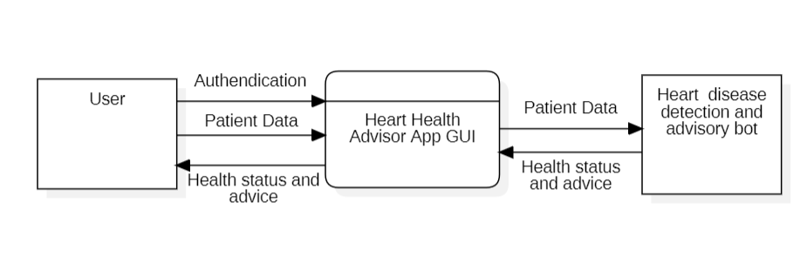

Figure 6.1 : Level 0 DFD

## Level 1 DFDs

This Level 1 DFD provides a more detailed view of specific interactions and processes within the proposed system. It helps visualize how data flows between different components and how users interact with the system at various stages. The figure 7.2 describes about the Level 1 DFD.

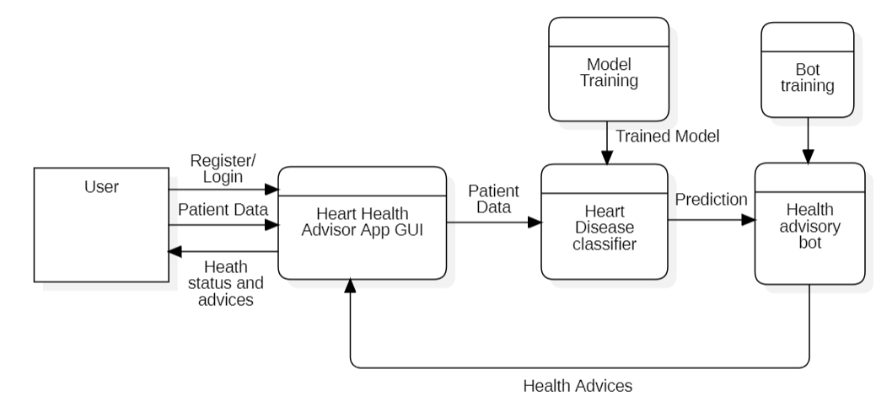

**USE CASE DIAGRAM**

The figure 6.3 mimics the use case over the proposed project

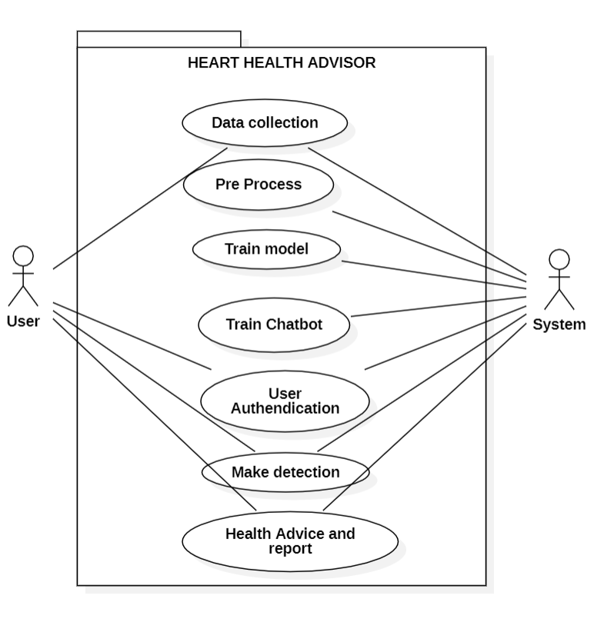

Figure 5.1 : Use case Diagram of application

**CLASS DIAGRAM**

The figure 6.4 describes the class diagram of the system.

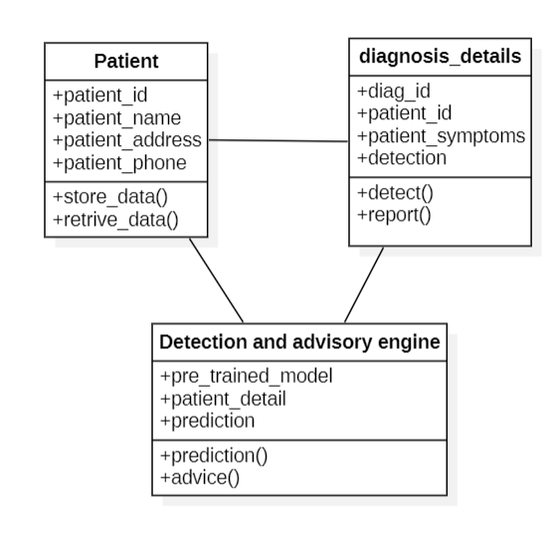

Figure 6.4 : Class Diagram

**SEQUENCE DIAGRAM**

The figure 6.5 describes about the sequence diagram

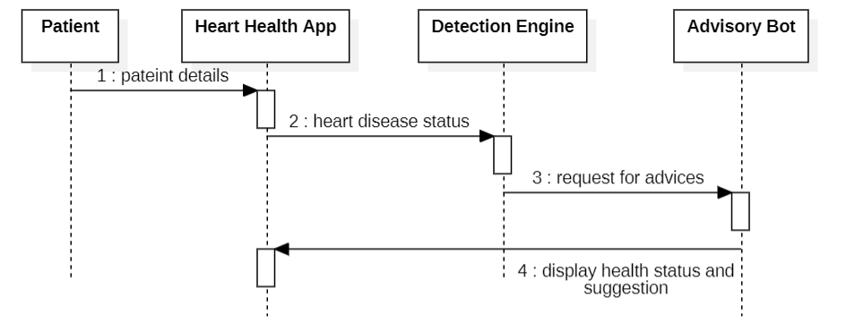

Figure 6.5 Sequence Diagram

**ER DIAGRAM**

The figure 6.6 describes about the ER diagram of the application

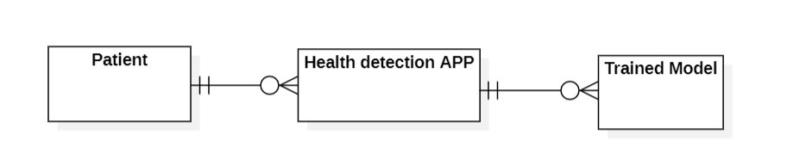

Figure 6.6 ER Diagram

**GANTT CHART**

The time line chart of the project is given below,

|  |  |  |  |  |  |  |  |  |  |  |  |  |  |  |  |  |  |  |  |  |  |  |  |  |  |
| --- | --- | --- | --- | --- | --- | --- | --- | --- | --- | --- | --- | --- | --- | --- | --- | --- | --- | --- | --- | --- | --- | --- | --- | --- | --- |
|  | 1st Evaluation | | | | | 1st Evaluation | | | | | 1st Evaluation | | | | | 1st Evaluation | | | | | Final Evaluation | | | | |
| Week start | 08/09/2023 | | | | | 16/10/2023 | | | | | 27/11/2023 | | | | | 01/03/2024 | | | | | 01/04/2023 | | | | |
| Activity |  |  |  |  |  |  |  |  |  |  |  |  |  |  |  |  |  |  |  |  |  |  |  |  |  |
| Final Year Project |  |  |  |  |  |  |  |  |  |  |  |  |  |  |  |  |  |  |  |  |  |  |  |  |  |
| Synopsis |  |  |  |  |  |  |  |  |  |  |  |  |  |  |  |  |  |  |  |  |  |  |  |  |  |
| Project Finalization PPT |  |  |  |  |  |  |  |  |  |  |  |  |  |  |  |  |  |  |  |  |  |  |  |  |  |
| SRS Report |  |  |  |  |  |  |  |  |  |  |  |  |  |  |  |  |  |  |  |  |  |  |  |  |  |
| Project UI |  |  |  |  |  |  |  |  |  |  |  |  |  |  |  |  |  |  |  |  |  |  |  |  |  |
| 60-70% workable project |  |  |  |  |  |  |  |  |  |  |  |  |  |  |  |  |  |  |  |  |  |  |  |  |  |
| 100% workable project |  |  |  |  |  |  |  |  |  |  |  |  |  |  |  |  |  |  |  |  |  |  |  |  |  |
| Final Report |  |  |  |  |  |  |  |  |  |  |  |  |  |  |  |  |  |  |  |  |  |  |  |  |  |
|  |  |  |  |  |  |  |  |  |  |  |  |  |  |  |  |  |  |  |  |  |  |  |  |  |  |

# REFERENCES

1. Muniasamy, A.; Tabassam, S.; Hussain, M.; Sultana, H.; Muniasamy, V.; Bhatnagar, R. Deep Learning for Predictive Analytics in Healthcare. In Advances in Intelligent Systems and Computing; Springer: Cham, Switzerland, 2019; pp. 32– 42. [Google Scholar] [CrossRef]
2. Mijwil MM., Al-Mistarehi AH., Aggarwal K: The effectiveness of utilising modern artificial intelligence techniques and initiatives to combat COVID-19 in South Korea: a narrative review. Asian J. Appl. Sci. 9(5) (2021). (ISSN: 2321-0893)
3. Haq, A.U., Li, J.P., Memon, M.H., Nazir, S., Sun, R.: A hybrid intelligent system framework for the prediction of heart disease using artificial intelligence. Mobile Inform. Syst.. 2018, 1–21 (2018)
4. Barragán-Montero, A., Javaid, U., Valdés, G., Nguyen, D., Desbordes, P., Macq, B., Willems, S., Vandewinckele, L., Holmström, M., Löfman, F., Michiels, S.: Artificial intelligence and machine learning for medical imaging: a technology review. Physica Med. 83, 242–256 (2021)
5. Soni, J., Ansari, U., Sharma, D., Soni, S.: Predictive data mining for medical diagnosis: an overview of heart disease prediction . Int. J. Comput. Appl. 17(8), 43– 48 (2011)
6. https://www.kaggle.com/datasets/fedesoriano/heart-failure-prediction