GLOBAL FUEL PRICE ANALYSIS
Comprehensive Technical Project Documentation & System Report
Submitted by: | Pragati Chourasiya
Course / Department: | B.Tech – Artificial Intelligence and Data Science
College / Institution: | Lakshmi Narain College of Technology (LNCT), Bhopal
Project Platform: | SmartBridge
Academic Year: | 2026–2027

Project Links and Access
The following access endpoints provide live and published access to the project artifacts, including the Python Flask web application and the published interactive Tableau visualization suite.
1. Project Website – Flask Application
The project website was engineered using Python Flask to provide a unified web interface for navigating project documentation, dataset metrics, the embedded Tableau dashboard, and the narrative story presentation.
Page / View | Local Access Endpoint | Description
Home Page | http://127.0.0.1:5000/ | Main landing portal and project overview
Dashboard Page | http://127.0.0.1:5000/dashboard | Integrated view hosting the Tableau Public dashboard
Story Page | http://127.0.0.1:5000/story | Structured analytical narrative and slide presentation
Note: These URLs represent local loopback endpoints (localhost) and can be accessed only in environments where the Flask WSGI development server is actively running.

2. Tableau Public – Published Dashboard
The Global Fuel Price Analysis Dashboard was published to Tableau Public cloud servers to ensure seamless, interactive online access without requiring local desktop software installations.
Published Dashboard URL:
https://public.tableau.com/views/Global_Fuel_Price_Analysis_Project/GlobalFuelPriceDashboard?:language=en-US&:sid=&:redirect=auth&:display_count=n&:origin=viz_share_link

1. Abstract
Global fuel prices play an important role in the economic development of countries. Changes in petrol, diesel, and LPG prices affect transportation, industries, businesses, and the daily lives of people. Fuel prices vary across countries due to factors such as crude oil prices, taxation policies, government subsidies, and economic conditions.
The project Global Fuel Price Analysis focuses on analyzing fuel price variations across different countries and regions using data visualization techniques. Tableau is used to explore fuel price trends, compare regional differences, and understand the relationship between fuel prices, taxes, income levels, and subsidies.
Interactive dashboards and a Tableau Story have been developed to present the findings in an understandable and visually appealing manner. Additionally, a Flask-based website has been developed to provide a centralized platform for accessing the project dashboard and story.
The project aims to transform raw fuel price data into meaningful insights that help users understand global fuel price patterns and differences.
2. Introduction
Fuel is one of the most important resources for transportation, electricity generation, industries, and economic activities. The prices of petrol, diesel, and LPG vary significantly across different countries. These variations are influenced by several factors, including international crude oil prices, government taxation, subsidies, regional economic conditions, and national energy policies.
Understanding these variations is important for analyzing the economic impact of fuel prices and identifying differences between countries. The Global Fuel Price Analysis project uses data visualization to study fuel prices across different countries and regions. Tableau is used to create charts, maps, dashboards, and stories that make the analysis easier to understand.
3. Problem Statement
Fuel prices differ considerably across countries and regions. However, understanding these differences becomes difficult when the information is available only in raw tabular form.
There is a need for an interactive and visual approach to analyze global fuel prices, compare regional patterns, and examine the possible influence of taxation, subsidies, and income levels.
Therefore, this project aims to analyze global fuel price data and present meaningful insights through interactive Tableau visualizations and a web-based interface.
4. Objectives of the Project
The primary objectives established for the design, development, and evaluation of this system are:
1. To analyze petrol, diesel, and LPG prices across different countries.
2. To compare fuel prices across different geographical regions.
3. To study changes in fuel prices over time.
4. To analyze the relationship between crude oil prices and fuel prices.
5. To examine variations in fuel taxation across regions.
6. To compare fuel prices based on country income levels.
7. To understand the role of government subsidies in fuel pricing.
8. To develop interactive dashboards and visualizations using Tableau.
9. To present the analysis through a structured Tableau Story.
10. To integrate the dashboard and story into a lightweight Flask-based web application.
5. Dataset Description
The project utilizes a curated multi-country time-series dataset named global_fuel_prices_Dataset.csv. The dataset aggregates comprehensive weekly observations covering retail fuel prices, taxation rates, macroeconomic income brackets, and subsidy classification levels.
Dataset File Name | global_fuel_prices_Dataset.csv
Approximate Record Count | 27,468 rows
Feature Count | 10 attributes
Geographic Scope | 84 Countries across 7 Continental Regions
Temporal Coverage | January 2020 to April 2026
Sampling Frequency | Weekly observations
Validation Protocol | Verified against primary institutional reporting records

Key Dataset Attributes
• Date: Temporal timestamp recording the weekly reporting date.
• Country: Name of the sovereign state or territory.
• Region: Geographical classification (e.g., Europe, Asia-Pacific, North America).
• Income Level: World Bank economic income category (High, Upper-Middle, Lower-Middle, Low).
• Subsidy Level: Categorical index indicating sovereign fuel market intervention/subsidies.
• Petrol Price: Retail petrol (gasoline) price quoted in USD per litre.
• Diesel Price: Retail commercial and automotive diesel price quoted in USD per litre.
• LPG Price: Liquefied Petroleum Gas retail consumer price in USD per litre equivalent.
• Crude Oil Price: Benchmark international crude reference price (Brent Crude, USD per barrel).
• Tax Information: Applicable statutory excise, VAT, and energy surcharges expressed as percentage/share.
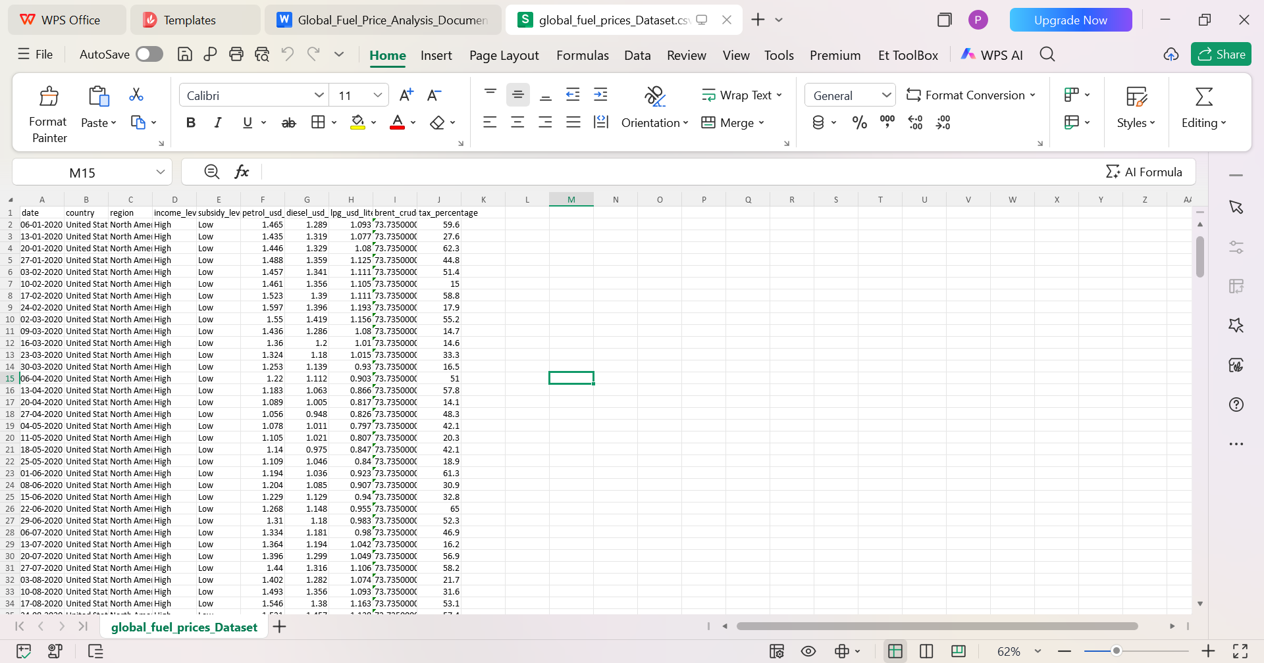(Insert visual screenshot here)
Figure 1: Overview of the Global Fuel Price Dataset.
6. Software and Tools Used
6.1 Tableau (Desktop & Public)
Tableau is an enterprise data visualization and business intelligence platform. It was utilized to build analytical worksheets, calculated fields, parameter controls, geographical bubble/choropleth maps, consolidated dashboards, and sequential Tableau Stories.
6.2 CSV / Spreadsheet Processing
Comma-Separated Values (CSV) formatted files served as the raw flat-file data exchange medium, manipulated via Microsoft Excel and pandas for baseline validation.
6.3 Python (v3.10+)
Core scripting language providing the backend engine, algorithmic data handling, and local web server invocation.
6.4 Flask Web Framework
Lightweight Python micro-framework utilized to structure MVC application routes, render HTML templates, and deliver custom embedded view containers.
6.5 HTML5 and CSS3
Standards-compliant frontend presentation layer, delivering modern styling, responsive grid layouts, typographic scales, and navigation bars.
6.6 Visual Studio Code
Primary Integrated Development Environment (IDE) utilized for source code editing, workspace management, debugging, and terminal operations.
7. Data Preparation and Preprocessing
Data preparation and cleansing represent a foundational phase prior to modeling and visual exploration. The dataset was verified to ensure structural consistency, numeric integrity, and standard geographic nomenclature.
✓ Dataset inspection to audit rows, structural schema, data types, and attribute definitions.
✓ Standardization of date formats, continuous temporal series, and categorical variables.
✓ Variable identification and indexing for pricing benchmarks (petrol, diesel, LPG), crude prices, and fiscal policies (tax rates, subsidy tags).
✓ Data hygiene review, evaluating null fields, duplicate instances, and anomalous pricing outliers.
✓ Data schema ingestion and schema relationship modeling within Tableau Desktop.
8. Exploratory Data Analysis
Exploratory Data Analysis (EDA) encompasses univariate, bivariate, and multivariate investigations to discover patterns, distributions, correlations, and anomalies. In this project, analytical inquiry was partitioned across geographic, economic, and fiscal dimensions:
• Comparative analysis across distinct fuel types (petrol, diesel, and LPG).
• Identification of top ranking countries exhibiting highest average retail fuel expenditures.
• Macro-level regional comparisons across seven continental zones.
• Longitudinal time-series evaluation tracking price shifts against economic disruptions.
• Tracking benchmark Brent Crude pricing volatility versus end-user consumer prices.
• Evaluating fuel affordability and cost burdens across World Bank income strata.
• Cross-regional fiscal taxation disparity assessments.
• Evaluating retail price insulation under differing sovereign subsidy programs.
9. Tableau Worksheets and Visualizations
Dedicated analytical worksheets were constructed within Tableau to address specific research questions and provide granular perspectives on the dataset.
9.1 Global Fuel Price and Tax Performance Indicators
High-level summary cards (KPI cards) aggregating mean global prices across petrol, diesel, and LPG alongside global weighted tax rates.
9.2 Fuel Price Trend
Dual-axis temporal line charts plotting weekly historical retail price fluctuations for all three fuel commodities from 2020 through 2026.
9.3 Brent Crude Trend
Longitudinal line visualization tracking Brent Crude spot prices, demonstrating global oil supply-demand shocks.
9.4 Diesel Price by Region
Comparative clustered horizontal bar charts evaluating regional diesel price benchmarks across commercial transport corridors.
9.5 Average Tax Percentage by Region
Ranked column chart displaying the fiscal tax load imposed on consumer fuel across various continents.
9.6 Top 10 Countries by Average Petrol Price
Focused bar visualization showcasing the top ten economies bearing the highest domestic retail petrol prices.
9.7 Fuel Prices by Income Level
Box plots and grouped bar charts comparing retail fuel costs classified by national GDP per capita categories.
9.8 Fuel Prices by Subsidy Level
Distribution graphs contrasting price stabilization across heavily subsidized versus completely deregulated fuel economies.
9.9 Petrol Price Map
Global choropleth map color-coding 84 nations by average retail petrol prices to visually contextualize geographic disparity.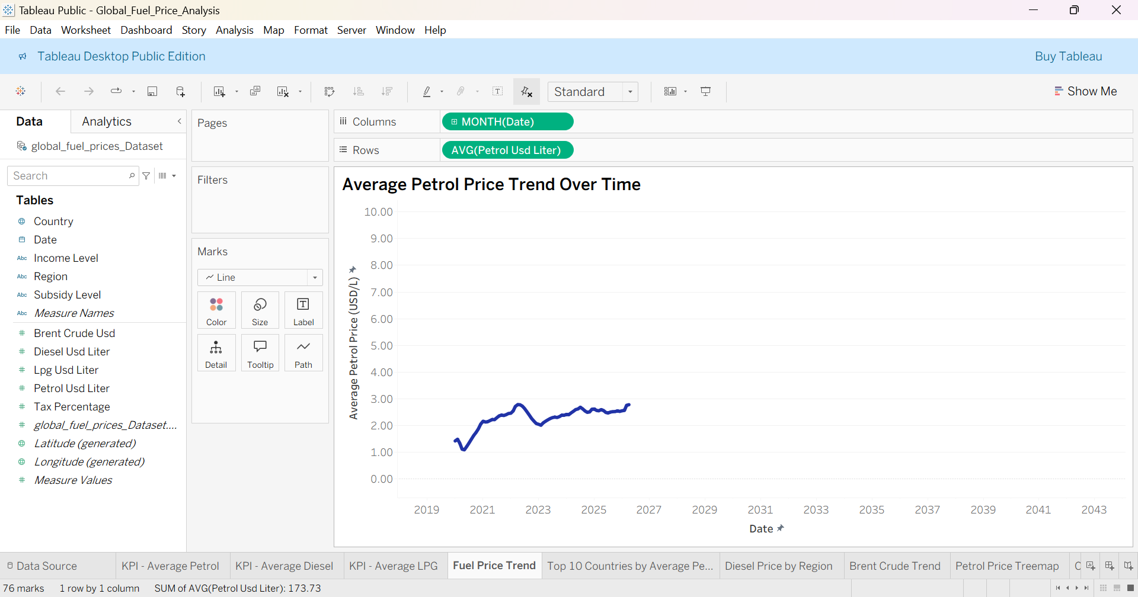

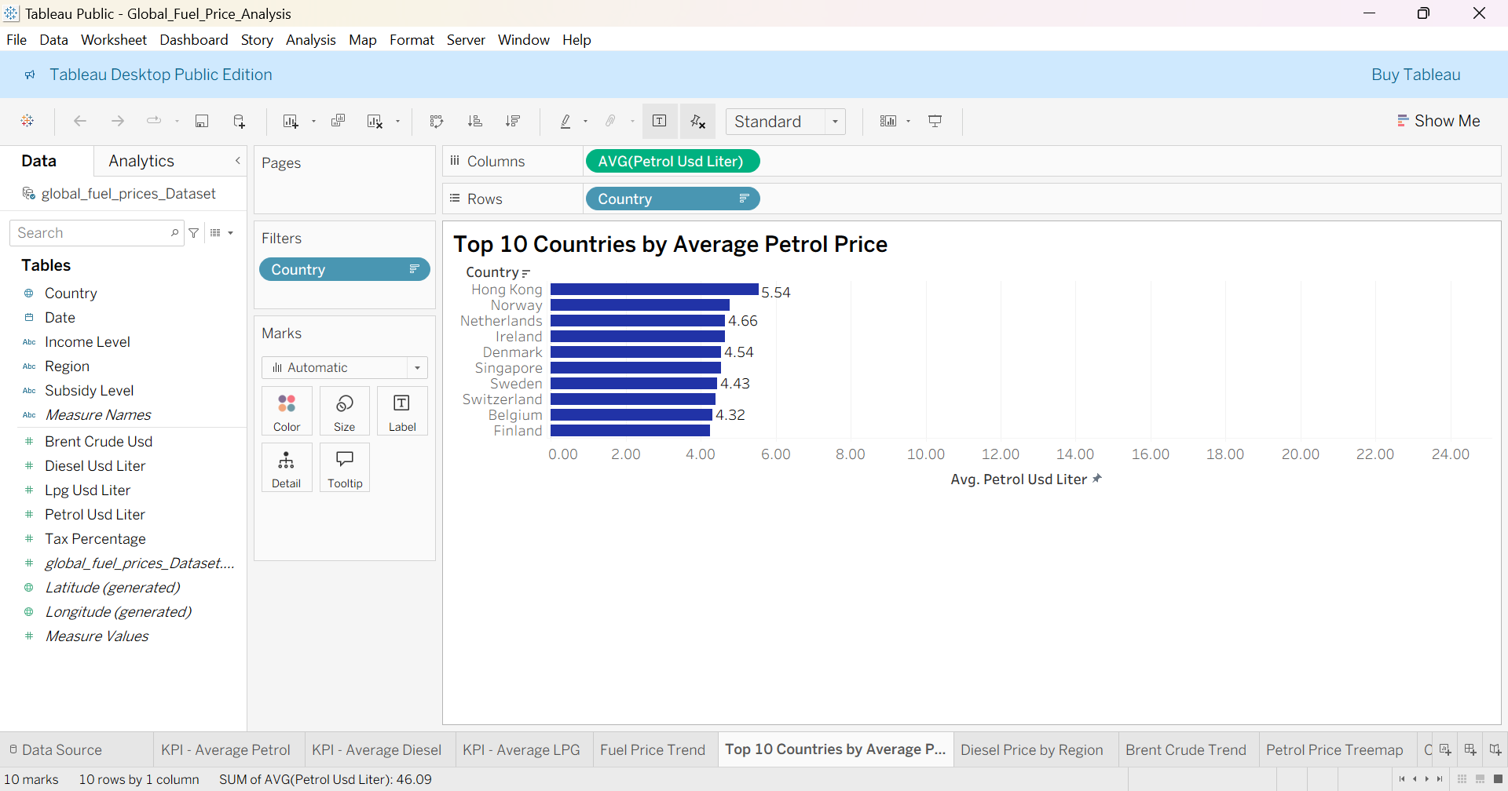
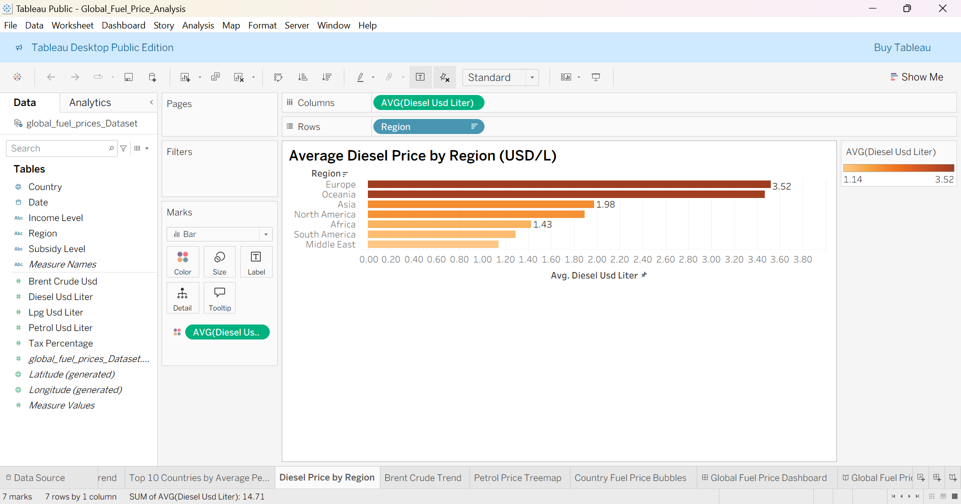

10. Dashboard Development
An integrated executive dashboard titled Global Fuel Price Dashboard was constructed by synthesizing the core worksheets into an interactive, cohesive cockpit. The layout applies visual hierarchy, synchronized filtering, and cross-highlighting actions.
Main Dashboard Features
• Key Performance KPI Tiles: Real-time indicators showing global average petrol, diesel, LPG, and tax benchmarks.
• Temporal Trend Window: Interactive time-series charts with customizable date range filters.
• Regional Disparity Comparison: Dynamic comparative views of regional diesel and tax profiles.
• High-Cost Country Rankings: Visual highlighting of highest-cost retail markets.
• Geographic Choropleth Map: Pan-and-zoom global map enabling click-to-filter drill-down into specific nations.
• Interactive Unified Filters: Global action filters linking region, fuel type, and income levels across all visual components.
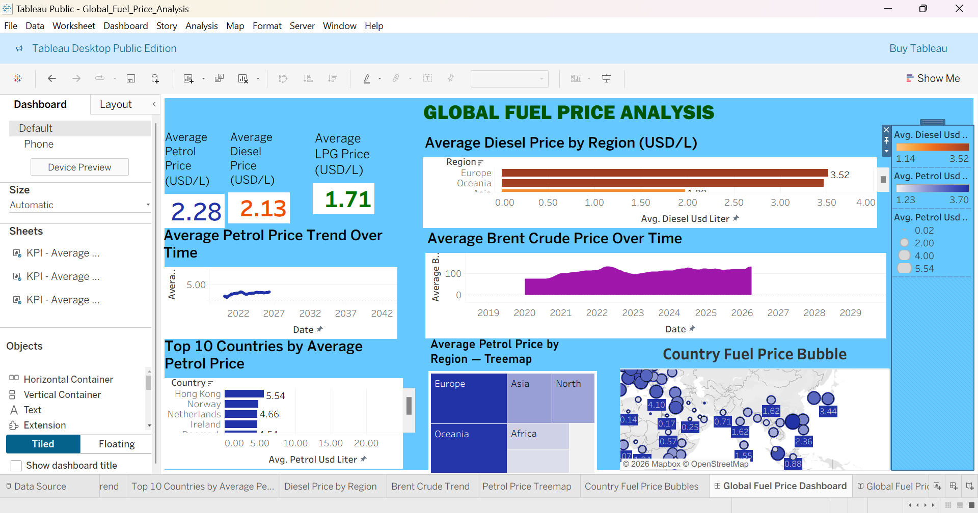
Figure 6: Global Fuel Price Analysis Dashboard.
Published Tableau Dashboard URL:
https://public.tableau.com/views/Global_Fuel_Price_Analysis_Project/GlobalFuelPriceDashboard?:language=en-US&:sid=&:redirect=auth&:display_count=n&:origin=viz_share_link

11. Tableau Story Development
A Tableau Story titled Global Fuel Price and Tax Performance Indicators was composed to provide a structured, chronological narrative of the analytical findings. Rather than overwhelming viewers with simultaneous dashboards, the story presents insights through sequential, annotated scenes.
• Scene 1: Introduction to Global Fuel Price Analysis: Setting the contextual baseline and defining the multi-national price dataset.
• Scene 2: Geographical Differences in Fuel Prices: Exploring continental variations and spatial distribution maps.
• Scene 3: Changes in Fuel Prices Over Time: Evaluating post-pandemic recovery shocks and temporal pricing trends.
• Scene 4: Fuel Taxation Patterns: Demonstrating how state fiscal policy governs the ultimate retail price at the pump.
• Scene 5: Comparison Based on Income Levels: Analyzing domestic affordability ratios and energy cost burdens across economic tiers.
• Scene 6: Analysis of Fuel Subsidies: Investigating state-sponsored market cushioning and price stabilization schemes.
• Scene 7: Key Findings and Strategic Recommendations: Synthesizing executive findings and outlining data-driven policy directions.
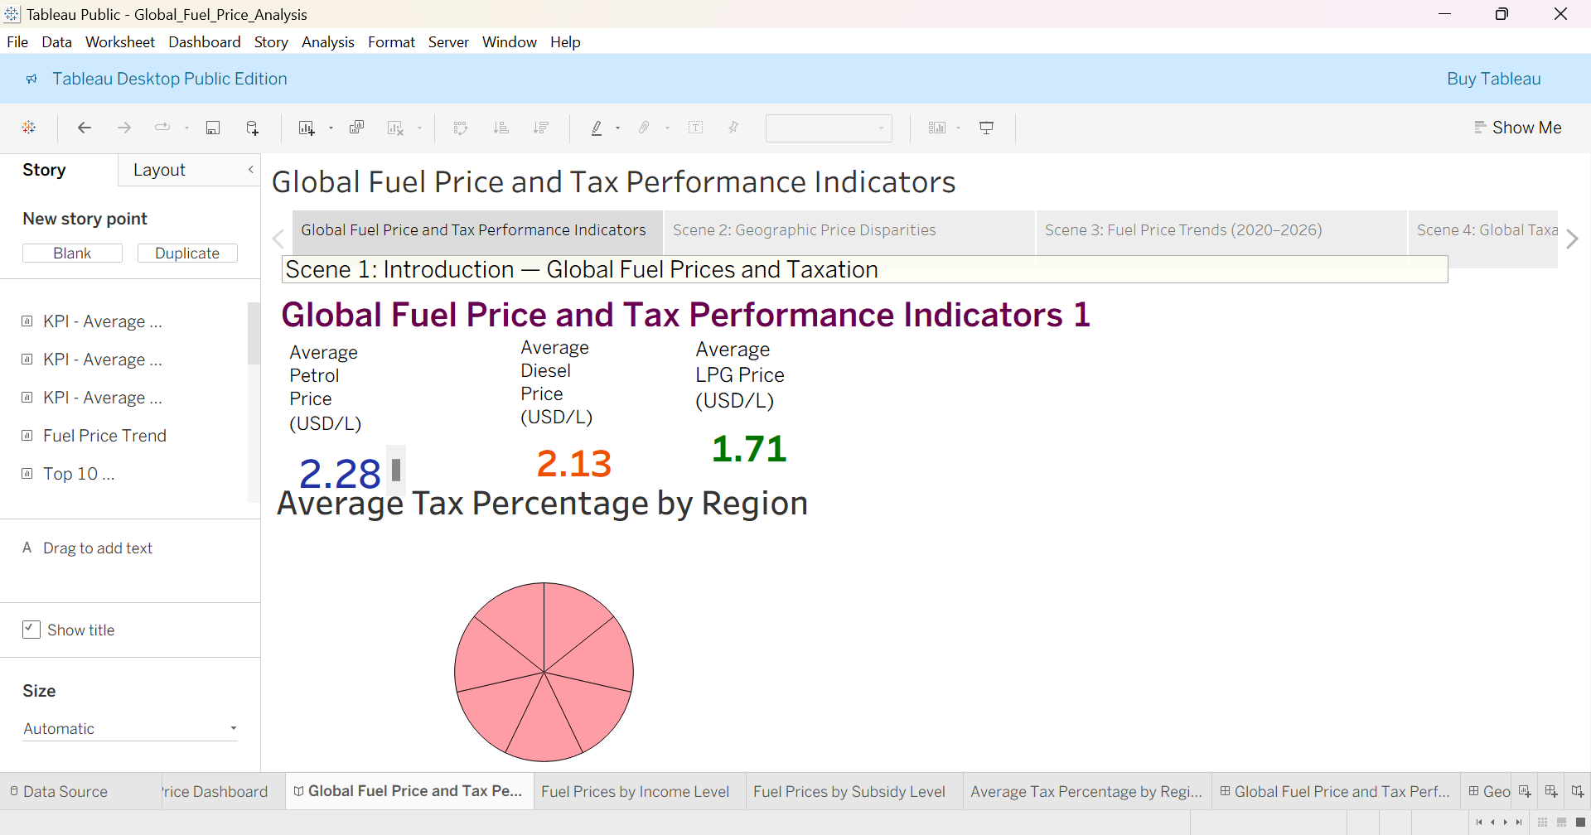
Figure 7: Introduction to the Tableau Story.
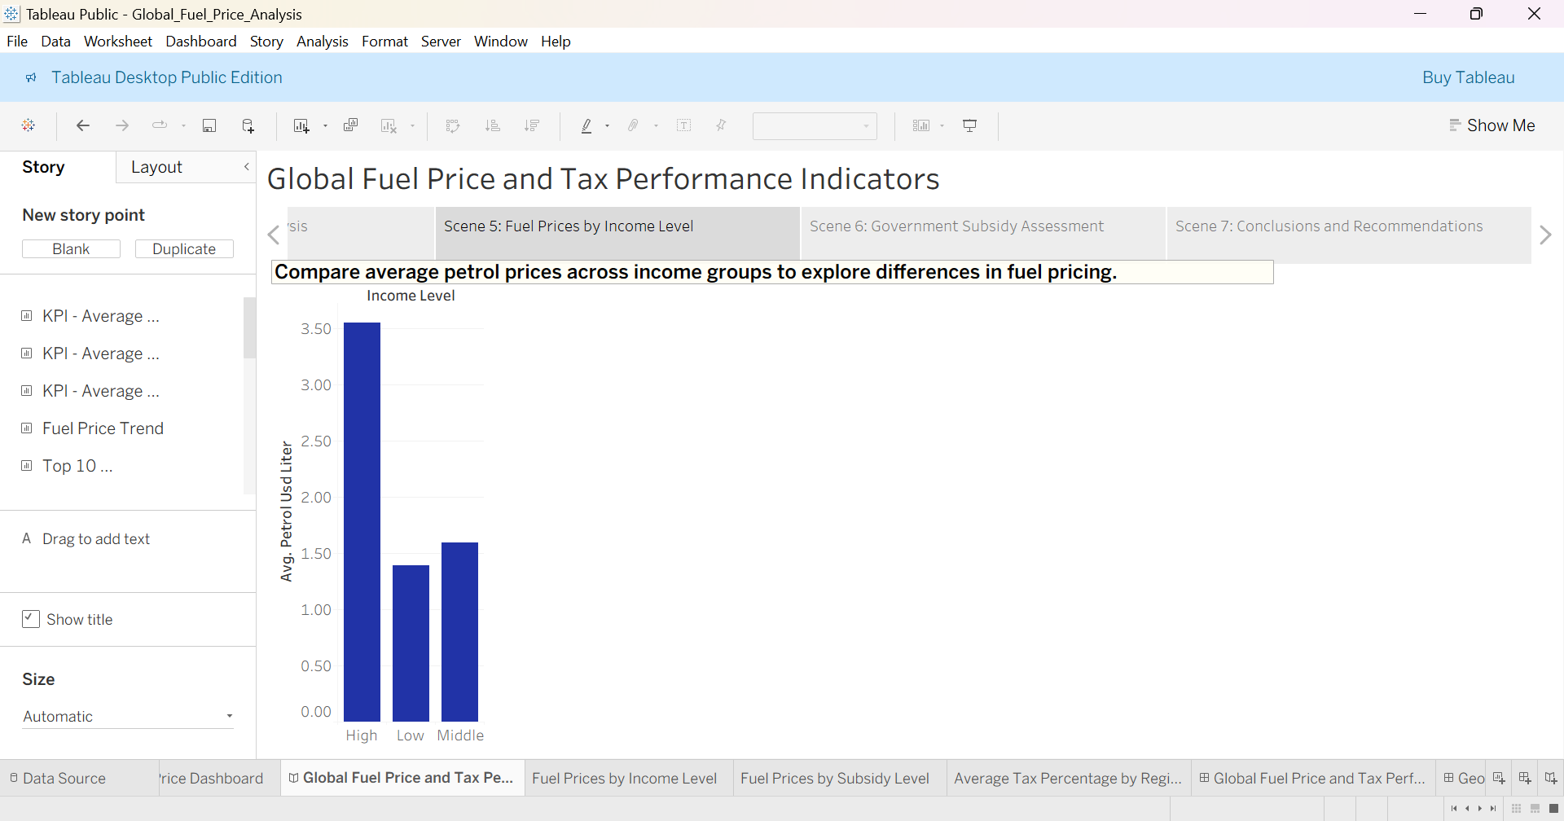
Figure 8: Fuel Price and Tax Performance Analysis.
Published Tableau Story: Available through the published Tableau Public project portal.

12. Flask Website Integration
To provide an intuitive, polished presentation portal, a custom web application was engineered using Python Flask. The web portal encapsulates the project documentation, background narratives, and embeds the interactive Tableau visualizations within responsive web wrappers.
Portal Architectural Features
✓ Comprehensive Home Page offering full project context, scope, and team credentials.
✓ Integrated Dashboard Page embedding Tableau Public via JavaScript API / iframe containers.
✓ Interactive Story Page hosting the sequential narrative presentation.
✓ Standardized navigational structure, responsive layout styling, and optimized load times.
Technology Stack
The implementation stack comprises Python, Flask, HTML5, CSS3, Tableau Public Embedded API, and Visual Studio Code.
Routing and Navigation Architecture
View Name | Application Route | Endpoint Function / Template
Home Page | / | index.html (Project Overview & Methodology)
Dashboard View | /dashboard | dashboard.html (Tableau Public Embed)
Story View | /story | story.html (Tableau Story Embed)

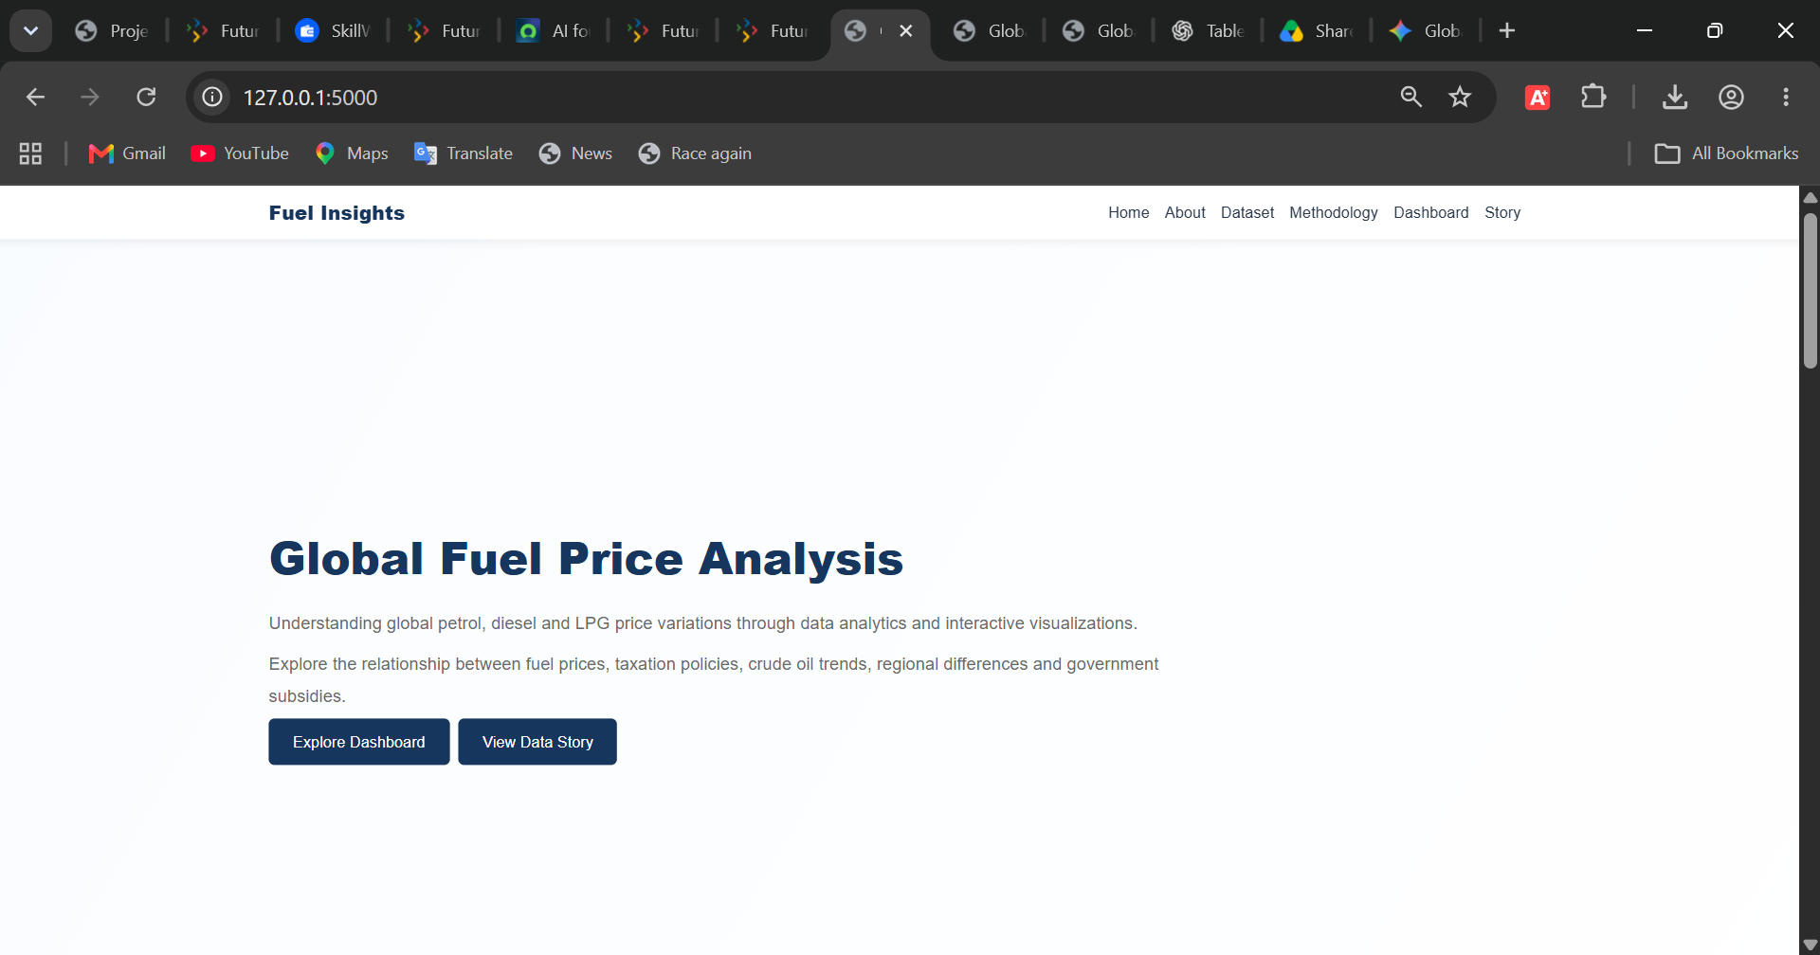
Figure 9: Home Page of the Global Fuel Price Analysis Website.
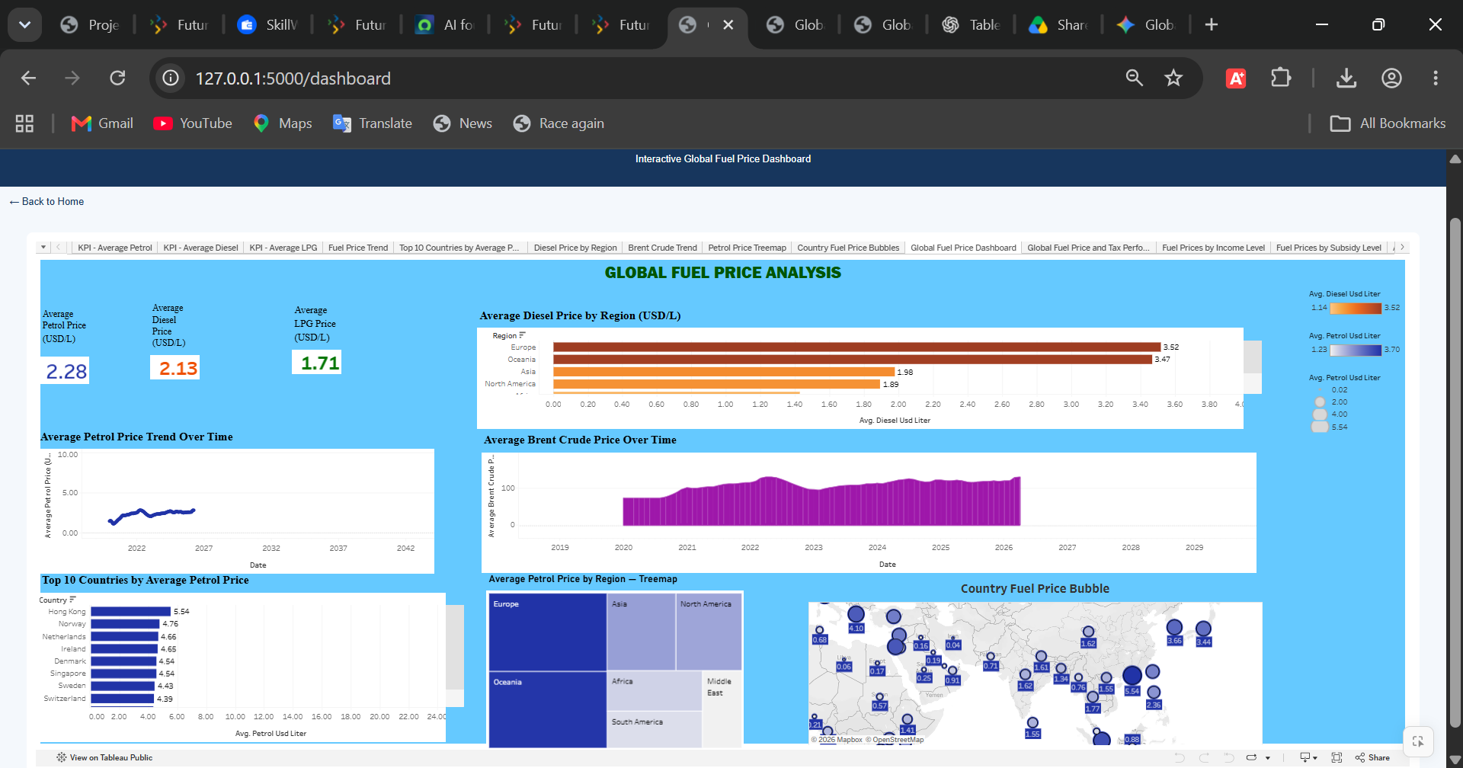
Figure 10: Dashboard Page Integrated with the Flask Website.
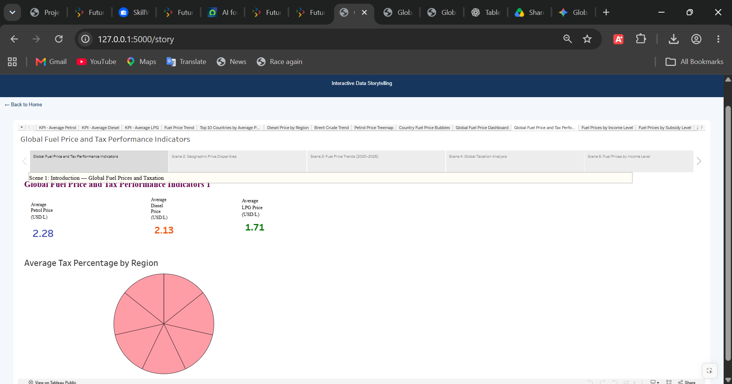
Figure 11: Story Page Integrated with the Flask Website.
13. Key Findings and Insights
Visual analysis in Tableau yielded several significant descriptive findings regarding the structure of the international fuel economy:
• Geographical Disparities: Retail fuel prices exhibit vast regional dispersion; Western European nations demonstrate the highest retail prices due to stringent fiscal policies, whereas major oil-producing nations exhibit substantially lower consumer price levels.
• Temporal Sensitivity: Consumer fuel prices track international macroeconomic cycles with noticeable lag periods, demonstrating elasticity differences across fuel types.
• Crude Oil Transmission: Benchmark Brent Crude price swings exert direct upstream pressure on retail fuel prices, but local tax regimes and refining margins substantially modulate this impact.
• Fiscal and Tax Regimes: Taxation constitutes the single largest variable determining retail price divergence across developed economies with comparable crude access.
• Income-Level Dynamics: High-income nations generally demonstrate higher absolute nominal prices, but lower price volatility relative to overall purchasing power.
• Subsidy Market Distortion: Economies with extensive state subsidies maintain artificial price ceilings, insulating consumers from global shocks while accumulating fiscal deficits.
• Outlier Top-Tier Economies: Certain economies consistently occupy top price rankings as a deliberate consequence of carbon taxation, environmental levies, and transportation disincentives.
Analytical Note: These observations describe empirical patterns identified within the historical dataset. They indicate visual correlations rather than proving direct causal mechanisms without controlled econometric modeling.

14. Challenges and Limitations
Technical and Analytical Challenges
! Harmonizing disparate multi-national datasets featuring inconsistent reporting cadences and currency exchange conversions.
! Selecting balanced visualization idioms capable of conveying complex multivariate relationships without visual clutter.
! Engineering synchronized dashboard action filters and calculated fields across multiple data grains.
! Formulating a cohesive narrative storyline connecting diverse analytical angles.
! Resolving responsive iframe container embedding challenges and CORS policies between Flask and Tableau Public.
Project Limitations
— Empirical accuracy remains fundamentally bound to the source data collection methodologies.
— The current project scope centers on descriptive analytics rather than predictive forecasting.
— Observed correlations cannot definitively establish macroeconomic causality without rigorous econometric controls.
— The Flask application is configured for local WSGI server execution and has not yet been deployed to a scalable production cloud environment.
15. Conclusion
The Global Fuel Price Analysis project demonstrates how data visualization and modern business intelligence tools can transform dense multi-dimensional datasets into actionable insights. Through Tableau, comprehensive dashboards and stories were built to illuminate geographic, temporal, fiscal, and economic dynamics governing global petrol, diesel, and LPG pricing.
By integrating the Tableau artifacts into an intuitive Flask web application, the project delivers a unified, professional user experience that bridges data engineering, business intelligence, and full-stack web integration. This work serves as a solid foundation for energy policy research, consumer cost index tracking, and future predictive modeling endeavors.
16. Future Scope
Prospective enhancements planned for subsequent iterations of this project include:
• Predictive Modeling: Integrating machine learning architectures (e.g., ARIMA, Prophet, LSTM) to forecast future retail fuel prices based on crude futures.
• Automated ETL Pipelines: Connecting live web APIs (such as EIA or World Bank feeds) to automate continuous weekly data ingestion.
• Advanced Econometrics: Deploying regression and causal inference models to quantify the exact elasticity of retail prices relative to tax changes.
• Cloud Infrastructure Deployment: Containerizing the application with Docker and deploying the Flask platform to AWS or Azure cloud hosting.
• Extended User Interactivity: Developing custom what-if scenario simulators allowing users to project retail fuel prices based on hypothetical crude price shocks.
17. References
[1] Tableau Software. Official Tableau Desktop & Public Documentation. Available at: https://help.tableau.com/
[2] Pallets Projects. Flask Web Framework Documentation. Available at: https://flask.palletsprojects.com/
[3] Python Software Foundation. Python 3 Language Reference. Available at: https://docs.python.org/3/
[4] Mozilla Developer Network (MDN). HTML5 and Web Standards Documentation. Available at: https://developer.mozilla.org/en-US/docs/Web/HTML
[5] Mozilla Developer Network (MDN). Cascading Style Sheets (CSS) Documentation. Available at: https://developer.mozilla.org/en-US/docs/Web/CSS
[6] Project Dataset Source. global_fuel_prices_Dataset.csv (SmartBridge Academic Repository, 2026).
[7] Tableau Public Community & Cloud Repository. Available at: https://public.tableau.com/
18. Appendix
Appendix A: Published Tableau Dashboard Access
The interactive Global Fuel Price Analysis Dashboard is published on Tableau Public and accessible via:
https://public.tableau.com/views/Global_Fuel_Price_Analysis_Project/GlobalFuelPriceDashboard?:language=en-US&:sid=&:redirect=auth&:display_count=n&:origin=viz_share_link

Appendix B: Local Flask Web Application Configuration
When executing the local Flask WSGI server (python app.py), the endpoints map as follows:
• Home Portal: http://127.0.0.1:5000/
• Dashboard Embed: http://127.0.0.1:5000/dashboard
• Narrative Story Embed: http://127.0.0.1:5000/story

Video Link : https://drive.google.com/file/d/1QZWtbshy_YErABNW5DeSx4P7hUew2TNH/view?usp=sharing
Appendix D: Visual Evidence and Screenshot Catalog
All screenshot figures referenced throughout sections 5, 7, 9, 10, 11, and 12 serve as verified visual evidence of project execution, dashboard interactivity, and Flask application functionality.

