Task-1

Solution

SELECT DISTINCT CITY

FROM STATION

WHERE LOWER(SUBSTRING(CITY, 1, 1)) IN ('a', 'e', 'i', 'o', 'u')

AND LOWER(SUBSTRING(CITY, LENGTH(CITY), 1)) IN ('a', 'e', 'i', 'o', 'u');

Output:

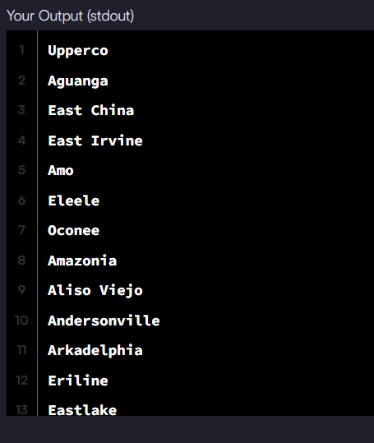

Task-2

Solution:

SELECT MAX(POPULATION) - MIN(POPULATION) AS PopulationDifference

FROM CITY;

Output:



Task-3

Solution:

SELECT

ROUND(

SQRT(

POWER(MAX(LAT_N) - MIN(LAT_N), 2) +

POWER(MAX(LONG_W) - MIN(LONG_W), 2)

), 4

) AS EuclideanDistance

FROM STATION;

Output:



Task-4

Soution:

SELECT

ROUND(

AVG(LAT_N), 4

) AS Median_LAT_N

FROM (

SELECT

LAT_N,

ROW_NUMBER() OVER (ORDER BY LAT_N) AS RowAsc,

ROW_NUMBER() OVER (ORDER BY LAT_N DESC) AS RowDesc

FROM STATION

) AS sub

WHERE RowAsc = RowDesc

OR RowAsc + 1 = RowDesc

OR RowAsc = RowDesc + 1;

Output:



Task-5

Solution:

SELECT CITY.NAME

FROM CITY

JOIN COUNTRY ON CITY.CountryCode = COUNTRY.Code

WHERE COUNTRY.Continent = 'Africa';

Output:

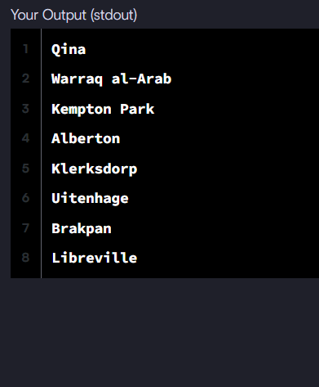

Task-6 is same as task -5

Task-7

Solution:

SELECT

CASE

WHEN G.Grade >= 8 THEN S.Name

ELSE NULL

END AS Name,

G.Grade,

S.Marks

FROM

Students S

JOIN

Grades G

ON

S.Marks BETWEEN G.Min_Mark AND G.Max_Mark

ORDER BY

G.Grade DESC,

CASE

WHEN G.Grade >= 8 THEN S.Name

ELSE NULL

END ASC,

CASE

WHEN G.Grade < 8 THEN S.Marks

ELSE NULL

END ASC;

Output :

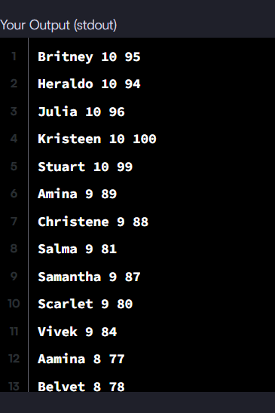

Task-8

Solution:

SELECT

s.hacker_id,

h.name

FROM

Submissions s

JOIN Challenges c ON s.challenge_id = c.challenge_id

JOIN Difficulty d ON c.difficulty_level = d.difficulty_level

JOIN Hackers h ON s.hacker_id = h.hacker_id

WHERE

s.score = d.score

GROUP BY

s.hacker_id, h.name

HAVING

COUNT(DISTINCT s.challenge_id) > 1

ORDER BY

COUNT(DISTINCT s.challenge_id) DESC,

s.hacker_id ASC;

Output:

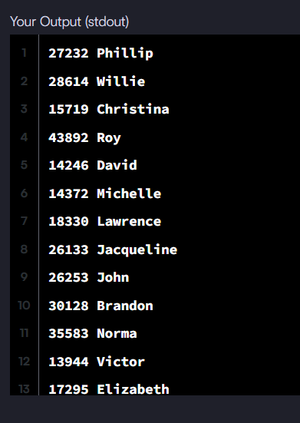

Task-9:

Solution:

SELECT

w.id,

wp.age,

w.coins_needed,

w.power

FROM

Wands w

JOIN

Wands_Property wp

ON w.code = wp.code

WHERE

wp.is_evil = 0

AND w.coins_needed = (

SELECT MIN(w2.coins_needed)

FROM Wands w2

JOIN Wands_Property wp2 ON w2.code = wp2.code

WHERE wp2.is_evil = 0

AND wp2.age = wp.age

AND w2.power = w.power

)

ORDER BY

w.power DESC,

wp.age DESC;

Output:



Task-10:

Solution:

SELECT

h.hacker_id,

h.name,

SUM(max_scores.max_score) AS total_score

FROM

Hackers h

JOIN (

SELECT

hacker_id,

challenge_id,

MAX(score) AS max_score

FROM

Submissions

GROUP BY

hacker_id, challenge_id

) AS max_scores

ON h.hacker_id = max_scores.hacker_id

GROUP BY

h.hacker_id, h.name

HAVING

total_score > 0

ORDER BY

total_score DESC,

h.hacker_id ASC;

Output:

