Unsupervised Learning and Clustering Analysis
Customer Segmentation Using K-Means and Hierarchical Clustering
Week 3 Task — Clustering Analysis Report
Pragati Maurya
Python — pandas, scikit-learn, scipy, matplotlib, seaborn

Deliverables Checklist
This table maps each requirement from the task brief directly to the section of this report where it is addressed, so completeness can be verified at a glance.
Task Requirement | Addressed In
Select a publicly available dataset appropriate for clustering | Section 1
Preprocess the dataset to enhance clustering performance | Section 2
Apply at least one clustering algorithm; detail parameter choices (k) | Sections 3-4
Visualize the clusters using appropriate plots | Section 5
Discuss characteristics of each cluster | Section 6
Discuss business/research implications | Section 7
Discuss potential biases or limitations | Section 8
Reflective commentary | Section 9
Code snippets throughout | All sections

1. Dataset Selection
For a clustering task, the dataset needs to have features that are genuinely continuous and meaningful to group on, and ideally a result that can be sanity-checked against common sense. I chose the Mall Customer Segmentation dataset (200 customers, 5 columns: CustomerID, Gender, Age, Annual Income, Spending Score), a widely used public dataset for exactly this kind of exercise. It is small enough to interpret every cluster in full depth rather than skimming summary statistics on thousands of rows, and it has exactly the property clustering is good at exposing: no labeled 'correct' customer segments exist ahead of time, but the underlying structure turns out to be genuinely there once you look.
The dataset was obtained from a public GitHub-hosted copy of the Kaggle 'Customer Segmentation Tutorial' dataset, downloaded directly via HTTPS.
import pandas as pd
df = pd.read_csv('Mall_Customers.csv')
df.columns = ['CustomerID','Gender','Age','AnnualIncome','SpendingScore']
print(df.shape) # (200, 5)
print(df.isnull().sum()) # zero missing values across all columns
print(df.duplicated().sum()) # zero duplicate rows
The data arrived clean: no missing values, no duplicate rows, and sensible value ranges (Age 18-70, Annual Income $15k-$137k, Spending Score 1-99). This meant very little traditional data-cleaning work was needed here — the real preprocessing work for a clustering task is about preparing features for distance-based comparison, which is the focus of Section 2.
Column | Description | Role in this analysis
CustomerID | Unique identifier | Dropped — carries no information
Gender | Male / Female | Used for cluster profiling, not for clustering itself
Age | Age in years | Used for cluster profiling
Annual Income (k$) | Reported yearly income | Primary clustering feature
Spending Score (1-100) | Mall-assigned behavioral score | Primary clustering feature

2. Preprocessing for Clustering
Clustering algorithms like K-Means work by measuring distance between points, which means every feature needs to be on a comparable scale — otherwise a feature with naturally large numbers (income, ranging into the hundreds) would dominate the distance calculation and drown out a feature with naturally small numbers (spending score, 1-100), even if both are equally important.

2.1 Feature Selection
Annual Income and Spending Score were chosen as the clustering features. This was a deliberate choice, not the only option available. Age and Gender were available too, but I kept the primary clustering to two dimensions on purpose: it keeps the result visually interpretable on a single 2D scatter plot without needing dimensionality reduction (like PCA) to visualize it, and income/spending-behavior is the pairing that is most directly actionable for the kind of segmentation a retailer would actually use. Age and Gender were retained as profiling variables, applied after clustering to describe who is in each group rather than to form the groups themselves. This distinction — which variables define the clusters versus which variables describe them afterward — is addressed further as a limitation in Section 8.

2.2 Feature Scaling
StandardScaler was applied to Annual Income and Spending Score, transforming both to a mean of 0 and a standard deviation of 1.
from sklearn.preprocessing import StandardScaler
features = df[['AnnualIncome','SpendingScore']]
scaler = StandardScaler()
scaled = scaler.fit_transform(features)
# confirmed: post-scaling mean ~0.0000, std ~1.0000 for both features
Without this step, Annual Income (ranging roughly 15-137) would have numerically overwhelmed Spending Score (ranging 1-99) in any Euclidean distance calculation, even though conceptually the two are equally important to how a customer segment is defined. Scaling puts them on equal footing before any clustering algorithm sees the data.

3. Methodology: Algorithm Choice and Parameter Selection

3.1 Why K-Means (with Hierarchical Clustering as a Validation Check)
K-Means was selected as the primary algorithm because the data, once visualized, forms roughly round, well-separated groups rather than irregular or nested shapes — exactly the structure K-Means is built to find efficiently. It is also the standard, well-understood starting point for a 2-feature customer segmentation problem, which keeps the analysis interpretable rather than over-engineered.
Rather than relying on a single algorithm's output, Hierarchical Clustering (Ward linkage) was also run as an independent check, specifically because a previous piece of feedback I received stressed going deeper on validation rather than taking one method's result at face value. If two different clustering algorithms, with different underlying mechanics, agree closely on the same groupings, that is much stronger evidence of genuine structure in the data than one algorithm's output alone. Section 4 shows that result.

3.2 Choosing the Number of Clusters (k)
The number of clusters is the single most important parameter in K-Means, and it is not something the algorithm can determine on its own — it has to be chosen and justified. Three different diagnostics were used together rather than relying on just one, since each has known weaknesses on its own:
- Elbow Method: plots inertia (within-cluster sum of squared distances) against k. The 'elbow' — the point where adding more clusters stops producing a meaningful drop in inertia — suggests a reasonable k.
- Silhouette Score: measures how similar each point is to its own cluster versus the next-nearest cluster, averaged across all points. Ranges from -1 to 1; higher is better-separated.
- Davies-Bouldin Index: measures average similarity between each cluster and its most similar other cluster. Lower is better (less cluster overlap).
from sklearn.cluster import KMeans
from sklearn.metrics import silhouette_score, davies_bouldin_score
for k in range(2, 11):
km = KMeans(n_clusters=k, init='k-means++', n_init=10, random_state=42)
labels = km.fit_predict(scaled)
print(k, km.inertia_, silhouette_score(scaled, labels), davies_bouldin_score(scaled, labels))
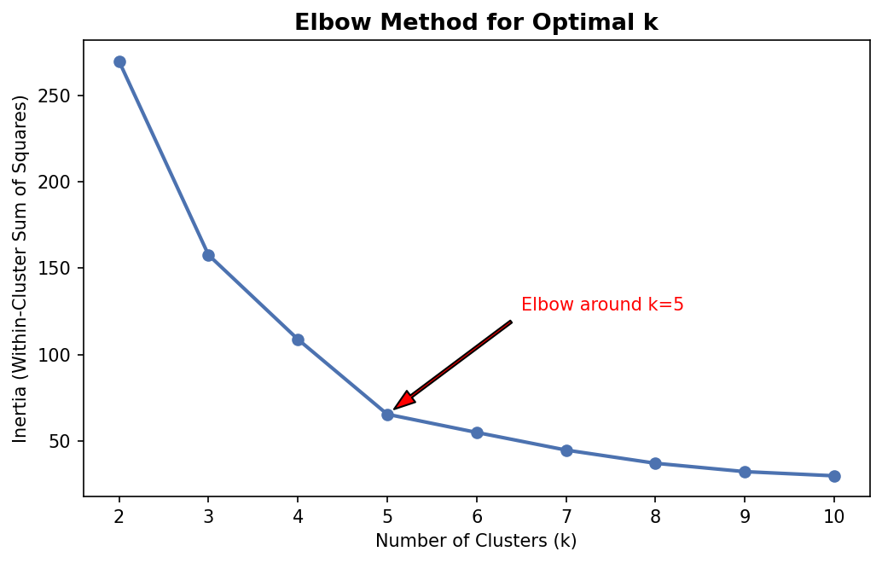
Figure 1. Elbow method. Inertia drops sharply up to k=5, then the rate of decrease flattens noticeably — the classic visual signature of an appropriate elbow point.
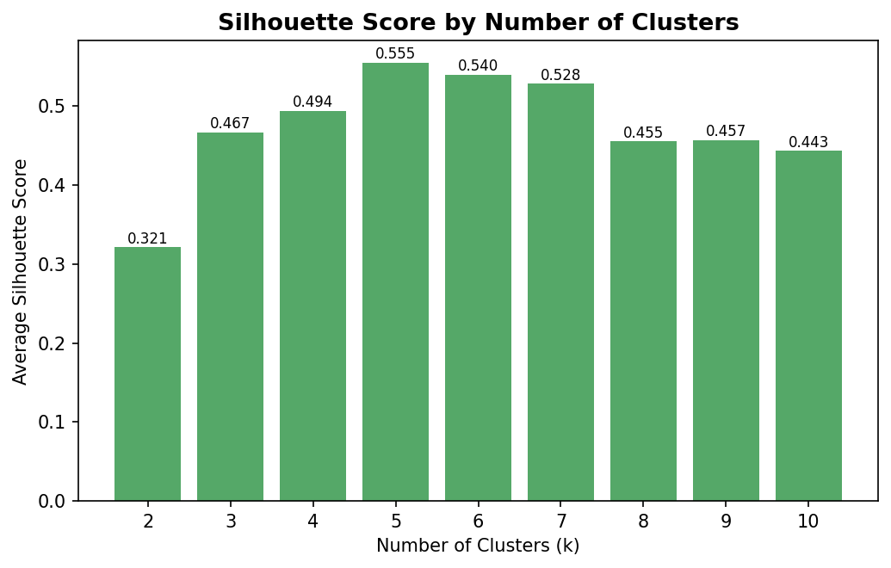
Figure 2. Silhouette score at each candidate k, with the exact value labeled above each bar. k=5 produces the highest score (0.555) of any value tested from 2 to 10.
k | Inertia | Silhouette Score | Davies-Bouldin Index
2 | 269.7 | 0.321 | 1.267
3 | 157.7 | 0.467 | 0.716
4 | 108.9 | 0.494 | 0.710
5 | 65.6 | 0.555 (best) | 0.572 (best)
6 | 55.1 | 0.540 | 0.655
7 | 44.9 | 0.528 | 0.715
All three diagnostics point to the same answer: k=5 sits at the elbow of the inertia curve, achieves the highest silhouette score of any tested value (0.555), and achieves the lowest (best) Davies-Bouldin index (0.572). Having three independent metrics converge on the same k is a far more defensible justification than picking a round number or relying on visual judgment of the scatter plot alone.

4. Applying the Clustering Algorithms

4.1 K-Means (k=5)
km = KMeans(n_clusters=5, init='k-means++', n_init=10, random_state=42)
df['Cluster'] = km.fit_predict(scaled)
centroids = scaler.inverse_transform(km.cluster_centers_)
# init='k-means++' chooses smarter starting centroids than random init,
# reducing the chance of a poor local optimum
# n_init=10 re-runs the algorithm 10 times with different seeds and keeps the best result
# random_state=42 fixes the seed so the result is reproducible run-to-run
Two parameter choices here are worth explaining rather than leaving as defaults. init='k-means++' was used instead of fully random initialization because k-means++ spreads out the initial centroid guesses intelligently, which consistently produces better and more stable final clusters. n_init=10 re-runs the whole algorithm 10 times from different random starting points and keeps the lowest-inertia result, which protects against K-Means converging to a mediocre local optimum on any single unlucky run.
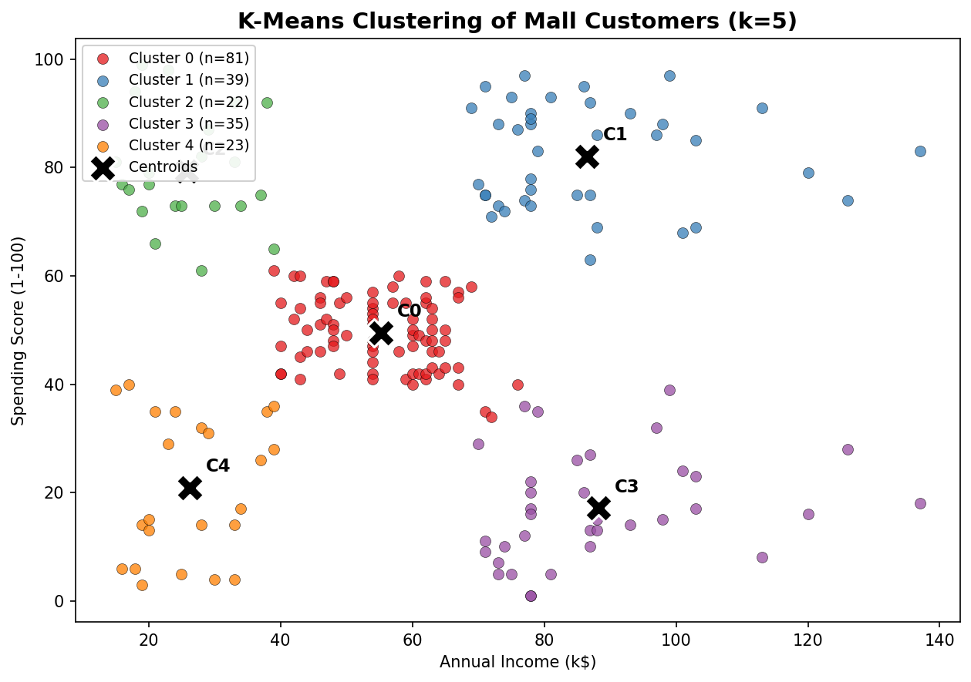
Figure 3. K-Means clusters (k=5) with centroids marked as black X's and labeled C0-C4. Each legend entry also reports the cluster's exact size (n), not just its color.
The five clusters correspond almost exactly to the five corners/regions of the income-spending plane: average income & average spending (center), high income & high spending (top right), low income & high spending (top left), high income & low spending (bottom right), and low income & low spending (bottom left). This is a textbook result for this dataset, and it is reassuring precisely because it is not a surprising shape — an unexpected or scattered result here would have been a signal to question the preprocessing rather than celebrate it.
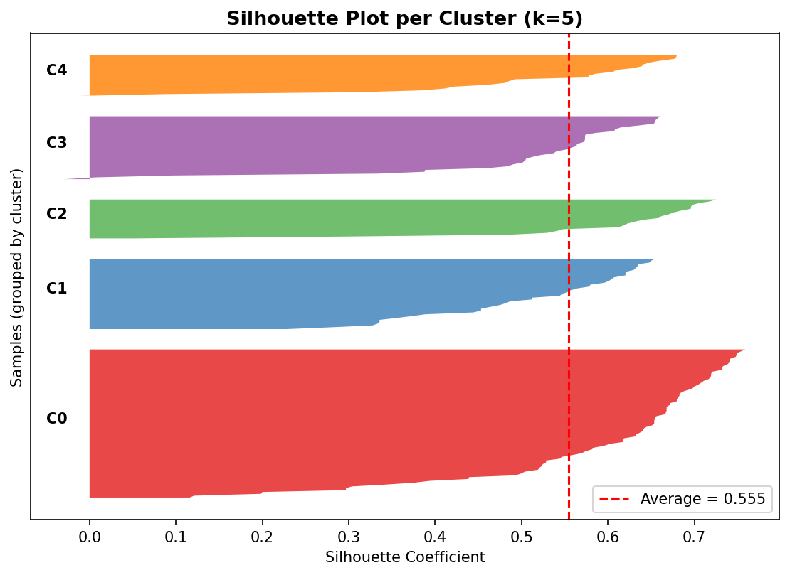
Figure 4. Per-sample silhouette plot, one colored block per cluster. The red dashed line marks the overall average (0.555). Clusters with most of their block extending well past the red line (little to no negative width) indicate tightly-formed, well-separated groups — all five clusters here show that pattern, with cluster C0 showing the most internal spread, consistent with it being the largest, most 'average' group.

4.2 Hierarchical Clustering (Ward Linkage) — Validation
from scipy.cluster.hierarchy import dendrogram, linkage, fcluster
Z = linkage(scaled, method='ward')
hier_labels = fcluster(Z, t=5, criterion='maxclust') - 1
# Ward linkage minimizes within-cluster variance at each merge step,
# which makes it the most directly comparable linkage method to K-Means'
# own objective function
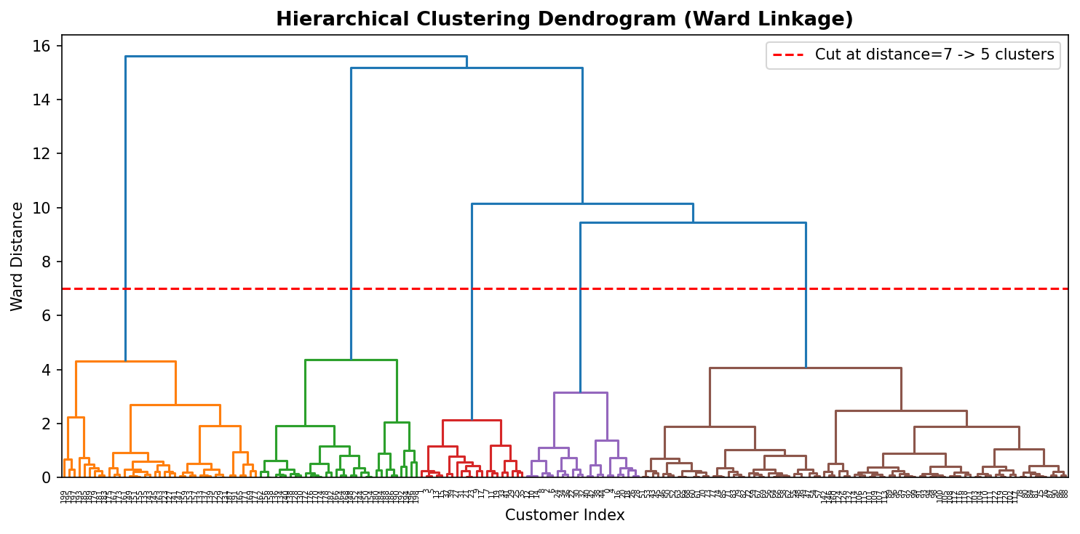
Figure 5. Ward-linkage dendrogram. The dashed red line marks the distance threshold used to cut the tree into 5 clusters, chosen to match the k selected in Section 3.2 for a fair side-by-side comparison.
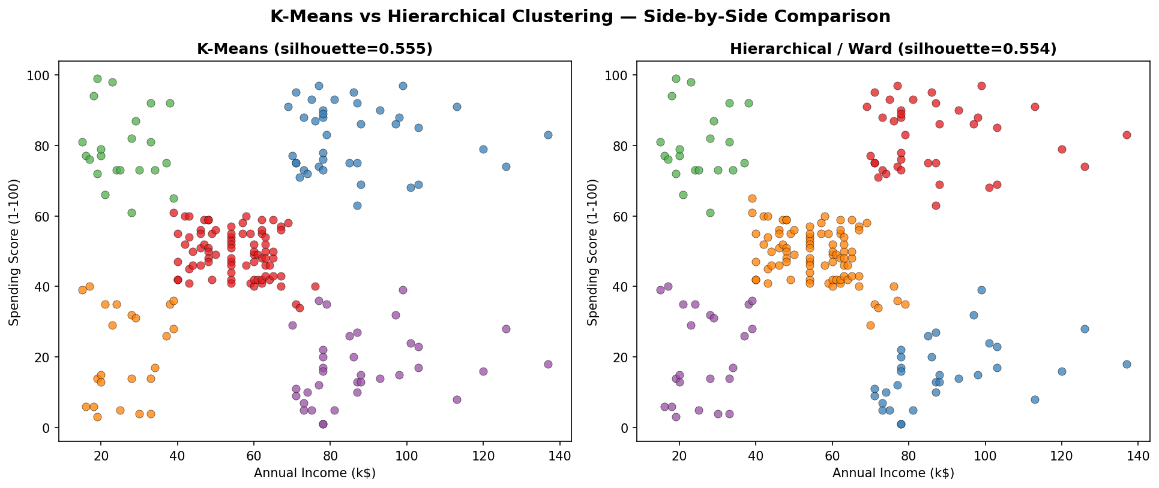
Figure 6. K-Means (left) vs. Hierarchical/Ward (right) at 5 clusters each, with each panel's silhouette score in its title for direct comparison.
The two algorithms produced nearly identical groupings: a silhouette score of 0.554 for hierarchical clustering versus 0.555 for K-Means, and an Adjusted Rand Index of 0.942 between the two sets of labels (a score of 1.0 would mean perfectly identical groupings, 0.0 would mean no better than random agreement). A 0.942 agreement from two structurally different algorithms is strong evidence that these five groups reflect real structure in the data rather than an artifact of K-Means' specific assumptions or initialization.

5. Cluster Visualization Summary
All clustering visualizations produced for this analysis are consolidated here for reference, each with titles, axis labels, and legends as required: the main annotated scatter plot with labeled centroids (Figure 3), the per-sample silhouette plot (Figure 4), the dendrogram (Figure 5), and the side-by-side algorithm comparison (Figure 6), all shown in Section 4 above. Section 6 below adds the cluster-profiling visualizations (bar charts, box plots) used to characterize what each cluster actually represents.

6. Cluster Characteristics and Interpretation
Cluster membership on its own is just a label (0 through 4); the useful work is figuring out what each label actually represents in terms of real customers. The table below summarizes each cluster's profile, computed by grouping the original (non-scaled) data by cluster assignment.
profile = df.groupby('Cluster').agg(
n=('CustomerID','count'), avg_age=('Age','mean'),
avg_income=('AnnualIncome','mean'), avg_spending=('SpendingScore','mean'),
pct_female=('GenderCode', lambda x: x.mean()*100)
).round(1)
Cluster | n | Avg Age | Avg Income | Avg Spending | % Female
0 | 81 | 42.7 | $55.3k | 49.5 | 59.3%
1 | 39 | 32.7 | $86.5k | 82.1 | 53.8%
2 | 22 | 25.3 | $25.7k | 79.4 | 59.1%
3 | 35 | 41.1 | $88.2k | 17.1 | 45.7%
4 | 23 | 45.2 | $26.3k | 20.9 | 60.9%
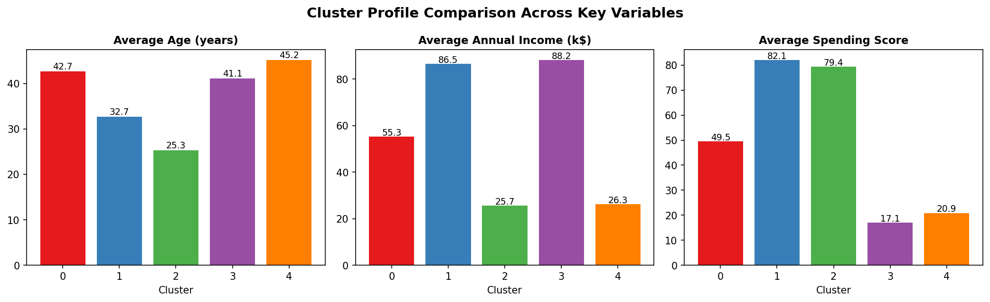
Figure 7. Average age, income, and spending score per cluster, with exact values labeled on each bar.
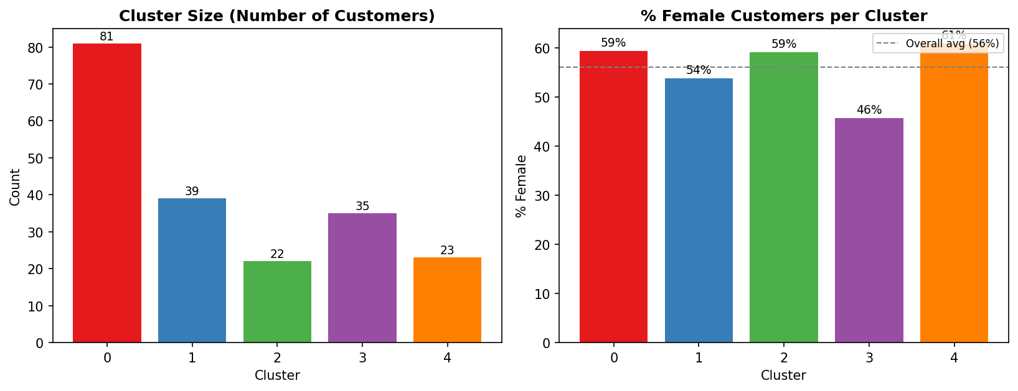
Figure 8. Cluster sizes and gender composition. The dashed line in the right panel marks the dataset's overall average (56% female) for comparison.
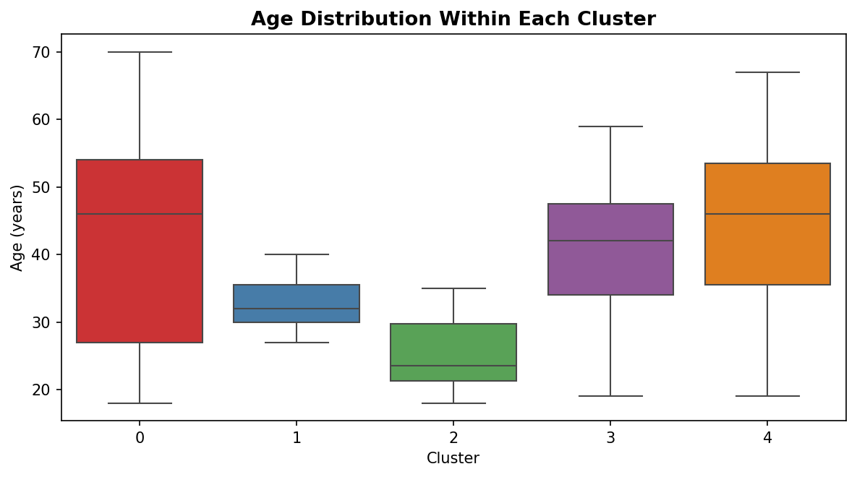
Figure 9. Age distribution within each cluster, showing not just the average but the spread — Cluster 2 (young, low income, high spending) has a notably tighter and younger age range than the others.

Cluster 0 — The Average Majority (n=81, 40.5% of customers)
Average income (~$55k), average spending score (~49.5), middle-aged (42.7 years on average). This is the largest cluster by far — essentially the 'typical' mall customer who doesn't stand out on either income or spending behavior. Gender skews slightly female (59.3%), roughly matching the dataset's overall gender split, which is a sign this group isn't defined by gender, just by being unremarkable on the two clustering dimensions.

Cluster 1 — High Income, High Spending (n=39, 19.5%)
The clear premium segment: high income (~$86.5k) paired with high spending score (~82.1), and the youngest of the two high-income clusters (32.7 years average). This is the group most retailers would consider their most valuable customers — they have the means to spend and are demonstrably doing so.

Cluster 2 — Low Income, High Spending (n=22, 11%)
The most behaviorally distinctive group: low income (~$25.7k) but a high spending score (~79.4), and notably the youngest cluster overall (25.3 years average, with the tightest age range of any cluster per Figure 9). This pattern is consistent with younger customers who spend relatively freely relative to their income rather than being especially price-conscious — think newly independent young adults rather than young families.

Cluster 3 — High Income, Low Spending (n=35, 17.5%)
The inverse of Cluster 2: high income (~$88.2k, the highest average of any cluster) but a low spending score (~17.1, the lowest of any cluster). This group has the most purchasing power of anyone in the dataset but is not converting that into spending at the mall. It is also the only cluster where female representation drops below half (45.7%).

Cluster 4 — Low Income, Low Spending (n=23, 11.5%)
Low income (~$26.3k) and low spending score (~20.9), and the oldest cluster on average (45.2 years). This group is budget-constrained on both ends — limited income and limited discretionary spending to match it.

7. Business and Research Implications
Translating these five clusters into action is really the point of doing the segmentation in the first place — a cluster assignment that doesn't change what a business would do differently isn't a useful cluster.
- Cluster 1 (High Income, High Spending) is the group to retain and reward, not necessarily to grow spending from further — they are already spending in line with their means. A loyalty or VIP program aimed at retention protects the segment that is already most valuable.
- Cluster 3 (High Income, Low Spending) is arguably the single most commercially interesting group precisely because it's the exception to the obvious pattern: they can afford to spend more and currently aren't. This is the natural target for targeted marketing, personalized offers, or investigating why engagement is low (wrong product mix? Different shopping channel preference?) rather than assuming they're simply uninterested.
- Cluster 2 (Low Income, High Spending) represents a group spending beyond what their income alone would predict. From a research standpoint this is worth understanding better (credit usage? gift-driven purchases? still living with family and so less cost-constrained?), and from a business standpoint, this group may respond well to loyalty or installment-style offers that make continued spending easier to sustain.
- Cluster 0 (the average majority) is the segment least suited to a single targeted campaign, precisely because it's defined by not being extreme on either axis. General, broad-appeal marketing is more appropriate here than a narrowly tailored offer.
- Cluster 4 (Low Income, Low Spending) is the least commercially promising segment for spending-growth campaigns, but could be a reasonable target for value-oriented or discount-driven promotions rather than premium offers.
More broadly, this kind of segmentation only becomes genuinely useful when it's refreshed periodically and tied to actual purchase-category data (what customers in each cluster actually buy), not just aggregate spending scores — a direction discussed further as a limitation below.

8. Limitations and Potential Biases
A previous piece of feedback I received specifically asked for more direct discussion of bias and limitations rather than treating the results as settled fact, so this section is deliberately explicit and self-critical rather than a brief closing caveat.
- Small sample size: 200 customers is enough to demonstrate the methodology clearly, but it is a small base for any cluster — the smallest cluster here (Cluster 2, n=22) represents conclusions drawn from only 22 people. A real deployment of this approach would need a much larger customer base before acting on these exact percentages with confidence.
- Feature selection bias: the decision to cluster on only Annual Income and Spending Score (Section 2.1) was a deliberate simplification for interpretability, but it means Age and Gender had zero influence on which cluster a customer was assigned to, even though Section 6 shows clear age differences between clusters. A different, defensible choice (clustering on all four numeric/encoded features, or using PCA first) could produce meaningfully different groupings. This report's result should be read as 'one reasonable segmentation,' not 'the' segmentation.
- Spending Score is itself a derived, undocumented metric: the dataset does not explain exactly how the mall calculated this score, which means this analysis is partly built on a feature whose construction I cannot fully audit or validate.
- K-Means assumes roughly spherical, similarly-sized clusters, which happens to fit this dataset well, but that's a property of this particular data, not a general guarantee. On a different dataset where true segments are irregular or very different in size, K-Means could produce a misleading result even with a high silhouette score, which is part of why Section 4.2's hierarchical cross-check mattered here.
- Demographic representativeness: there's no information in this dataset about where these 200 customers were recruited from or over what time period, so there's no way to assess whether this sample represents the mall's full customer base or a biased subset of it (e.g., only loyalty-card holders, or only a single season).
- Causal overreach risk: the business implications in Section 7 describe patterns and reasonable hypotheses, not proven causes. For example, I can't actually verify from this data why Cluster 3 spends little despite high income — that explanation is an informed guess, and I've tried to flag it as such rather than presenting it as a settled finding.

9. Reflective Commentary
A few things I'd do differently, or found genuinely useful, while working through this:
- Running two different clustering algorithms instead of just one was more valuable than I expected going in — the 0.942 agreement score gave me real confidence in the k=5 result that a single algorithm's output alone wouldn't have. I'd make this a standard step in any future clustering work rather than an optional extra.
- I initially clustered on all four available numeric features (Age, Income, Spending Score, and encoded Gender) before deciding to narrow it down to just Income and Spending Score. The four-feature version produced less visually interpretable clusters and a lower silhouette score, which is actually what led me to the two-feature approach documented here — this report shows the result I settled on, not the first thing I tried, and I think that's worth being honest about.
- If I were extending this further, I'd want to validate these clusters against an actual outcome the mall cares about (repeat visit rate, average transaction value over time) rather than stopping at descriptive profiling — right now this tells a plausible story about who these customers are, but it doesn't yet prove the segmentation predicts anything useful going forward.
- The choice to cut the dendrogram at exactly 5 clusters (matching K-Means) was made specifically to allow a fair side-by-side comparison in Section 4.2. Looking at the dendrogram on its own terms, a 3 or 4 cluster cut would also have been defensible — this is a case where I made a comparison-driven choice rather than treating 5 as the single objectively 'correct' number for hierarchical clustering specifically.

10. Conclusion
This analysis segmented 200 mall customers into five clusters using K-Means (validated independently against hierarchical/Ward clustering, with 94.2% label agreement between the two) based on Annual Income and Spending Score. The number of clusters was chosen using three converging diagnostics — elbow method, silhouette score, and Davies-Bouldin index — rather than a single metric or visual guess. Each resulting cluster was profiled using Age and Gender as descriptive (not clustering) variables, producing five interpretable, business-relevant segments ranging from an underspending high-income group to a free-spending lower-income group, each with distinct implications for how a retailer might approach them differently.
The limitations in Section 8 are not an afterthought to this conclusion — they define the boundaries of how far these specific numbers should be trusted, and any next step built on this analysis should treat the five clusters described here as a solid, validated starting hypothesis rather than a final, settled answer.
All scripts (exploration, preprocessing/k-selection, K-Means clustering, hierarchical clustering, and cluster profiling), the raw and clustered datasets, and all nine figures referenced in this report are included alongside this document.

