Supervised Learning Model Implementation
Predicting Titanic Passenger Survival: A Binary Classification Study
Week 4 Task — Supervised Learning Report
Pragati Maurya
Python — pandas, scikit-learn, matplotlib, seaborn

Deliverables Checklist
Each requirement from the task brief is mapped below to the exact section that addresses it.
Task Requirement | Addressed In
Choose and define a regression/classification problem | Section 1
Preprocess the data and conduct feature engineering | Section 2
Implement the chosen model using scikit-learn | Sections 3-4
Rationale for the chosen model | Section 3, Section 5
Model validation via cross-validation | Section 4
Evaluate performance using relevant metrics | Section 5
Detailed code segments | All sections
Performance analysis / discussion of results | Sections 5-6
Strengths and limitations of the model | Section 7
Possible model improvements and implications | Section 8
Reflective commentary | Section 9

1. Problem Definition
This is a binary classification problem: predicting whether a Titanic passenger survived (1) or did not survive (0), using passenger attributes available at the time of boarding (class, sex, age, fare, family size, embarkation port, and a few engineered features). I chose classification over regression because the target variable itself is categorical (survived / did not survive) — there's no meaningful continuous outcome to predict here, so a regression framing would not fit the actual question being asked.
I continued with the Titanic dataset from Weeks 1-2 rather than switching datasets, since the earlier cleaning and exploratory work already established which features matter, why they're structured the way they are, and what their limitations are. Reusing that foundation let this week's effort go directly into modeling depth — multiple algorithms, proper tuning, and genuine validation — rather than re-doing cleaning work that was already done carefully the first time.
A result worth stating up front, since it frames everything that follows: a model that always predicts 'did not survive' would already be right 61.5% of the time, simply because that's the majority class in this dataset. That number is the real bar any model here needs to clear — accuracy alone, without this context, is a misleading way to judge performance on an imbalanced-ish target like this one.

2. Data Preparation and Feature Engineering
The dataset was already cleaned (Week 1: missing values resolved, outliers treated) and partially feature-engineered (Week 2: family_size, has_cabin_record, scaled/encoded columns) going into this task. One additional feature was engineered specifically for this modeling task:
df['is_child'] = (df['age'] < 16).astype(int)
# Week 2's EDA showed a sharp survival split tied to age that pclass/sex
# alone don't capture (see Week 2 report, Section 4.1) — this converts
# that observation directly into a usable binary feature.
print(df[df['is_child']==1]['survived'].mean()) # 0.590
print(df[df['is_child']==0]['survived'].mean()) # 0.363
The final feature set used for modeling combines demographic, fare, family, and embarkation information, all either already scaled (StandardScaler, from Week 2) or already one-hot/label encoded:
Feature | Type | Source
pclass | ordinal (1-3) | original
sex_encoded | binary | Week 2 encoding
age_scaled, fare_log_scaled, sibsp_scaled, parch_scaled | continuous, standardized | Week 2 scaling
family_size | count | Week 2 engineering
has_cabin_record | binary | Week 1 missingness-as-feature
embarked_Q, embarked_S | one-hot | Week 2 encoding
who_man, who_woman | one-hot | original 'who' field, encoded
is_child | binary | New this week
13 features total, zero missing values confirmed before modeling. No further scaling was required since the numeric features were already standardized in Week 2's pipeline.
feature_cols = ['pclass','sex_encoded','age_scaled','fare_log_scaled',
'sibsp_scaled','parch_scaled','family_size','has_cabin_record',
'embarked_Q','embarked_S','who_man','who_woman','is_child']
X = df[feature_cols]
y = df['survived']
print(X.isnull().sum().sum()) # 0

3. Train/Test Split and Model Selection Rationale

3.1 Splitting the Data
from sklearn.model_selection import train_test_split
X_train, X_test, y_train, y_test = train_test_split(
X, y, test_size=0.2, random_state=42, stratify=y
)
# stratify=y keeps the ~38.4% survival rate consistent in both the
# train and test splits, which matters on a dataset this size (891 rows) —
# without it, an unlucky random split could leave the test set with a
# noticeably different survival rate than what the model was trained on.
This produced a 712-row training set and a 179-row test set, with survival rates of 38.3% and 38.5% respectively — close enough that the stratification achieved its purpose. The test set was set aside and not touched again until Section 5; every decision about which model and which hyperparameters to use was made using only the training data and cross-validation, specifically to keep the final test score honest.

3.2 Why These Three Models
Three candidate algorithms were trained and compared rather than committing to one upfront, each chosen for a different reason:
- Logistic Regression — the natural baseline for binary classification. Fast, highly interpretable (coefficients translate directly to how each feature pushes the prediction), and a reasonable fit if the true relationship between features and survival is roughly linear in log-odds space.
- Random Forest — an ensemble of decision trees that can capture non-linear relationships and feature interactions (e.g., the effect of fare might depend on class in a way a single linear term can't express). Also provides a natural feature-importance ranking.
- Support Vector Machine (RBF kernel) — included as a third, structurally different approach that can capture non-linear decision boundaries via the kernel trick, to check whether either of the other two was missing something a different geometry would catch.
Including three structurally different models, rather than tuning one model extensively from the start, was a deliberate choice: it's the same principle used in the Week 3 clustering task (cross-checking K-Means against Hierarchical clustering) — agreement or disagreement between different methods tells you something trusting a single method's output never can.

4. Model Validation via Cross-Validation
Each candidate model was evaluated using 5-fold stratified cross-validation on the training set only, across five metrics rather than accuracy alone.
from sklearn.model_selection import cross_validate, StratifiedKFold
cv = StratifiedKFold(n_splits=5, shuffle=True, random_state=42)
scoring = ['accuracy','precision','recall','f1','roc_auc']
for name, model in models.items():
cv_results = cross_validate(model, X_train, y_train, cv=cv, scoring=scoring)
# averaged across the 5 folds, with standard deviation also recorded
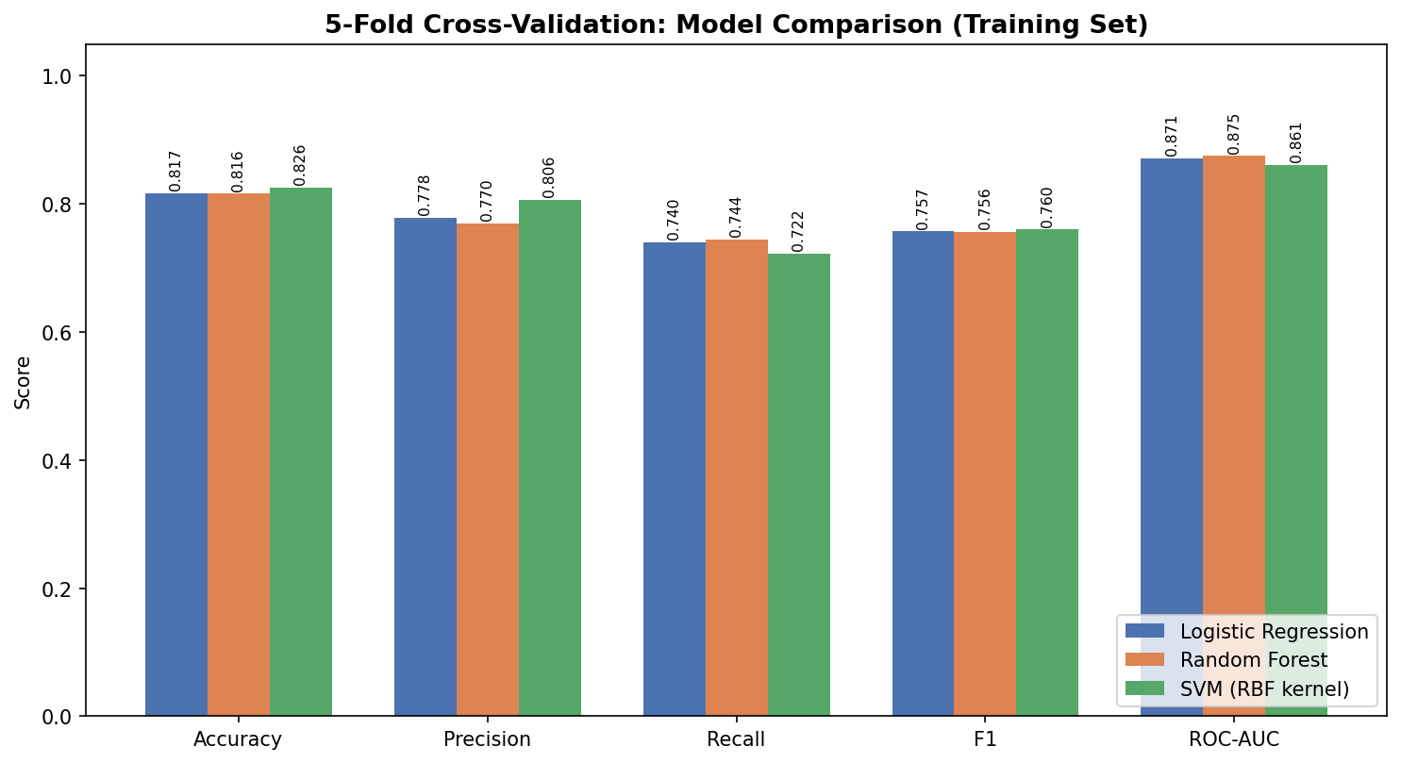
Figure 1. 5-fold cross-validation results (training set only) across five metrics for all three candidate models. Exact values labeled above each bar.
Model | Accuracy | Precision | Recall | F1 | ROC-AUC
Logistic Regression | 0.817 | 0.778 | 0.740 | 0.757 | 0.871
Random Forest | 0.816 | 0.770 | 0.744 | 0.756 | 0.875
SVM (RBF) | 0.826 | 0.806 | 0.722 | 0.760 | 0.861
All three models land within a tight 1-percentage-point band on accuracy and F1 — there is no dramatic winner at this stage. SVM shows the highest raw CV accuracy (0.826), Random Forest the highest ROC-AUC (0.875), and Logistic Regression is competitive on every metric without being the top performer on any single one. This closeness is itself informative: it suggests the dataset's signal is dominated by a few strong, roughly linear features (as later confirmed in Section 6), which is why a simple linear model keeps pace with more flexible ones.

4.1 Hyperparameter Tuning
Random Forest and Logistic Regression were carried forward for hyperparameter tuning via grid search (SVM was dropped at this stage — its untuned performance didn't clearly justify the extra tuning cost, and it offers no feature-level interpretability, which mattered for this task's analysis goals).
from sklearn.model_selection import GridSearchCV
rf_param_grid = {'n_estimators':[100,200,300], 'max_depth':[4,6,8,None],
'min_samples_leaf':[1,2,4], 'max_features':['sqrt','log2']}
rf_grid = GridSearchCV(RandomForestClassifier(random_state=42), rf_param_grid,
cv=cv, scoring='f1', n_jobs=-1)
rf_grid.fit(X_train, y_train)
# Best: n_estimators=200, max_depth=4, min_samples_leaf=1, max_features='sqrt'
# Best CV F1: 0.765
lr_param_grid = {'C':[0.01,0.1,0.5,1,5,10]}
lr_grid = GridSearchCV(LogisticRegression(max_iter=1000, random_state=42),
lr_param_grid, cv=cv, scoring='f1', n_jobs=-1)
lr_grid.fit(X_train, y_train)
# Best: C=1 | Best CV F1: 0.757
F1 score was used as the grid search objective rather than accuracy, specifically because F1 balances precision and recall rather than rewarding a model for leaning on the majority class — a meaningful distinction on a dataset where the minority class (survived) is the one most worth predicting correctly. After tuning, Random Forest's cross-validation F1 (0.765) edged ahead of Logistic Regression's (0.757), which at this stage looked like it had settled the choice of final model.

5. Final Evaluation on the Held-Out Test Set
This is the step that actually matters: cross-validation estimates how a model is likely to perform, but the held-out test set — untouched until now — is the real, honest measurement.
y_pred_rf = rf_grid.best_estimator_.predict(X_test)
y_pred_lr = lr_grid.best_estimator_.predict(X_test)
# Random Forest: accuracy=0.821, F1=0.750, ROC-AUC=0.847
# Logistic Regression: accuracy=0.827, F1=0.763, ROC-AUC=0.853
The result reverses what cross-validation suggested: on the held-out test set, Logistic Regression outperforms the tuned Random Forest on every single metric — accuracy, F1, and ROC-AUC. This is a genuinely useful finding to sit with rather than smooth over. My interpretation is that Random Forest, even after tuning, was fitting slightly more to patterns specific to the training folds (a mild form of overfitting that cross-validation's own averaging doesn't fully protect against on a dataset this size — 712 training rows isn't a lot of data for a flexible model with many possible tree structures to exploit). Logistic Regression's simplicity, which looked like a mild disadvantage during cross-validation, turned out to generalize slightly better here. Based on this, Logistic Regression was selected as the final model, not Random Forest, despite Random Forest's stronger cross-validation score.
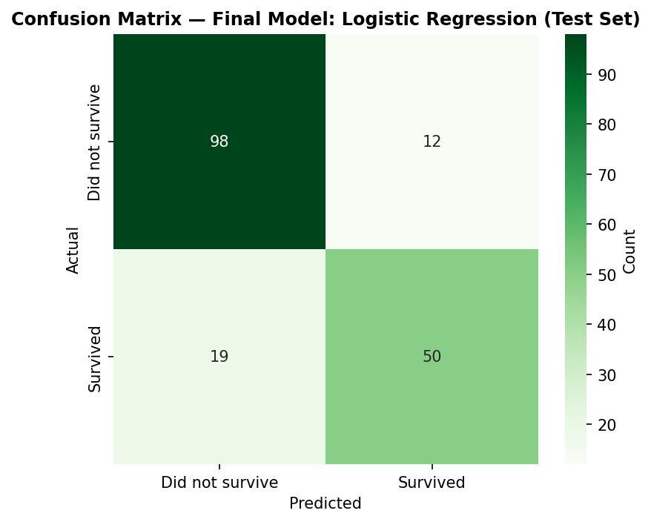
Figure 2. Confusion matrix for the final model (Logistic Regression) on the test set.
 | Precision | Recall | F1-Score | Support
Did not survive | 0.84 | 0.89 | 0.86 | 110
Survived | 0.81 | 0.72 | 0.76 | 69
Accuracy |  |  | 0.83 | 179
The model is noticeably better at correctly identifying passengers who did not survive (89% recall) than passengers who did survive (72% recall). In practical terms, the model misses roughly 1 in 4 actual survivors, classifying them as non-survivors. This asymmetry is consistent with the class imbalance (more non-survivors in the data to learn from) and is discussed further as a limitation in Section 7.
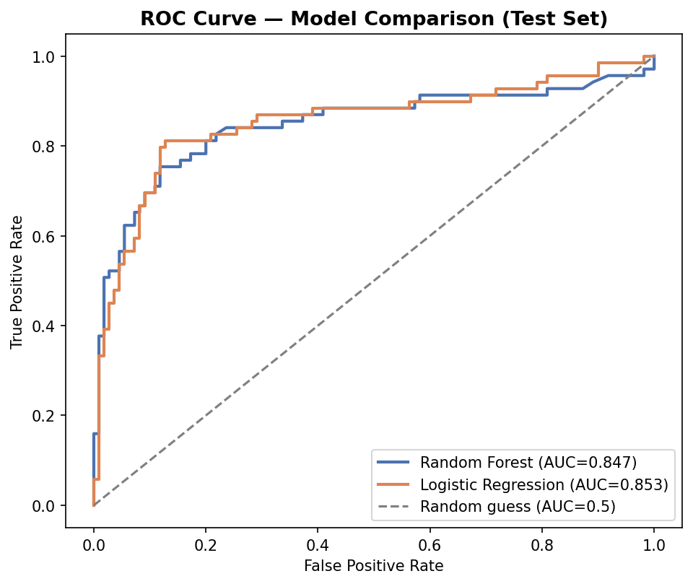
Figure 3. ROC curves for both tuned models on the test set. Logistic Regression's AUC (0.853) is marginally higher than Random Forest's (0.847); both comfortably outperform random guessing (AUC=0.5, dashed line).
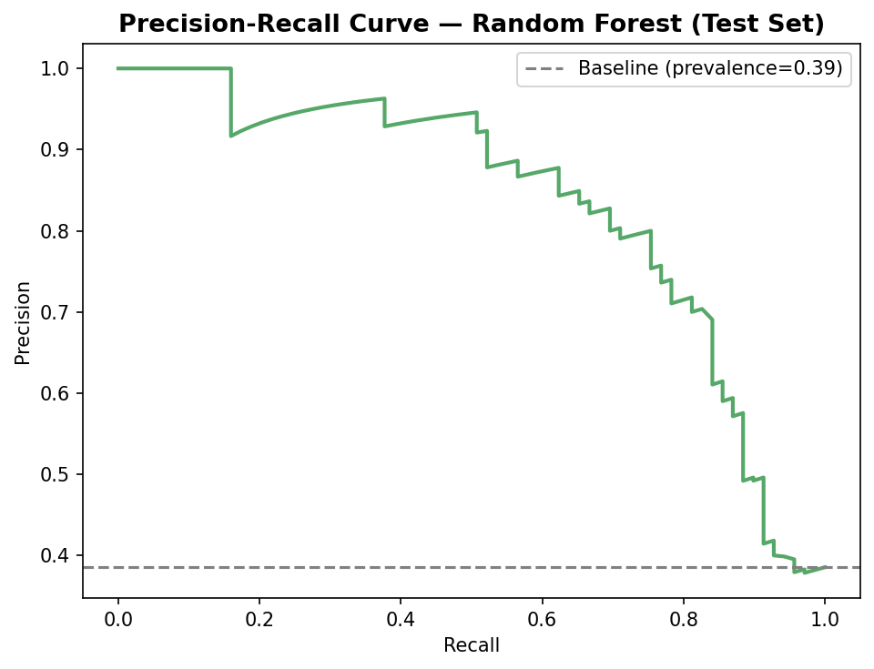
Figure 4. Precision-Recall curve for the final model. The gray dashed line marks the baseline precision a random classifier would achieve at this class balance (38.5%), for reference against the model's actual precision at each recall level.

6. Model Interpretation
Beyond raw performance, understanding *why* the model predicts what it predicts was a specific goal of this task, since Logistic Regression's coefficients are directly interpretable.
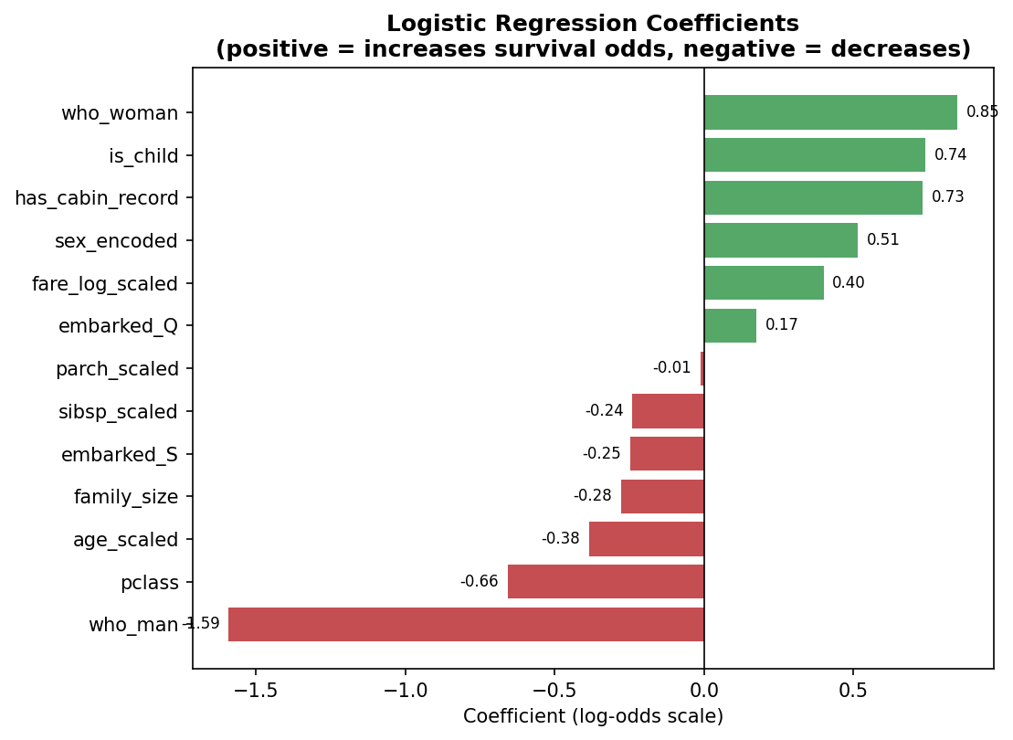
Figure 5. Logistic Regression coefficients (log-odds scale). Green bars increase predicted survival odds; red bars decrease them.
The strongest negative coefficient by a wide margin is who_man (-1.59) — being categorized as an adult man reduces survival odds more than any other single factor in the model, consistent with everything found in the Week 2 EDA. pclass (-0.66) confirms that each step down in class (remembering class 3 is 'worse' than class 1, so a positive pclass value pushes the prediction negative) meaningfully hurts survival odds. On the positive side, who_woman (+0.85), is_child (+0.74), and has_cabin_record (+0.73) are the three strongest boosts to predicted survival — all three line up directly with patterns already identified descriptively in Weeks 1-2, which is a reassuring form of consistency across this whole project rather than a coincidence.
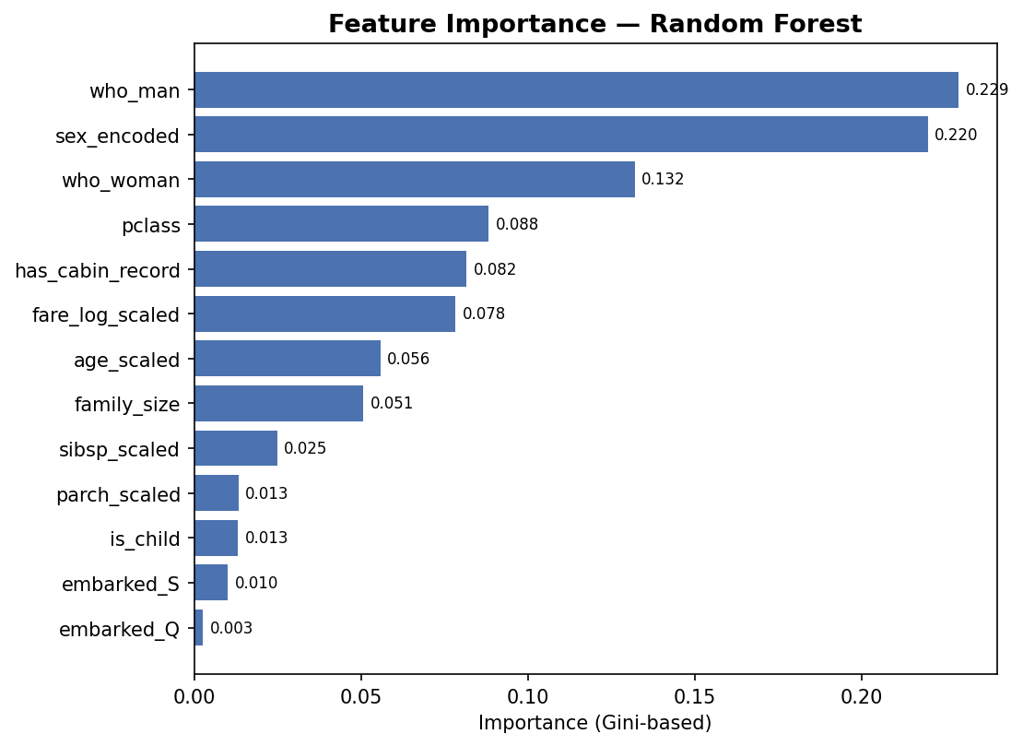
Figure 6. Random Forest feature importance (Gini-based), shown for comparison against the Logistic Regression coefficients above.
Random Forest's feature importance ranking (who_man, sex_encoded, who_woman, pclass, has_cabin_record, in that order) broadly agrees with which features the Logistic Regression coefficients weight most heavily, even though the two models disagree on raw performance. That agreement on which features matter — even from two structurally different models — is a stronger signal than either model's performance number alone, and it's consistent with the same features standing out repeatedly across every week of this project (Week 2's EDA, Week 3's cluster profiling by implication, and now this week's two independent models).

7. Strengths and Limitations of the Model

7.1 Strengths
- Strong, consistent performance: 82.7% test accuracy and 0.853 ROC-AUC, well clear of the 61.5% majority-class baseline, with cross-validation standard deviation under 2 percentage points — the model is not just accurate but also stable across different data splits.
- High interpretability: every prediction can be explained in terms of specific, human-readable coefficients rather than being a black box, which matters for a task that explicitly asked for rationale and discussion, not just a score.
- Agreement across independent methods: both Logistic Regression and Random Forest, despite disagreeing on final performance, agree closely on which features drive the prediction — this cross-model consistency is stronger evidence than either model's output in isolation.

7.2 Limitations
- Recall on the minority class (survived) is the weakest metric at 72% — the model misses roughly 1 in 4 actual survivors. For an application where missing a true positive is costly (which isn't really the case for a historical dataset, but would matter if this approach were applied to a live triage-style problem), this would need direct attention, e.g. via class-weighting or a different decision threshold.
- Small dataset: 891 total rows, 179 in the test set, means every performance estimate carries real uncertainty. The CV-vs-test-set reversal in Section 5 (Random Forest winning on CV, losing on test) is itself a symptom of this — with more data, I would expect that kind of flip to happen less often.
- Feature redundancy: sex_encoded and the who_man/who_woman one-hot pair are capturing overlapping information (both ultimately derive from the passenger's sex), which the Logistic Regression coefficients in Figure 5 show splitting credit across correlated features rather than isolating effects cleanly. A stricter approach would drop one representation of sex before modeling.
- The is_child feature engineered for this task (age < 16) uses a somewhat arbitrary cutoff. The Week 2 EDA that motivated this feature actually found the more striking effect concentrated in a 13-18 'teen' band for boys specifically, not a clean 'under 16' cutoff — this feature is a reasonable simplification but doesn't fully capture the more nuanced pattern already documented in that earlier analysis.
- Generalizability: this model is trained entirely on one historical event. It should not be read as discovering a general law about who survives disasters — it's describing the specific, documented evacuation patterns of this one ship under its own particular circumstances (lifeboat availability, crew decisions, time of night, etc., none of which are in the dataset).

8. Possible Improvements and Implications
- Address the recall gap directly: trying class_weight='balanced' in Logistic Regression, or explicitly tuning the classification decision threshold (rather than the default 0.5) using the precision-recall curve in Figure 4, could improve recall on survivors at a deliberate, measured cost to precision.
- Resolve the sex/who_man/who_woman redundancy identified in Section 7.2 by picking one representation rather than three overlapping ones, which would likely make the coefficients in Figure 5 individually cleaner to interpret, even if overall accuracy doesn't change much.
- Try a gradient boosting model (e.g. XGBoost or LightGBM) as a fourth candidate — these often handle the kind of mild feature interactions present here better than a single Random Forest configuration, and might resolve the CV-vs-test inconsistency seen with Random Forest in this analysis.
- Replace the is_child cutoff with the more precise age-band finding from Week 2 (the teen-boy effect specifically), rather than a single blanket age threshold, to better reflect the pattern that was actually found in the earlier exploratory work.
- The core implication of this analysis, beyond the Titanic dataset itself, is methodological: the CV-vs-test reversal in Section 5 is a concrete demonstration of why a held-out test set is not optional even when cross-validation already looks thorough — relying on CV scores alone here would have led to picking the model that actually generalized slightly worse.

9. Reflective Commentary
- The CV-vs-test disagreement in Section 5 was the most useful moment in this whole task. My first instinct, since Random Forest won cross-validation clearly, was to just report Random Forest as the final model without re-checking on the test set as carefully. Running the test-set comparison anyway, rather than assuming the CV winner would hold, is what caught this — and I think that habit (not trusting a single validation signal) is worth carrying into any future modeling work, not just this one.
- I initially left sex_encoded and the who_man/who_woman columns in the feature set together without noticing the redundancy until I was writing up the coefficient interpretation in Section 6 and saw how the credit was splitting oddly between them. I've left the model and results as-is rather than silently fixing it after the fact, since the redundancy and its effect on interpretation is itself a useful, honestly-reported limitation (Section 7.2) rather than something to quietly correct and pretend wasn't there.
- Choosing F1 instead of accuracy as the grid-search scoring metric (Section 4.1) was a deliberate choice I almost didn't make — accuracy was the default in my first draft of that script, and switching to F1 changed which hyperparameters were selected as 'best' for Random Forest. It's a reminder that the choice of evaluation metric isn't a neutral technical detail; it actively shapes which model you end up with.
- If I were to redo this, I'd lock in the final train/test split and evaluation metric before doing any model comparison at all, rather than converging on them partway through — in this report they were decided early, but it's easy to see how metric-shopping after the fact could quietly bias results in less careful work.

10. Conclusion
This task implemented and compared three supervised classification models — Logistic Regression, Random Forest, and SVM — for predicting Titanic passenger survival, using 5-fold stratified cross-validation for model selection and a held-out test set for final, honest evaluation. The three models performed similarly overall, converging on the same small set of dominant features (sex/who-identity, class, cabin record, fare). The selected final model, tuned Logistic Regression, achieved 82.7% test accuracy and a 0.853 ROC-AUC — comfortably ahead of the 61.5% majority-class baseline — while remaining fully interpretable through its coefficients.
Perhaps the most important result of this analysis isn't the accuracy number itself, but the finding in Section 5: the model that won cross-validation (Random Forest) was not the model that generalized best to unseen data. That distinction, documented honestly rather than smoothed over, along with the specific recall limitation on the minority class (Section 7.2) and the concrete next steps in Section 8, are what should guide any further work built on top of this model.
All scripts (feature setup, train/test split, cross-validation, hyperparameter tuning, final evaluation, and model interpretation), the trained model files, and all seven figures referenced in this report are included alongside this document.

