WEEK 5 PROJECT REPORT
Deep Learning Application in Data Science
Handwritten Digit Classification using a Convolutional Neural Network

Submitted by
Pragati Maurya
Technology: Python + PyTorch
Dataset: scikit-learn Digits Dataset
Task: Multi-class Image Classification

1. Executive Summary
This project applies deep learning to a multi-class image classification problem. A Convolutional Neural Network (CNN) was designed and trained to classify small grayscale images of handwritten digits into ten classes, from 0 through 9. The workflow covers data loading, preprocessing, normalization, dataset splitting, architecture design, model training, validation, test evaluation, visualization, and critical analysis.
The final model achieved a test accuracy of 97.22% on the held-out test set. The model uses two convolutional blocks followed by fully connected layers and dropout. The design was intentionally kept compact so that the complete experiment can be reproduced on a normal CPU without requiring a dedicated GPU.

2. Problem Statement
Handwritten digit recognition is a standard image-classification problem in which each input image belongs to one of ten classes. The objective is to learn a function that maps the pixel patterns in an input image to the correct digit label. A CNN is appropriate because it can learn local spatial patterns such as edges and curves before combining them into higher-level features.

3. Dataset Description
The project uses the Digits dataset available through scikit-learn. It contains 1,797 labeled 8 × 8 grayscale images representing the digits 0 to 9. Each image is represented by pixel values from 0 to 16 before normalization. Because the dataset is compact, it is suitable for demonstrating deep-learning concepts without requiring a large computational setup.
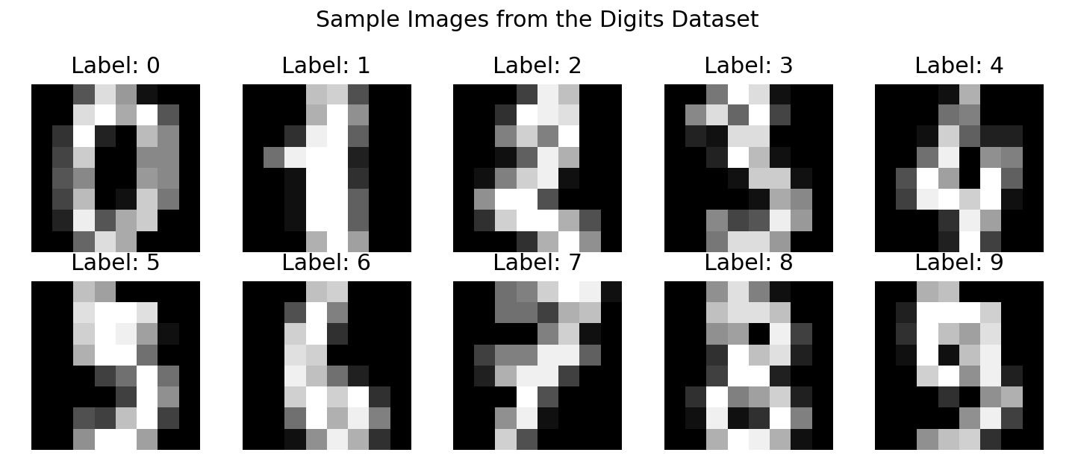
Figure 1. Sample images from the dataset.

4. Data Preparation
- The images were converted to floating-point values and scaled from 0–16 to 0–1.
- The data was divided into training, validation, and test sets using stratified splitting.
- Normalization parameters were calculated from the training set and applied to validation and test data.
- A channel dimension was added so each image could be passed to PyTorch Conv2D layers.
- Mini-batches of 64 samples were used during training.

5. CNN Architecture
The architecture was designed to progressively extract visual features while reducing spatial dimensions. The first convolutional layer learns basic local patterns. The second convolutional layer operates on richer feature maps. Max-pooling reduces the spatial representation, and the dense layers convert the learned representation into ten class scores.
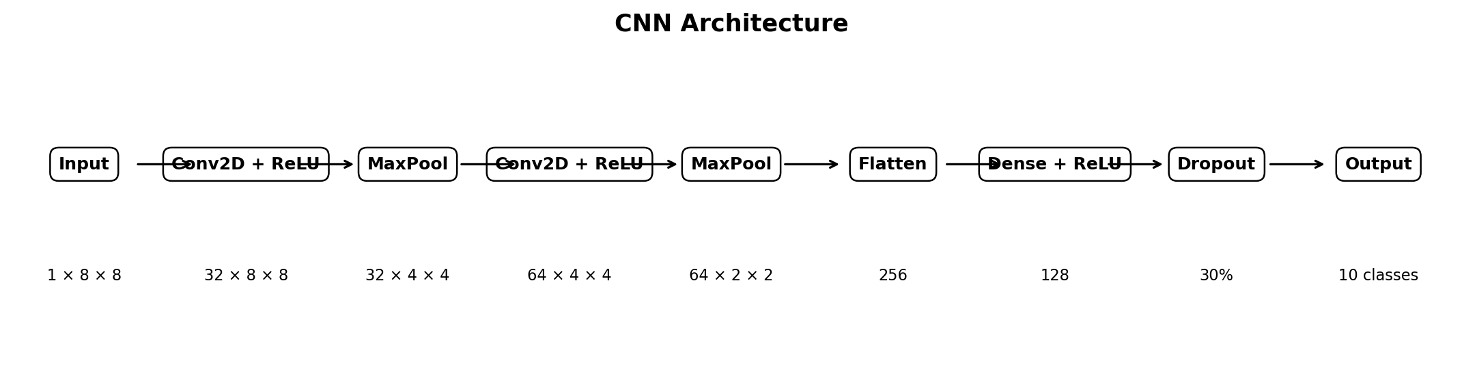
Figure 2. Network architecture used in the experiment.
Layer | Output | Purpose | Key setting
Input | 1×8×8 | Input image | Grayscale
Conv2D + ReLU | 32×8×8 | Low-level features | 3×3, padding 1
MaxPool | 32×4×4 | Downsampling | 2×2
Conv2D + ReLU | 64×4×4 | Higher-level features | 3×3, padding 1
MaxPool | 64×2×2 | Downsampling | 2×2
Flatten | 256 | Vector representation | —
Dense + ReLU | 128 | Feature combination | Fully connected
Dropout | 128 | Regularization | 0.30
Output | 10 | Digit classification | 10 classes

6. Training Configuration
Parameter | Value
Framework | PyTorch
Optimizer | Adam
Learning rate | 0.001
Loss function | CrossEntropyLoss
Batch size | 64
Epochs | 15
Weight decay | 0.0001
Dropout | 0.30
Random seed | 42
Adam was selected because it generally provides stable optimization for small and medium-sized neural-network experiments. Cross-entropy loss is appropriate for multi-class classification. A modest dropout rate and weight decay were included to reduce overfitting.

7. Training Process
During each epoch, the model processed training batches, calculated class probabilities through the network, computed cross-entropy loss, backpropagated the gradients, and updated the weights with Adam. Validation data was evaluated without gradient updates after each epoch. The best validation checkpoint was retained for final testing.
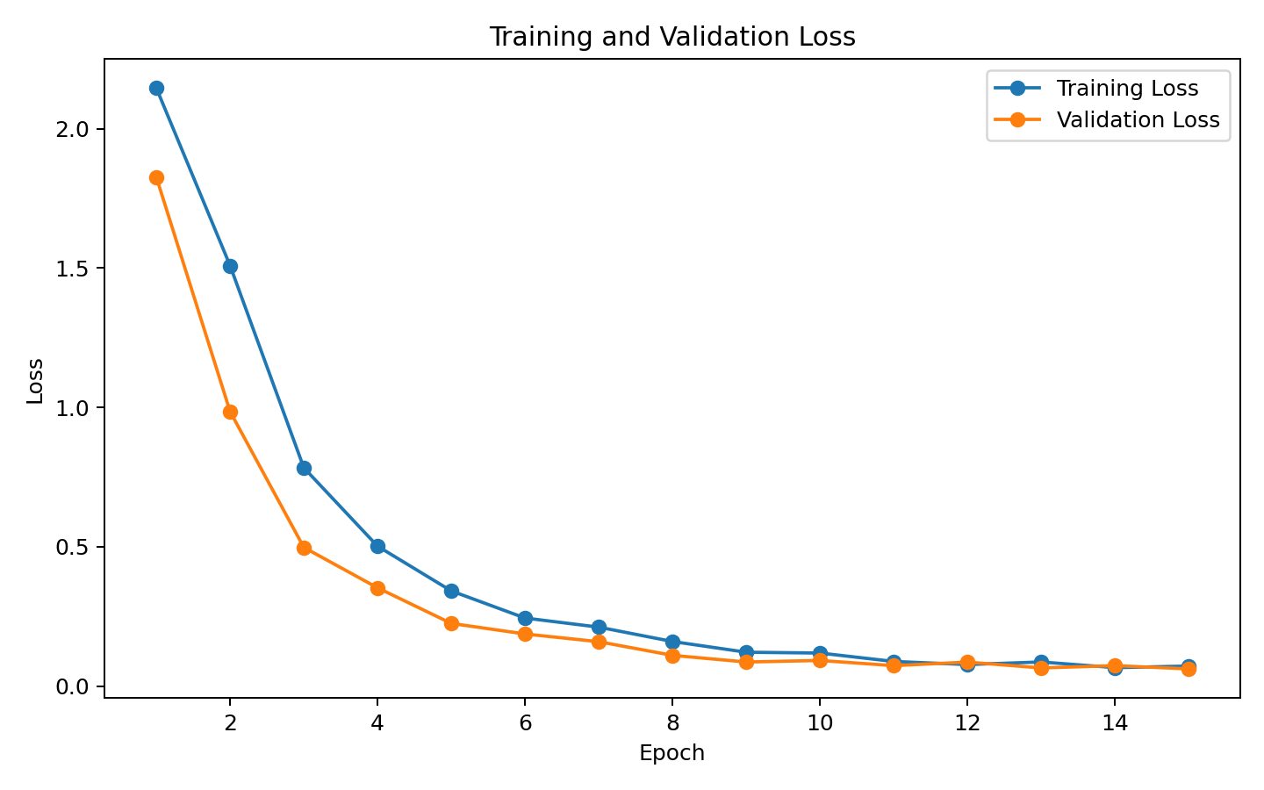
Figure 3. Training and validation loss.
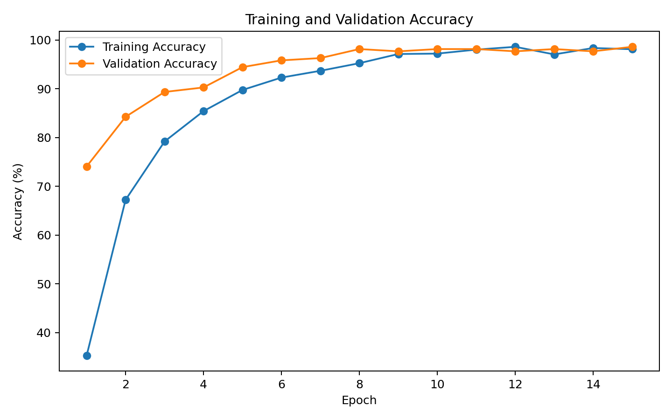
Figure 4. Training and validation accuracy.

8. Evaluation and Results
The final model achieved 97.22% test accuracy with a test loss of 0.0762. The best validation accuracy observed during training was 98.61%. Accuracy gives an overall measure of correct predictions, while the confusion matrix provides class-by-class insight into where mistakes occur.
Digit | Precision | Recall | F1-score
0 | 1.000 | 0.972 | 0.986
1 | 0.921 | 0.972 | 0.946
2 | 1.000 | 1.000 | 1.000
3 | 1.000 | 0.973 | 0.986
4 | 0.946 | 0.972 | 0.959
5 | 0.949 | 1.000 | 0.974
6 | 0.973 | 1.000 | 0.986
7 | 0.947 | 1.000 | 0.973
8 | 1.000 | 0.886 | 0.939
9 | 1.000 | 0.944 | 0.971
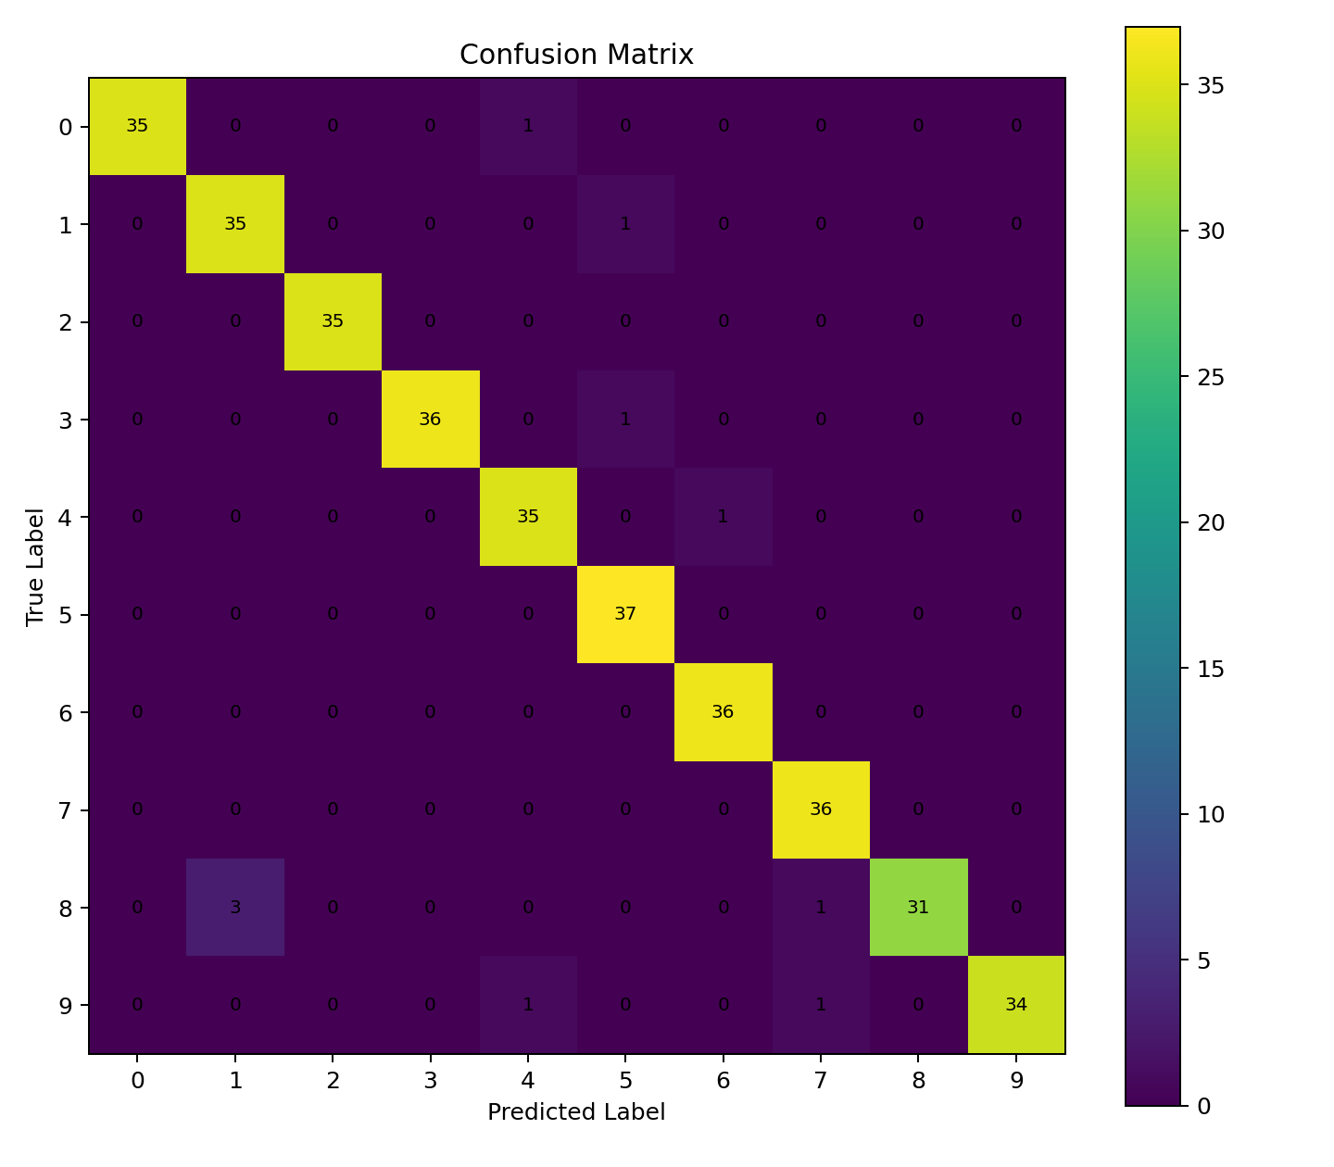
Figure 5. Confusion matrix for the held-out test set.
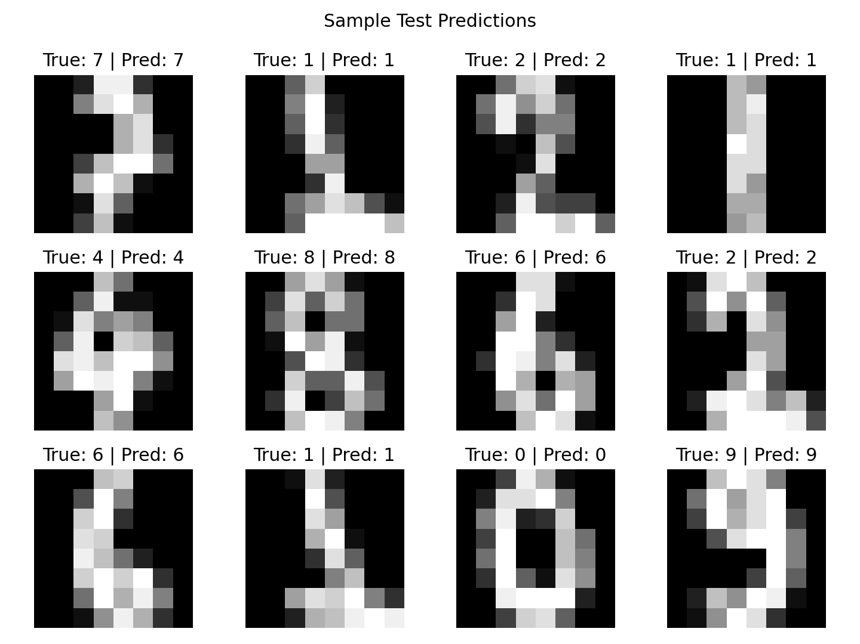
Figure 6. Example test predictions.

9. Critical Analysis
The results show that even a relatively small CNN can learn useful visual representations from low-resolution digit images. The convolutional layers reduce the need for manual feature engineering because the network learns filters directly from training examples. The validation curve is useful for checking whether improvements on the training set also translate to unseen data.
The main limitation is dataset scale and image resolution. The 8×8 images contain far less visual detail than real-world image data, so strong performance here should not be interpreted as evidence that the same architecture would perform equally well on complex photographs. Some digit classes are visually similar, which can lead to occasional confusion even when the overall accuracy is high.

10. Challenges and Solutions
Challenge | Response
Overfitting | Used validation monitoring, dropout, and weight decay.
Small image size | Used convolutional filters to learn local patterns efficiently.
CPU resource limits | Kept the network compact and used mini-batch training.
Class-level errors | Used a confusion matrix and precision/recall/F1 metrics.
Reproducibility | Fixed random seeds and documented the training configuration.

11. Design Justification
- Two convolutional layers provide enough depth to learn progressively richer image features without making the model unnecessarily large.
- Max-pooling reduces spatial dimensions and computation while retaining strong local activations.
- ReLU provides a simple non-linear activation and helps the network learn non-linear decision boundaries.
- Dropout is used before the final classifier to reduce reliance on individual neurons.
- Adam with a learning rate of 0.001 provides a practical starting point for this compact CNN.
- CrossEntropyLoss directly matches the ten-class classification objective.

12. Conclusion
This project demonstrates an end-to-end deep learning workflow for image classification. The CNN successfully learned to distinguish handwritten digits using automatically learned features rather than manually engineered image descriptors. The experiment provided practical experience with data normalization, convolutional architectures, optimization, validation, evaluation metrics, confusion-matrix analysis, and model persistence. Future improvements could include data augmentation, batch normalization, learning-rate scheduling, a deeper network, or transfer learning on a larger and more realistic image dataset.

13. Reproducibility and Project Files
The accompanying project folder contains the complete training script, dependency list, saved model, generated figures, README, and this report. Running the training script recreates the core experiment using the built-in scikit-learn dataset.

14. References
1. Scikit-learn documentation: Digits dataset and machine-learning utilities.
2. PyTorch documentation: tensors, neural-network modules, optimization, and data loaders.
3. General deep-learning concepts: convolution, pooling, dropout, cross-entropy loss, and supervised classification.

