FACEE — Deep Learning Approaches for Face & Gait Recognition

MCA Major Project — Project Diagrams

Afsana Chettri (202422018) | Guide: Mr. Simanta Kalita | Co-Guide: Mr. Sachin Manger
Dept. of Computer Application, SMIT, Majhitar, East Sikkim

Fig 1 — Project Team Structure
The following diagram shows the team hierarchy for the FACEE project, including the student, internal guide, and external guide.
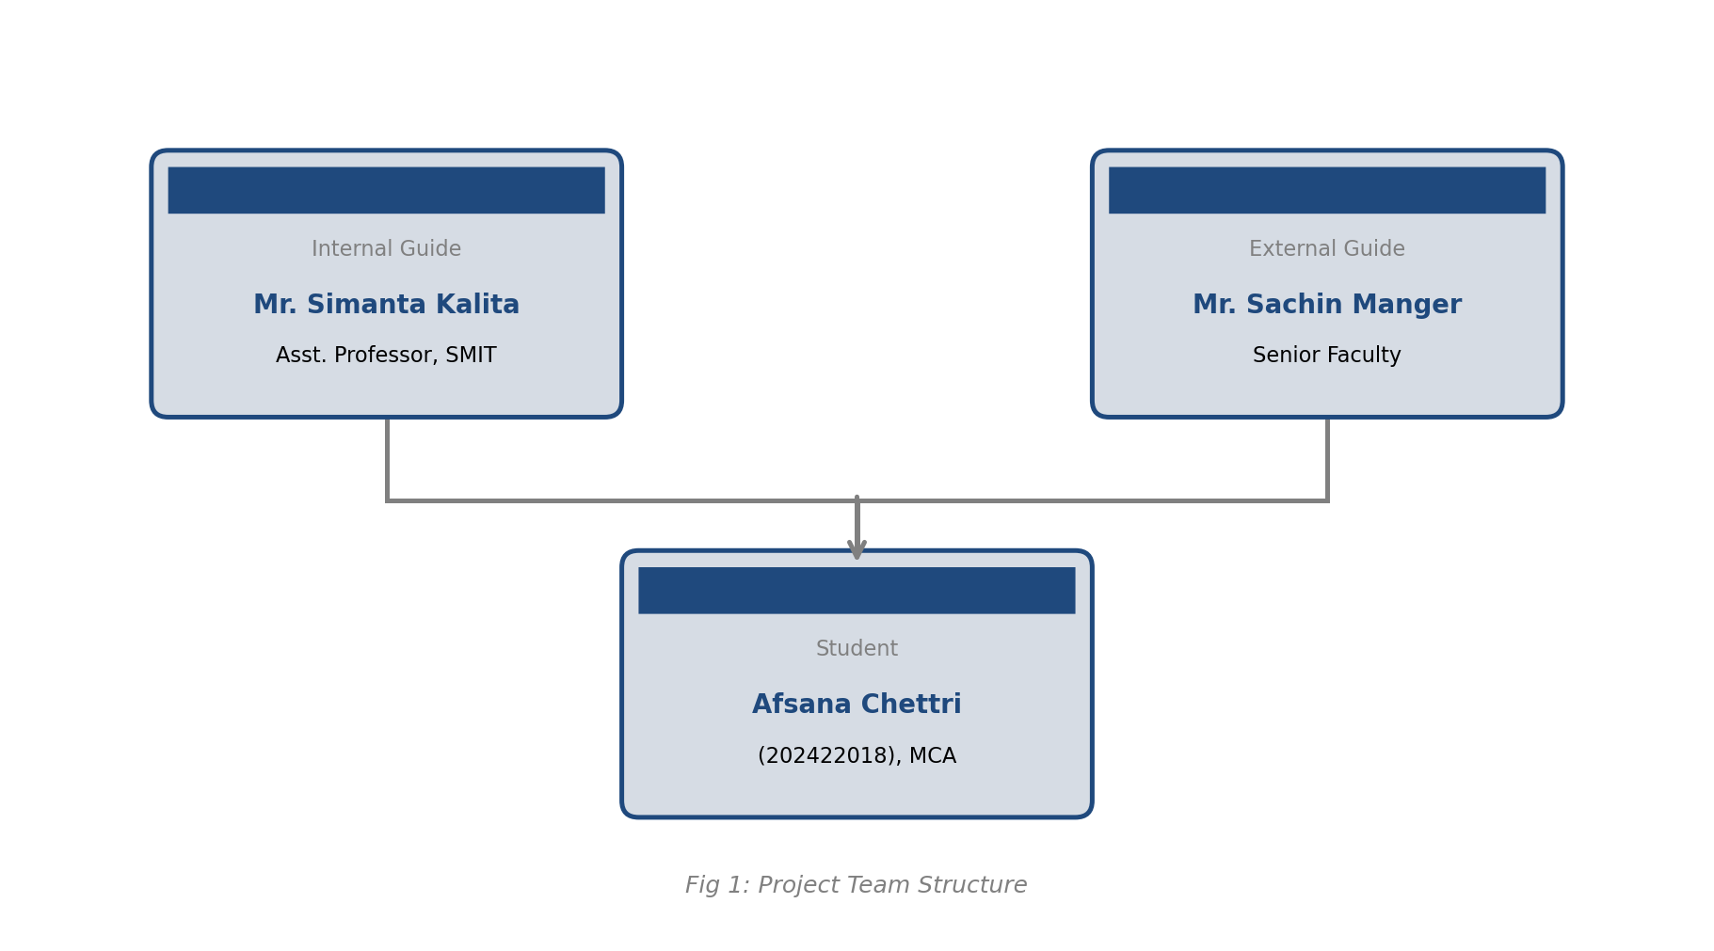
Fig 1: Project Team Structure — Afsana Chettri, Mr. Simanta Kalita, Mr. Sachin Manger

Fig 2 — Project Gantt Chart
The Gantt chart shows the planned schedule (red rows) and actual progress (green rows) for each project phase across the timeline from January to July.
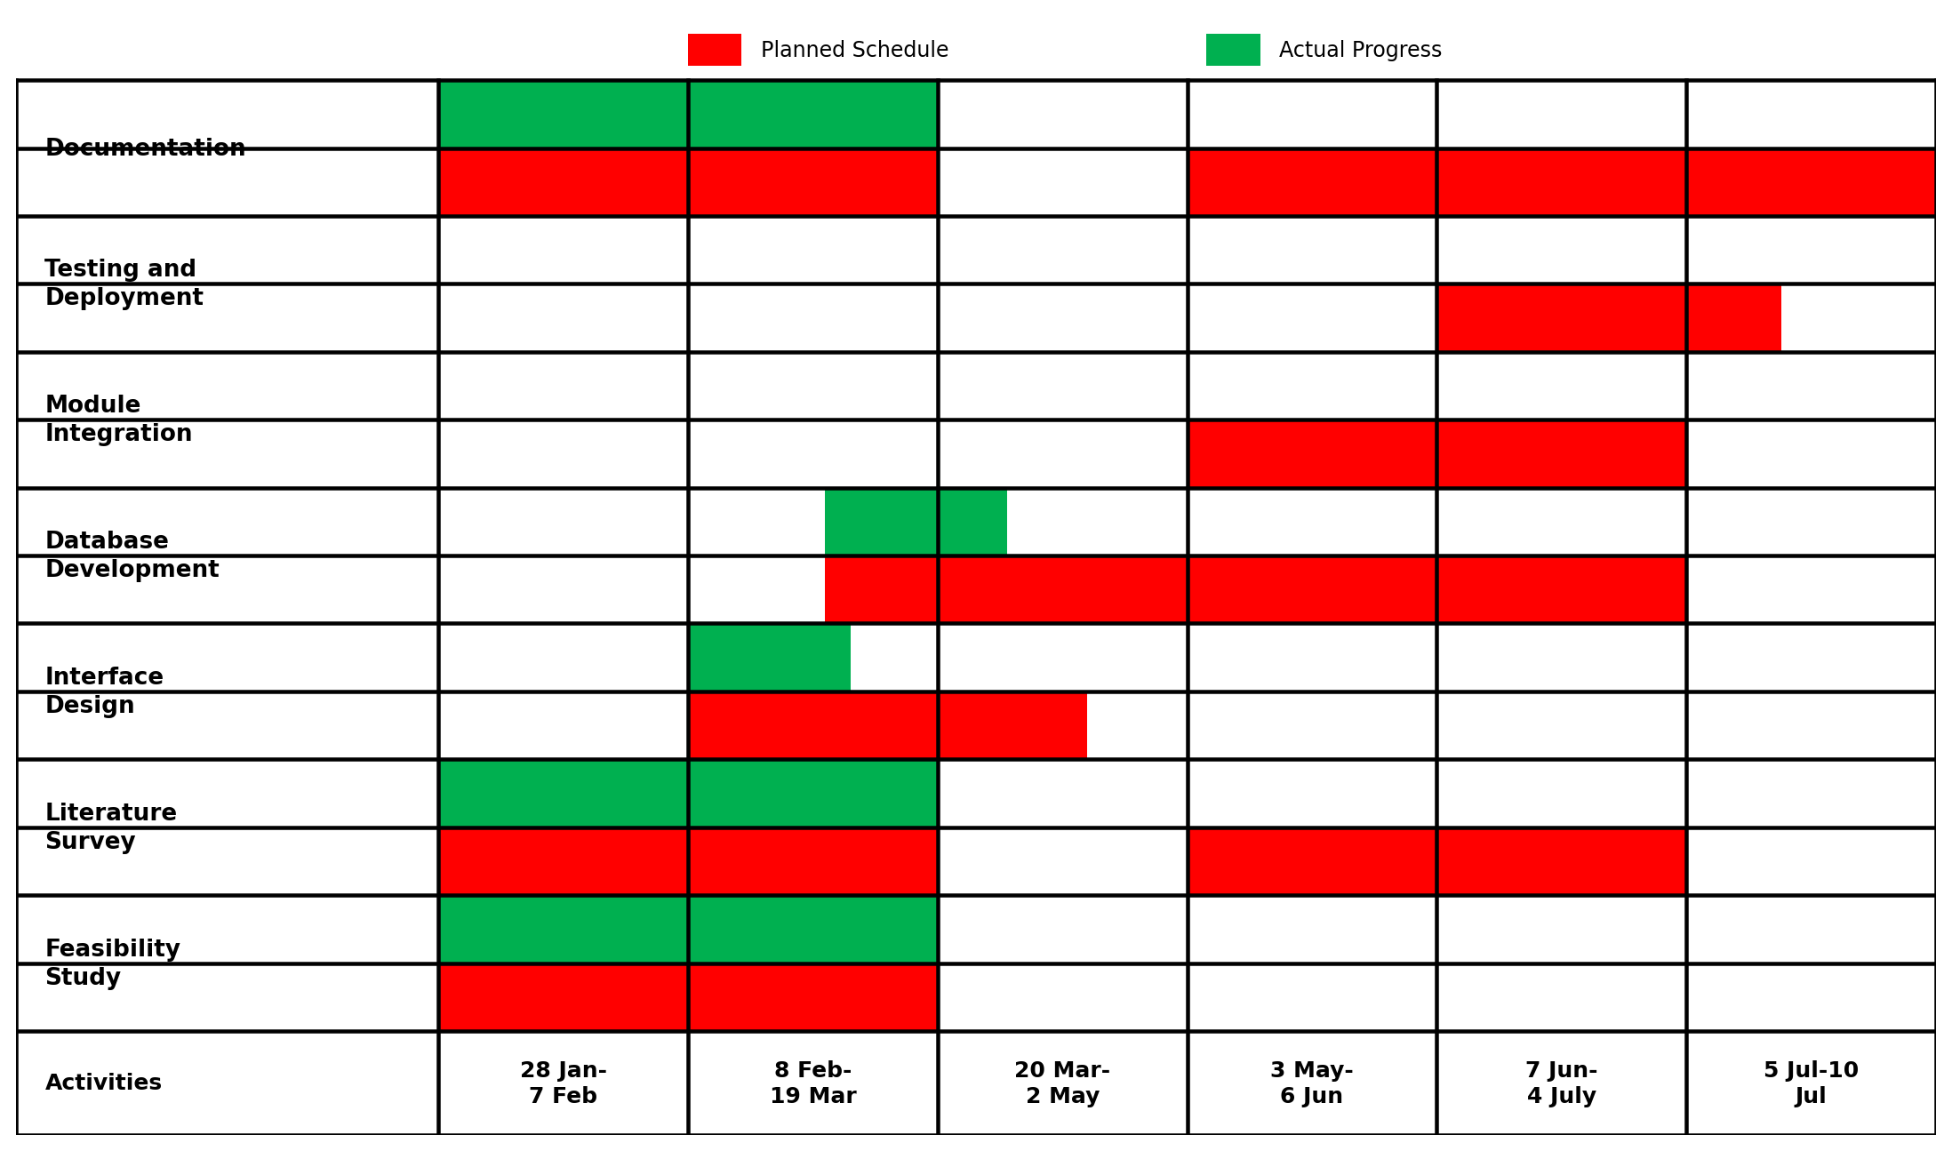
Fig 2: Project Gantt Chart — Red = Planned Schedule, Green = Actual Progress

Fig 3 — System Architecture Diagram
The architecture diagram illustrates the end-to-end data flow of the FACEE system — from camera input through preprocessing, CNN-based face detection (YuNet), face recognition (SFace), gait detection (MOG2), and final output logging.
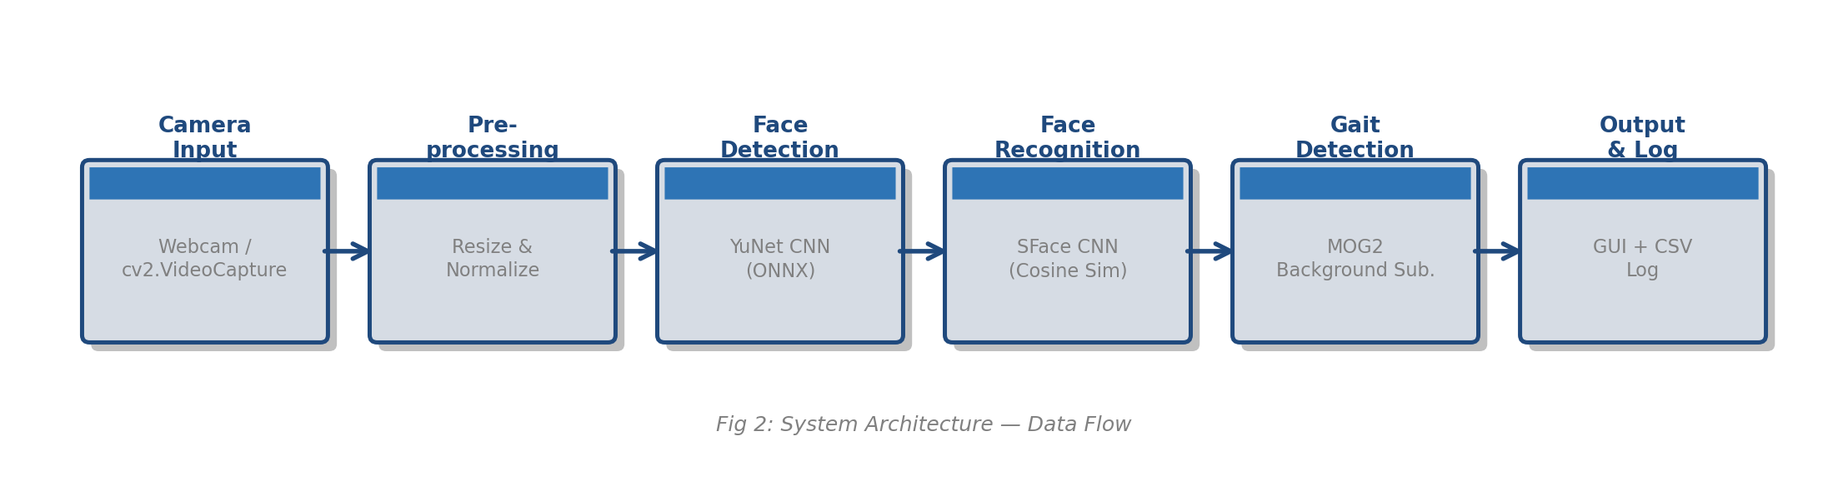
Fig 3: System Architecture — Data Flow from Camera to Output

Fig 4 — Data Processing Workflow
The data processing workflow diagram shows the six-stage pipeline used to process input frames: data collection, preprocessing, CNN feature extraction, 128-dimensional embedding representation, cosine similarity classification, and final identity + gait output.
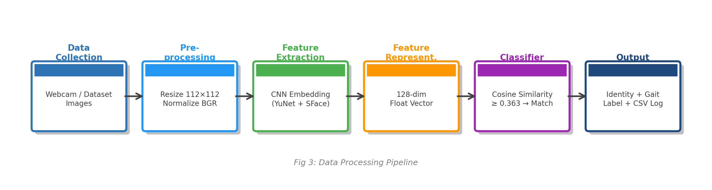
Fig 4: Data Processing Pipeline — From Raw Input to Identified Output

