PYTHON ASSIGNMENT 2 REPORT
CO2: Control Flow, String Operations, Functions and Recursion

Student Name : Alan Jerry F
Register Number : 1913260096
Slot : C
Course Code : CSA0821
Department : B. Tech (EEE)
GitHub Repository Link
https://github.com/<your-username>/CSA08-1913260096-Assignment2 (replace with your repository link before submission)
Test environment
Python 3.12.3 on a single-core Linux machine. All programs use only the Python standard library. Times vary from one computer to another; the counts of operations and function calls are exact and machine independent.
Contents and repository layout
Question | Topic | Folder / main file | Marks
Q1 | Decisions with many boundaries | Q1/q1_subsidy.py | 6
Q2 | Loops that count attempts | Q2/q2_otp.py | 4
Q3 | Vehicle registration validator | Q3/q3_vehicle.py | 6
Q4 | Building long text: + or join() | Q4/q4_build.py, q4_benchmark.py | 6
Q5 | Functions, parameters and scope | Q5/q5_canteen.py | 7
Q6 | Recursion and its limits | Q6/q6_steps.py | 8
Q7 | Day-4 design challenge | Q7/q7_redesign.py, q7_raw_counts.csv | 13

Q1: Decisions with Many Boundaries (6 Marks, K4 Analyse)

1.1 Aim
To implement the State Electricity Subsidy rule twice, once with separate if statements and once with if-elif-else, to predict the decision for eight households (including the boundaries 100, 101, 200 and 201 units), and to compare the results.

1.2 Rule and assumptions
- Units up to 100: FULL subsidy.
- 101 to 200 units: PARTIAL subsidy only if the household holds a ration card, otherwise NONE.
- Above 200 units: NONE, unless a member is above 80 years; the question does not name that subsidy, so it is called SENIOR here.
- Units are whole numbers. A household of 100 units or less receives FULL whether or not it has a ration card.

1.3 Predictions made before running any code
# | Units | Ration card | Member > 80 | Predicted (correct rule) | Predicted (separate ifs)
1 | 50 | Yes | No | FULL | FULL + PARTIAL (two)
2 | 100 | No | No | FULL | FULL
3 | 100 | Yes | No | FULL | FULL + PARTIAL (two)
4 | 101 | Yes | No | PARTIAL | PARTIAL
5 | 101 | No | No | NONE | NONE
6 | 200 | Yes | No | PARTIAL | PARTIAL
7 | 201 | Yes | No | NONE | NONE
8 | 201 | No | Yes | SENIOR | SENIOR

1.4 Why separate if statements can give more than one result
Every if in a series is an independent test: Python evaluates each condition whether or not an earlier one was true. When the conditions overlap, several bodies run. In the buggy code, units <= 200 and ration_card is also true for a household with 50 units, so it receives FULL and PARTIAL. An if-elif-else chain is one decision: as soon as one condition is true its body runs and all remaining branches are skipped, so exactly one outcome (the final else if nothing matched) is produced.

1.5 Implementation
Program: q1_subsidy.py (decision functions)
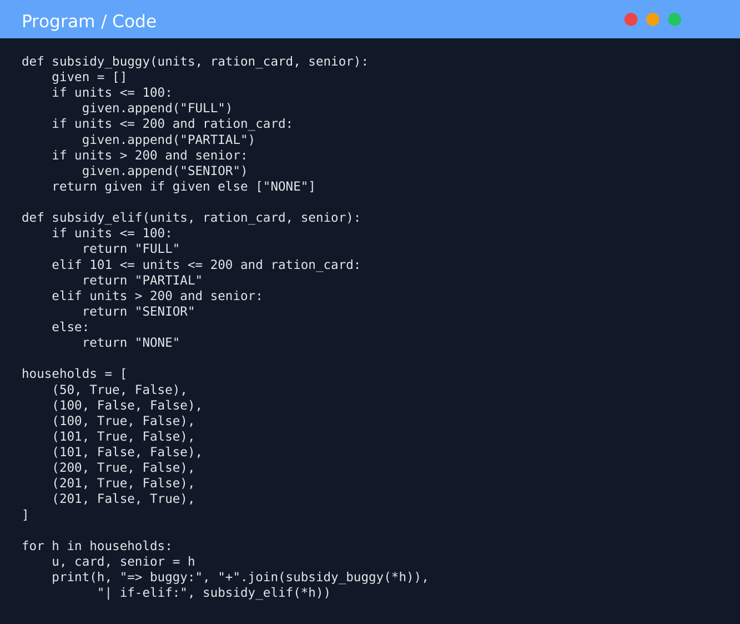

1.6 Output
Output
units card senior | predicted | buggy (separate ifs) | if-elif | nested | match | lookup
----------------------------------------------------------------------------------------------------
50 True False | FULL | FULL+PARTIAL | FULL | FULL | FULL | FULL OK
100 False False | FULL | FULL | FULL | FULL | FULL | FULL OK
100 True False | FULL | FULL+PARTIAL | FULL | FULL | FULL | FULL OK
101 True False | PARTIAL | PARTIAL | PARTIAL | PARTIAL | PARTIAL| PARTIAL OK
101 False False | NONE | NONE | NONE | NONE | NONE | NONE OK
200 True False | PARTIAL | PARTIAL | PARTIAL | PARTIAL | PARTIAL| PARTIAL OK
201 True False | NONE | NONE | NONE | NONE | NONE | NONE OK
201 False True | SENIOR | SENIOR | SENIOR | SENIOR | SENIOR | SENIOR OK

All predictions matched by if-elif / nested / match / lookup: True
Households that received TWO subsidies from the buggy code: 2
Exhaustive check: 1604 input combinations, all four correct versions agree.

Time per decision (worst case = last slab), microseconds, best of 5 x 20000 calls
k if-elif lookup loop bisect table size (bytes)
3 0.057 0.118 0.073 120
10 0.096 0.195 0.080 184
100 1.014 1.561 0.101 920
1000 9.141 15.043 0.159 8856

1.7 Observations at every boundary
- Boundary 100 to 101: FULL changes to PARTIAL for a card holder and to NONE for a household without a card.
- Boundary 200 to 201: a card holder drops from PARTIAL to NONE; only a household with a member above 80 keeps a subsidy (SENIOR).
- All eight predictions matched the if-elif-else, nested, match-case and lookup versions. The buggy version gave two subsidies to 2 of the 8 households (rows 1 and 3): every ration-card household at or below 100 units.
- An exhaustive test of 1,604 combinations (units 0 to 400, ration card yes/no, senior yes/no) showed all four correct versions always agree.

1.8 Design decision: nested if or combined Boolean conditions?
I chose a flat if-elif-else with combined Boolean conditions and chained comparisons such as 101 <= units <= 200 and ration_card. Reasons: (1) each branch states its complete condition, so it can be read against the policy sentence by sentence; (2) the nesting depth is 1, against 3 in the nested version; (3) the nested version returns NONE in two different places, so a later edit can change one and forget the other; (4) a new slab is one more elif. Nested if is better only when one precondition guards many branches, which is not the case here. The cost is a few repeated comparisons, which is negligible.

1.9 Alternative concept and complexity analysis
match-case. With range tests the cases need guards (case u if u <= 100). Python tests guarded cases one after another, exactly like if-elif, so match gives no speed advantage for ranges; its strength is structural or literal patterns. Lookup table. A list of (upper limit, decision) pairs is searched in a loop; adding a slab means adding a data row, which could even come from a file:
SLABS = [
(100, lambda ration, senior: "FULL"),
(200, lambda ration, senior: "PARTIAL" if ration else "NONE"),
(float("inf"), lambda ration, senior: "SENIOR" if senior else "NONE"),
]

def subsidy_lookup(units, ration_card, senior):
for upper, decide in SLABS: # k comparisons in the worst case
if units <= upper:
return decide(ration_card, senior)

For k slabs, if-elif, match with guards and the lookup loop all take O(k) time per decision in the worst case; the table needs O(k) extra space while if-elif and match need O(1). If the limits are sorted, bisect reduces the time to O(log k). Measured worst-case time per decision (microseconds):
k slabs | if-elif | lookup loop | bisect | table list size (bytes)
3 | 0.057 | 0.118 | 0.073 | 120
10 | 0.096 | 0.195 | 0.080 | 184
100 | 1.014 | 1.561 | 0.101 | 920
1000 | 9.141 | 15.043 | 0.159 | 8856

Ten times more slabs cost about ten times more time for if-elif and for the loop, which confirms O(k). The loop is about 1.6 to 2 times slower because of tuple unpacking and the function call. For the real rule (k = 3) every version takes under 0.2 microseconds, so readability decides: if-elif-else is kept. (The table size is that of the list container only.)
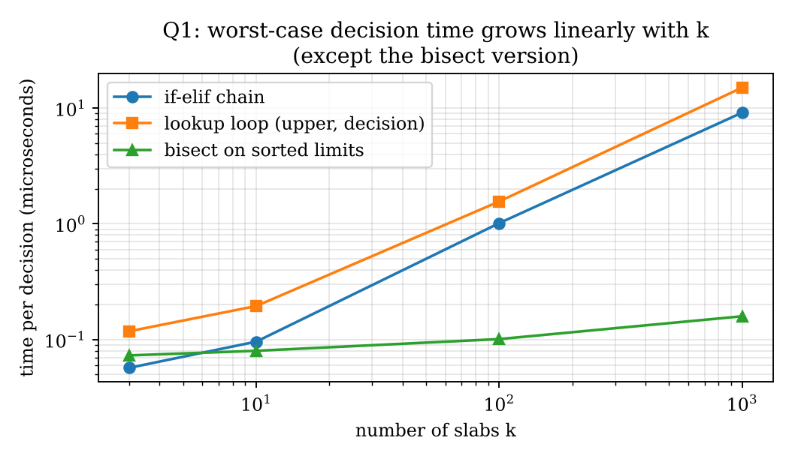
Figure 1.1: Worst-case time per decision against the number of slabs k

1.10 Final output and result
All predictions were confirmed. Separate if statements wrongly awarded two subsidies to ration-card households of 100 units or less, while if-elif-else always gave exactly one decision. The chosen design is a flat if-elif-else with chained comparisons; decision time is O(k) in the number of slabs and O(1) extra space.

Q2: Loops that Count Attempts (4 Marks, K3 Apply)

2.1 Aim
To design the OTP attempt loop of a bank kiosk using while and using for with range(3), to show where break, continue, pass and the loop else are needed, and to re-evaluate the design when two extra attempts are allowed.

2.2 Rules and assumptions
- Three attempts; a blank entry is not an attempt; after three wrong entries the account is locked for 30 minutes.
- The sample OTP is 482913. The customer's typing is supplied as a list so every run is repeatable; replacing next(feed) by input() makes the same code a real kiosk.

2.3 Implementation
Program: q2_otp.py (all designs)
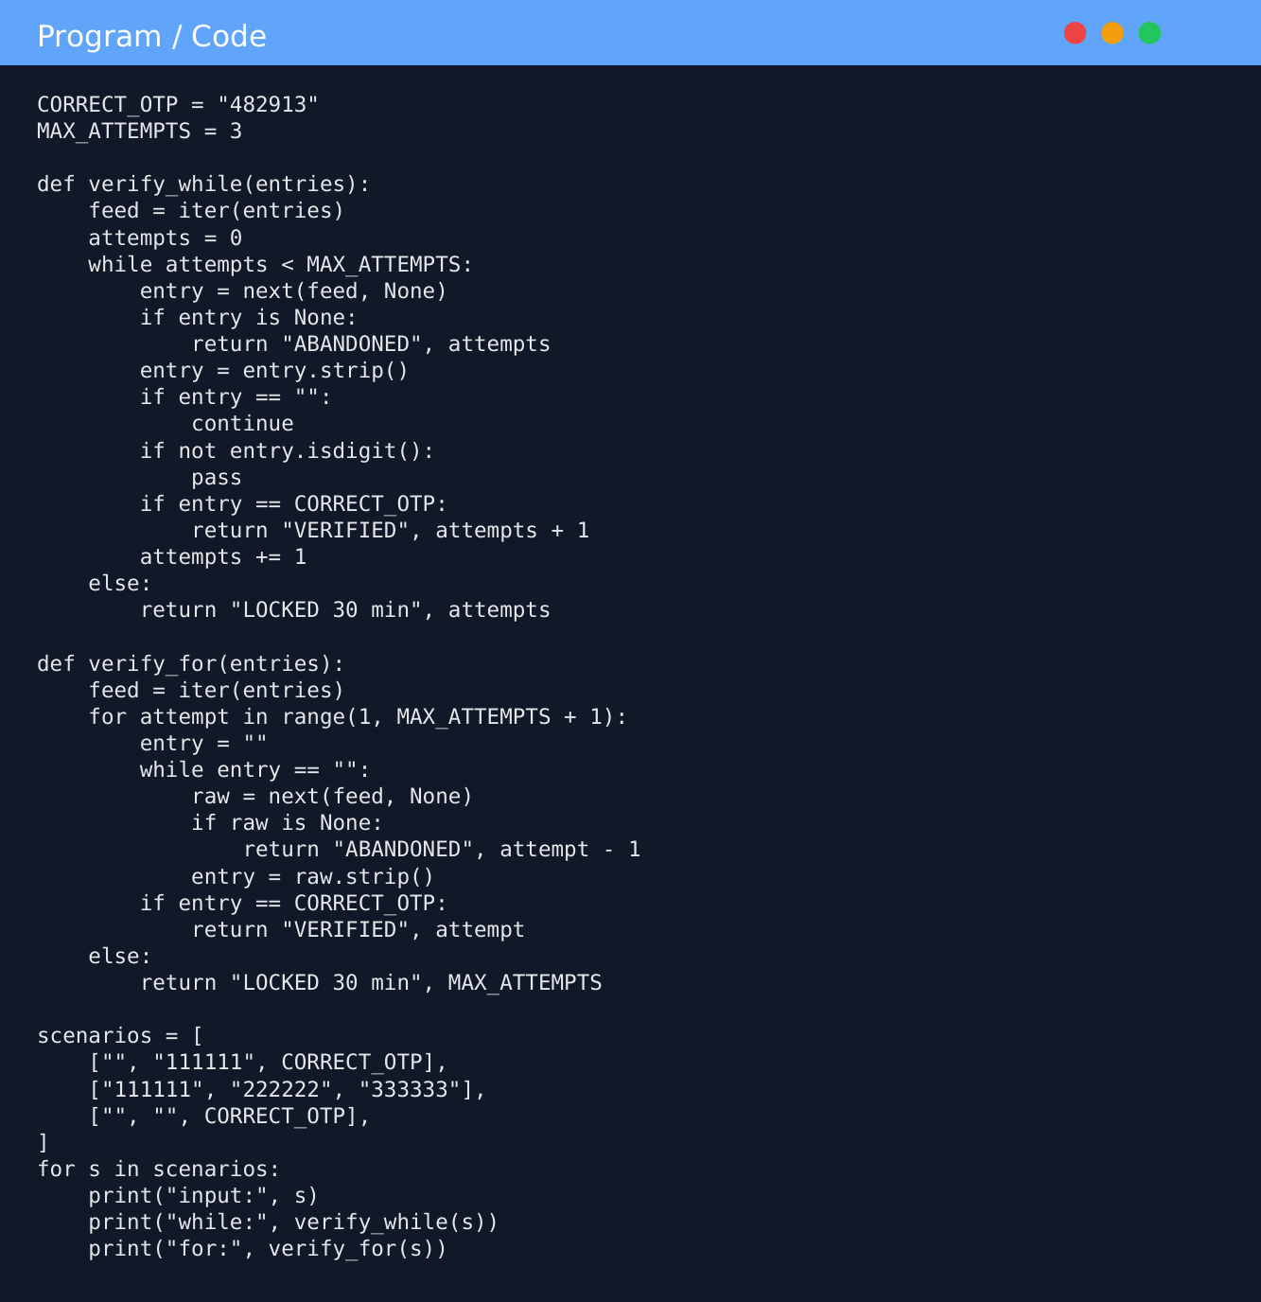

2.4 Where break, continue, pass and loop-else are needed
- continue: a blank entry is skipped without touching the counter (verify_while).
- break: leaves the loop on the correct OTP, so the else part is skipped (verify_while_break).
- pass: a no-operation placeholder where a future "log malformed entry" feature will go; the entry then falls through and is counted as a wrong attempt.
- loop else: runs only when the loop finished without break or return, which means three attempts were used, so the account is locked.
- In the for ... in range(3) design a blank cannot simply continue, because that would use up one of the three iterations. An inner while re-reads until the entry is not blank.

2.5 Output
Output
=== Part A: while design vs for-range(3) design vs while-break design ===
scenario while for/range(3) while+break
S1 blank, wrong, correct ('VERIFIED', 2) ('VERIFIED', 2) ('VERIFIED', 2)
S2 three wrong -> lock ('LOCKED 30 min', 3) ('LOCKED 30 min', 3) ('LOCKED 30 min', 3)
S3 two blanks then correct ('VERIFIED', 1) ('VERIFIED', 1) ('VERIFIED', 1)
S4 letters, wrong, correct ('VERIFIED', 3) ('VERIFIED', 3) ('VERIFIED', 3)
S5 blanks between wrong ones ('LOCKED 30 min', 3) ('LOCKED 30 min', 3) ('LOCKED 30 min', 3)

=== Part B: buggy counter placement ===
input: blank, blank, blank, correct OTP (customer never typed a wrong OTP!)
correct while design : ('VERIFIED', 1)
BUG A (counter at top): ('LOCKED 30 min', 3)
BUG B (counter on success only): ('NEVER LOCKED (stopped by safety cap after 50 spins)', 0)

=== Part C: changed condition (two extra attempts after security question) ===
3 wrong, security OK, correct on 5th -> ('VERIFIED', 5)
3 wrong, security OK, 5 wrong -> lock -> ('LOCKED 30 min', 5)
3 wrong, security WRONG -> lock -> ('LOCKED 30 min', 3)
correct on 2nd attempt -> ('VERIFIED', 2)

=== Part D: recursion vs loop for a attempts (all wrong inputs) ===
a loop time (us) recursion time (us) max stack depth
3 0.2 0.9 4
50 3.3 15.8 51
200 8.5 92.3 201
900 48.8 330.4 901
a = 5000 -> RecursionError (limit = 1000); the loop version handles it: ('LOCKED 30 min', 5000)

The three designs agree in all five scenarios (column "while+break" now reports the attempt number that succeeded, like the others).

2.6 Questions
When is a while loop more natural? When the number of repetitions is not fixed in advance but depends on a condition. Here a blank entry must not count, so the number of loop passes is not the number of attempts; while attempts < 3 states the real rule and lets us decide where the counter changes. for range(3) is natural only when every pass is exactly one attempt.
What bug appears if the counter is updated in the wrong place? (A) Counter at the top of the loop: blank entries are counted. For the input blank, blank, blank, correct OTP the customer never typed a wrong OTP, yet the buggy loop returned LOCKED after 3 counts, while the correct design returned VERIFIED. (B) Counter updated only on the success path: wrong entries are never counted, the lock never triggers and an attacker could guess forever (the demonstration needed a safety cap of 50 spins to stop).

2.7 Changed condition: two extra attempts after a correct security answer
The while design adapts easily: keep a variable limit (initially 3) and, when the attempts reach it, ask the security question once; if it is answered correctly raise limit by 2 and continue. verify_extended does this. A for ... in range(3) loop fixes its count when it starts, so it would need range(5) with extra conditions or a restructure; the while design is therefore the better one. Results: 3 wrong, security OK, correct on the 5th gives VERIFIED (5); 3 wrong, security OK, then more wrong entries gives LOCKED after 5; security answer wrong gives LOCKED after 3; correct on the 2nd attempt gives VERIFIED (2). The bonus is offered only once.

2.8 Alternative concept and complexity analysis
A recursive version calls itself for the next attempt (verify_recursive, in the program above): it returns on success, returns LOCKED when attempts_left reaches 0, and otherwise recurses with one fewer attempt left (a blank recurses without reducing it). With a attempts, the loop and the recursion both take O(a) time, but the recursion needs O(a) stack space (one frame per call) against O(1) for the loop. Measured with all-wrong inputs:
a attempts | loop time (us) | recursion time (us) | recursion stack depth
3 | 0.2 | 0.9 | 4
50 | 3.3 | 15.8 | 51
200 | 8.5 | 92.3 | 201
900 | 48.8 | 330.4 | 901

Both grow in proportion to a, and recursion is several times slower because of call overhead. At a = 5000 the recursion raised RecursionError (limit 1000) while the loop returned LOCKED normally.
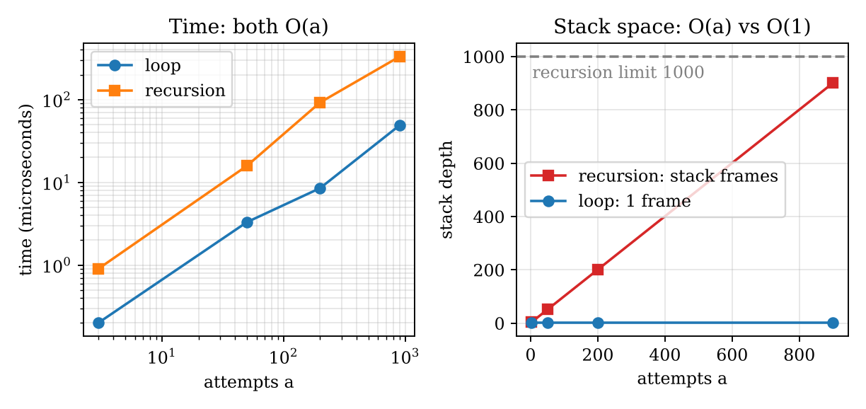
Figure 2.1: Loop against recursion: time and stack depth

2.9 Final output and result
The while design with continue, break, pass and loop-else handled every scenario, ignored blank entries and locked the account after three real wrong entries. The for range(3) design needed an inner loop for blanks. The while design also adapted to the changed condition with a one-line change of the limit. Loops use O(a) time and O(1) space; recursion uses O(a) time and O(a) stack.

Q3: Engineer a Vehicle Registration Number Validator (6 Marks, K4)

3.1 Aim
To normalise, validate and format toll-plaza vehicle numbers using only string operations and slicing (no regular expressions in the main solution). A valid number has 2 letters (state), 2 digits (district), 1 or 2 letters (series) and 4 digits.

3.2 Predictions for six inputs I designed
Input typed | Predicted normal form | Predicted | Reason
mh 12 c 4567 | MH12C4567 | valid | MH, 12, C, 4567
ap39-bz-9999 | AP39BZ9999 | valid | hyphens removed
T N-0 9-A B-12 34 | TN09AB1234 | valid | messy spacing is removed
DL-8-CAF-5030 | DL8CAF5030 | INVALID | 1-digit district, 3-letter series
TN09AB123 | TN09AB123 | INVALID | only 3 final digits
tn 09 a1 1234 | TN09A11234 | INVALID | digit inside the series

3.3 Inquiry: immutability and slicing
Strings are immutable: after a string object is created its characters cannot be changed (s[0] = "X" raises TypeError). Therefore text.upper() cannot change text; it builds and returns a new string and leaves the original untouched, so the result must be stored (text = text.upper()) or it is lost. Immutability makes strings safe to share and usable as dictionary keys.
Negative indices count from the end, so s[-4:] is always the last four characters. For the 9-character KA01M0007, s[-4:] is 0007 and s[4:-4] is M. For the 10-character TN09AB1234, s[-4:] is 1234 and s[4:-4] is AB. The slice s[4:-4] adapts to the length: it is the series, whose length is len(s) - 8.

3.4 Implementation (TODO 1 and TODO 2 completed, plus the formatting function)
Program: q3_vehicle.py
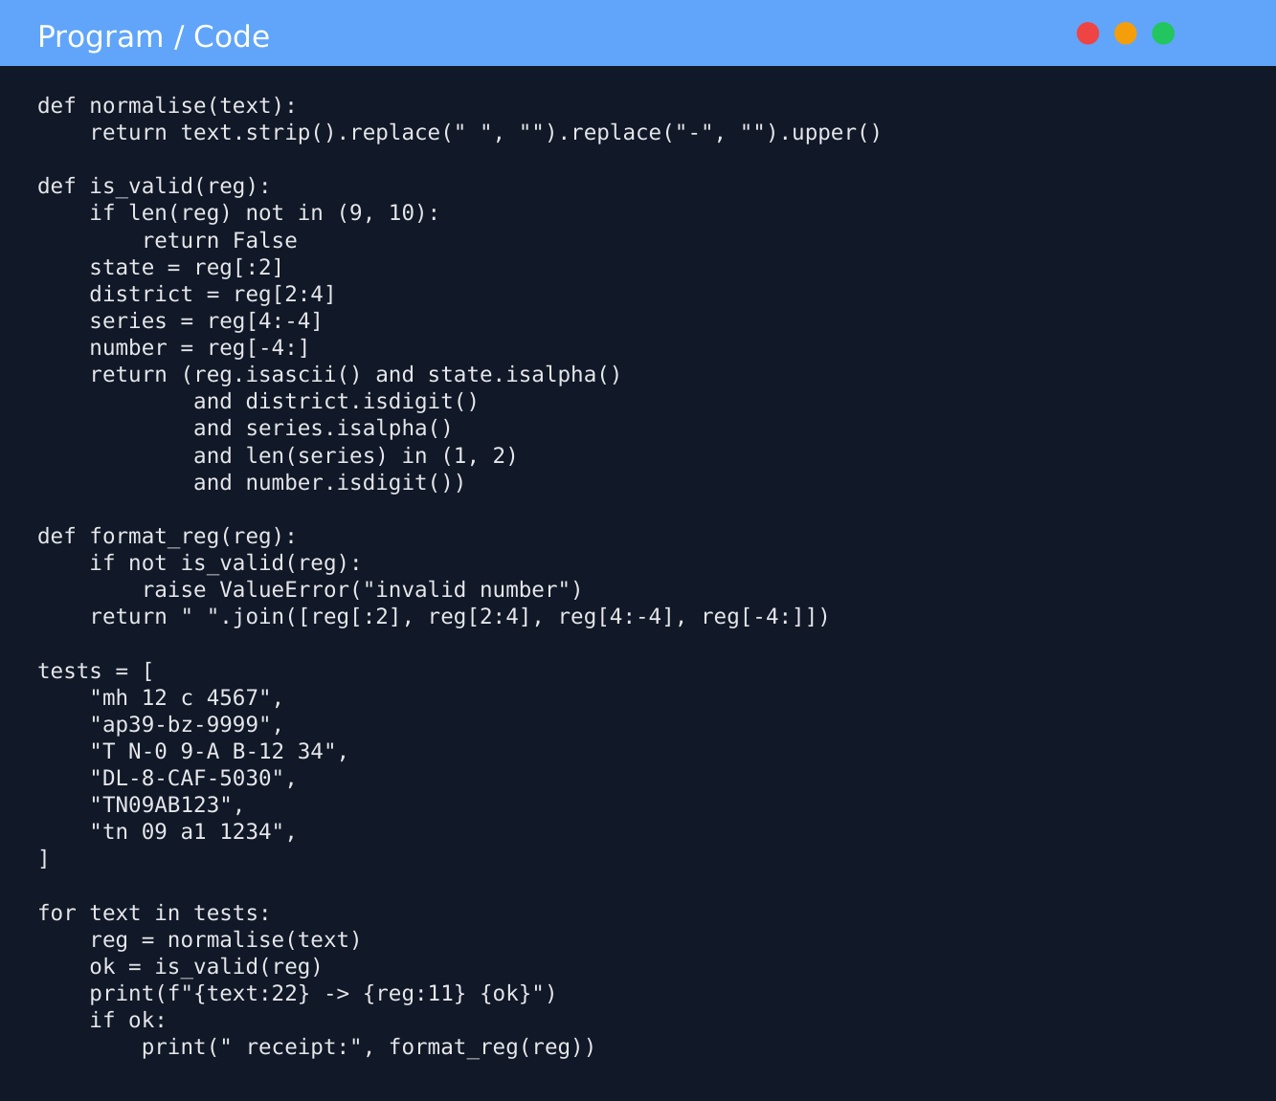

3.5 Output
Output
=== Given test data (expected output from the question) ===
tn 09 ab 1234 -> TN09AB1234 valid
KA-01-M-0007 -> KA01M0007 valid
TN9AB1234 -> TN9AB1234 INVALID
TN 22 1234 AB -> TN221234AB INVALID

=== My six test inputs: prediction vs observed ===
mh 12 c 4567 pred: MH12C4567 True | got: MH12C4567 True | receipt: MH 12 C 4567 OK
ap39-bz-9999 pred: AP39BZ9999 True | got: AP39BZ9999 True | receipt: AP 39 BZ 9999 OK
T N-0 9-A B-12 34 pred: TN09AB1234 True | got: TN09AB1234 True | receipt: TN 09 AB 1234 OK
DL-8-CAF-5030 pred: DL8CAF5030 False | got: DL8CAF5030 False | receipt: - OK
TN09AB123 pred: TN09AB123 False | got: TN09AB123 False | receipt: - OK
tn 09 a1 1234 pred: TN09A11234 False | got: TN09A11234 False | receipt: - OK
All six predictions correct: True

=== Inquiry: immutability and slicing ===
s.lower() returns tn09ab1234 - original s is still TN09AB1234
id(s) == id(s.lower()) -> False
s[0] = 'X' -> TypeError: 'str' object does not support item assignment
9-character KA01M0007: s[-4:] = '0007' s[4:-4] = 'M' len = 9
10-character TN09AB1234: s[-4:] = '1234' s[4:-4] = 'AB' len = 10

=== Cross-check: slicing validator vs regex on 50,000 random strings ===
valid strings found: 12426, disagreements between the two methods: 0
('²'.isdigit() -> True ; without isascii() the slicing method would accept it)

=== Time per validation (microseconds, best of 5 x 100000) ===
TN09AB1234 slicing: 0.334 regex: 0.220
KA01M0007 slicing: 0.301 regex: 0.228
TN9AB1234 slicing: 0.253 regex: 0.173

=== normalise + validate for growing length L (typed number padded with spaces) ===
L slicing (us) regex (us)
10 0.59 0.44
1000 1.22 1.02
100000 63.86 60.25
1000000 710.37 668.07

=== Ease of change: also allow a 3-letter series ===
slicing: change len(reg) in (9,10) -> (9,10,11) and len(series) in (1,2) -> (1,2,3) [2 edits]
regex : change {1,2} -> {1,3} in the pattern [1 edit]

The four lines of the given test match the expected output (spaces between columns differ only because of the field widths 15 and 11 in the print). All six of my predictions were correct, and the receipt format TN 09 AB 1234 is produced only for valid numbers. isalpha() and isdigit() also accept non-ASCII characters ("²".isdigit() is True), so isascii() was added; with it the slicing validator and the regex validator disagreed on 0 of 50,000 random strings (12,426 were valid).

3.6 Alternative concept and complexity analysis
Validation with a regular expression is one line: re.fullmatch(r"[A-Z]{2}[0-9]{2}[A-Z]{1,2}[0-9]{4}", reg). Both methods scan the normalised string at most once, so the time is O(L) for a number of length L and the auxiliary space is O(1) apart from the normalised copy (O(L)). With the slicing method the length test rejects any string that is not 9 or 10 characters in O(1), so the cost of the whole pipeline is dominated by normalise() (replace and upper). Measured:
Typed length L (spaces added) | slicing (us) | regex (us)
10 | 0.59 | 0.44
1,000 | 1.22 | 1.02
100,000 | 63.86 | 60.25
1,000,000 | 710.37 | 668.07

Time grows linearly with L in both. For a single valid number the regex was faster (0.220 against 0.334 microseconds for TN09AB1234). Readability: the regex states the whole format in one line but is cryptic for beginners and cannot say which part failed; the slicing code is longer but each part is explicit and can give specific error messages. Ease of change: allowing a 3-letter series needs two edits in the slicing code (length set and series length) but one edit ({1,2} to {1,3}) in the regex. For this assignment the slicing method is required; in production a commented regex would be a good choice.

3.7 Final output and result
normalise, is_valid and format_reg work correctly for the given and the six designed inputs. Slicing and immutability were demonstrated, and the slicing validator was verified against a regex on 50,000 strings with no disagreement.

Q4: Building Long Text: + or join()? (6 Marks, K4)

4.1 Aim
To build a monthly SMS bill statement in three ways: (a) repeated += in a loop, (b) a list of parts followed by "".join(), and (c) an f-string for each line, and to predict and then measure which is faster for 1,000, 10,000 and 200,000 lines.

4.2 Prediction before measuring
I predicted that join would be the fastest because it computes the total length once, allocates once and copies every part once, O(n). I predicted that += would be slower because strings are immutable, so each += must copy the whole growing string, up to O(n^2) characters copied. The f-string version would be about as fast as join plus the cost of formatting every line.

4.3 Implementation (TODO 1 completed)
Program: q4_build.py (the given program)
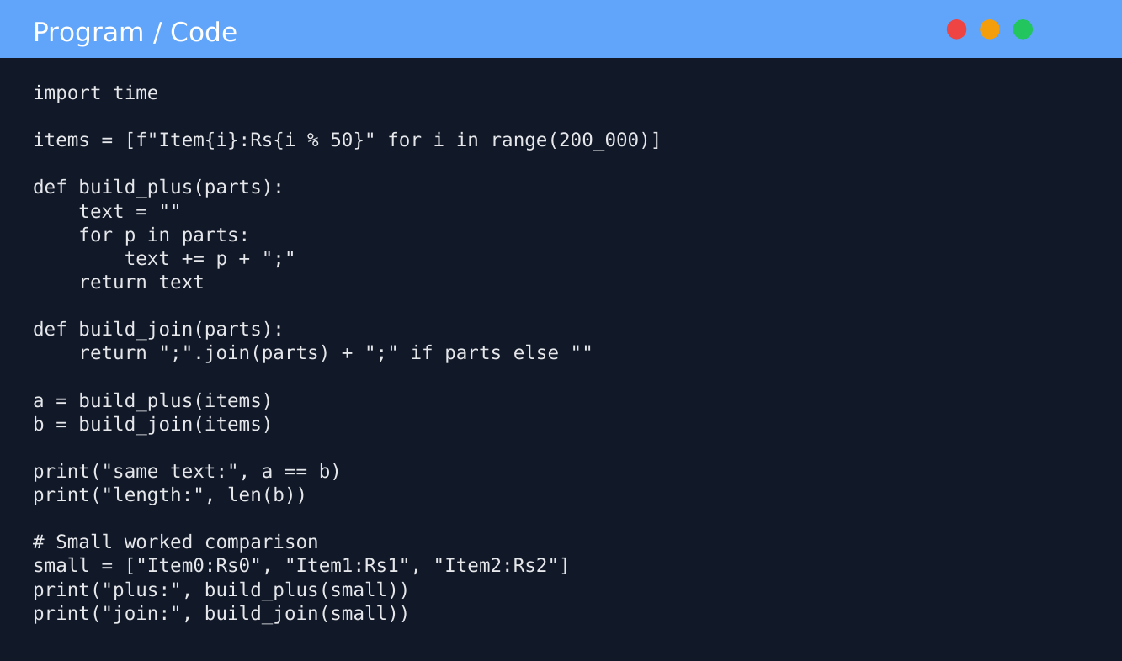

Extra builders used in q4_benchmark.py (f-string, StringIO, file, and += with the optimisation defeated)
# (a) repeated += inside a loop
def build_plus(parts):
text = ""
for p in parts:
text += p + ";"
return text

# (b) list of parts followed by join
def build_join(parts):
return ";".join(parts) + ";" if parts else ""

# (c) an f-string for each line, collected and joined
def build_fstring(n):
lines = [f"Item{i}:Rs{i % 50};" for i in range(n)] # one f-string per line
return "".join(lines)

# (d) alternative: io.StringIO buffer
def build_stringio(parts):
buf = io.StringIO()
for p in parts:
buf.write(p)
buf.write(";")
return buf.getvalue()

# (e) alternative: write line by line directly to a file
def build_file(parts, path="statement.txt"):
with open(path, "w") as fh:
for p in parts:
fh.write(p)
fh.write(";")
with open(path) as fh:
return fh.read()

# (f) += written so CPython's in-place optimisation CANNOT apply
def build_plus_slow(parts):
text = ""
for p in parts:
text = text + p + ";" # text + p creates a brand-new string every time
return text

4.4 Output of the given program, three runs
Run | += time (s) | join time (s)
1 | 0.0120 | 0.0056
2 | 0.0116 | 0.0051
3 | 0.0120 | 0.0055
Average | 0.0119 | 0.0054

The program printed same text: True | length: 3048890, matching the expected output.

4.5 Measured times at three sizes and the full benchmark
Output
Python 3.12.3

=== Part 1: the given program, run three times (separate processes) ===
--- run 1 ---
same text: True | length: 3048890
+= time: 0.0120 s join time: 0.0056 s
--- run 2 ---
same text: True | length: 3048890
+= time: 0.0116 s join time: 0.0051 s
--- run 3 ---
same text: True | length: 3048890
+= time: 0.0120 s join time: 0.0055 s
average += time : 0.0119 s (runs: [0.012, 0.0116, 0.012])
average join time: 0.0054 s (runs: [0.0056, 0.0051, 0.0055])

=== Part 2: time (milliseconds) at three sizes, best of 3 ===
lines += loop join f-string+join StringIO file write
1000 0.060 0.009 0.152 0.047 0.202
10000 0.552 0.138 1.670 0.499 1.441
200000 12.693 3.946 37.971 10.141 21.756

=== Part 3: += with the CPython optimisation defeated (text = text + p + ';') ===
lines time (s) ratio to previous
5000 0.0086
10000 0.0346 4.04x
20000 0.1453 4.20x
40000 0.6609 4.55x
80000 4.5786 6.93x
(doubling the lines should multiply the time by about 4 if the work is O(n^2))

=== Part 4: peak extra memory at 200,000 lines (tracemalloc, MB) ===
+= loop result length 3048890 peak = 3.05 MB
join result length 3048890 peak = 6.10 MB
StringIO result length 3048890 peak = 6.86 MB
file write (includes reading it back to compare) peak = 6.10 MB
file only (write line by line, nothing kept) peak = 0.02 MB

The "f-string + join" column includes the cost of formatting each line from scratch, whereas the other columns start from the prepared list items, so compare columns (a) and (b) for the pure joining cost. The "file write" column includes reading the file back to compare it.
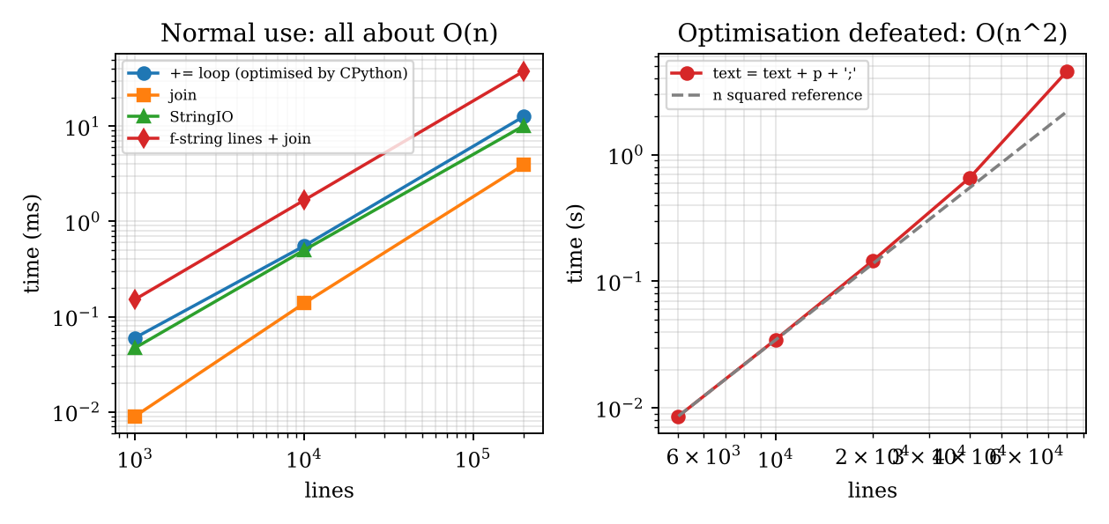
Figure 4.1: Time to build the statement (left) and the quadratic behaviour when the CPython optimisation is defeated (right)

4.6 Inquiry: explanation using immutability
A string cannot be changed in place, so text += p + ";" conceptually creates a new string of length len(text) + len(p) + 1, copies the old text and the new piece into it, and rebinds the name. Copying 1, 2, 3, ... n pieces gives about n^2/2 piece-copies. For 200,000 lines of about 15 characters that would be roughly 3 x 10^11 characters (about 300 GB) copied.
My measurement shows += only 2.2 times slower than join at 200,000 lines (12.7 ms against 3.9 ms). The reason is a CPython optimisation: when the string being extended has only one reference (a local variable), CPython resizes it in place instead of copying. This is an implementation detail, not a language guarantee. When I wrote text = text + p + ";", which defeats it, the time rose about four times for every doubling of the input (0.0086 s, 0.0346 s, 0.1453 s, 0.6609 s, 4.5786 s for 5,000 to 80,000 lines), the signature of O(n^2). The growth above 4 at the largest sizes appears when the strings no longer fit in the processor cache.
join() remains the recommended practice because it is O(n) on every interpreter and in every situation, whereas += is fast only when the optimisation happens to apply (not on other Python implementations, nor when the string has other references, such as an attribute or a global). It also states the intention clearly.

4.7 Alternative concept and complexity analysis
Instead of collecting parts, the text can be written line by line directly to a file, or built in an io.StringIO buffer (see the extra builders above). The comparison is:
Method | Time | Extra memory | Measured at 200,000 lines
+= (optimised by CPython) | O(n) in practice, O(n^2) in the worst case | result only | 12.7 ms, peak 3.05 MB
list + join | O(n) | O(n): parts list and result | 3.9 ms, peak 6.10 MB
io.StringIO | O(n) amortised | O(n): buffer plus copy on getvalue() | 10.1 ms, peak 6.86 MB
write to file line by line | O(n) | O(1) in Python (data goes to disk) | 21.8 ms (includes reading back), peak 0.02 MB when nothing is kept

The 6.10 MB peak of join arises because ";".join(parts) + ";" briefly holds the joined text and the longer concatenated copy; appending the final ; to the last part would avoid it. If the statement only has to be stored or printed, writing line by line is the best for memory, even though it is slower per line because of I/O.

4.8 Final output and result
The three builders produced identical text of length 3,048,890. join was the fastest (0.0054 s against 0.0119 s average for += over three runs); += was close only because of a CPython optimisation and was demonstrably quadratic when the optimisation was prevented. Conclusion: use join (or write straight to a file) for long statements.

Q5: Functions, Parameters and Scope (7 Marks, K4)

5.1 Aim
To explain why items of one customer appear in the next customer's order, to design the canteen order functions correctly, and to demonstrate parameter kinds, returning several values, and local, global and nonlocal names.

5.2 The bug explained using the given principle
A default value is created once, when the `def` statement runs, not each time the function is called. order=[] therefore creates one list that is stored in the function object (add_item_buggy.__defaults__). Every call that leaves out order receives that same list; append changes it, so "Tea" from one customer is still there when the next customer's "Vada" is added. In the test, both calls return the same list object and the print happens after both calls, so both outputs show ['Tea', 'Vada']. The program printed __defaults__ as (['Tea', 'Vada'],) and confirmed that the returned list is the default list.
Correction: use order=None (an immutable value, harmless to share) and create a fresh list inside the function when order is None.

5.3 Design decisions
- Positional parameters: required values whose order is obvious (item). Keyword arguments: clearer when there are several or optional values and order should not matter (price_of(qty=3, item="Vada")). Default parameters: optional values with a sensible common value (qty=1, gst_rate=0.05, order=None). A default must be immutable; parameters without defaults cannot follow those with defaults.
- Returning more than one value: return a tuple, for example return subtotal, gst, total, and unpack it in the caller: sub, gst, total = bill(order).
- Local, global, nonlocal: an assignment inside a function creates a new local name. global is needed to assign to a module-level variable; without it orders_today += 1 raises UnboundLocalError, because Python decides the name is local and it is read before it has a value. nonlocal lets an inner function change a variable of the enclosing function (used for the token counter). Changing globals inside functions is usually avoided because it creates hidden dependencies and side effects: the result then depends on state outside the parameters, tests need resetting, and different customers (or threads) can interfere. Parameters and return values are clearer.

5.4 Implementation (TODO 1 completed) and test
Program: q5_canteen.py
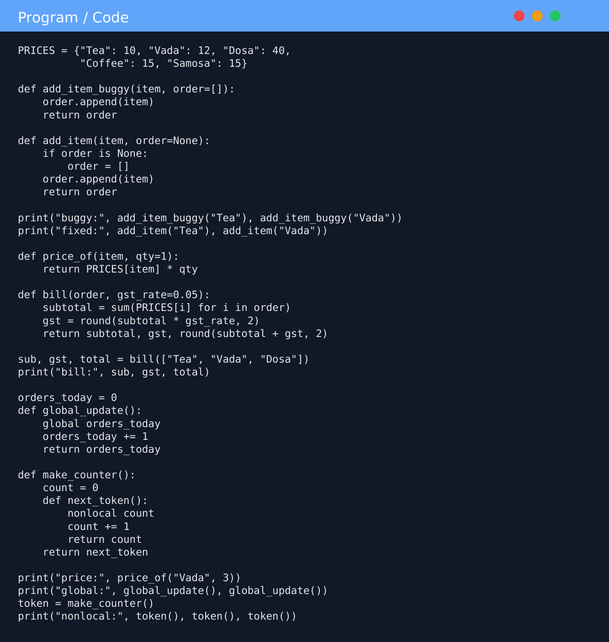

5.5 Output
Output
=== Given test ===
['Tea', 'Vada'] ['Tea', 'Vada']
['Tea'] ['Vada']
add_item_buggy.__defaults__ = (['Tea', 'Vada'],)
add_item.__defaults__ = (None,)
buggy calls return the same object: True

=== Positional / keyword / default parameters ===
price_of('Vada') -> 12
price_of('Vada', 3) -> 36 (positional)
price_of(qty=3, item='Vada') -> 36 (keyword, any order)

=== Returning several values ===
subtotal = 62, GST = 3.1, total = 65.1
what bill() really returns: (10, 0.5, 10.5) tuple

=== Local vs global vs nonlocal ===
local_demo() -> 100 | global is still 0
read_global_demo()-> 1
broken_update() -> UnboundLocalError: cannot access local variable 'orders_today' where it is not associated with a value
after two global_update() calls the global is 2
nonlocal token numbers: 1 2 3

=== Three customers in sequence ===
customer 1: ['Tea', 'Vada'] bill (subtotal, GST, total) = (22, 1.1, 23.1)
customer 2: ['Dosa'] bill (subtotal, GST, total) = (40, 2.0, 42.0)
customer 3: ['Coffee', 'Samosa', 'Tea'] bill (subtotal, GST, total) = (40, 2.0, 42.0)
all three lists are different objects: True | no leakage: True

Same three customers with the BUGGY function (default list cleared first):
customer 1: ['Tea', 'Vada']
customer 2: ['Tea', 'Vada', 'Dosa']
customer 3: ['Tea', 'Vada', 'Dosa', 'Coffee', 'Samosa', 'Tea']
defaults now: (['Tea', 'Vada', 'Dosa', 'Coffee', 'Samosa', 'Tea'],)

=== Alternative designs behave the same ===
explicit : ['Tea', 'Vada']
closure : ['Tea', 'Vada', 'Coffee'] ['Dosa', 'Samosa']

=== Time per item (microseconds, 200000 calls) and space per customer ===
default None : 0.057 explicit list : 0.052 closure : 0.041
bytes for an empty list: 56 | list with 1 item: 88 | closure object (function): 160 | its cell: 40
adding 10 items to ONE order: 0.356 microseconds per item
adding 1000 items to ONE order: 0.076 microseconds per item
adding 1000000 items to ONE order: 0.071 microseconds per item

The expected output of the question was obtained: ['Tea', 'Vada'] ['Tea', 'Vada'] for the buggy function and ['Tea'] ['Vada'] for the corrected one. Three customers in sequence received three different list objects with no leakage, while the buggy function gave customer 3 all six items of the earlier orders.

5.6 Alternative concept and complexity analysis
Two other designs also avoid the bug: (1) the caller always passes the list explicitly (add_item_explicit(item, order)), and (2) a closure: new_order() returns an inner function add that keeps its own private list. In the explicit design the caller owns and must manage every list (a caller who reuses a list shares it by mistake). The closure hides the list, so accidental sharing is impossible, but the list is harder to inspect or save; for a larger system a class would be better.
All three designs take O(1) time per item (list append is amortised O(1)): measured 0.057 microseconds (default None), 0.052 (explicit) and 0.041 (closure) per call; adding 1,000,000 items to one order cost 0.071 microseconds per item, the same as for 1,000 items. The space per customer is O(m) for m items in every design (an empty list is 56 bytes, a list with one item 88 bytes); the closure adds a fixed overhead per customer (160 bytes for the function object and 40 bytes for its cell).

5.7 Final output and result
The default-parameter bug was explained, demonstrated and corrected with order=None. Positional, keyword and default parameters, tuple returns, and local, global and nonlocal names were demonstrated with output, and three customers' orders were shown to be independent.

Q6: Recursion and Its Limits (8 Marks, K5 Evaluate)

6.1 Aim
To count the ways of climbing n temple steps (1 or 2 steps at a time) recursively, to explain the repeated work with a call tree, to remove it with memoisation, to measure the growth of the number of calls, and to decide how to deploy the solution for n up to 1,000.

6.2 Recursive design
- Base case: ways(n) = 1 for n <= 1 (one way to stay at the bottom or to climb a single step).
- Recursive case: the last move was a 1-step from step n-1 or a 2-step from step n-2; these cases do not overlap and cover everything, so ways(n) = ways(n-1) + ways(n-2). (This is the Fibonacci sequence shifted by one place.)

6.3 Correctness check for n = 1 to 6, worked by hand
ways(1) = 1; ways(2) = ways(1) + ways(0) = 2 (1+1, 2); ways(3) = 2 + 1 = 3 (1+1+1, 1+2, 2+1); ways(4) = 3 + 2 = 5; ways(5) = 5 + 3 = 8; ways(6) = 8 + 5 = 13. The program gave identical values (see the output table below).

6.4 Why the plain version repeats work: call tree for n = 5
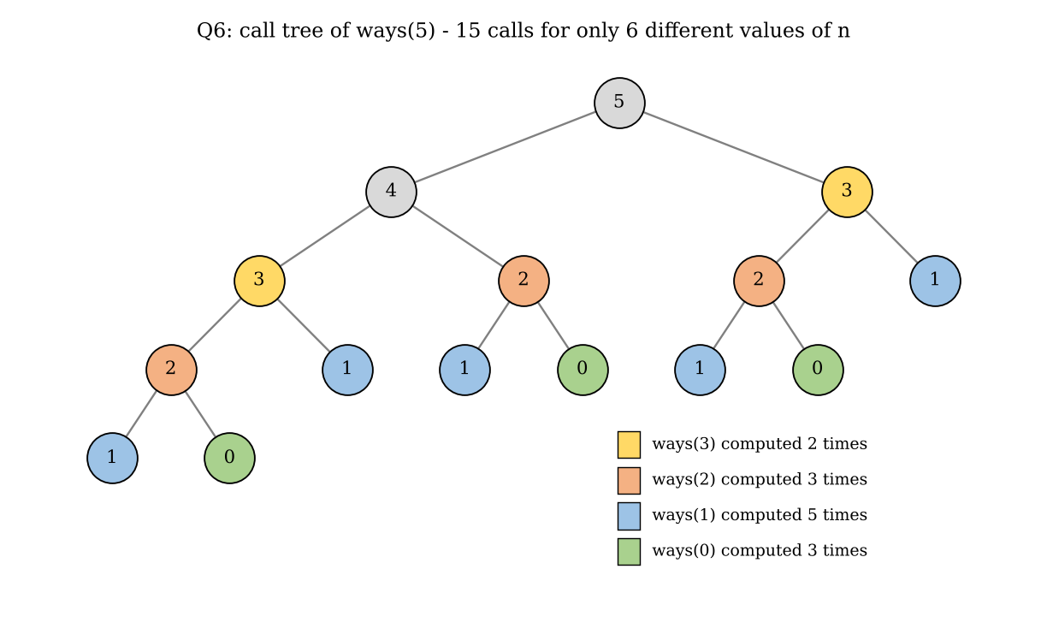
Figure 6.1: Call tree of ways(5)
ways(5) makes 15 calls although only 6 different values of n exist: ways(3) is computed twice, ways(2) three times, ways(1) five times and ways(0) three times. The number of calls C(n) = C(n-1) + C(n-2) + 1 equals 2 x ways(n) - 1, so it grows by the golden ratio 1.618 for every extra step.

6.5 Memoisation (TODO 1 completed)
lru_cache stores the result of every ways_memo(n) it has computed in a dictionary. Each distinct n is therefore computed once and later requests are answered from the cache, so the number of real calls is n + 1.
Program: q6_steps.py
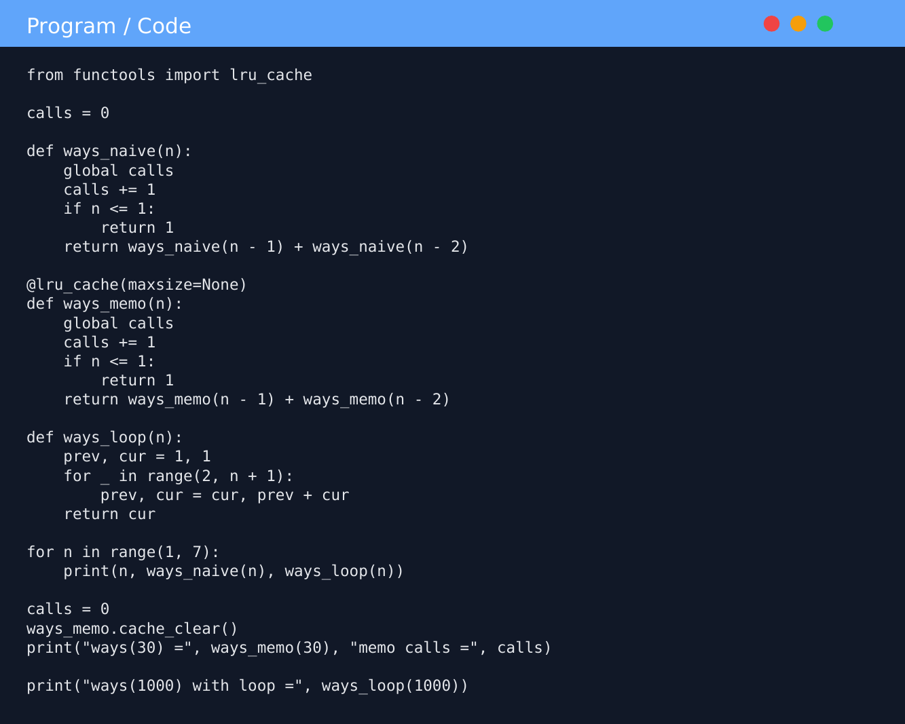

6.6 Output, correctness and growth investigation
Output
Python 3.12.3 recursion limit = 1000

=== Given program ===
naive: 121393 calls = 242785
memo : 121393 calls = 26

=== Correctness check n = 1..6 (hand-worked values vs program) ===
n by hand naive memo loop
1 1 1 1 1
2 2 2 2 2
3 3 3 3 3
4 5 5 5 5
5 8 8 8 8
6 13 13 13 13

=== Call tree for n = 5 (plain recursion) ===
ways(5)
ways(4)
ways(3)
ways(2)
ways(1)
ways(0)
ways(1)
ways(2)
ways(1)
ways(0)
ways(3)
ways(2)
ways(1)
ways(0)
ways(1)
total calls: 15
how many times each value was computed: {5: 1, 4: 1, 3: 2, 2: 3, 1: 5, 0: 3}

=== Growth investigation: function calls ===
prediction: naive calls = 2*ways(n) - 1 (about 1.618x more for every extra step); memo calls = n + 1
n naive calls predicted 2*W-1 memo calls memo = n+1? ratio to previous
10 177 177 11 True
20 21891 21891 21 True 123.68
25 242785 242785 26 True 11.09
30 2692537 2692537 31 True 11.09
golden ratio phi = 1.618; phi^5 = 11.09 (n=20 -> 25), phi^5 again for 25 -> 30

=== Run times (seconds) ===
n naive memo (cold cache) loop
20 0.00137 0.0000068 0.0000045
25 0.01514 0.0000075 0.0000021
30 0.22151 0.0000251 0.0000062
32 0.44617 0.0000256 0.0000065

=== Deployment decision: n = 1000 ===
ways_memo(1000) -> RecursionError: maximum recursion depth exceeded
sys.getrecursionlimit() = 1000 (maximum nested Python calls); ways_memo(1000) needs about 1000 nested calls
after sys.setrecursionlimit(3000): memo(1000) has 209 digits; cache size = 1001
warm-up trick (200, 400, ... 1000) also works with the default limit: True
loop(1000) == memo(1000): True | loop works with no limit change
ways(1000) = 70330367711422815821... (209 digits)
plain recursion at n=1000 would need about 2*ways(1000)-1 = 1.407e+209 calls -> impossible in practice

=== All implementations at n = 1000 (time in microseconds, best of 20) ===
memoised recursion (cold cache, limit raised): 295.7
loop with two variables : 34.6
plain recursion : not run (about 1.4e209 calls)

Prediction: plain calls = 2 x ways(n) - 1, so each 5 extra steps multiply the calls by 1.618^5 = 11.09; memoised calls = n + 1. Observed: the given program printed 121393 with 242785 calls (naive) and 26 calls (memo), exactly as expected. For n = 10, 20, 25, 30 the plain calls were 177, 21,891, 242,785 and 2,692,537, equal to the prediction in every case; the ratios from 20 to 25 and from 25 to 30 were both 11.09. The memoised version made 11, 21, 26 and 31 calls, i.e. n + 1.
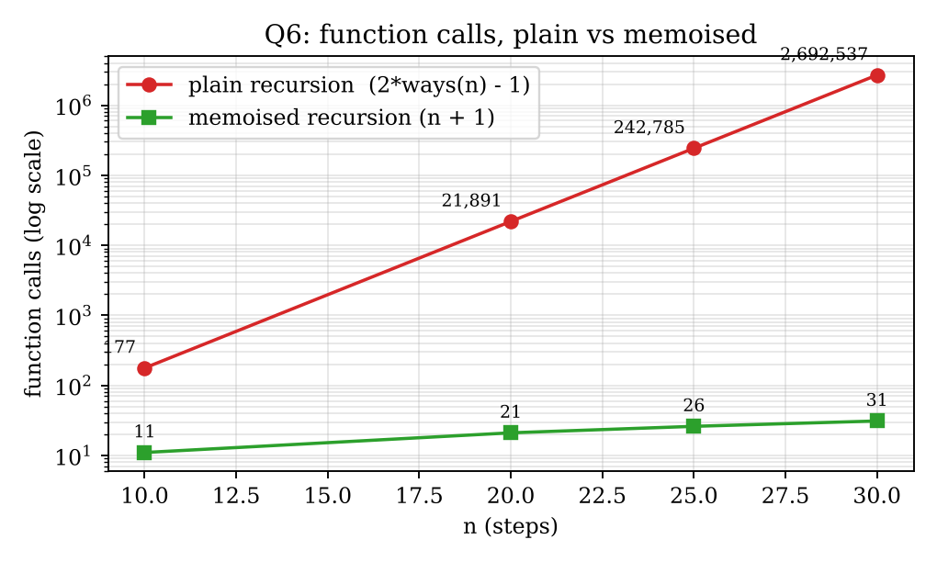
Figure 6.2: Function calls of the plain and memoised versions

6.7 Deployment decision for n = 1,000
ways_memo(1000) failed with RecursionError: maximum recursion depth exceeded. sys.getrecursionlimit() returned 1000, the maximum number of nested Python calls, which protects the interpreter's C stack from overflowing. The memoised function must nest about 1,000 calls deep (ways(1000) calls ways(999), which calls ways(998) and so on) before the first result can be stored, so the limit is exceeded.
Options evaluated: (1) Raise the limit with sys.setrecursionlimit(3000): this worked (ways(1000) has 209 digits and the cache held 1,001 entries) but each level uses real stack memory, the safe value depends on the machine, and a limit that is too high can crash the interpreter. (2) Warm-up trick: calling n = 200, 400, ... 1000 in turn also worked, but it is fragile. (3) Rewrite with a loop that keeps the last two values: no depth limit, O(1) space, and at n = 1000 it took 34.6 microseconds against 295.7 for the memoised recursion.
Decision: rewrite with a loop and do not rely on a raised limit. The trust needs 1,000 steps, which is exactly at the edge of the limit, and any larger staircase would fail again with recursion. The loop is deterministic, faster and needs no global interpreter setting. The memoised version is kept only as a cross-check; the loop result equalled the memoised result for n = 1000.

6.8 Alternative concept and complexity analysis
def ways_loop(n):
"""Iterative version that keeps only the last two values."""
prev, cur = 1, 1 # ways(0), ways(1)
for _ in range(2, n + 1):
prev, cur = cur, prev + cur
return cur

Version | Time | Space | At n = 1000
Plain recursion | O(phi^n), phi = 1.618 | O(n) stack | not possible: about 1.4 x 10^209 calls
Memoised recursion | O(n) | O(n) cache + O(n) stack | RecursionError at default limit; 295.7 us with raised limit
Loop, last two values | O(n) | O(1) | 34.6 us, 999 additions

Run times in seconds (single runs): plain recursion 0.00137 (n=20), 0.01514 (n=25), 0.22151 (n=30), 0.44617 (n=32); the memoised version needed 7 to 26 microseconds and the loop 2 to 7 microseconds for the same n. Note: the numbers themselves grow large (209 digits at n = 1000), so each addition is not strictly constant time; the total bit cost is O(n^2) for both the memoised and loop versions, which is small for n = 1000.

6.9 Final output and result
The recursive design is correct for n = 1 to 6 and reproduces the expected output. Plain recursion repeats work exponentially (2.69 million calls at n = 30), memoisation reduces this to n + 1 calls, and the recursion limit blocks n = 1,000. The deployment decision is to use the loop version.

Q7: Day-4 Design Challenge: Diagnose, Redesign and Validate (13 Marks, K5)
Program chosen: the plain recursive ways_naive(n) of Q6 (counting temple-step climbs), because the evidence from Q6 shows that its cost explodes as the input grows. I did not simply replace it with a built-in function; the redesign below follows from the diagnosis.

A. Diagnose the bottleneck (2 marks)
Each call does a constant amount of work (one comparison and at most one addition), so the total work is the number of calls. It grows by 1.618 for every extra step and by 11.09 for every five steps (Q6). The calls are also repeated: only n + 1 different values of n exist, yet the program makes 2,692,537 calls at n = 30, which is 86,856 calls for every distinct value. The call tree of n = 5 (Figure 6.1) already shows ways(1) evaluated five times. The recursion depth also equals n, which caused the RecursionError at n = 1,000.
n | Calls | Distinct values of n | Calls per distinct value | Max depth
5 | 15 | 6 | 2.5 | 5
10 | 177 | 11 | 16.1 | 10
20 | 21,891 | 21 | 1,042.4 | 20
25 | 242,785 | 26 | 9,337.9 | 25
30 | 2,692,537 | 31 | 86,856.0 | 30

B. Design objective (2 marks)
The redesign must: (1) use at most n additions at n = 30 (the original needs about 1.35 million); (2) finish n = 30 in under 0.1 ms; (3) answer n = 1,000 without RecursionError and without changing the recursion limit; (4) give the same answers as the original for every n tested; (5) use O(1) extra memory.

C. Design of the revised solution (4 marks)
What changed: the top-down recursion (ask for ways(n), which asks for smaller values) is replaced by bottom-up iteration: start from the known values ways(0) = ways(1) = 1 and compute ways(2), ways(3), ... upward. Property exploited: (i) overlapping sub-problems, because the same ways(k) is needed many times, so each is computed once; (ii) each value depends only on the previous two, so only two values must be kept. Extra memory: none beyond two integers, O(1) (memoisation would need an O(n) cache). New trade-offs: the code no longer mirrors the recurrence as directly; it gives no automatic reuse between different queries (ways(1000) followed by ways(999) repeats the work, unless a table is kept); and the integers grow, so additions are not strictly constant time.
Pseudocode
FUNCTION ways(n)
prev <- 1 ; cur <- 1 // ways(0), ways(1)
FOR i <- 2 TO n
next <- prev + cur
prev <- cur
cur <- next
END FOR
RETURN cur
END FUNCTION

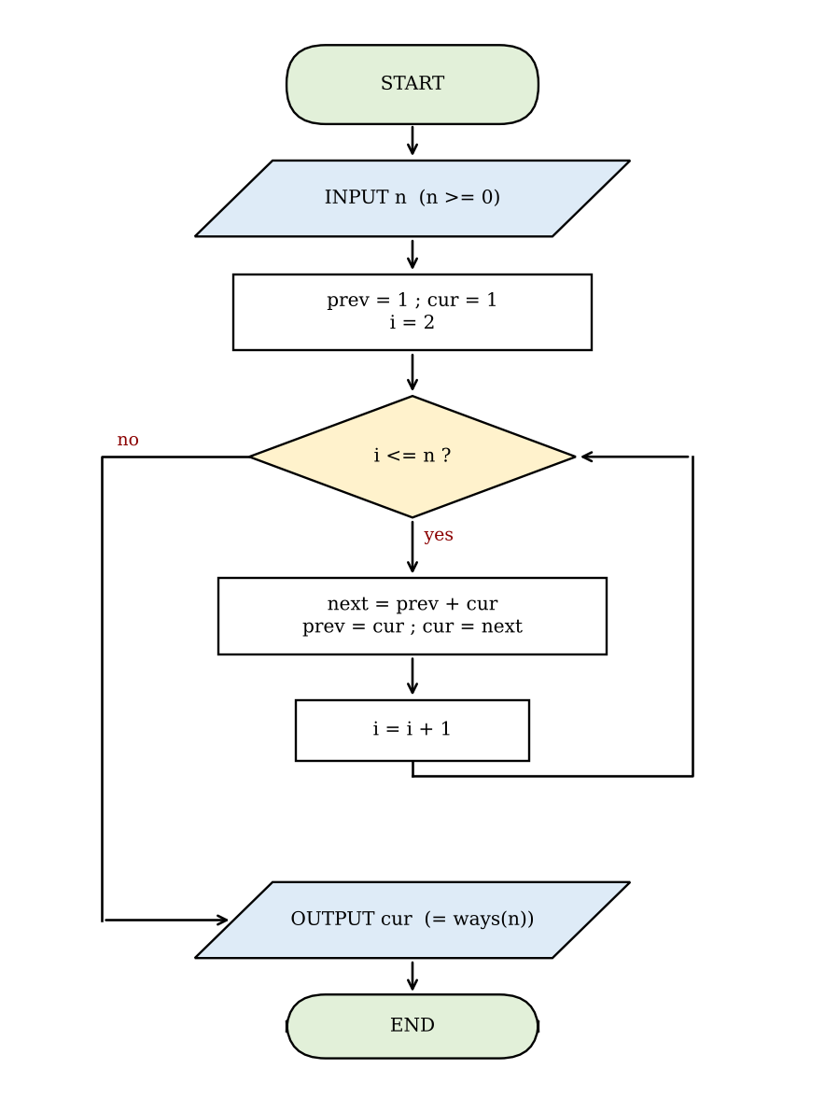
Figure 7.1: Flowchart of the redesigned solution

D. Prediction before implementing (1 mark)
I predicted (written in the program before it was run): (1) at n = 30 the operation ratio would be 2,692,537 / 29 = 92,846; (2) the time ratio at n = 30 would lie between 10^4 and 10^5, lower than the operation ratio because a function call costs more than a loop addition; (3) the redesign would need n - 1 additions and would work at n = 1,000 without changing the limit.
Program: q7_redesign.py (original and redesign)
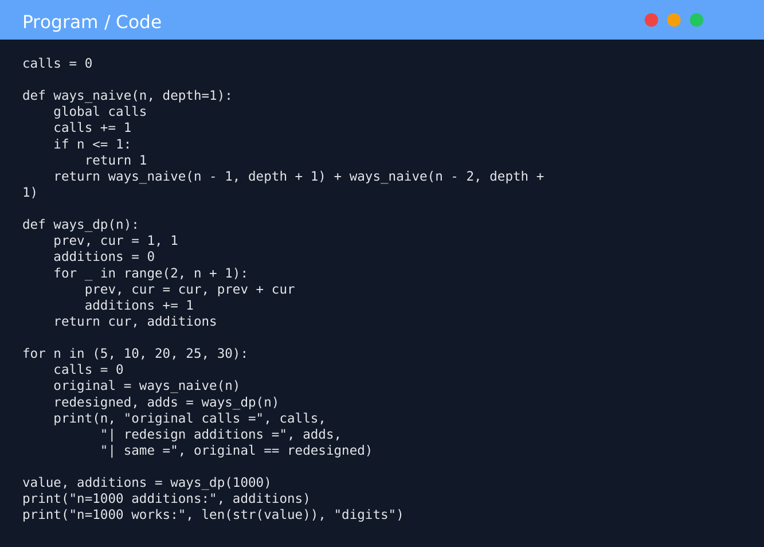

E. Implementation and validation (2 marks)
Output
=== A. Diagnosis: where is the work done, and is it repeated? ===
n calls distinct n values calls per distinct value max depth
5 15 6 2.5 5
10 177 11 16.1 10
20 21891 21 1042.4 20
25 242785 26 9337.9 25
30 2692537 31 86856.0 30

=== E. Validation: same inputs, counts and times ===
n original calls redesign adds op ratio original s redesign s time ratio same answer
10 177 9 20 0.000032 0.00000040 80 True
20 21891 19 1152 0.003812 0.00000067 5706 True
25 242785 24 10116 0.042661 0.00000081 52799 True
30 2692537 29 92846 0.495417 0.00000092 539670 True

Prediction check (n=30): operation ratio predicted 92846, observed 92846
Prediction check (n=30): time ratio predicted between 1e+04 and 1e+05, observed 539670 -> OUTSIDE the range
Objective 1 (<= n additions at n=30): 29 additions -> met
Objective 2 (< 0.1 ms at n=30): 0.0009 ms -> met

redesign == original for n = 0..25 : True
memoised recursion at n=1000 with default limit: RecursionError
redesign at n=1000: 999 additions, no RecursionError, equals memoised value: True
redesign == memoised recursion for n = 0..1000: True

=== Trade-off: answering all 1000 staircases (n = 1..1000) ===
approach additions time (ms) extra memory
redesign, one call per staircase 499500 21.78 O(1)
redesign table (one pass, reuse) 999 0.07 O(n) list
memoised recursion (shared cache) 999 0.23 O(n) cache + O(n) stack

raw counts and timings saved to q7_raw_counts.csv

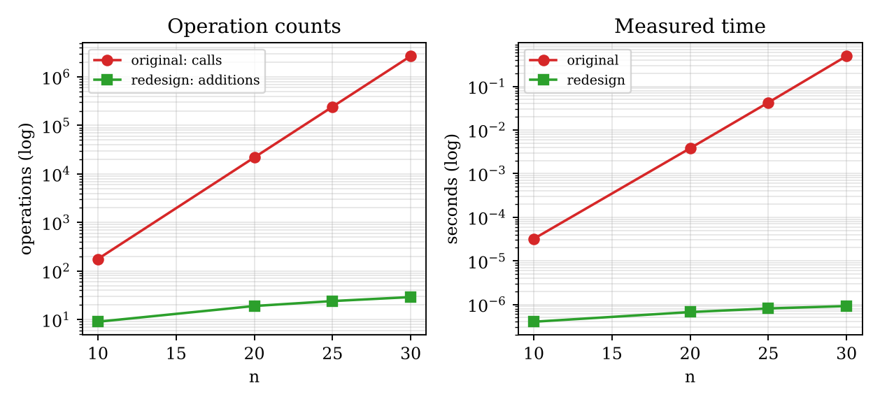
Figure 7.2: Original against redesign: operation counts and measured times
The raw counts and timings are saved in q7_raw_counts.csv. The redesign matched the original for n = 0 to 25 and the memoised version for n = 0 to 1,000. Prediction check: the operation ratio was exactly 92,846, as predicted. The time ratio at n = 30 was 539,670, outside my predicted range of 10^4 to 10^5. The cause is that I underestimated the cost of a function call: the instrumented original took about 184 nanoseconds per call (0.4954 s for 2,692,537 calls) while a loop iteration took about 32 nanoseconds (0.92 microseconds for 29 iterations), roughly 5.8 times more per operation. The original here also carries counters, which makes it slower than the plain Q6 version (0.22 s at n = 30 in Q6, giving a ratio of about 240,000), but even that is above my predicted range.

F. Defend the final design (2 marks)
- Objective achieved: all five targets were met: 29 additions (at most 30), 0.0009 ms (under 0.1 ms), n = 1,000 solved with 999 additions and no RecursionError, identical answers, O(1) memory.
- Size of the improvement: 92,846 times fewer operations and more than 5 x 10^5 times faster at n = 30. At n = 1,000 the original is impossible (about 1.4 x 10^209 calls) and the loop is 8.5 times faster than the memoised recursion (34.6 against 295.7 microseconds).
- New costs: less direct code; no reuse between queries. For the trust's real task, printing the answer for every staircase from 1 to 1,000, calling the loop once per staircase needs 499,500 additions (21.78 ms). A single pass that stores all values needs 999 additions (0.07 ms, O(n) memory) and was about three times faster than memoised recursion (0.23 ms, which also needs the raised recursion limit). So the best deployed design for that task is the table version of the redesign.
- Where the original is still preferable: for very small n (n = 10 needs only 177 calls, about 30 microseconds) plain recursion is perfectly adequate and mirrors the mathematical definition; I also kept it as the reference ("oracle") to verify the redesign for n up to 25. Top-down memoisation would be preferable only if a recurrence needed a sparse subset of sub-problems, which is not the case here.
Conclusion: the redesign met its objective and is recommended, with the original retained as a test oracle. My one wrong prediction (the time ratio) was explained by the higher cost of function calls.

Mark Distribution and Submission Checklist
Question | Assessed area | Bloom level | Marks
Q1 | if, if-else and if-elif-else | K4 Analyse | 6
Q2 | while, for, break, continue, pass and loop-else | K3 Apply | 4
Q3 | String operations and slicing | K4 Analyse | 6
Q4 | String building and immutability | K4 Analyse | 6
Q5 | Functions, parameters and scope | K4 Analyse | 7
Q6 | Recursion and memoisation | K5 Evaluate | 8
Q7 | Day-4 design challenge | K5 Evaluate | 13
Total |  |  | 50

Run commands (for the README.md)
Commands (Python 3.12, standard library only)
python Q1/q1_subsidy.py
python Q2/q2_otp.py
python Q3/q3_vehicle.py
python Q4/q4_build.py ; python Q4/q4_benchmark.py
python Q5/q5_canteen.py
python Q6/q6_steps.py
python Q7/q7_redesign.py

- Create the repository CSA08-1913260096-Assignment2, one folder per task, with the source file, the saved output and a screenshot of your own run.
- Commit each task separately (at least one commit per task); add README.md with your name, register number, Python version, run commands and a one-line result per task.
- Re-run the programs on your own computer and replace the timing values with yours; counts of calls and operations will be identical.

