Decision Tree – Bank Marketing Subscription Prediction

1. Introduction
The objective of this project is to predict whether a bank customer will subscribe to a term deposit using a Decision Tree classifier. The UC Bank Marketing dataset is used to analyze customer behavior and build an interpretable machine learning model.

2. Dataset Description
The dataset contains customer information such as:
- Age, job, marital status, education
- Contact type, duration of last call
- Campaign-related variables
- Target variable: y (yes/no – subscription status)

3. Data Preprocessing
The following steps were performed:
- Checked for missing values and replaced "unknown" with null values.
- Removed duplicate records.
- Encoded categorical variables using Label Encoding.
- Split the dataset into training (80%) and testing (20%) sets.
- 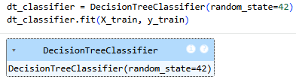

4. Model Building
A Decision Tree Classifier was trained:
- One model without depth restriction (unpruned).
- One model with max_depth = 4 to reduce overfitting.

5. Model Evaluation

Performance Metrics:
- Accuracy score
- Confusion matrix
- Classification report (precision, recall, F1-score)
The pruned model showed better generalization and reduced overfitting compared to the unpruned model.

6. Decision Tree Visualization
The trained decision tree was visualized using plot_tree(). The tree shows how customer features like call duration and previous campaign outcomes influence subscription decisions.
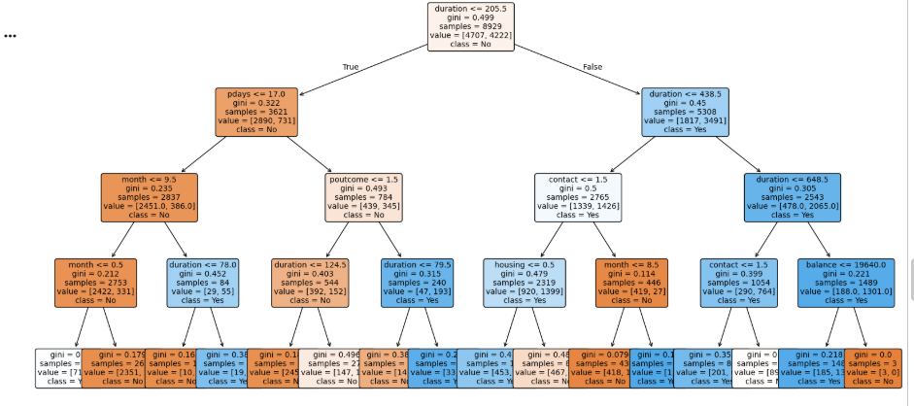

7. Feature Importance
The most important features influencing prediction were:
- Duration of last contact
- Number of contacts performed
- Outcome of previous marketing campaigns
- Customer age
- 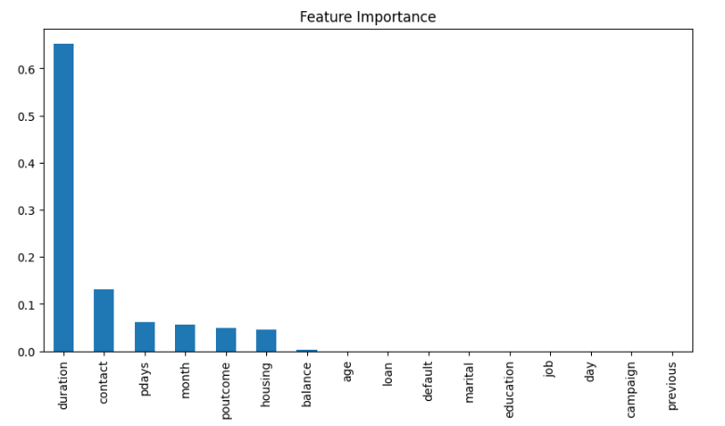

8. Interpretation of Rules
Sample decision rules extracted from the tree:
- If duration > X and previous outcome = success → Subscription = Yes
- If duration ≤ Y and campaign > Z → Subscription = No
These rules help the bank understand customer behavior and optimize marketing strategies.

9. Overfitting Analysis
The unpruned model had higher training accuracy but lower test accuracy, indicating overfitting. Pruning improved the model’s ability to generalize to unseen data.

10. Conclusion
The Decision Tree model effectively predicts customer subscription behavior and provides clear decision rules that can support business decision-making in marketing campaigns.

