AI & ML Internship – Task 6

Linear Regression: House Price Prediction

1. Introduction
The objective of this task is to implement a Linear Regression model to predict house prices using the California Housing dataset. Linear Regression is a supervised machine learning algorithm used to model the relationship between dependent and independent variables. This task helps in understanding data preprocessing, model training, prediction, and evaluation using Python-based tools.

2. Tools and Technologies Used
The following tools and libraries were used to complete this task:
- Python – Programming language
- Pandas – Data manipulation and analysis
- NumPy – Numerical computations
- Scikit-learn – Dataset loading, model training, and evaluation
- Matplotlib – Data visualization

3. Dataset Description
The California Housing Dataset was used for this project.
It contains information collected from the 1990 California census.

Key Features:
- MedInc – Median income in block group
- HouseAge – Median house age
- AveRooms – Average number of rooms
- AveBedrms – Average number of bedrooms
- Population – Block group population
- AveOccup – Average house occupancy
- Latitude – Location latitude
- Longitude – Location longitude

Target Variable:
- House Price – Median house value (continuous numeric variable)

4. Data Loading and Exploration
The dataset was loaded using the fetch_california_housing() function from Scikit-learn and converted into a Pandas DataFrame. Initial exploration was performed using head(), info(), and describe() functions to understand the structure, data types, and statistical distribution of the dataset.
No missing values were found, and all features were numerical, making the dataset suitable for Linear Regression.

5. Data Preprocessing
The dataset was divided into:
- Independent variables (X) – All input features
- Dependent variable (y) – House price
The dataset was then split into training and testing sets using an 80:20 ratio with a fixed random state to ensure reproducibility.

6. Model Training
A Linear Regression model was created using Scikit-learn.
The model was trained using the training dataset to learn the relationship between housing features and house prices.

7. Prediction
After training, the model was used to predict house prices on the test dataset. A comparison table of actual and predicted house prices was created to observe the prediction accuracy.
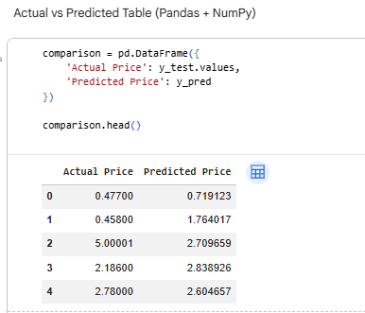

8. Model Evaluation
The model performance was evaluated using the following metrics:
- Mean Absolute Error (MAE): Measures the average absolute difference between actual and predicted values.
- Root Mean Squared Error (RMSE): Measures the square root of the average squared differences between actual and predicted values.
Lower values of MAE and RMSE indicate better prediction performance.

9. Visualization
A scatter plot of Actual vs Predicted House Prices was plotted using Matplotlib.
The plot shows a positive correlation between actual and predicted values, indicating that the model performs reasonably well.
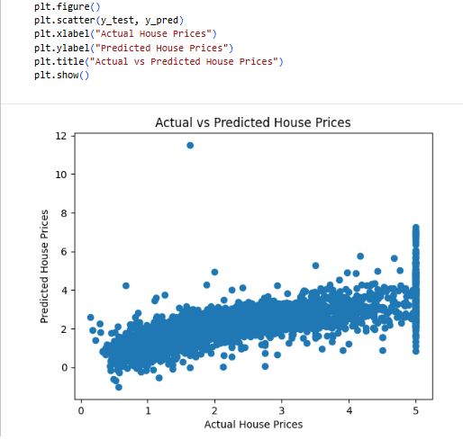

10. Interpretation of Results
The coefficients of the Linear Regression model were analyzed to understand feature importance. Features such as Median Income showed a strong positive influence on house prices, while some geographical features had varying impacts. This analysis helps identify which factors most significantly affect housing prices.

11. Conclusion
In this task, a Linear Regression model was successfully implemented to predict house prices using the California Housing dataset. The model was trained, evaluated, and visualized using Python libraries. The results demonstrate that Linear Regression can effectively model relationships in structured numerical data.

12. Learning Outcome
- Understanding of Linear Regression algorithm
- Hands-on experience with Scikit-learn
- Data preprocessing and evaluation techniques
- Model interpretation and visualization

