📄 TASK 3: EXPLORATORY DATA ANALYSIS (EDA)
Dataset: Netflix Movies and TV Shows
Tool Used: Python (Google Colab)
Libraries: Pandas, Matplotlib
1. Objective
The objective of this task is to perform Exploratory Data Analysis (EDA) on the Netflix Movies and TV Shows dataset. EDA helps in understanding the structure of data, identifying patterns, trends, outliers, and important features using visualizations before applying any machine learning models.

2. Dataset Description
The Netflix Movies and TV Shows dataset contains information about content available on Netflix, including movies and TV shows.
The dataset includes attributes such as:
- Type (Movie or TV Show)
- Title
- Country
- Release Year
- Rating
- Duration
The dataset consists of 8807 records and 12 features.

3. Tools and Technologies Used
- Programming Language: Python
- Platform: Google Colab
- Libraries:
  - Pandas (for data handling)
  - Matplotlib (for data visualization)
Only one tool (Python) was used as per task guidelines.

4. Data Loading and Understanding
The dataset was loaded into Google Colab using Pandas.
Basic functions like .head(), .info(), and .describe() were used to understand:
- Data types
- Number of records
- Missing values
- Statistical summary of numerical columns
This step helped in gaining an initial understanding of the dataset.

5. Handling Missing Values
Some columns such as country and rating contained missing values.
These missing values were handled by replacing them with the value "Unknown" to maintain data consistency and avoid loss of records during analysis.
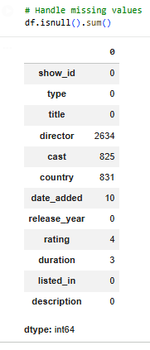

6. Exploratory Data Analysis (EDA)
6.1 Categorical Data Analysis
A bar chart was created to analyze the distribution of Movies vs TV Shows on Netflix.
Insight:
- Movies are more common than TV Shows on Netflix, indicating a higher focus on movie content.

6.2 Numerical Feature Distribution
A histogram was plotted for Release Year to analyze content distribution over time.
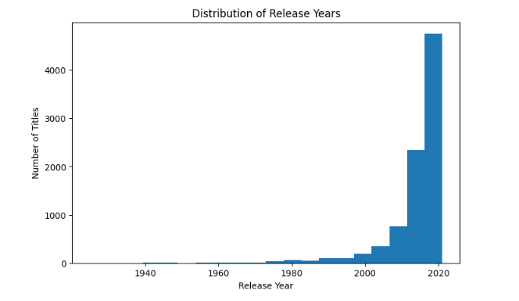
Insight:
- Most Netflix content was released after 2010, showing rapid growth in recent years.

6.3 Rating Analysis
A bar chart was used to visualize the distribution of content ratings.
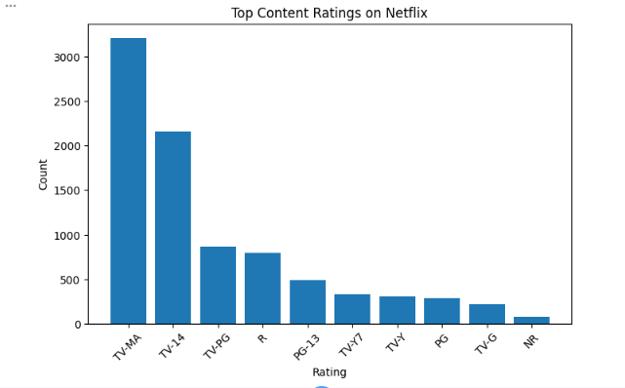
Insight:
- TV-MA and TV-14 are the most frequent content ratings, indicating a large amount of mature content.

6.4 Outlier Detection
A box plot was created for the Release Year feature.
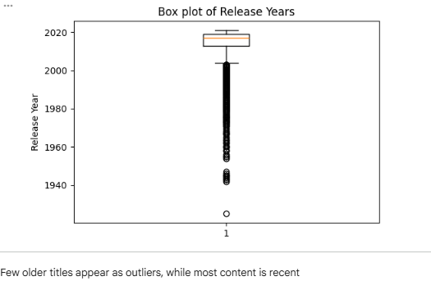
Insight:
- Few older titles appear as outliers, while most content belongs to recent years.

6.5 Country-wise Analysis
A horizontal bar chart was used to analyze the top content-producing countries.
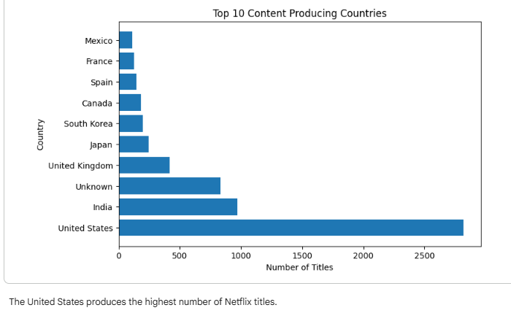
Insight:
- The United States produces the highest number of Netflix titles, followed by other countries.

7. Correlation and Feature Understanding
Although the dataset contains mostly categorical data, numerical analysis helped understand trends and variations.
EDA helped identify how features like type, release year, rating, and country influence Netflix content distribution.

8. Important Features Identified
The most important features identified during EDA are:
- Type (Movie / TV Show)
- Release Year
- Rating
- Country
These features play a major role in understanding content trends and viewer preferences.

9. Summary and Conclusion
- Netflix has more movies than TV shows.
- Content production increased significantly after 2010.
- Mature-rated content dominates the platform.
- The United States is the leading content producer.
- Exploratory Data Analysis helped uncover patterns, trends, and outliers effectively.
EDA is a crucial step before applying machine learning models, as it improves data understanding and decision-making.

10. Final Outcome
Through this task, an understanding of data patterns, feature behavior, and visualization techniques was achieved.
The analysis provided meaningful insights into Netflix content distribution and trends.

