IU2541230047 - CPP28 - PROJECT REPORT
Supermarket Billing System
Enrollment No.: IU2541230047
Student Name: PRAGI PATEL
Semester: 3
Subject: C++ Guided Project
GitHub Repository: Add the public repository URL before submitting.

1. Introduction
Supermarkets need fast and accurate billing while keeping product details and stock available across program sessions. The Supermarket Billing System is a console-based C++ application that stores products, supports product management and completes customer checkout in one menu-driven program.
The project applies object-oriented programming through Product, Customer, Cart, Bill, Payment, FileManager and SupermarketSystem classes. Product records are held in a dynamic array and saved to a text file, allowing records to remain available after the program is closed.

2. Problem Statement
A supermarket needs a simple way to maintain product information, check available stock and calculate a customer bill without manual arithmetic. Manual methods can lead to wrong totals, unavailable items being sold and lost records. This project provides a menu-driven C++ solution that validates input, manages products, creates a cart, calculates discounts, accepts payment and saves data permanently.

3. Objectives
Apply classes, encapsulation, inheritance and runtime polymorphism to a practical billing problem.
Manage product records with add, display, search, update and delete operations.
Implement the main transaction: add products to a cart, check stock, create a bill and process payment.
Use dynamic memory with new[] and delete[] for a product list that can grow.
Use file handling so products are available after restarting the application.
Validate input and report invalid price, stock, product ID or payment safely.

4. Functional Requirements
FR1 - Add Record: add a product with name, price and available stock.
FR2 - Display Records: list all products with ID, price and stock.
FR3 - Search Record: find a product by its ID.
FR4 - Update Record: change product name, price or stock.
FR5 - Delete Record: delete a product by ID.
FR6 - Main Transaction: add products and quantities to a cart, reject insufficient stock and calculate bill/discount.
FR7 - Report: display the current product list and billing result.
FR8 - Save / Load: load records at start-up and save at exit or by menu option.
FR9 - Validation: reject negative price or stock, unknown product ID and insufficient payment without crashing.

5. System / Project Flow
USER -> MAIN MENU (main.cpp) -> SUPERMARKET SYSTEM CLASS -> ENTITY CLASSES (Product, Customer, Cart, Bill, Payment) -> CHECKOUT -> FILE MANAGER -> DATA/products.txt
main.cpp creates a SupermarketSystem object and calls the menu loop. At start-up, FileManager loads old records. Each user option is handled by SupermarketSystem. At exit, products are saved back to the data file, following the required cycle: START -> Load -> Perform operations -> Save -> EXIT.

6. Class Descriptions
Class | Data Members | Member Functions | Responsibility
Product | productId, name, price, stock | Product(), display(), update(), reduceStock() | Stores one product and manages its available stock.
Customer | customerId, name, phone | Customer(), display() | Stores customer information for billing.
Cart | cartId, customerId, entries | Cart(), addItem(), calculateTotal() | Holds selected products and quantities.
Bill | billId, cartId, subtotal, discount, total | Bill(), printBill() | Calculates bill and discount.
Payment | paymentId, billId, amount, mode | Payment(), processPayment(), display() | Checks and displays payment.
FileManager | file paths / streams | save(), load() | Saves and loads product records.

7. OOP Concepts Used
Classes and Objects: Product, Customer, Cart, Bill, Payment, FileManager and SupermarketSystem model the application.
Encapsulation: product data members are private and accessed through public member functions.
Constructors and Destructors: default and parameterized constructors initialize each object; virtual destructors provide safe cleanup.
Inheritance and Runtime Polymorphism: Product, Customer and Payment inherit from the abstract Displayable class. SupermarketSystem::printEntity(const Displayable&) calls display() polymorphically, so the correct derived display function runs at runtime.
Dynamic Memory: SupermarketSystem allocates Product* products = new Product[capacity], grows it when full and releases it with delete[].
File Handling: FileManager uses ifstream and ofstream to load and save Data/products.txt.
Exception Handling: try/catch reports invalid prices, stock values and file errors cleanly.

8. File Handling and Data Persistence
Data is stored in Data/products.txt. Each record uses the format productId|name|price|stock. For example: 1|Rice 5kg|350.000000|20.
At start-up, FileManager::load() reads each line, separates the fields and creates Product objects. FileManager::save() writes the updated records when the user selects Save or exits. A missing data file is treated as an empty list on the first run.

9. UML Diagrams
Figure 1: Use Case Diagram - Supermarket Billing System
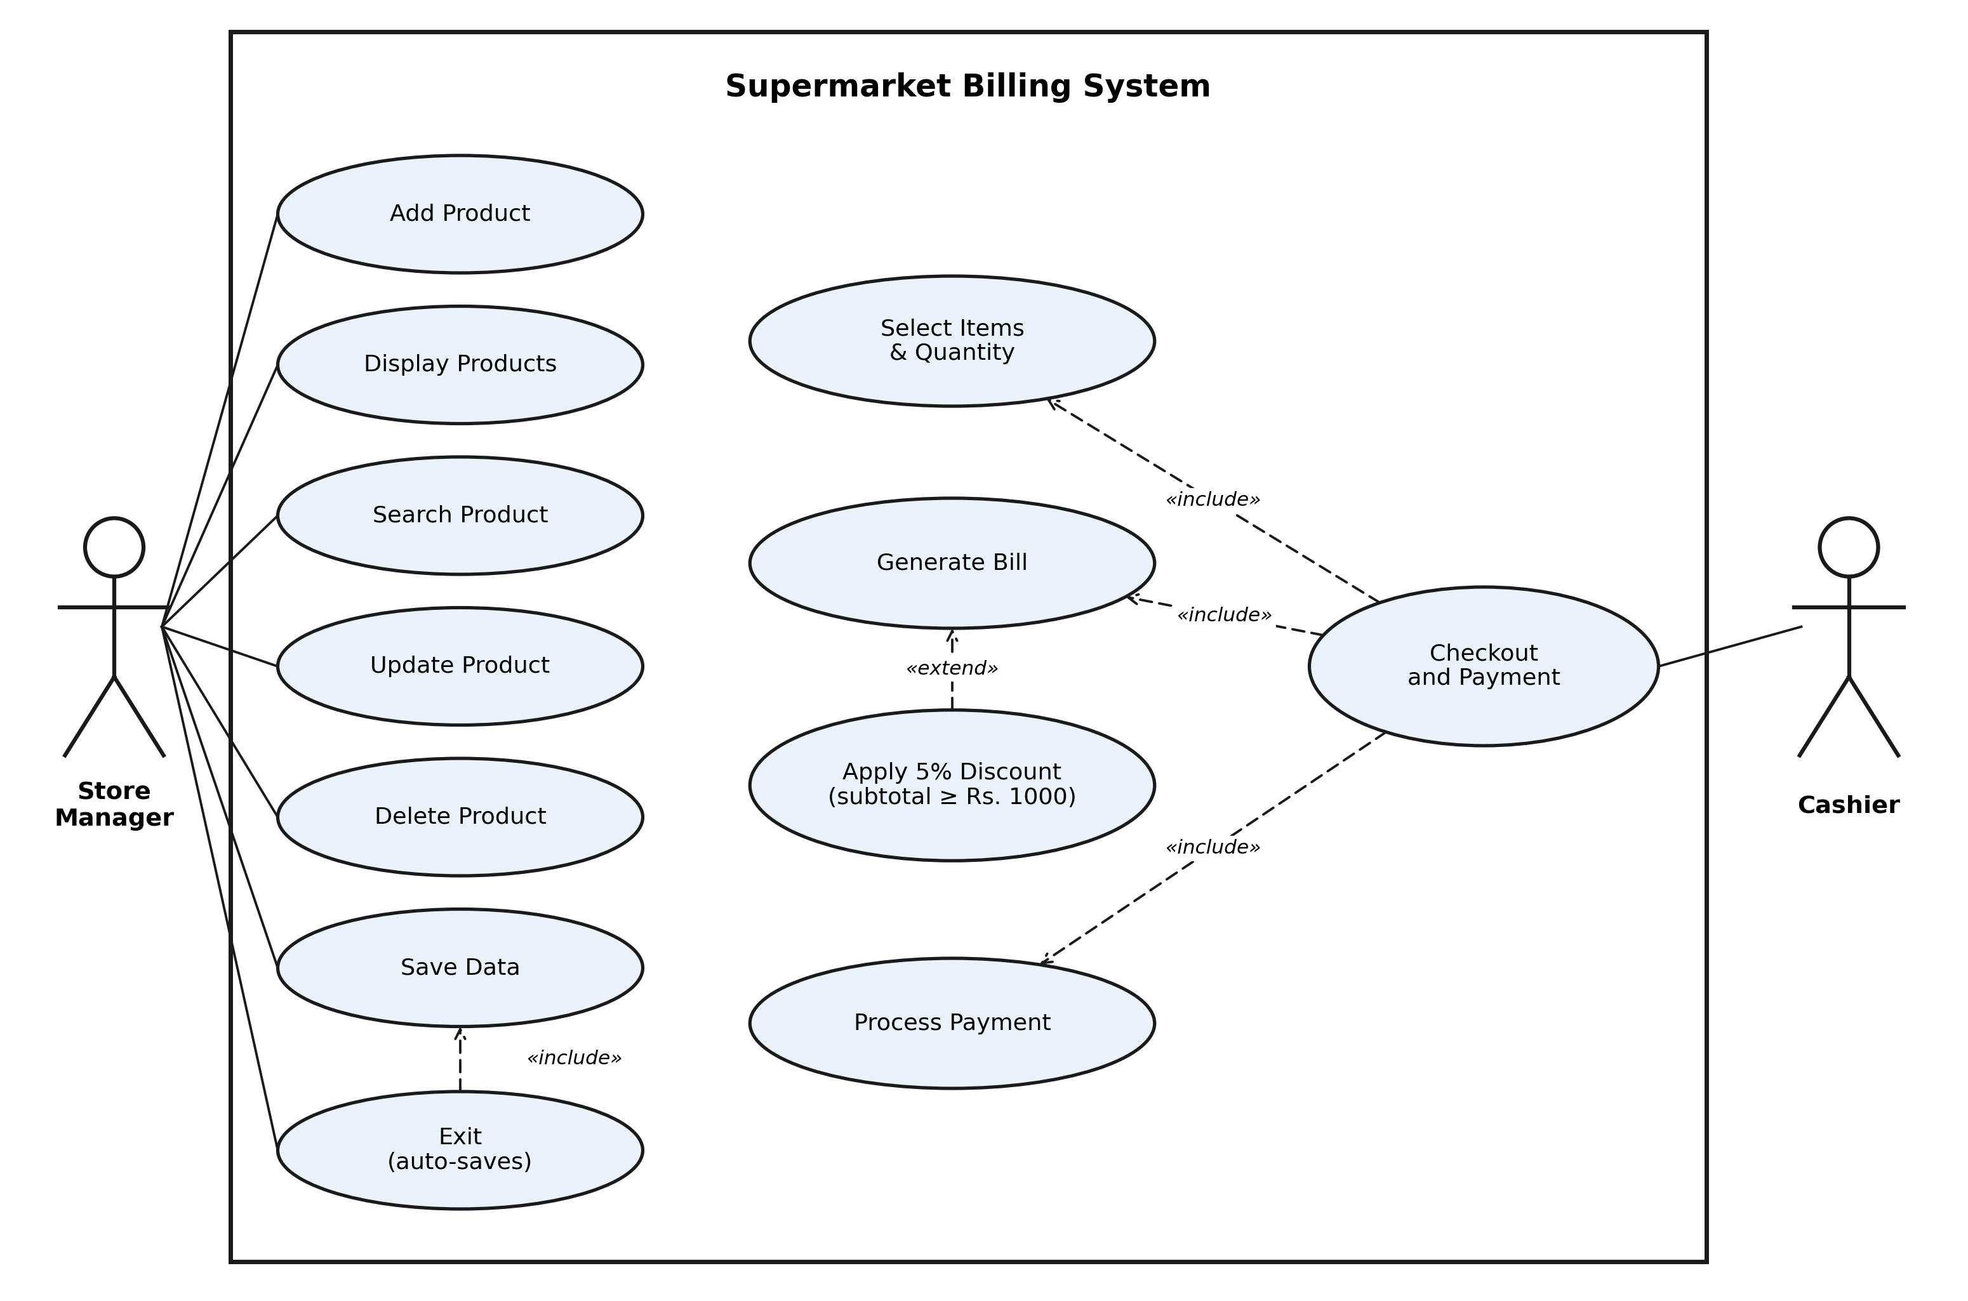
Figure 1: Use Case Diagram (2 actors, 12 use cases)

Figure 2: Class Diagram - Supermarket Billing System
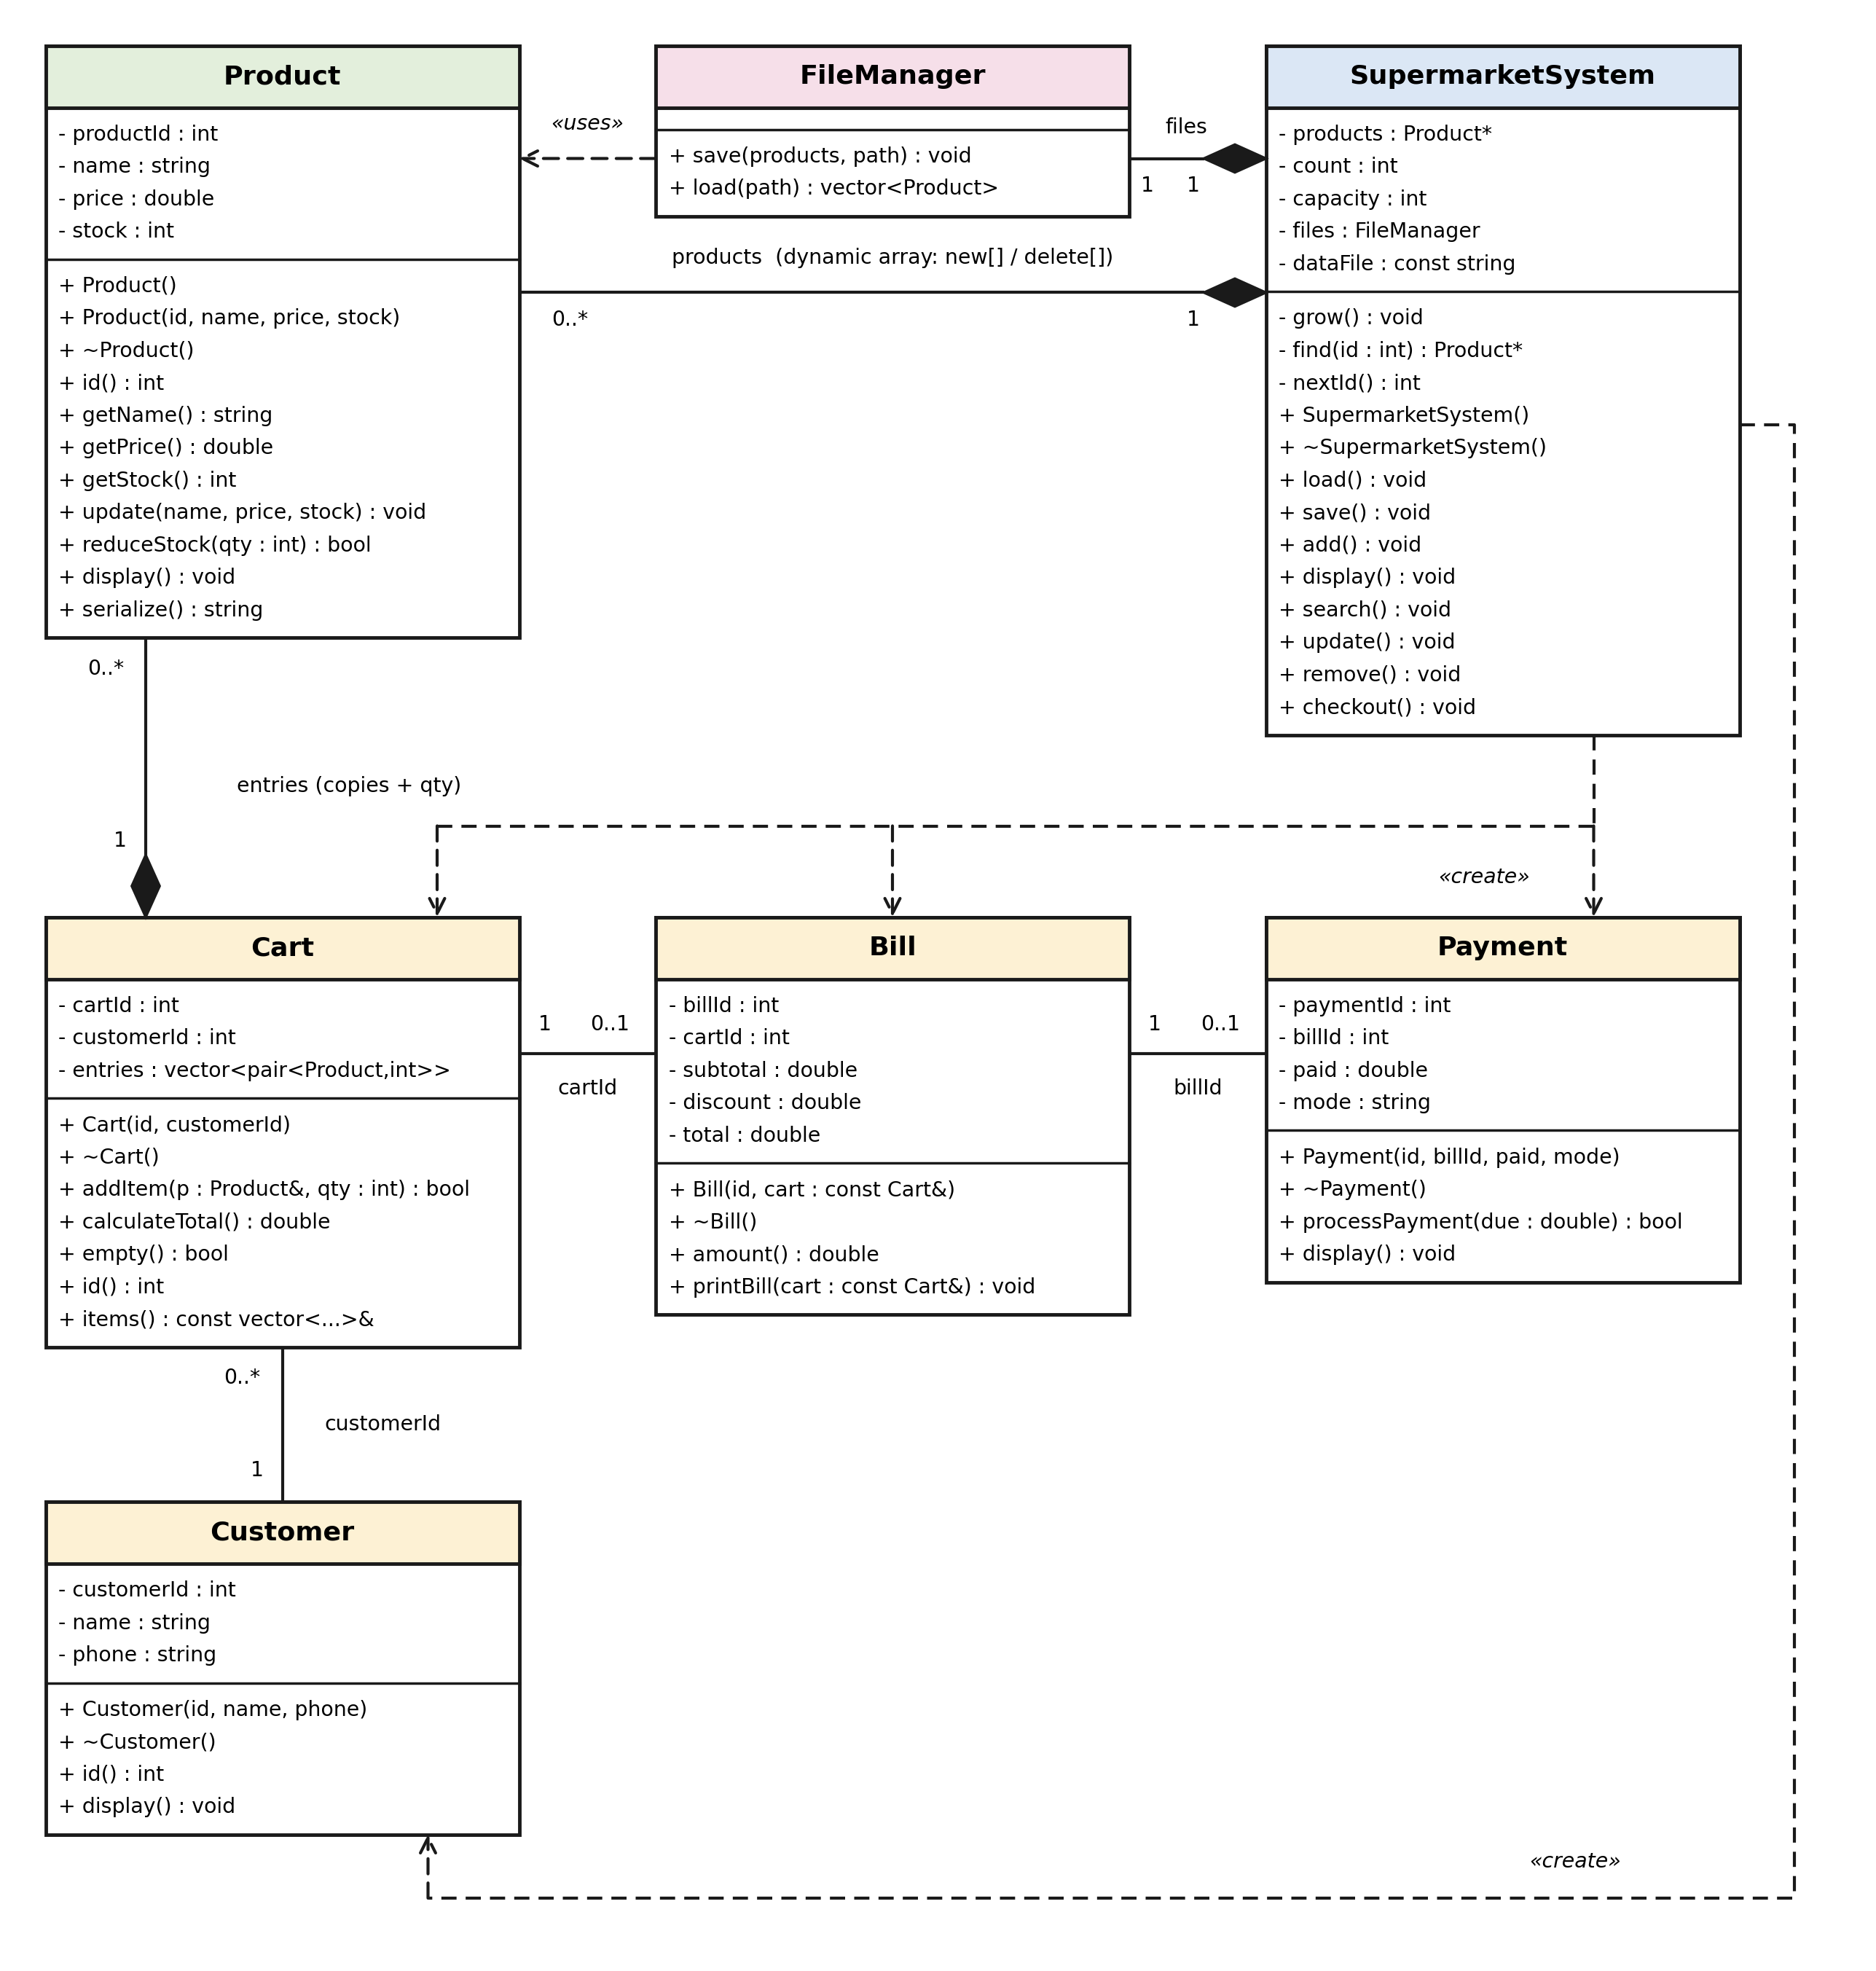
Figure 3: Sequence Diagram 1 - Checkout and Payment
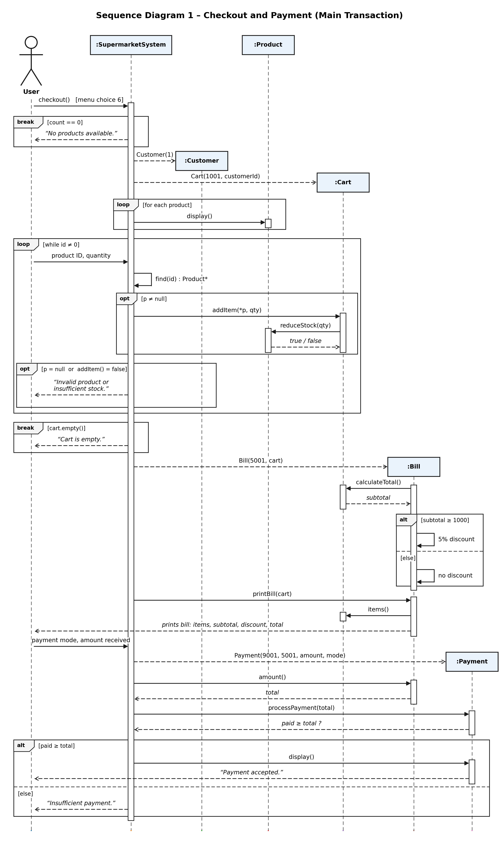
Figure 4: Sequence Diagram 2 - Search Product
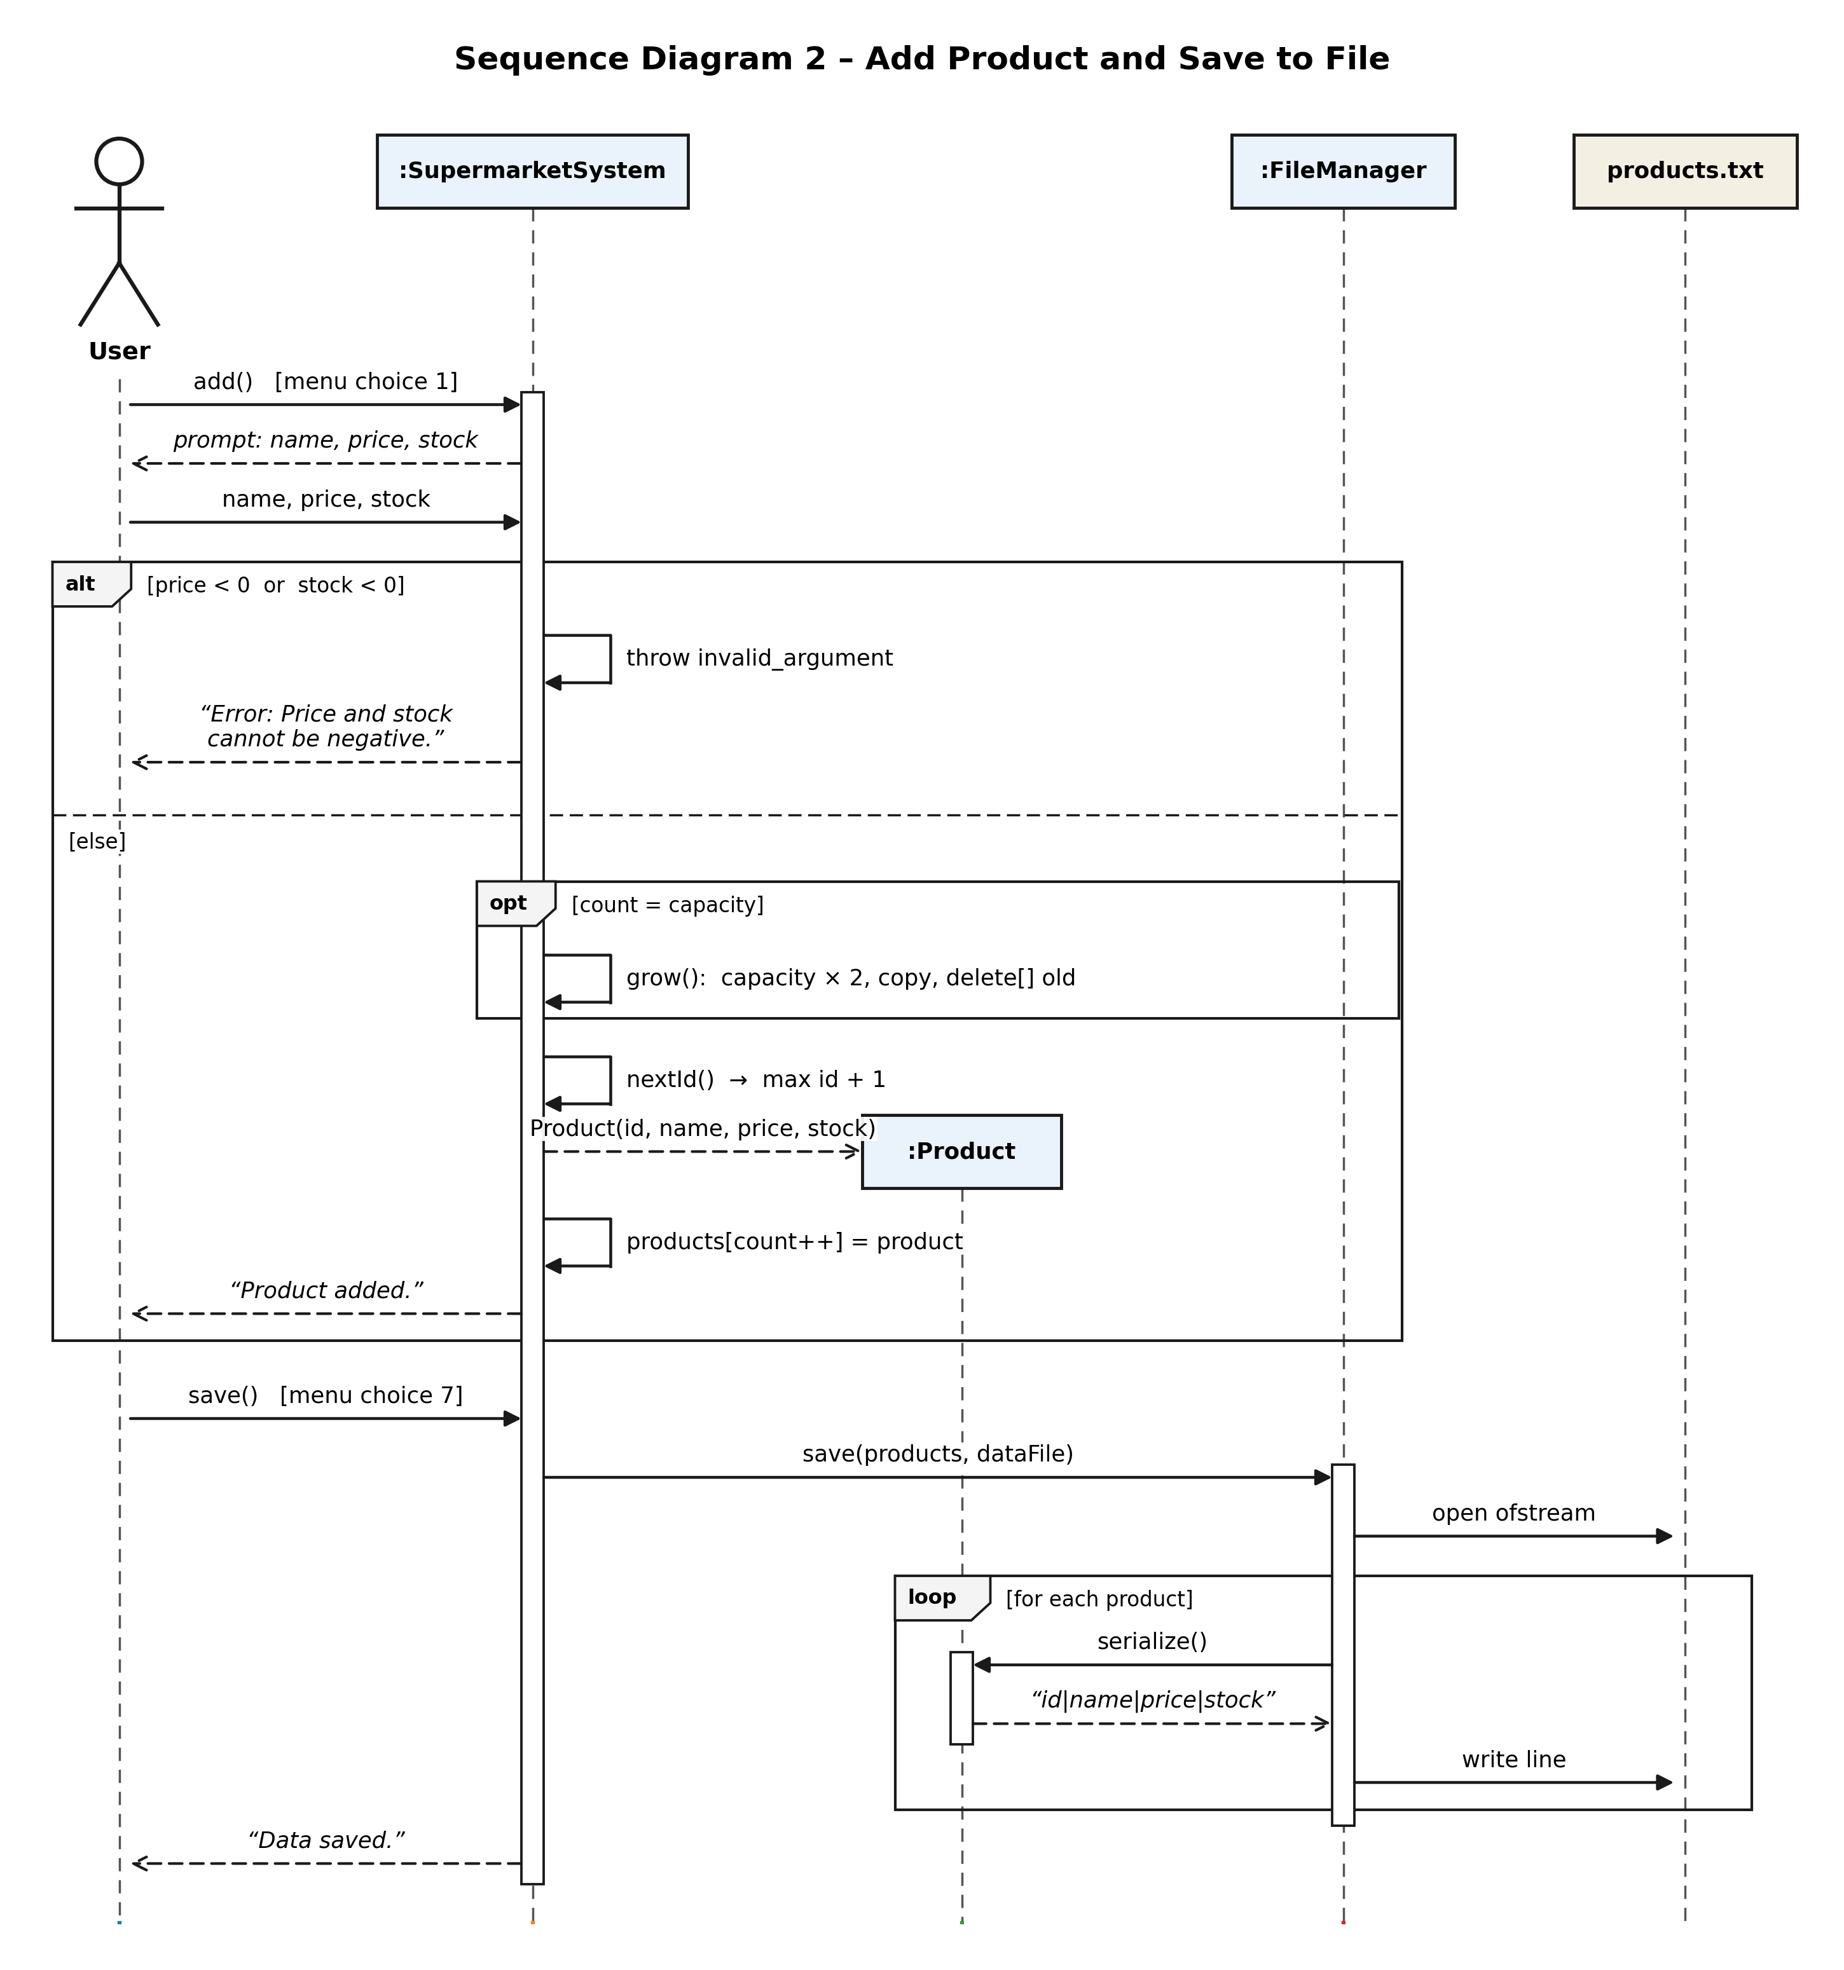

10. Implementation Details
main.cpp - creates SupermarketSystem and runs the menu.
Product - stores ID, name, price and stock; supports update and stock reduction.
Customer - stores walk-in customer details.
Cart - stores selected products and quantities; calculates subtotal.
Bill - calculates total and applies a 5% discount for bills of Rs. 1000 or more.
Payment - accepts cash or UPI payment when the amount is sufficient.
FileManager - reads and writes Data/products.txt.
SupermarketSystem - owns the dynamic product array and implements all menu operations.
Compilation: g++ -std=c++17 -Wall -Wextra main.cpp -o SupermarketBillingSystem.exe

11. Testing and Results
All 15 planned tests passed. The tests cover product CRUD operations, invalid inputs, stock validation, checkout totals, discount calculation, payment validation and data persistence after reopening the program.
Test ID | Input / Operation | Expected | Actual | Status
T01 | Add product | Expected output achieved | Matched expected output | Pass
T02 | Invalid price | Expected output achieved | Matched expected output | Pass
T03 | Display products | Expected output achieved | Matched expected output | Pass
T04 | Search existing product | Expected output achieved | Matched expected output | Pass
T05 | Search unknown product | Expected output achieved | Matched expected output | Pass
T06 | Update product | Expected output achieved | Matched expected output | Pass
T07 | Delete product | Expected output achieved | Matched expected output | Pass
T08 | Delete unknown product | Expected output achieved | Matched expected output | Pass
T09 | Checkout one product | Expected output achieved | Matched expected output | Pass
T10 | Checkout two products | Expected output achieved | Matched expected output | Pass
T11 | Stock reduction | Expected output achieved | Matched expected output | Pass
T12 | Discount threshold | Expected output achieved | Matched expected output | Pass
T13 | Successful payment | Expected output achieved | Matched expected output | Pass
T14 | Insufficient payment | Expected output achieved | Matched expected output | Pass
T15 | File persistence after restart | Expected output achieved | Matched expected output | Pass

12. Sample Screens / Output
Screen 1: Adding a product
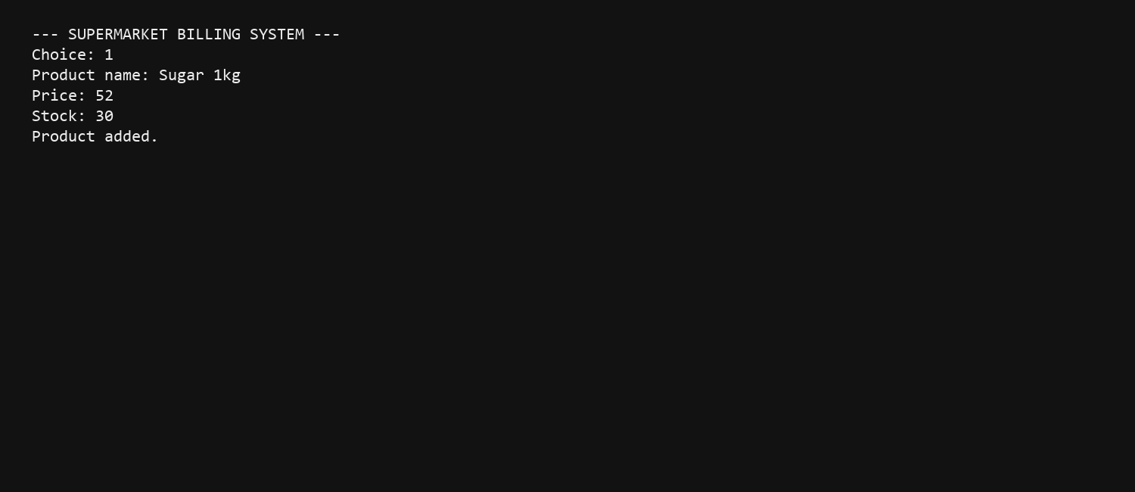
Screen 2: Invalid price rejected
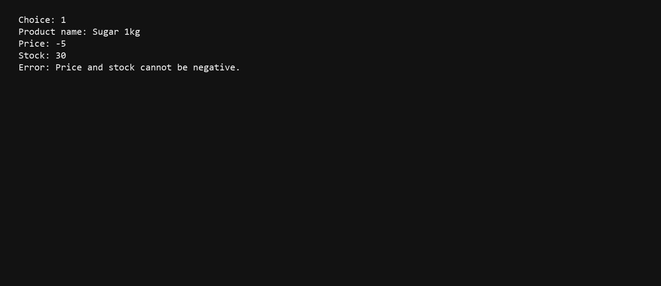
Screen 3: Displaying products
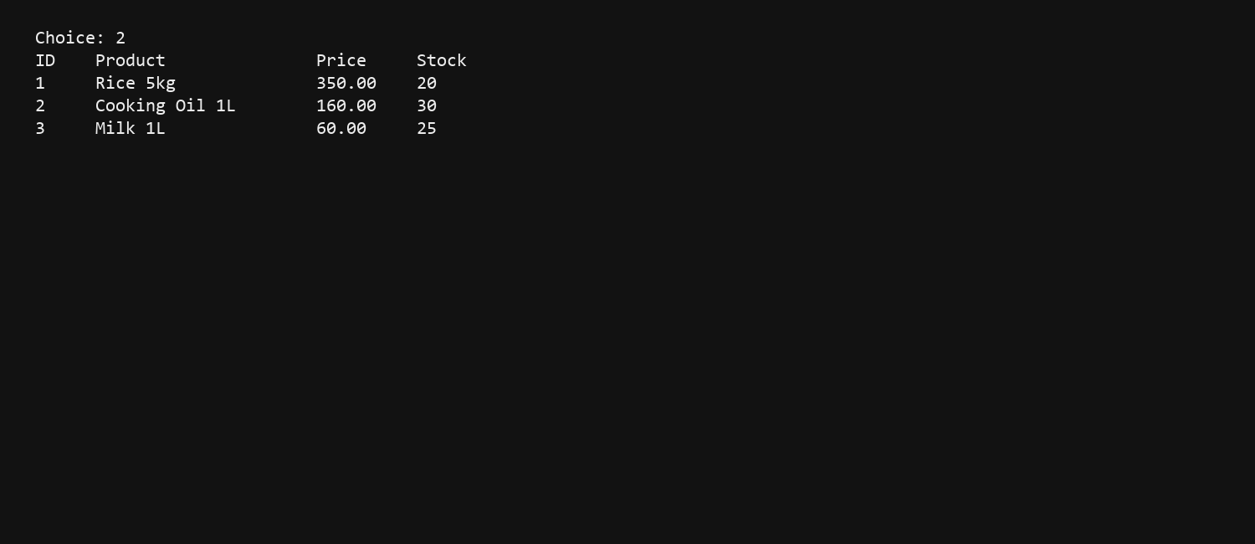
Screen 4: Searching for a product
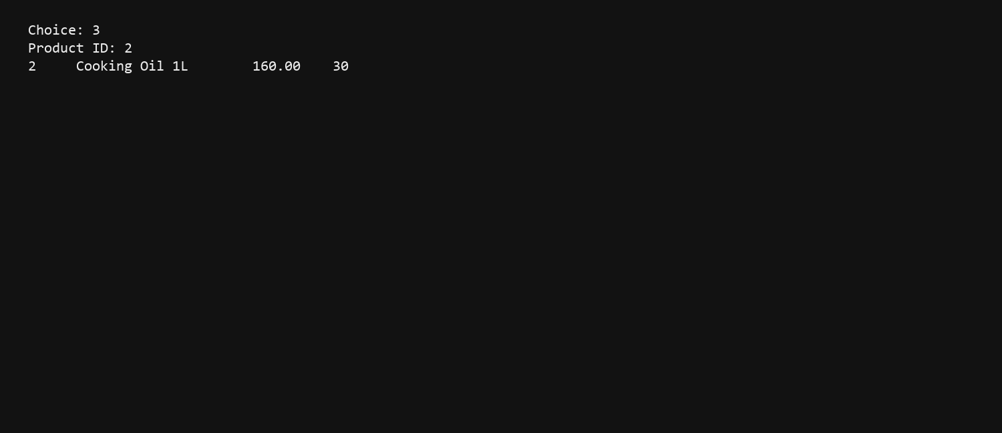
Screen 5: Main transaction - checkout and payment
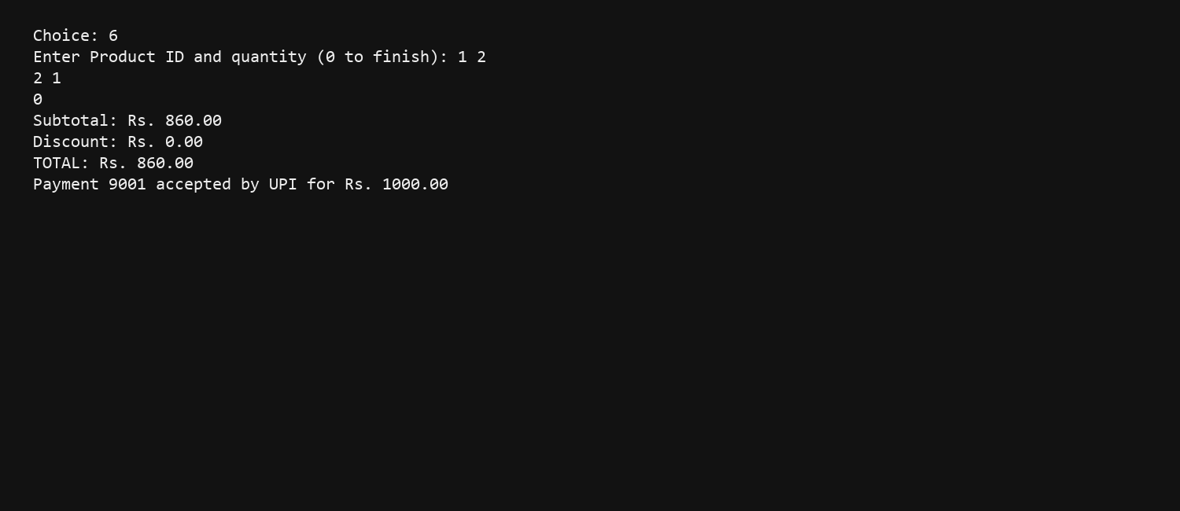
Screen 6: Insufficient stock rejected
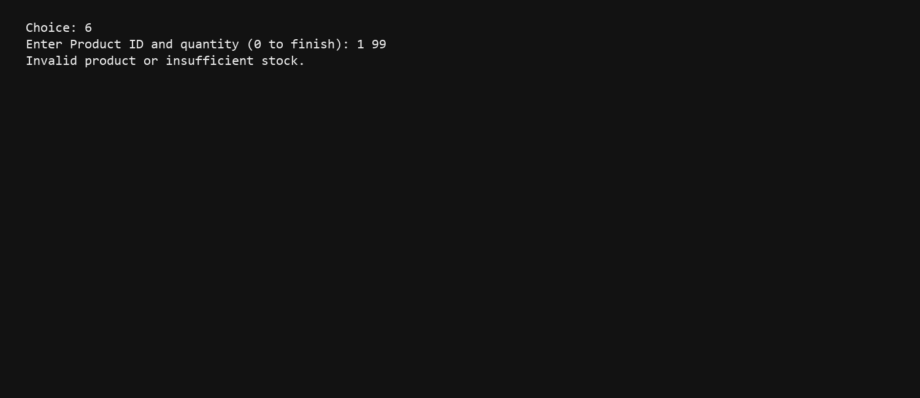
Screen 7: Discount applied
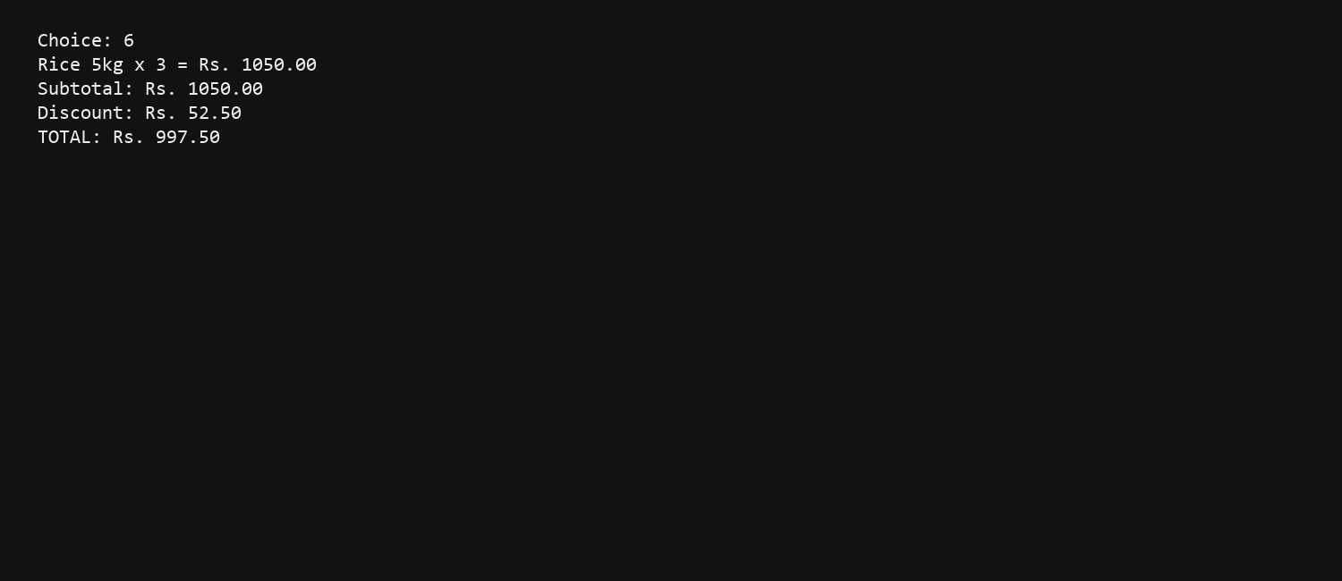
Screen 8: Program reopened - saved records loaded
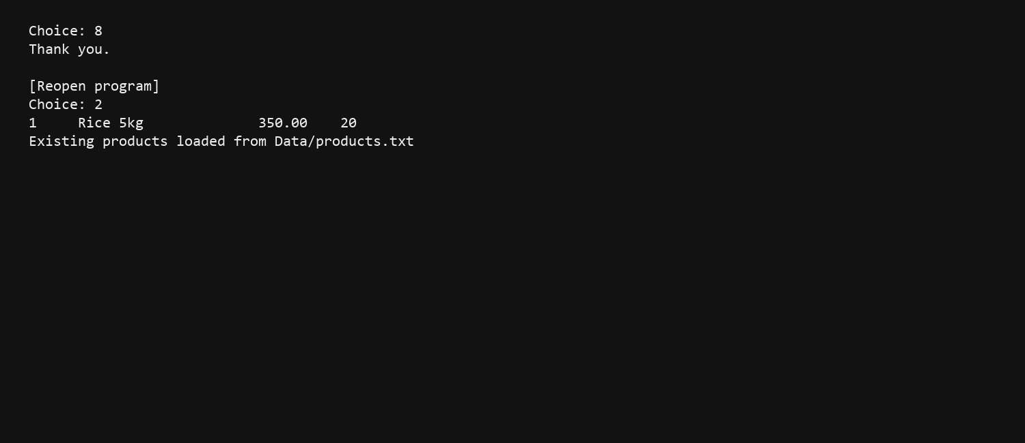

13. Limitations
Console interface only; no graphical interface.
Product records are stored in a plain text file, not a database.
The project uses one walk-in customer rather than a customer account system.
It does not maintain an invoice-history or supplier-management module.

14. Future Scope
Add barcode scanning and quantity editing in the cart.
Store customer details and create sales-history reports.
Add user login and cashier roles.
Use a database such as SQLite or MySQL.
Add GST settings, invoices and PDF receipt export.

15. Conclusion
The Supermarket Billing System fulfils the guided-project requirements. It demonstrates object-oriented design, dynamic memory, file persistence, validation and exception handling in a working C++ console application. All planned test cases pass, product data persists between runs and the program can be extended with further supermarket features.

