- Application names, descriptions
NCHC’s Ezilla – Cloud WebOS: As virtualization technologies become more prevalent, Cloud users usually encounter the problem of building and managing his/her own virtual cluster with a friendly user interface for virtual resource management. To help resolving this problem, Ezilla toolkit - Cloud Web-Based OS has been developed by the Pervasive Computing Team at the National Center for High-Performance Computing (NCHC). Through the Ezilla system, with a click, Cloud users can customize and configure the specified virtual cluster environment. It is an extremely lightweight approach, and work with a web browser, helping users to access virtual computing resources. The Cloud WebOS leverages virtualization techniques and cluster queuing system. The approach also work with SDSC and AIST to tackle the issue of interoperability between different Cloud IaaS providers. The POC was carried out by 3 PRAGME sites and demonstrated in PRAGMA meeting.
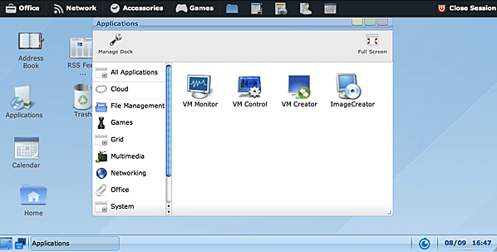
Figure 1. Cloud Widgets in Ezilla: Connecting users to NCHC’s Cloud Resources
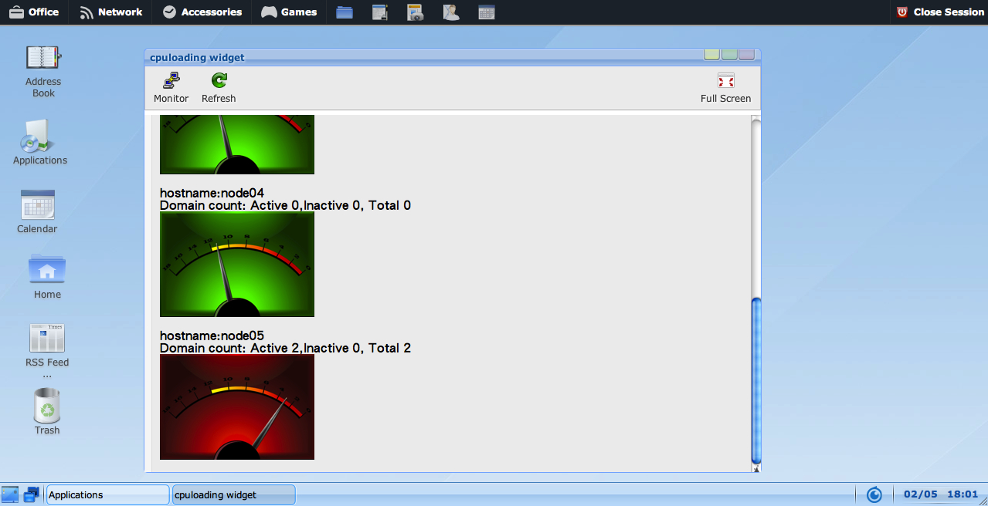
Figure 2. VM Monitor Widget
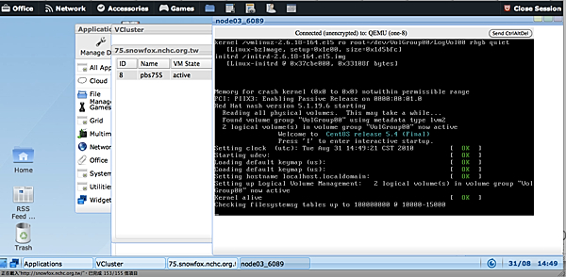
Figure 3. VM Control Widget Cloud Visualizer – Linux Booting Status
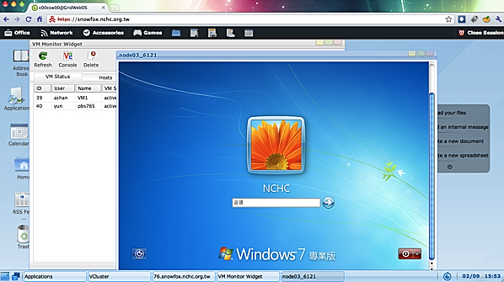
Figure 4. VM Control Widget Cloud Visualizer – Windows 7 Booting Status
- Codes, hardware used
- Results (technical or application)
- http://goc.pragma-grid.net/mediawiki-1.16.2/index.php/FMotif
- The F-motif, aka Motif Finder, Simulation Widget provides specialized Cloud services to search and analyze the sequence of gene in real time, in figure 5. The F-Motif is a novel unsupervised method for identification of phosphorylation motifs. F-Motif uses clustering of sequence information represented by numerical features that exploit the statistical information hidden in some foreground data. Furthermore, these identified motifs are then filtered to find “actual” motifs with statistically significant motif scores. An web-based F-Motif service is created for biologist and bio-informatics researchers under the collaboration umbrella with Y.M. University in Taiwan.

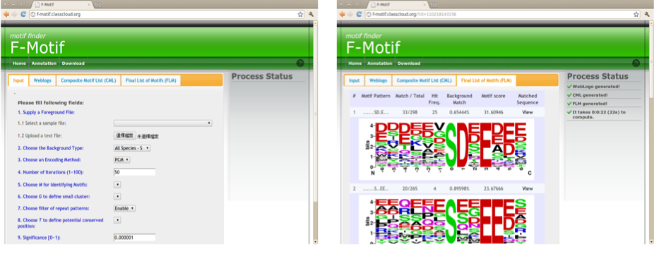
Figure 5. F-motif Widget
- Publications
- Hui-Shan Chen, Kuo-Yang Cheng, Zong-Shuo Jheng and Yi-Lun Pan, “Easy Virtual Cluster with Cloud Storage for HPC Numerical Simulation“, The 13th IEEE Conference on Commerce and Enterprise Computing (CEC), Luxembourg, 2011, 09,05-2011,09,07.
- Yi-Lun Pan, Chang-Hsing Wu, Hsi-En Yu, Hui-Shan Chen, and Weicheng Huang, “On-Demand Virtual Cluster in Cloud WebOS with Fault Tolerance Module“, International Conference on Grid Computing and Application, Las Vegas, USA, 2011, 07,18-2011,07,21.
- Yi-Lun Pan, Chang-Hsing Wu, and Hsi-En Yu, “PlasmasKits: Visual Interface for Plasma Solver Middleware：Grid WebOS“, Development of a General-Purpose Parallel Multi-physics Simulation Package for Low-Temperature Plasmas Workshop, Hsinchu, Taiwan, 2010, 05, 27-28.
- Yi-Lun Pan, Chia-Yen Liu, Chang-Hsing Wu, Hsi-En Yu, Kuo-Yang Cheng, and Weicheng Huang, “Automatic Workflow Management System in Grid Web-Based OS Environment with Advanced Scheduling Module”, International Conference on Grid Computing and Application, Las Vegas, USA, 2010, 07,12-2010,07,15.
- Yi-Lun Pan, Chang-Hsing Wu, Chia-Yen Liu, Hsi-En Yu, and Weicheng Huang, “The Lightweight Approach to Use Grid Services with Grid Widgets on Grid WebOS,”The 10th IEEE/ACM International Symposium on Cluster, Cloud and Grid Computing, Melbourne, Victoria, Australia, 2010, 5, 17-2010, 5, 20.
- Yi-Cheng Chen, Kripamoy Aguan, Chu-Wen Yang, Yao-Tsung Wang, Nikhil R. Pal, I-Fang Chung, “Discovery of Protein Phosphorylation Motifs through Exploratory Data Analysis,” http://www.plosone.org/article/info%3Adoi%2F10.1371%2Fjournal.pone.0020025

