[Note: For Major Activities section and Student Association Activities]

[Note: Major Activities section assumes previous section is Luca’s descriptions of PRAGMA Bootstrap text]

# Major Activities

## Higher Level Control architecture

To provide users with an easy-to-use interface for managing the lifecycle of virtual clusters from startup to status monitoring and shutdown, a higher-level control architecture activity was started during PY2. This activity led to the design of a Personal Cloud Controller (PCC) tool, a lightweight management tool that integrates various PRAGMA tools like PRAGMA Bootstrap with a well known resource management tool called HTCondor. The architecture is shown in Figure 1 where the user views available virtual cluster images and submits a request through the Web Interface. The request is then forwarded to HTCondor, which utilizes a PCC extension (PCC-HTCondor) to invoke PRAGMA Bootstrap to create the virtual cluster on one or more clusters and then sets up virtual networking (i.e., iPOP or ViNE) to connect the nodes together as a single cluster.

Figure : Architecture design of PCC.

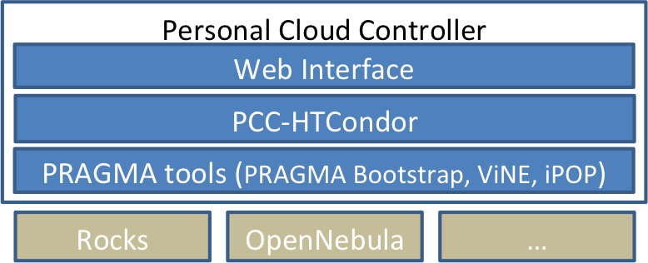

An initial prototype implementation of PCC was created by PhD student Yuan Luo (IU) and Shava Smallen (UCSD) and presented as a demo and poster during PRAGMA 26 in April 2014. Luo developed the PCC-HTCondor component that invoked PRAGMA Bootstrap to create a couple virtual clusters on a small Rocks cluster at UCSD and Smallen created the Web Interface frontend show in Figure 2. PCC- HTCondor started and controlled the virtual clusters from its Virtual Machine universe using extended resource specifications that were advertised and matched in HTCondor’s ClassAd mechanism.  A custom GAHP (Grid Ascii Helper Protocol) module then invoked PRAGMA bootstrap.

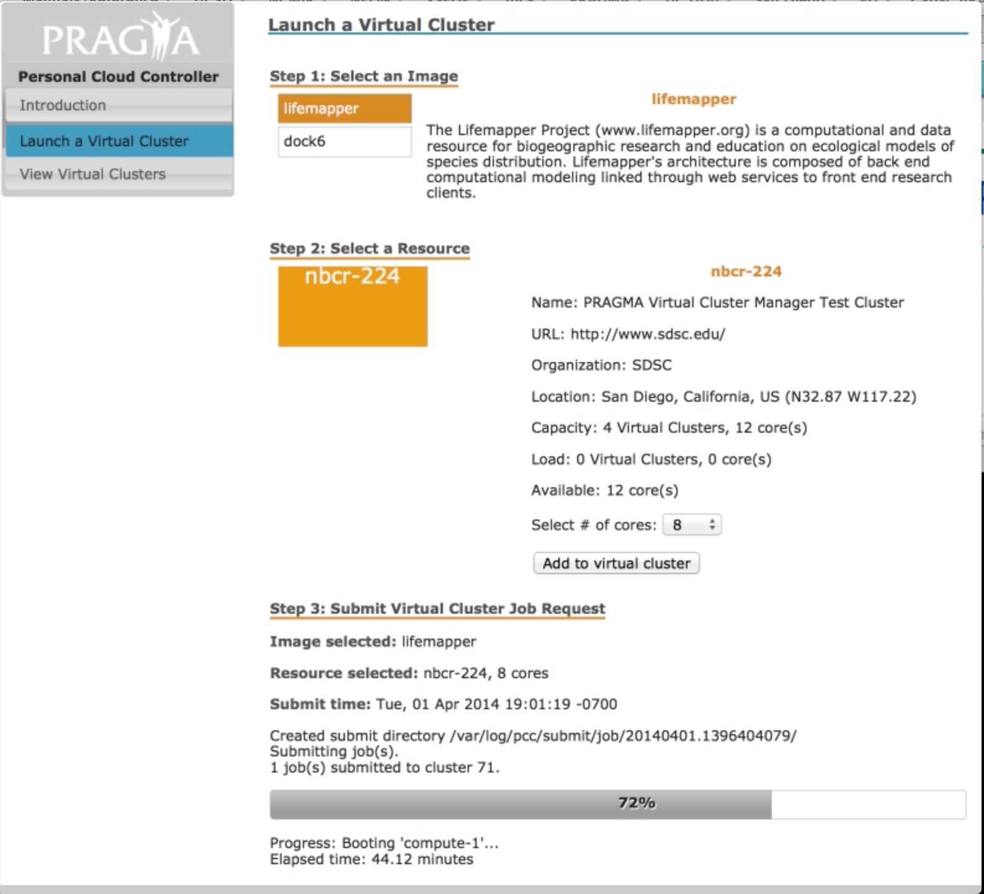

Figure : Frontend web interface of PCC showing the launch of a virtual cluster.

Since PRAGMA 26, Luo has been working to integrate iPOP with PCC-HTCondor so that multi-site virtual clusters can be created and managed by PCC. The goal is to demo this new capability at PRAGMA 27 in October 2014 utilizing a demo application possibly from LifeMapper. Luo is also working to complete his PhD work at IU based on his PRAGMA work and starting resource scheduling research that will enable science gateways like LifeMapper to make effective use of virtual clusters.

## Student Association Activities

IU PhD student, Yuan Luo, developed a prototype implementation of the Personal Cloud Controller (PCC) with technical guidance from Shava Smallen (UCSD). Luo presented a poster and demo during PRAGMA 26 in April 2014 and won best overall presentation for his presentation during the PRAGMA 26 student workshop. Luo is also working to complete his PhD work at IU based on his PRAGMA work.