Virtual Cluster Sharing
To enable sharing of software platforms and to allow running computational experiments across different sites, PRAGMA members have decided to define a common way to publish virtual clusters. This activity has led to the development of the Virtual Cluster Sharing technology and creation of a standard to author PRAGMA Virtual Clusters.

A PRAGMA Virtual Cluster is composed of virtual machine disk images and an XML file (vc-in.xml) describing how to connect the booted virtual machines in a computing cluster. This approach is different from other available cloud system because its smallest deployment unit is based on the concept of a cluster of machines connected together and not just on a single virtual machine. This self-contained description mechanism simplifies the creation of computational infrastructure and facilitates the creation of cluster appliance libraries. Libraries can contain different cluster images (application-centric or general) and can be hosted on various storage systems (from local shared file system to HTTP base web sites).

Virtual Cluster Image
Frontend
Image.gz
Compute
Image.gz
vc-in.xml

Before a virtual machine is booted, the hosting environment places a file vc-out.xml in its root file system. The file contains all the needed information to configure the individual machine’s network and to know what are the other hosts in the cluster.

PRAGMA members have developed several software tools in order to verify the design soundness and to use the Virtual Cluster Sharing for real simulations:
- PRAGMA Bootstrap: an extensible framework that can bootstrap PRAGMA Virtual Cluster on different cloud infrastructures. All the project source code and detailed documentation of the vc-in.xml and the vc-out.xml file format is available at https://github.com/pragmagrid/pragma_boot. Currently, PRAGMA Bootstrap supports booting Virtual Clusters on physical infrastructure with Rocks Cluster 6.1 distribution and with Open Nebula.
- DynIP: a software application which can be used to enable a generic Rocks Cluster to be packaged and executed as a PRAGMA Virtual Cluster (https://github.com/rocksclusters/dynip). DynIP can parse the vc-out.xml produced by the PRAGMA Bootstrap and reconfigure a Rocks Cluster accordingly, achieving a seamless integration with the Virtual Cluster sharing environment.
- VC Out Parser: an application which can enable a generic Red Hat Enterprise Linux and derivatives (e.g.: Centos, Scientific Linux) to properly bootstrap and configure the network inside a PRAGMA Virtual Cluster (https://github.com/pragmagrid/vc-out-parser)

These software tools were presented in PRAGMA 25 during the demo session which involved the deployment of a Rocks based Virtual Cluster running Lifemapper on AIST Open Nebula cloud infrastructure. At the same time, a docking cluster based on Centos was deployed on UCSD Rocks hosting infrastructure.
PRAGMA Boostrap, VC Out Parser and DynIP were all used to manage the deployment of the VM both at UCSD and at AIST.

The following PRAGMA members were involved in the development of the tools and cluster images:
- PRAGMA Boostrap, VC Out Parser and DynIP - Luca Clementi (UCSD)
- Integration with Open Nebula at AIST - Pongsakorn U-chupala (NAIST)
- Lifemapper image - Nadya Williams (UCSD) and Aimee Stewart (KU)
- Docking cluster image - Jason Haga (UCSD) and Kohei Ichikawa (NAIST)

During March and April of 2014 PRAGMA Bootstrap was enhanced by Pongsakorn U-chupala (NAIST) to support downloading Virtual Cluster Images from Amazon CloudFront and Amazon S3. This functionality was demonstrated at PRAGMA 26 where a sustained download bandwidth of more than 50MB/s both from Japan and from USA was achieved.

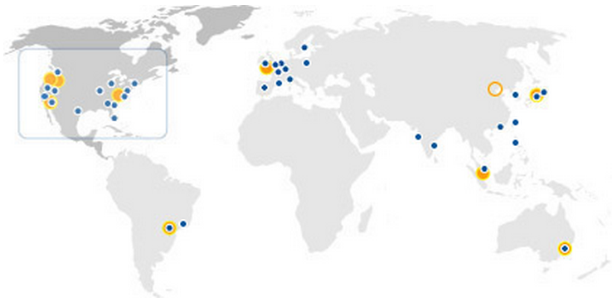

One of the main obstacles encountered in this activity is to convince other sites to deploy this software on their infrastructures to increase the pool of available resources that can support execution of PRAGMA Virtual Cluster. Moreover, having access to a wide pool of resources would drive more domain researchers to adopt PRAGMA Virtual Cluster format for publishing their software stacks.

Student activities
2013 PRIME students Kevin Lam and Karen Rodriguez used the Docking cluster image during the winter of 2013/2014 to perform docking simulations on UCSD PRAGMA hardware resources with the help of PRAGMA Bootstrap software.
During spring of 2014 Pongsakorn U-chupala (Ph.D student from NAIST) stayed at UCSD for 2 months. During this time he developed the Amazon CloudFront plugin for PRAGMA Bootstrap and had an active role in the deployment of the PRAGMA ENT infrastructure at UCSD.

