Introduction to HTML5

# 1th Course in the Web Design for Everyone Specialization

# About Course

# Skills You Will Gain

**Html**

**Html5**

**Web Accessibility**

Web Design

# Course Materials

General Links

Online Text book

Author: Shay Howe

Link:  <https://learn.shayhowe.com/html-css/>

[W3Schools](http://www.w3schools.com/html/default.asp)

[Codecademy.com](https://www.codecademy.com/)

*Additional Reading*

*Beyond Scope*

# Week

Week 1

Notes

What is HTML?

* HTML stands for Hypertext Markup Language
* Markup languages are not the same as programming language in that they use tags to annotate documents

Screen readers and other assistive devices can also utilize the HTML tags to present the information in a specialized way.

Tags

Tags are used to markup your files so browsers know how to display the material such as header, an image, a link, etc. These are called elements. You need to mark the start and end of each element.

Syntax

Refers to the spelling and grammar of a programming (Markup) language the environment expects in order to understand your intent.

Semantics

So what exactly are semantics? Semantics within HTML is the practice of giving content on the page meaning and structure by using the proper element.

Semantic HTML or semantic markup is HTML that introduces meaning to the web page rather than just presentation. For example, a <p> tag indicates that the enclosed text is a paragraph. This is both semantic and presentational because people know what paragraphs are, and browsers know how to display them.

A semantic element clearly describes its meaning to both the browser and the developer.

What are Semantic Elements?

* A semantic element clearly describes its meaning to both the browser and the developer.
* Examples of non-semantic elements: <div> and <span> - Tells nothing about its content.
* Examples of semantic elements: <form>, <table>, and <article> - Clearly defines its content.

There are several benefits to using semantic elements, including enabling computers, screen readers, search engines, and other devices to adequately read and understand the content on a web page.

Web Standards and Organizations

* Internet Engineering Task Force (ETF)
* World Wide Web Consortium (W3C)
* The Web Accessibility Initiative (WAI)
* Web Hypertext Application Technology Working Group (WHATWG)

How Page Request work?

Client/Server Relationship

The client requests a page and a server responds with the appropriate files.

Uniform Resource Locator ( URL )

There are three parts to a URL

* Protocol – how to connect (http)
* Domain – the server
* (optional) document – the specific file needed (note: most pages are made up of multiple files

Protocols

* HTTP – Hypertext Transfer Protocol
* HTTPS – Secure Hypertext Transfer Protocol
* FTP – File Transfer Protocol

Domain Names

Domain names identify the entity you want to connect to. Each has different top-level domain (e.g, .com, .gov, .org).

* Determined by Internet Corporation for Assigned Names and Numbers (ICAAN)

IP Addresses

The Domain Name Server (DNS) converts websites addresses to the IPv6.

Document(s)

## **Browsers Support**

You need to test your site on multiple browsers to ensure your content renders the way you intended.

**Issues of Accessibility**

<http://www.html5accessibility.com> **keeps a review of the accessibility of browsers.**

You can check to see if the browser that you are using supports most of the HTML5 tags by going to <http://html5test.com/index.html>. This site will give you a score for the browser you are using. You can also click on the "Other Browsers" link to get an idea of how the other browsers are doing.

Links

<http://www.html5accessibility.com>

<http://html5test.com/index.html>.

Closing Thoughts

Week 2

Notes

## *The Document Object Model (DOM)*

The basis of HTML5 is “New features should be based on HTML, CSS, the DOM, and Javascript…”. The purpose of the DOM is to standardize the organization of all pages with a common tree-like structure.

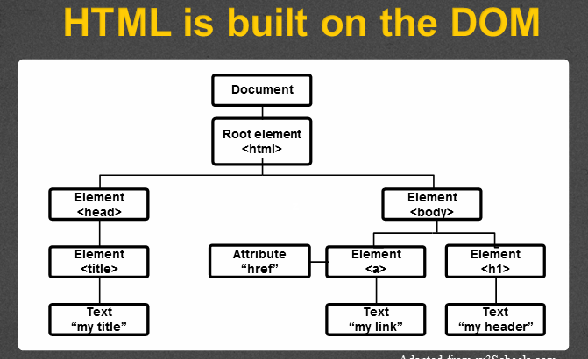

Three parts of a well-formed document

* Doctype – Version of HTML tht you will be using
* Head
  + with nested Metadata tag
* Body – Displayable content

**Doctype**

<!DOCTYPE html>

**Head**

Additional information used by the browser

* Metadata,language, title
* Supporting files – JavaScript, Styling, Add-ons

**Body**

Bulk of your page written in a well formatted (tree-like) code

## *HTML Overview*

HTML comments start with <!-- and end with -->. CSS comments start with /* and end with */.

**Building Structure**

For the longest time the structure of a web page was built using divisions <div>. The problem was that divisions provide no semantic value, and it was fairly difficult to determine the intention of these divisions. Fortunately HTML5 introduced new structurally based elements, including the <header>, <nav>, <article>, <section>, <aside>, and <footer> elements.

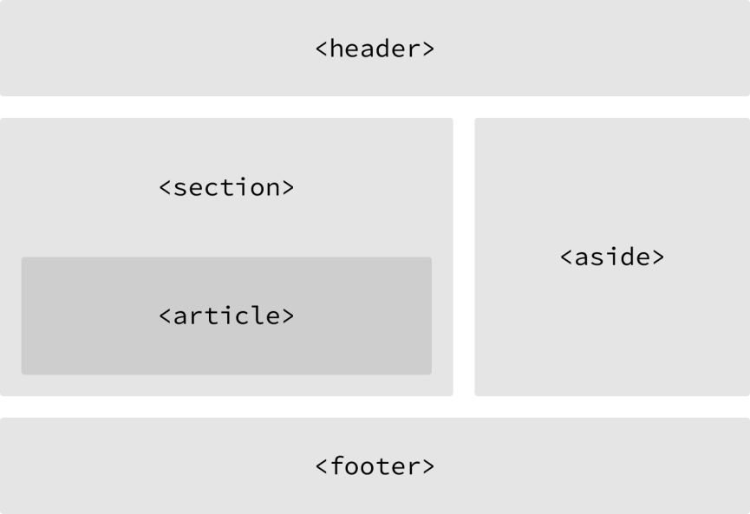

**Header**

The <header> element is used to identify the top of a page, article, section, or other segment of a page.

**Article**

The <article> element is used to identify a section of independent, self-contained content that may be independently distributed or reused. Often used to markup blog posts, newspaper articles, user-submitted content, and the like. When deciding whether to use the <article> element, we must determine if the content within the element could be replicated elsewhere without any confusion. If the content within the <article> element were removed from the context of the page and placed, for example, within an email or printed work, that content should still make sense.

Section

The <section> element is used to identify a thematic grouping of content, which generally, but not always, includes a heading. The grouping of content within the <section> element may be generic in nature, but it’s useful to identify all of the content as related. Also, the <section> element is commonly used to break up and provide hierarchy to a page.

Aside

The <aside> element holds content, such as sidebars, inserts, or brief explanations, that is tangentially related to the content surrounding it. When used within an <article> element, for example, the <aside> element may identify content related to the author of the article

Footer

The <footer> element identifies the closing or end of a page, article, section, or other segment of a page.

Linking to an Email Address

Creating a hyperlink to our email address. To create an email link, the href attribute value needs to start with mailto: followed by the email address to which the email should be sent. To create an email link to [shay@awesome.com](mailto:shay@awesome.com), for example, the href attribute value would be <mailto:shay@awesome.com>. Additionally, subject, body text, and other information for the email may be populated. To add a subject line, we’ll include the subject= parameter after the email address. The first parameter following the email address must begin with a question mark, ?, to bind it to the hyperlink path. Multiple words within a subject line require that spaces be encoded using %20. Adding body text using body= parameter. Because we are binding one parameter to another we need to use the ampersand, &, to separate the two. Spaces encoded with %20, Line breaks must be encoded using %0A.

Altogether, a link to shay@awesome.com with the subject of “Reaching Out” and body text of “How are you” would require an href attribute value of <mailto:shay@awesome.com?subject=Reaching%20Out&body=How%20are%20you>.

<a href="mailto:shay@awesome.com?

subject=Reaching%20Out&body=How%20are%20you">Email Me</a>

Linking to Parts of the Same Page

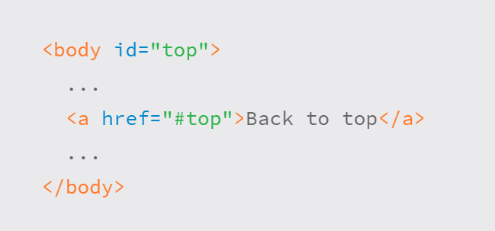

## **HTML5 Tags and Syntax**

**Attributes**

* Attributes provide additional information about an element
* Always specified in the start tag
* Attributes come in name/value pairs

<img src =”myimage.jpg” alt = “Image of something”/>

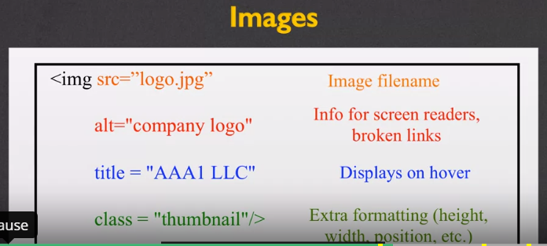

More attributes:

* Class
* Id
* Style
* Accesskey – a shortcut key to activate an element
* Tabindex – the order elements will come into focus using the tab key

**Special Entities**

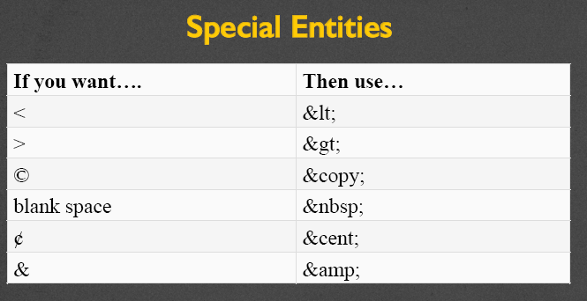

**Tags**

# Semantics Tags

<figure>

Offers more semantics than <img>. Can include :

* Caption
* Multiple multi-media resources

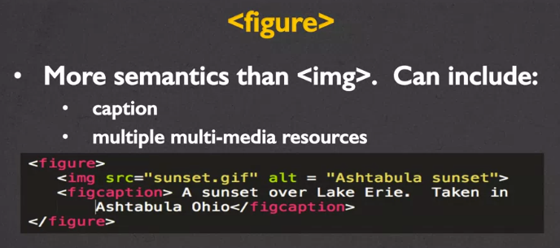

### Images

**Favicons**

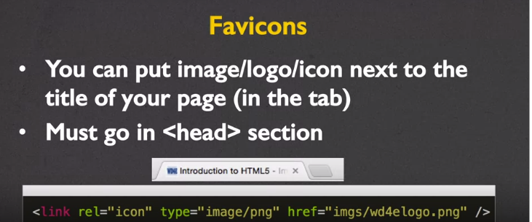

**Alternative Text Attribute**

* Provides a textual alternative to non-text content
* Read by screen readers
* Displayed in place of images
* Provides semantic meaning for search engines

**Font Awesome**

Regarding accessibility. If you decide to use icons for links. Use the attribute aria-label=”link destination”. This will allow screen readers to read the link destination.

### Hyperlinks

Target attribute

Anchors <a> can take a target attribute

* _self – default action
* _blank – open in new tab or window

### Multimedia

Video element <video>

Video tag uses a src attribute or embedded <source>. Some common attributes include:

* Height, width
* Autoplay
* Loop
* Controls

The text nested in the <video>..</video> is displayed if browser can not support tag

Audio element <audio>

Audio users a src attribute to link to audio file, typically .mp3 or .wav. Common attributes include:

* Autoplay, controls, loop
* Buffered
* Muted
* Volume

Setting clips

Set both the video and audio elements to play clips by adding to the src attribute

* .ext#= 5, 25 – play from 5 seconds to 25 seconds of clip
* .ext#= , 39 – play from 0 seconds to 39 seconds of clip

### Tables

Always remember to design before coding, this is true for almost all programming and markup languages.

The Tags

<table> - the container tag

<tr>…</tr> - the row

<td>…</td> - the column

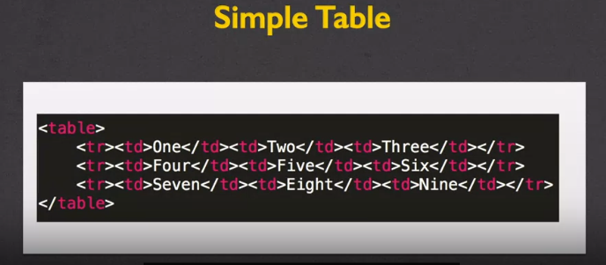

Table Headings

The bold text that define the table data? The semantic tag <th>..</th> - table heading

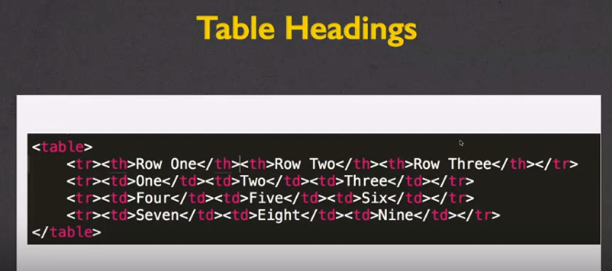

Spanning Multiple Cells(table data)

Use attributes rowspan and colspan

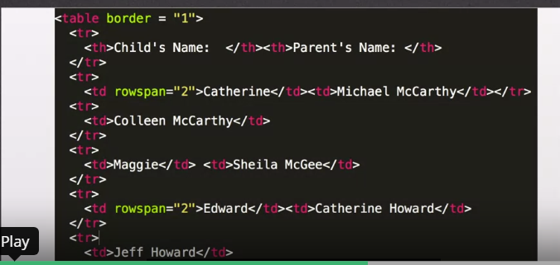

Captions

The <caption> tag defines a table caption

<table>  
  <caption>Monthly savings</caption>  
  <tr>  
    <th>Month</th>  
    <th>Savings</th>  
  </tr>  
  <tr>  
    <td>January</td>  
    <td>$100</td>  
  </tr>

</table>

### Useful Tags

Block Tags

<hr> tag – places a hard line through page

<address> tag – semantic: lets screen readers quickly find and read addresse(s)

<blockquote> tag – semantic: has cite attribute

<details> with <summary>

Inline Tags

<span>

<cite>

<abbr> - abbreviation

<time>

<code>

<sub> and <sup>

Links

<https://validator.w3.org/>

# [The Ultimate HTML 5 Cheat Sheet](https://www.wpkube.com/html5-cheat-sheet/)

Closing Thoughts

Week 3

### Accessibility

Web Accessibility coordinator

* Helps guide policy and purchasing decisions
* Evaluates web interfaces for accessibility
* Assists those with disabilities to access online infrastructure

### Validating Your Code

You can use [wave.webaim.org](https://wave.webaim.org/) to validate accessibility

### Using Secure File Transfer Protocol (FTP/SFTP)

What you’ll need to use FTP/SFTP:

* Find/install a FTP client
  + PC – WinSCP
  + Mac – Fugu/Cyberduck
* Find the ftp address for your host

Notes

Links

Closing Thoughts

Week 4

Notes

Links

Closing Thoughts

# Closing Thoughts