Introduction to CSS

# 2nd Course in the Web Design for Everybody: Basics of Web Development & Coding Specialization

# About Course

# Skills You Will Gain

**Cascading Style Sheets (CSS)**

**Web Development**

**Style Sheets**

Web Design

# Course Materials

General Links

*Additional Reading*

*Beyond Scope*

# Week

## Styling your text

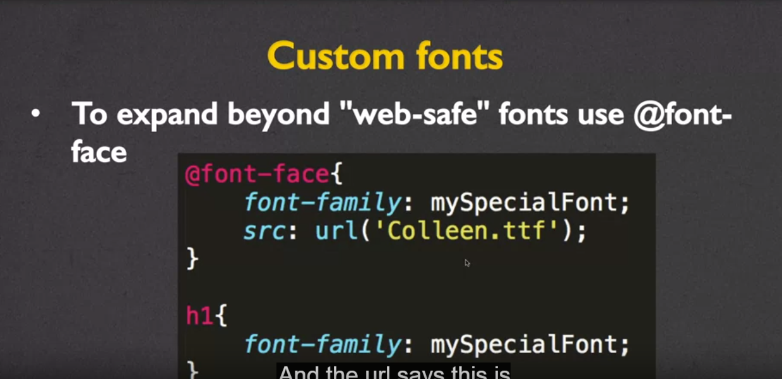

Line-height

This property will adjust the space between the lines of text

p{

line-height: 50%;

}

## Display and Visibility

Block –span entire row

Inline-Block – block element that accepts both width and height (allowing block elements to share a row)

Display None – hide the element

Float property

* Reposition elements to the right or left.
* Elements are aware of one another and will not overlap.
* Values: left, right

Clear property

* Used to keep floating elements away
* Values: left, right, both

Overflow property

Values:

* visible: Can cause text to show up “on top” of other text
* hidden: Hides anything that goes beyond bounding box
  + note this can cause problems if the user increases font size, they may not be able to see content
* scroll: Gives horizontal and vertical scrollbars
* auto: Adds scrollbars as needed

Display table and display table-cell

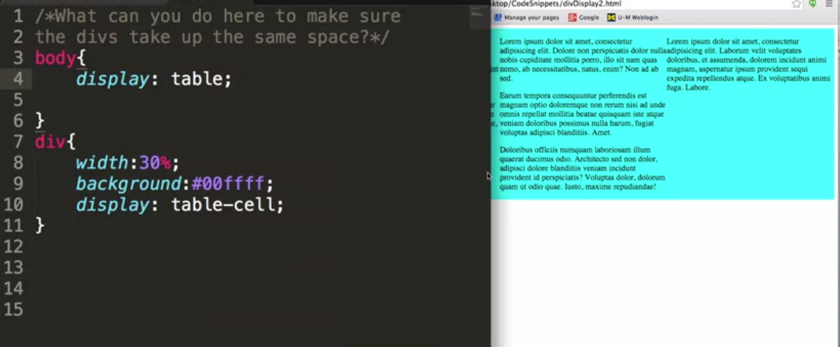

Visibility Property

This property specifies whether or not an element is visible.(note this element will still occupy the space it consumes)

Values:

* visible
* hidden
* collapse (only for table elements)

Week 1

Notes

Links

Closing Thoughts

Week 2

Notes

Links

Closing Thoughts

Week 3

Notes

Links

Closing Thoughts

Week 4

Notes

Links

Closing Thoughts

# Closing Thoughts