## **FRUIT IDENTIFICATION USING COLOR ANALYSIS**

Team members

AKUL NAGASHAYANA -21BEC1221

RAAVI SAI RITHVIK - 21BEC1249

TUMMALA PRAGNA -21BEC1196

S MADHAN SAI - 21BEC1276

SIDDHARTH HUGGAHALLI -21BEC1338

Mini project under the guidance of

Dr. ashok mondal

BECE301L-Digital Signal Processing- (F2+TF2 slot)



B Tech - Electronics and Communication Engineering

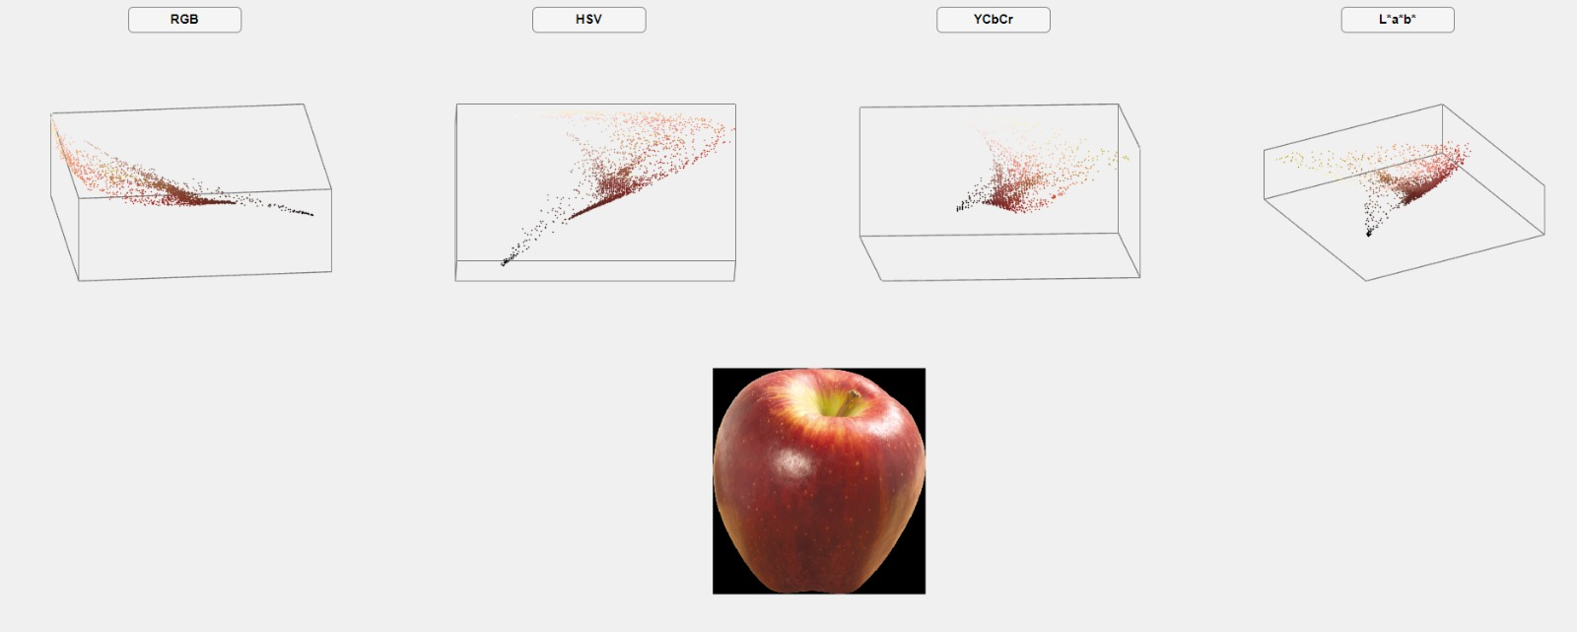

**PROJECT INTRODUCTION**

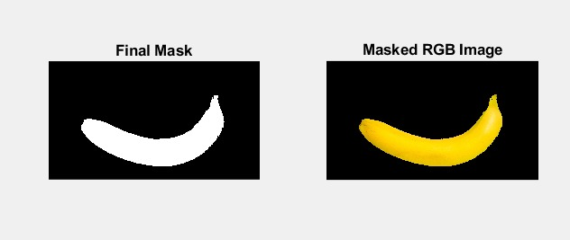

The project is based on fruit recognition system in MATLAB used to identify a given image of a fruit (Apple, Banana, Guava or Strawberry).

The computational challenge of visual object detection is intriguing, unusual, and occasionally quite challenging. The fundamental issue is that every object in the universe has the potential to project a countless number of alternative 2-D representations onto the retina due to variations in the object's position, stance, lighting, and backdrop in relation to the viewer. The brain, however, effortlessly resolves this issue. But in order for computers to eventually be able to recognize objects at levels close to those of a human, it is a significant problem.

The fruit recognition system can be used in grocery stores to automatically add the names of the fruits the consumer selects to the bill. This technique can be used to categorise fruits in stores. With a few adjustments, this technology can also be used to separate rotting fruits from ripe fruits or to grade foods, which will save a lot of manual effort. By making the necessary adjustments for the medical area, this project can be used to detect cysts and tumours, which can subsequently be treated with the right pharmaceuticals to avert dangerous cancers.

Several obstacles may need to be overcome for fruit photos captured by cameras to be accurately recognised. Depending on how ripe they are, one type of fruit typically varies greatly in colour and texture. Bananas, for instance, can be uniformly green, yellow, spotty, or brown. Analysis of colour values alone is insufficient, as a result. The fundamental elements of an image are its colour and texture, which are frequently employed for visual classification.

Here we calculate certain statistical and textural properties on the colour channels of the image, and then compare them with the mean values from a table, MATLAB is used to preprocess input images to carry out image segmentation and then use colour grading in order to identify the fruit. System identifies fruits based on specified RGB range.

**Literature review-**

The vigorous development of fruit industry has led to the use of effective technical methods to classify all kinds of fruits. As we all know, manual check is not popular any more, Image recognition system methods are used to deal with this problem. The emergence and development of Image recognition system is based on the people who use visual and auditory to identify various information. Image recognition system is a state-of-the-art technique to process complex information automatically using computer and mathematical theory. For these reasons, the researchers use Image recognition system as an intelligent technology to replace and even expand human daily mental activities. Image recognition systems are used in many fields and here we shall use them to identify fruits through colour analysis.

**ABSTRACT**

This study proposes a fruit identification system using colour analysis and image processing. The approach involves capturing fruit images, preprocessing them, and extracting colour features. A classification algorithm is trained using a labelled dataset, enabling accurate fruit identification based on colour characteristics. Experimental results demonstrate the system's effectiveness, offering potential for automated fruit sorting and grading in agriculture and food processing. This research highlights the value of computer vision and machine learning in fruit identification tasks, paving the way for intelligent real-time fruit recognition systems.

**PROBLEM STATEMENT**

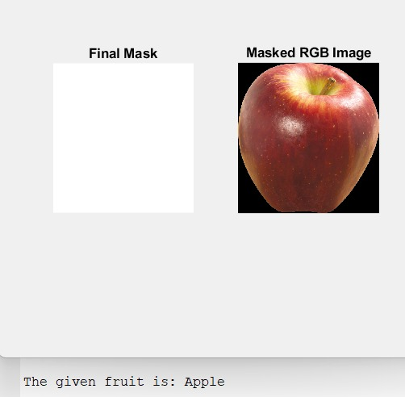

For agricultural practises, food processing, and sorting techniques, accurate fruit identification is essential. Manual processes take a lot of time and are prone to mistakes. Fruits must be recognised automatically using colour analysis and image processing to determine their identity. It should be able to reliably identify fruits despite differences in lighting, shape, and texture. This will boost fruit sector production, sorting effectiveness, and waste reduction.

**METHODOLOGY**

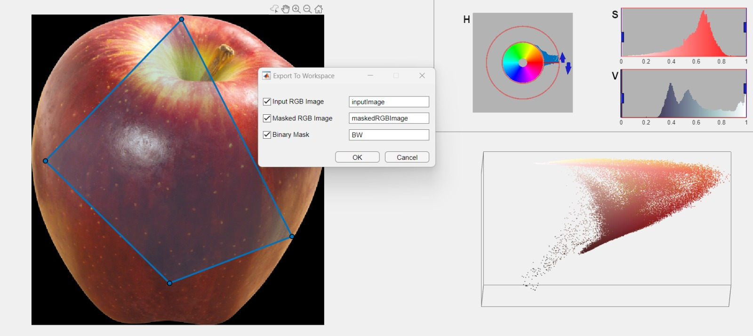

Various collection of four fruit group Images have been Obtained and

has been shortlisted into two sections Training and Testing Images,

In Training-phase we pre-process and Threshold the Background using HSV color scheme

Also an RGB image is sent back and foreground is sent for Extracting the Feature.

Image is again converted to HSV scheme and calculation of certain statistical color and textural properties are carried out and is stored in database.

Next an input Testing image to be analysed is processed using similar steps by removing background and carrying out the analysis, this is sent to minimum distance classifier function which identifies the image and shows the result in the terminal.

Software used-

* MATLAB
* Image Processing and Colour Recognition
* Computer Vision
* Basic Machine Learning

**Applications-**

* The fruit recognition system can be used in grocery stores to automatically add the names of the fruits the consumer selects to the bill. This technique can be used to categories fruits in stores. (Used in Amazon cashier less stores for billing process)
* With a few adjustments, this technology can also be used to separate rotting fruits from ripe fruits or to grade foods, which will save a lot of manual effort. (Used in Fruit based drink Industry for segregation).
* Can be used to detect unknow fruits originating from various parts of the world.
* Agriculture: Assisting farmers in accurate fruit identification during harvesting, enabling efficient sorting and grading processes.
* Sorting Systems: Facilitating automated fruit sorting and inventory management in supermarkets and grocery stores.

**BLOCK DIAGRAM-**

Phase1

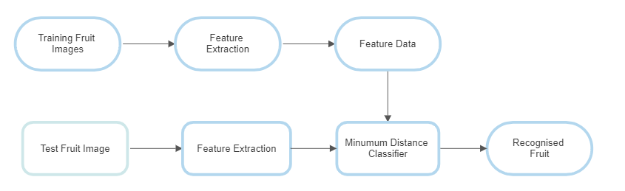

Phase2

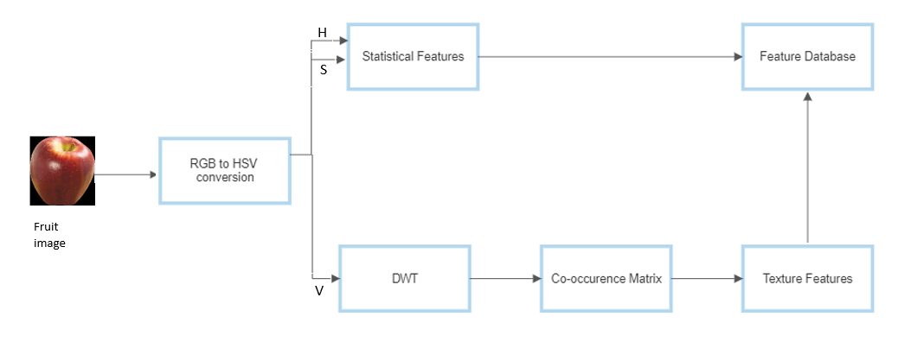

CODE-

FruitMain.m

%This program is used to identify a given image of a fruit (Apple, Banana,

%Guava or Strawberry), by calculating certain statistical and textural

%properties on the color channels of the image, and then comparing them

%with the mean values from a table.

clear;

clc;

disp('This program will identify a given image of a fruit');

disp(' ');

path = input('Enter the entire filepath: ', 's');

I = imread(path);

disp(' ');

disp('In order to correctly remove the background from the fruit, you must now use the Colour Thresholder App');

disp(' ');

disp('Step 1: The Colour Thresholder App will open with the image loaded. You must first click on the HSV Colour Space.');

disp('Step 2: On the left hand side, under the toolbar, there will be a polygon selector tool. Click on it and move to the image.');

disp('Step 3: The mouse pointer will now be shaped like a + sign. Click and drap the pointer on the fruit to select the region of interest.');

disp('Step 4: Move to the right hand side, where there will be histograms of each of the channels - Hue (H), Saturation (S), Lightness (L). Use the faders given to correctly select only the fruit from the image.');

disp('Step 5: In the toolbar, click on the Export button.');

disp('Step 6: Leave the filenames as they are. Click OK.');

disp('Step 7: Close the Colour Thresholder App. Return to MATLAB command window and press ANY key.');

disp(' ');

prompt = 'Confirm that you have read the above instructions and wish to proceed [Y]: ';

str = input(prompt,'s');

while(str ~= 'Y')

str = input(prompt,'s');

end

disp(' ');

%Background Removal

colorThresholder(I);

pause; %Wait until the user presses any key

BW = imfill(BW, 'holes'); %Fills up any holes in the mask

BW = bwareafilt(BW, 1); %Get the largest object

figure;

subplot(1,2,1);

imshow(BW);

title('Final Mask', 'FontSize', 10);

BW = cast(BW, 'like', I); %Convert the mask into an image with 3 channels - just like the input image

maskedRGBImage = bsxfun(@times, I, BW); %Multiply our input image and the mask, to get the fruit alone

subplot(1,2,2);

imshow(maskedRGBImage);

title('Masked RGB Image', 'FontSize', 10);

%Calculating the Properties

props = propcalc(maskedRGBImage);

%Identifying the Fruit

frt_name = mindistcalc(props);

fprintf('\nThe given fruit is: %s\n\n', frt_name);

FruitTrainer.m

%This program is used to prepare a datasheet with mean values of several

%properties of 4 fruits - Apple, Banana, Guava and Stawberry. This data can

%be used to identify a given fruit.

clear;

clc;

myDir = 'Training Images\Apple'; %gets directory

myFiles = dir(fullfile(myDir,'*.jpg')); %gets all jpg files in struct

for img_index = 1:length(myFiles)

baseFileName = myFiles(img_index).name;

fullFileName = fullfile(myDir, baseFileName);

fprintf('Now reading %s\n', fullFileName);

I = imread(fullFileName);

fprintf('##Background Removal... \nPress any key \n');

colorThresholder(I);

pause; %Wait until the user presses any key

BW = imfill(BW, 'holes'); %Fills up any holes in the mask

BW = bwareafilt(BW, 1); %Get the largest object

fprintf('##Property Calculation... \n');

props = propcalc(maskedRGBImage);

prompt = '\nEnter the name of the fruit: ';

frt_name = input(prompt,'s');

fprintf('\n##Updating File... \n');

updatefile(frt_name,props);

fprintf('##Process Over... \n');

clear

myDir = 'Trial'; %gets directory

myFiles = dir(fullfile(myDir,'*.jpg')); %gets all jpg files in struct

end

mindistcalc.m

function frt_name = mindistcalc(props)

table = readtable('PropTable.txt');

dist = zeros(1,max(table.S_No));

for i = 1:max(table.S_No)

index = i+1;

dist(i) = sqrt(((props(1)-table.H_Mean(index))^2) + (props(2)-table.H_SD(index))^2 + (props(3)-table.H_Skewness(index))^2 + (props(4)-table.H_Kurtosis(index))^2 + (props(5)-table.S_Mean(index))^2 + (props(6)-table.S_SD(index))^2 + (props(7)-table.S_Skewness(index))^2 + (props(8)-table.S_Kurtosis(index))^2 + (props(9)-table.V_Contrast(index))^2 + (props(10)-table.V_Energy(index))^2 + (props(11)-table.V_Shade(index))^2 + (props(12)-table.V_Prominence(index))^2);

end

[~,pos] = min(dist);

frt_name = string(table.Fruits(pos+1));

end

Tableinitializer.m

%This script is used to initialize the table used in the recognition of

%fruits, that holds the various properties of color.

S_No = 0;

Fruits = "Empty";

H_Mean = 0;

H_SD = 0;

H_Skewness = 0;

H_Kurtosis = 0;

S_Mean = 0;

S_SD = 0;

S_Skewness = 0;

S_Kurtosis = 0;

V_Contrast = 0;

V_Energy = 0;

V_Shade = 0;

V_Prominence = 0;

t = table(S_No, Fruits, H_Mean, H_SD, H_Skewness, H_Kurtosis, S_Mean, S_SD, S_Skewness, S_Kurtosis, V_Contrast, V_Energy, V_Shade, V_Prominence);

writetable(t, 'PropTable.txt');

updatefile.m

%This function updates the table containing the properties of various

%fruits.

function updatefile(frt_name, props)

t = readtable('PropTable.txt');

index = max(t.S_No) + 1;

x = table();

x.S_No = index;

x.Fruits = frt_name;

x.H_Mean = props(1);

x.H_SD = props(2);

x.H_Skewness = props(3);

x.H_Kurtosis = props(4);

x.S_Mean = props(5);

x.S_SD = props(6);

x.S_Skewness = props(7);

x.S_Kurtosis = props(8);

x.V_Contrast = props(9);

x.V_Energy = props(10);

x.V_Shade = props(11);

x.V_Prominence = props(12);

t = [t; x];

writetable(t, 'PropTable.txt');

OUTPUT-

HSV Masked Image (Apple)-

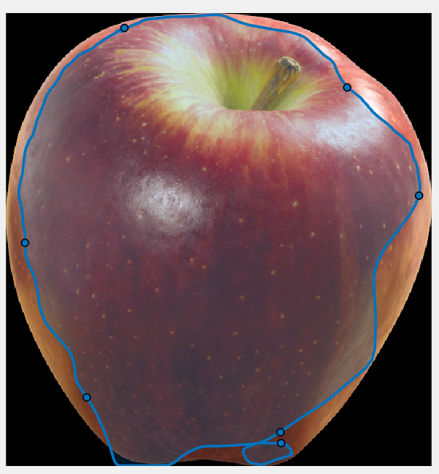

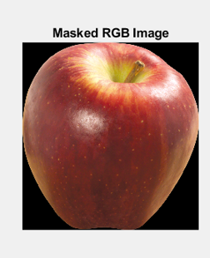

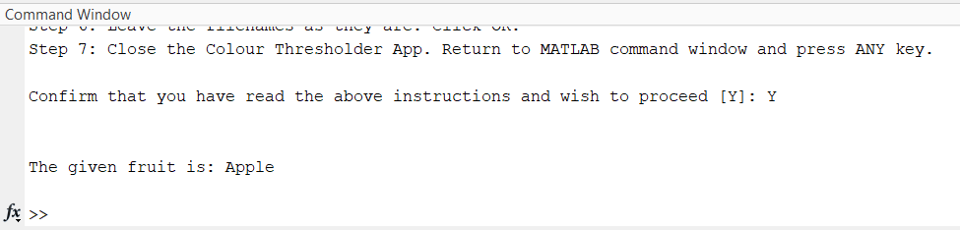

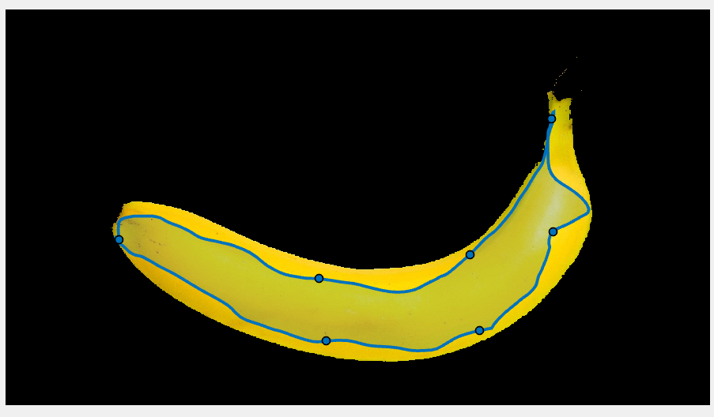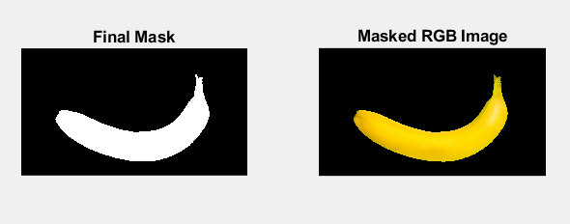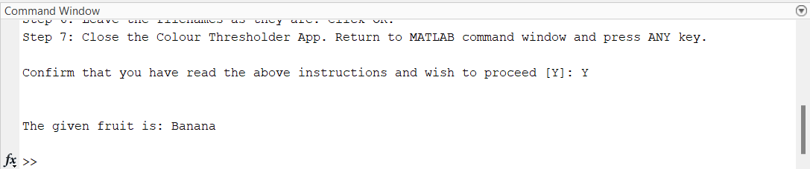

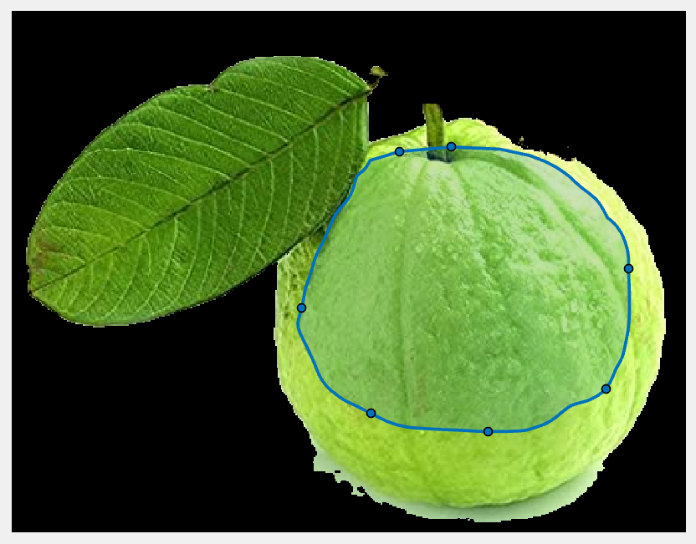

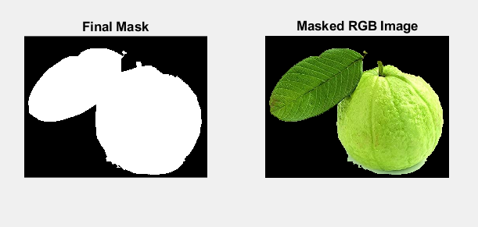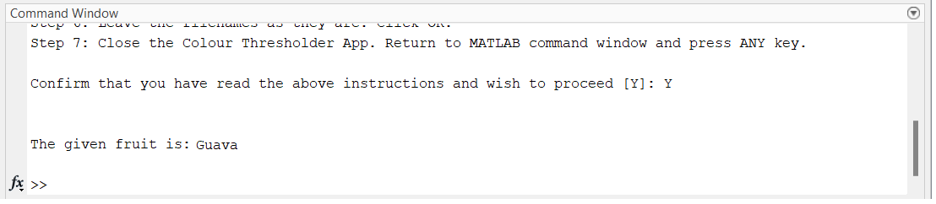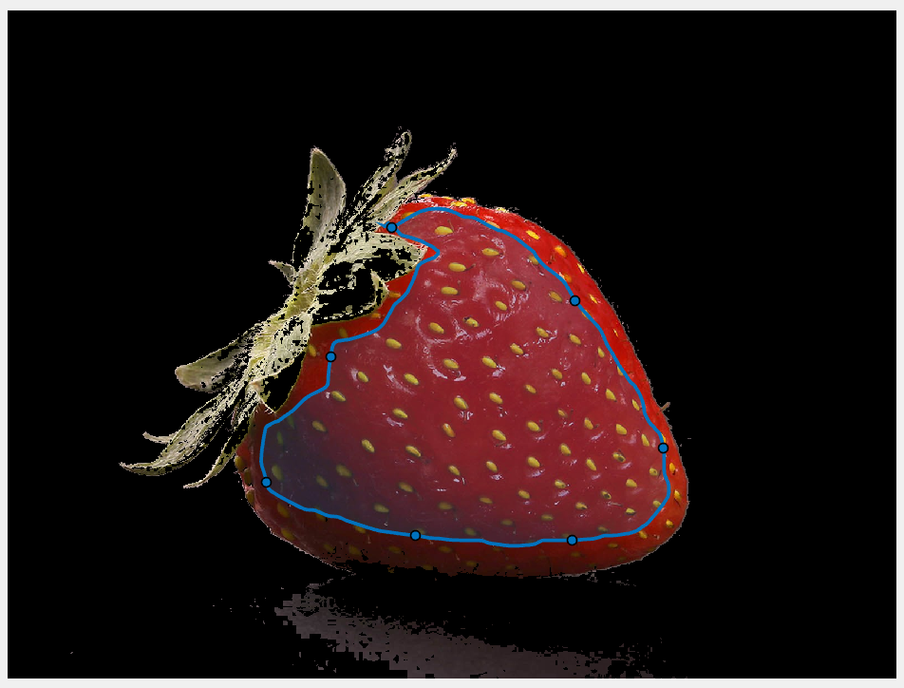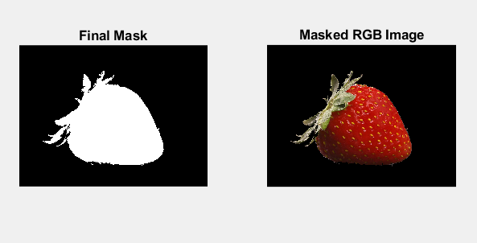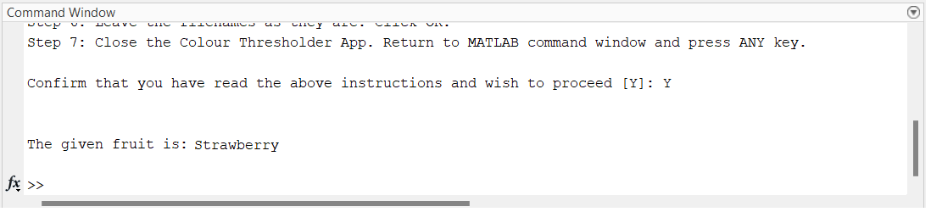

**Conclusion**

The relevant images are inducted into testing and training phase. They are classified into 4 classes and pre-processed systematically using the project framework. The images are accurately analysed using 3 main sections HSV analysis, RGB analysis and background or feature extraction. The inducted images are then concluded into the 4 main classes which are Apple, Banana, guava, strawberry.

The suggested project can identify fruits based on details like colour and texture. This will raise people's knowledge of some unusual and foreign fruits. The project's main objective is to minimize human effort and simplify people's lives. Fruit identification may help to lessen the current persistent problem. Cut down on the fruit's overlap with one another. Here, many classification strategies for fruit grading and sorting systems based on image processing are examined. Fruit inspection and grading systems based on machine vision are capable of taking the place of manual labour.

Thus, this model has a great accuracy of detecting various fruits and classify them.