***PROJECT ON***

***TOURISM WEBSITE FOR RAYALSEEMA***

SUBMITTED IN FULFILMENT OF THE REQUIREMENTS FOR THE AWARD OF

**DIPLOMA IN COMPUTER ENGINEERING**

Submitted By

**A.BABY SRAVANTHI 22057-CM-002**

**M.AKSAH 22057-CM-027**

**P.L.V.SAI PRAGNA 22057-CM-037**

**S.NASREEN 22057-CM-027**

**M.MOLAKA SRAVANTHI 22057-CM-053**

GUIDED BY

A.KEERTHI garu,M.Tech.,

Lecturer in CME

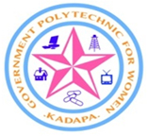

GOVERNMENT POLYTECNIC FOR WOMEN,KADAPA

Ramanjaneyapuram,Kadapa-A.P-516002

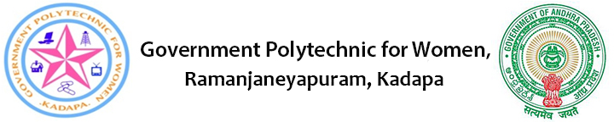

Academic year(2024-25)

Certificate

This is to certify that the project report entitled “cse academiy mobile app” was successfully completed by student of fifth semester diploma in computer engineering

A.BABY SRAVANTHI 22057-CM-002

M.AKSAH 22057-CM-027

P.L.V.SAI PRAGNA 22057-CM-037

S.NASREEN 22057-CM-027

M.MOLAKA SRAVANTHI 22057-CM-053

in partial fulfillment of the requirements for the award of the “diploma” in “computer engineering” and submitted to the state board of technical education of government polytechnic for women, Kadapa.in the course of academic year 2022-25 as per c-20 curriculum.

**Signature of Guide : Signature of HOD:**

**External Examiner:**

**ACKNOWLEDGEMENT**

This satisfaction and euphoria accompany the successfully completion of the task and would be incomplete without the mention of the people who made it possible, whose constant guidance and encouragements crown all the effort with success. We consider it as our privilege to express our gratitude and respect to all those who guided, inspired and helped us in completion of our project work.

We owe our gratitude to our Principal Sri **CH.JYOTHI**, M.TECH., GPW. Kadapa for his attention and valuable guidance to us throughout the course.

We express our deep sense of gratitude to **SRI K.SUDHA RANI, M.TECH**., Head of the Department of Computer Engineering for all provisions made and for his constant encouragement throughout the work.

We are thankful to our guide **A.KEERTHI, M.TECH.** Lecture, Department of Computer Engineering for his guidance and cooperation.

All of the above we great fully acknowledge and express our thanks to all the teaching and non-teaching staff of information Technology Department.

Project associate…

**ABSTRACT**

The tourism website application is more beneficial for tourist who loves travelling.your ultimate destination for exploring the rayalseema most captivating travel experiences. Our platform offers a comprehensive guide to popular destinations and historical places tailored to every type of traveler.

Computer science in diploma is a course that impacts everything in the world. and students will study the design,development and analysis of software and hardware used to solve the problems in variety of business at the diploma level

From detailed itineraries and local insights to user-friendly booking options, we empower you to plan unforgettable adventures with ease. Whether you seek relaxation on pristine beaches, thrilling outdoor adventures, or cultural explorations, <https://pragna668.github.io/waytorayalseema/> is here to inspire and assist you every step of the way. Join our community of passionate travelers and embark on your next journey today!

**CONTENTS**

1. **Introduction**