**DBMS ASSIGNMENT -1**

**Title name : improvement of Car-D portal**

**Abstract :**

CAR-D (Cargo - Data) is a web-based portal for collection & compilation, analysis and dissemination of all the cargo and cruise movement data for IWAI and its stakeholders. Portal gives access of the data to general public showcasing IWAI capabilities and potential of inland waterways transport. The Car-D portal helps in collating real-time information on all the cargo and cruise traffic data of the National Waterway. It also provides information related to the infrastructure of Waterways. It provides access to all stakeholders and general public thus bringing trust in the data being reported for IWT sector. It assists potential shippers & cargo owners in identifying cargo type and commodity at various waterways, terminals and jetties.

**Information about tables & it’s attributes :**

Number of tables = 7

1. Cargo_ship :

cargo_name varchar2(15),

cargo_id varchar2(8) primary key ,

capacity number(5),

load varchar2(10)

1. Cruise_ship :

cruise_id varchar2(8) primary key ,

cruise_name varchar2(15),

no_of_passengers number(5),

rating number(1) ,

fare number(5)

1. Movement :

starting_port varchar2(10),

destination_port varchar2(10),

ship_id varchar2(8) primary key ,

starting_date date

1. Stakeholders :

holder_id number(3) primary key ,

holder_name varchar2(15),

1. Passengers : booking_id number(5) primary key ,

name varchar2(15),

1. Reserves :

ship_id varchar2(8),

booking_id number(5),

date_of_reservation date

1. Holds : ship_id varchar2(8),

holder_id number(3),

since date

**E-R Model :**

hlods

has

reserves

**Relational model :**

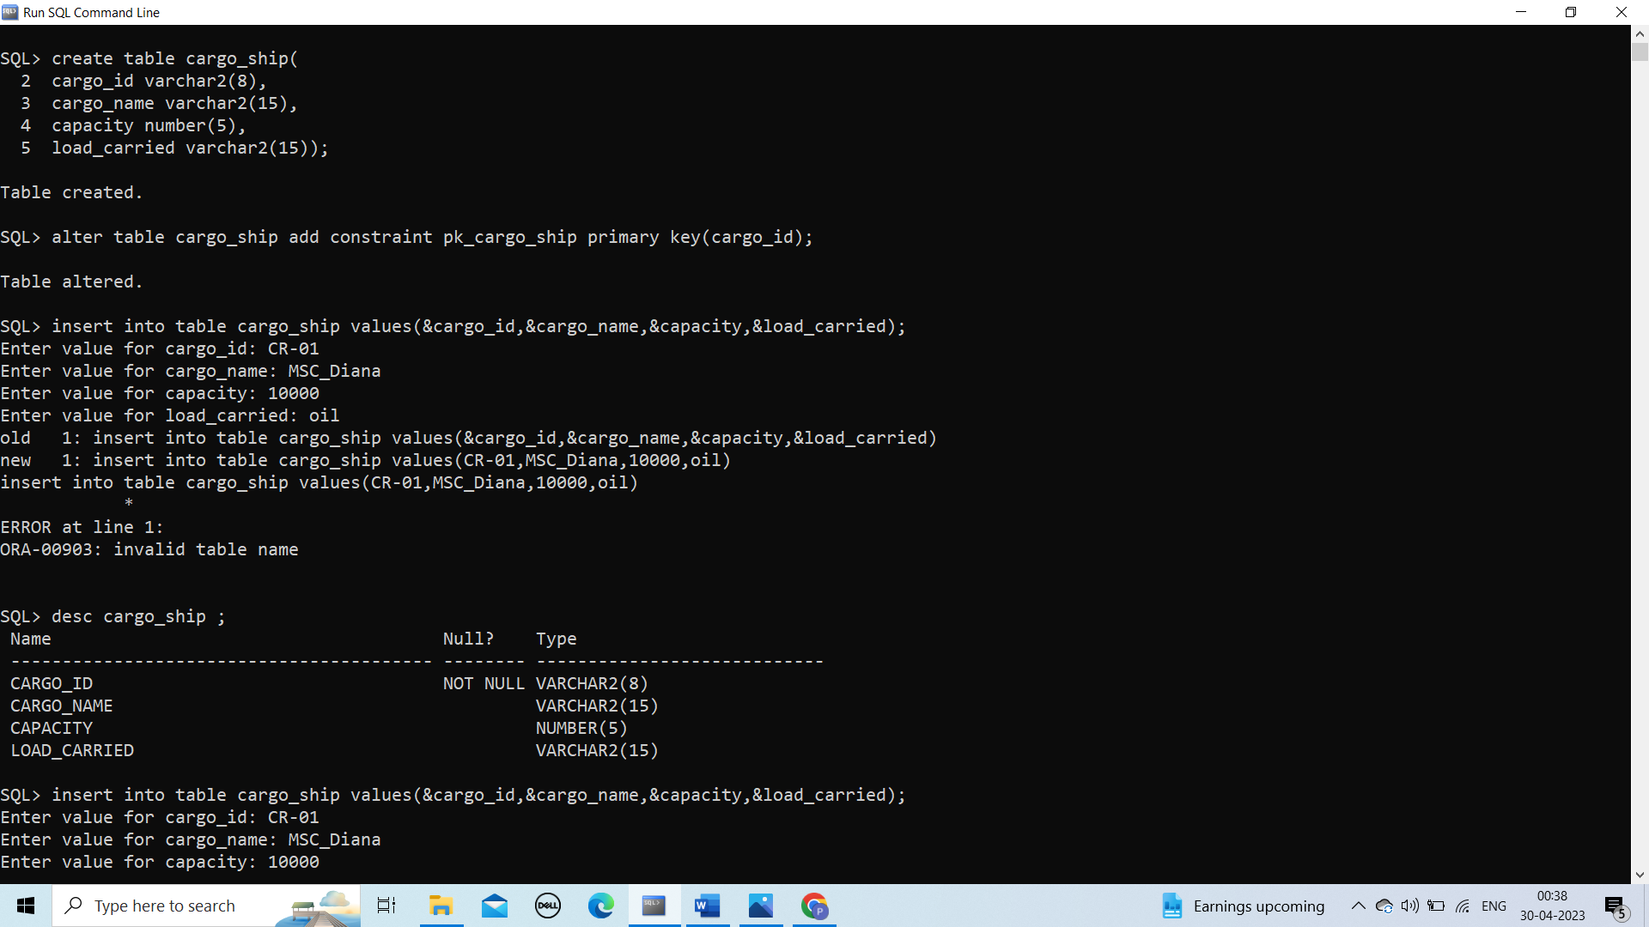

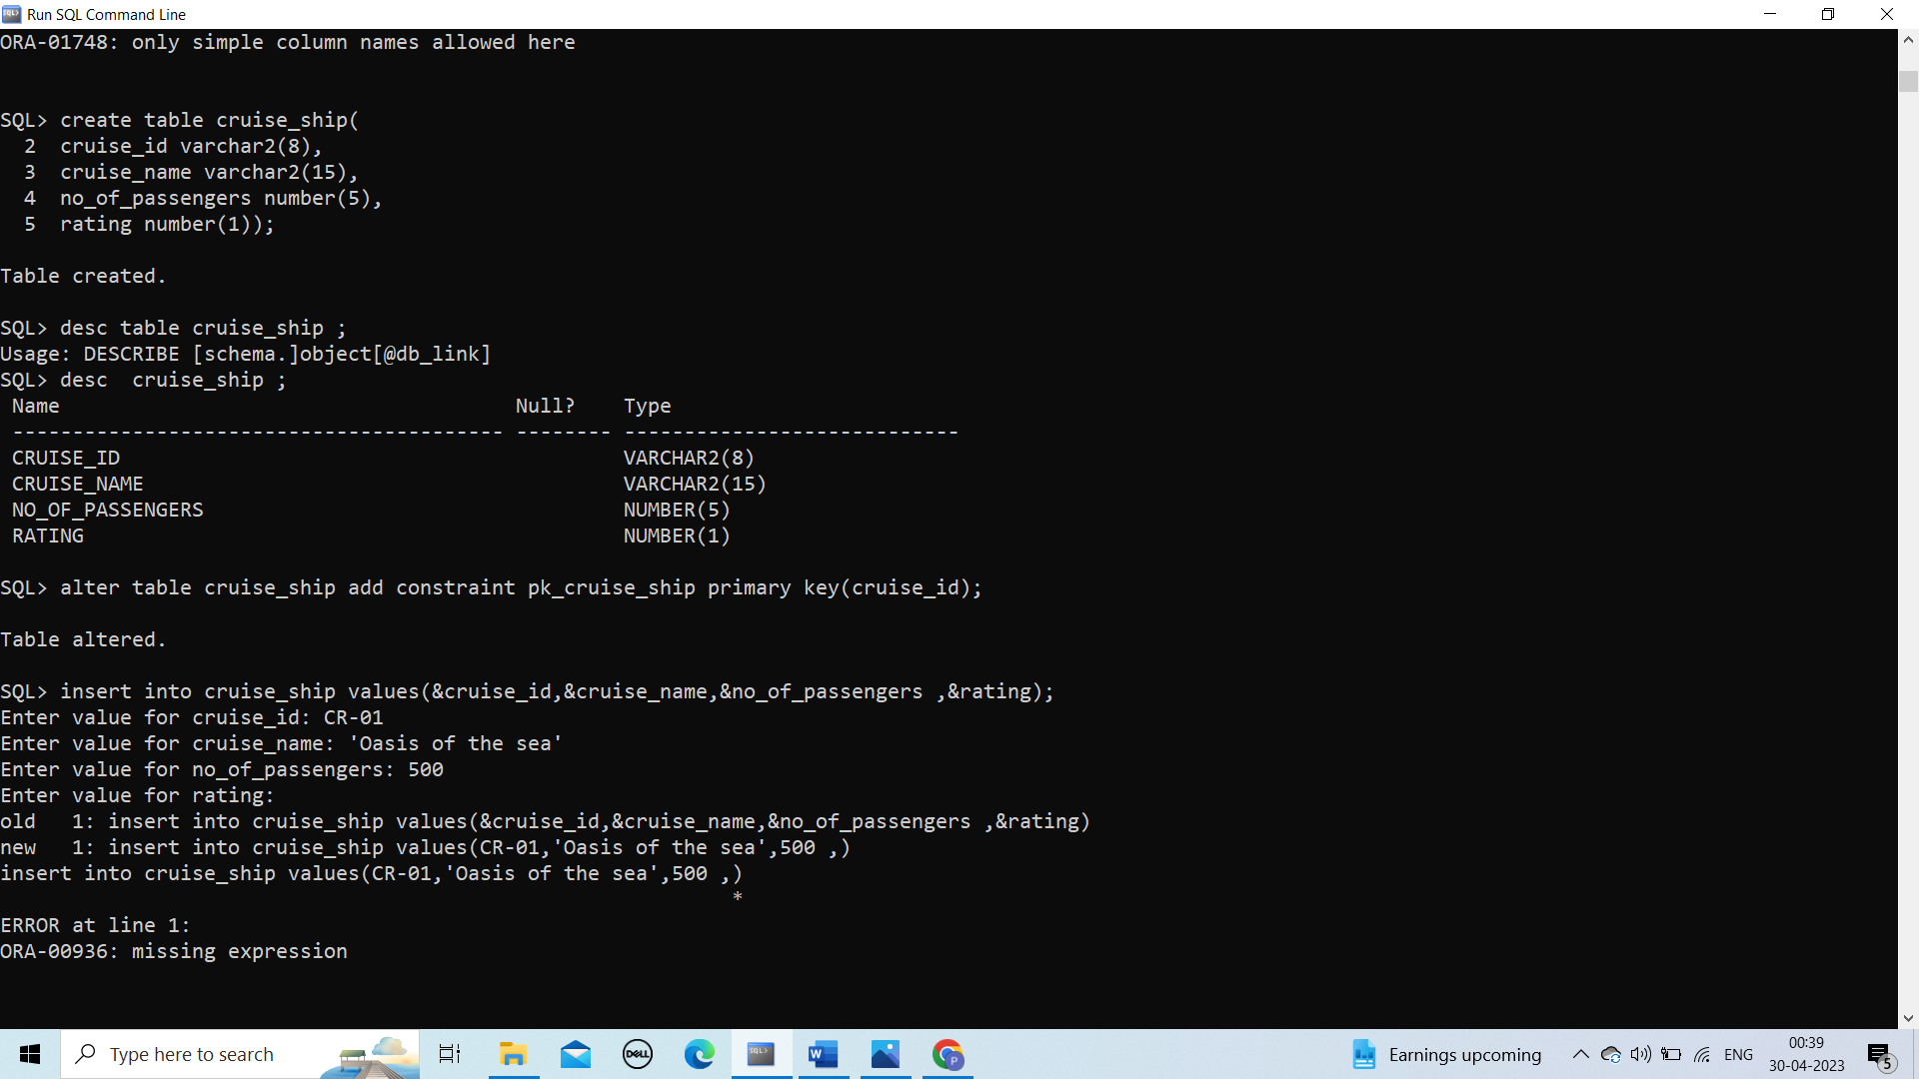

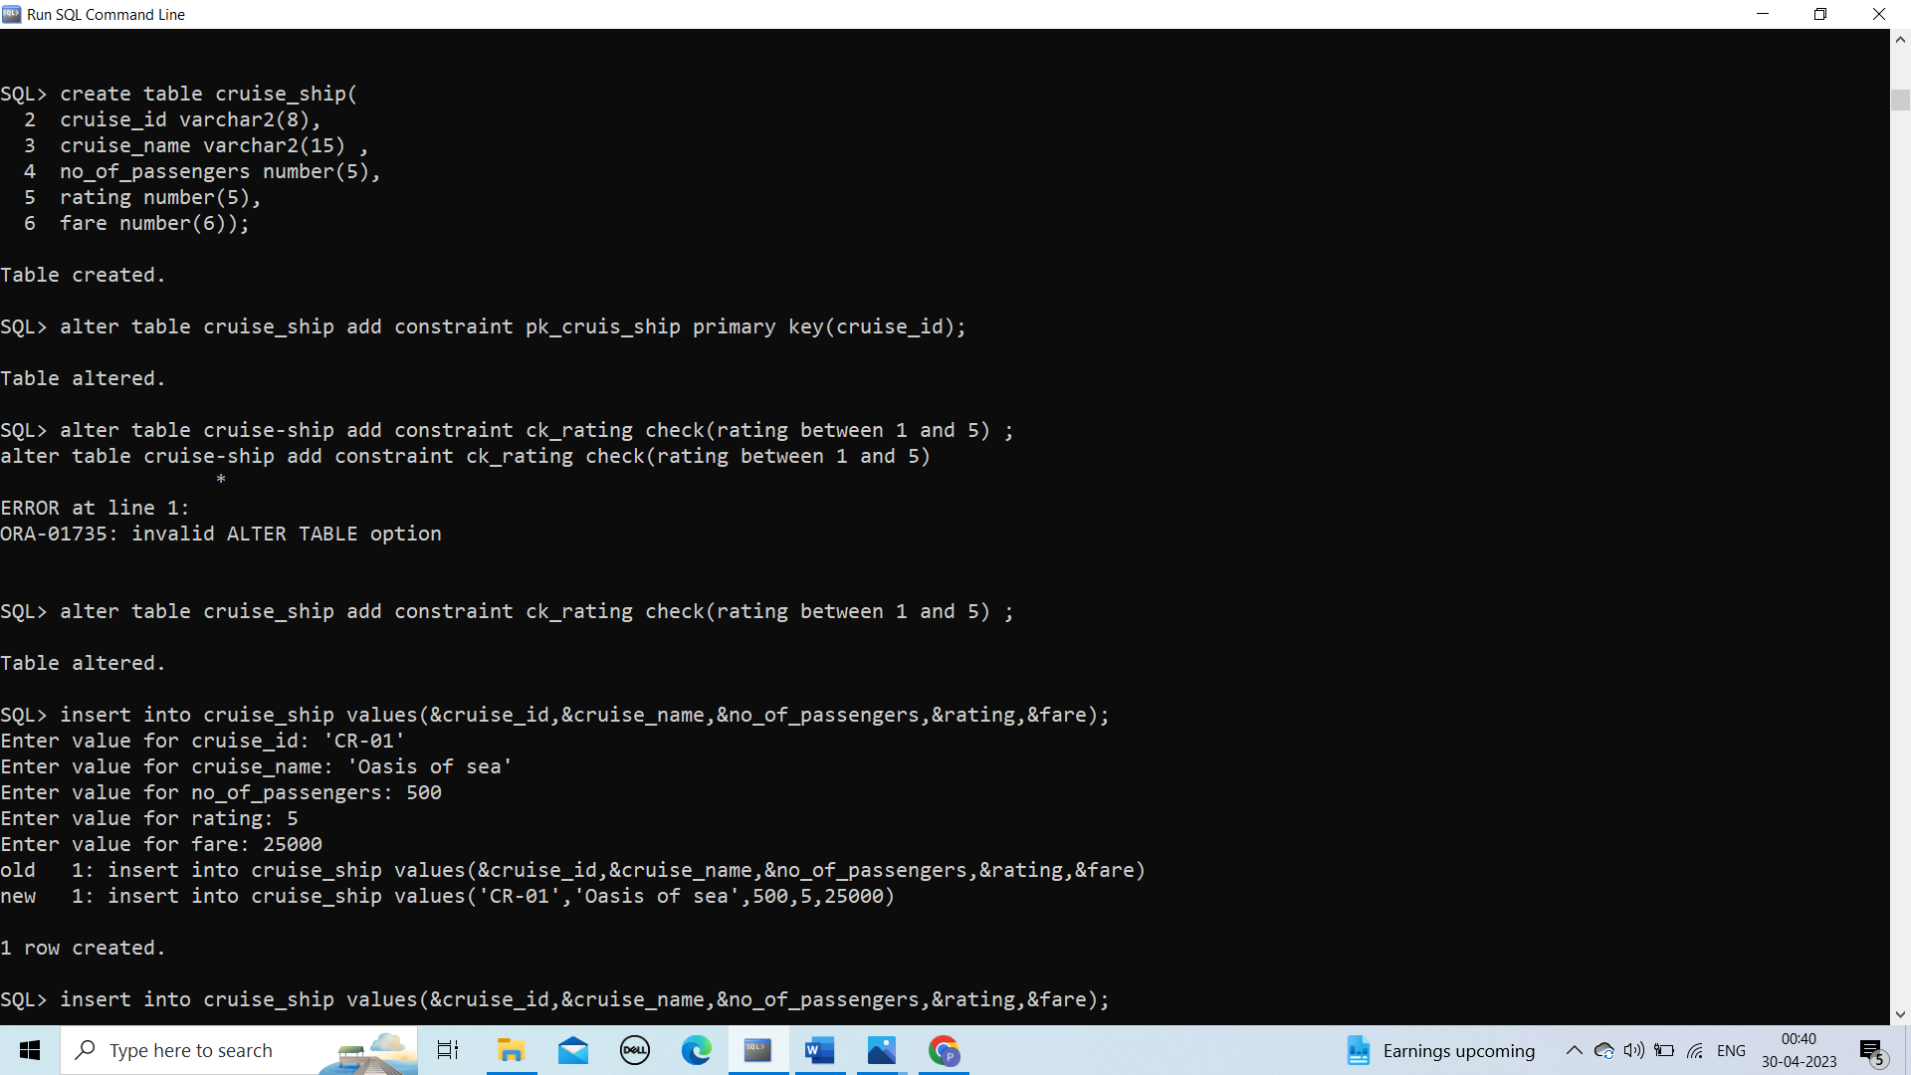

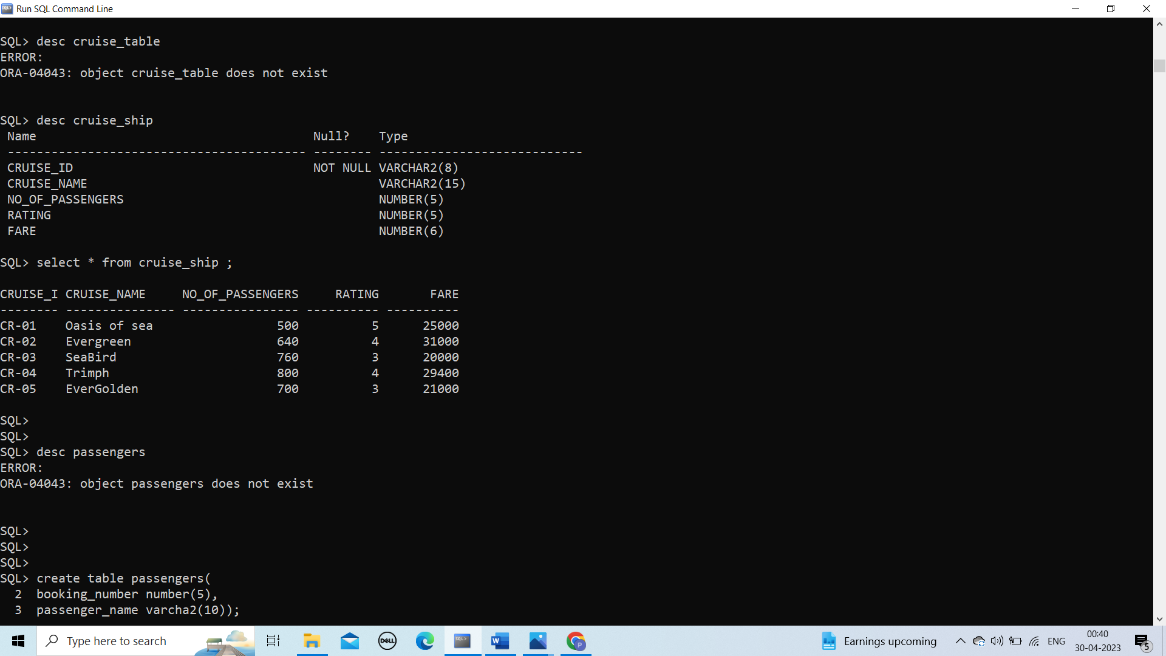

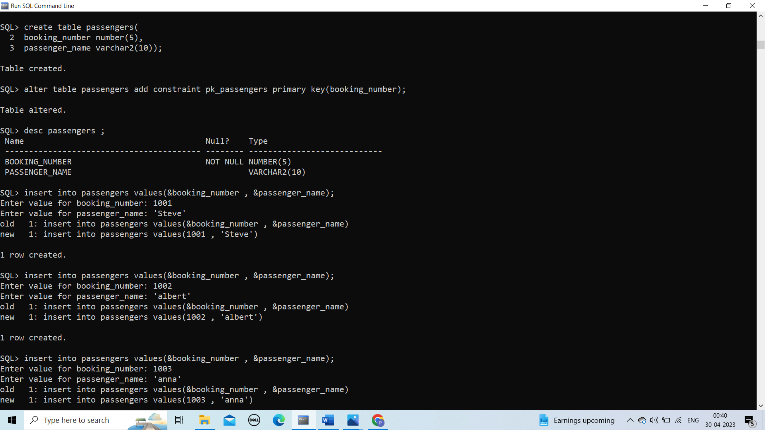

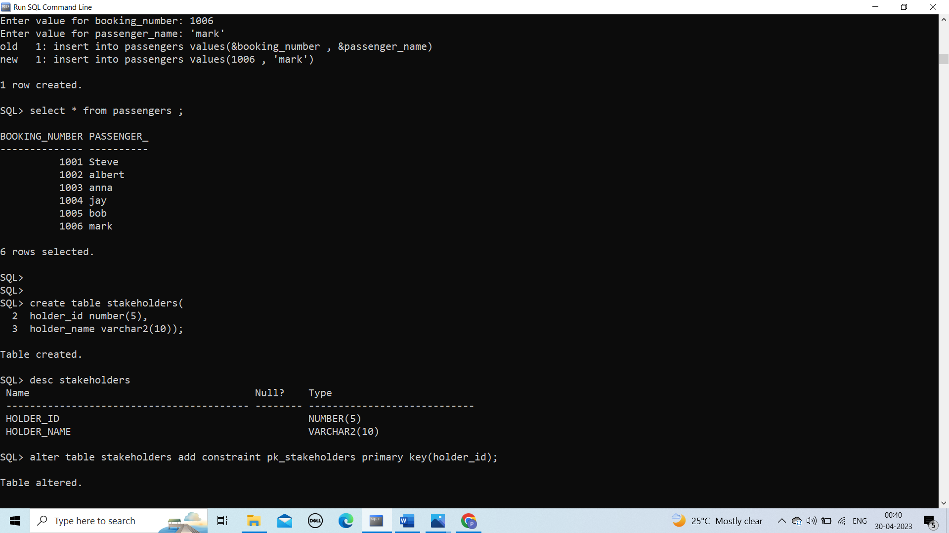

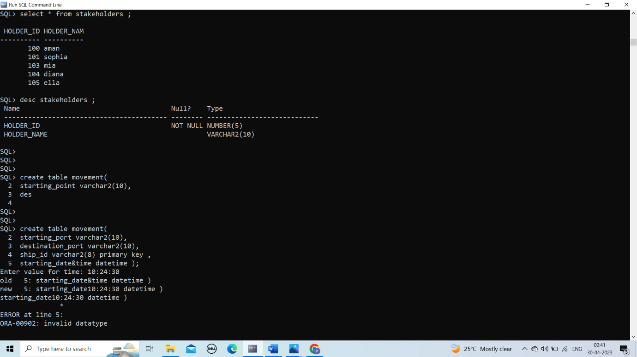

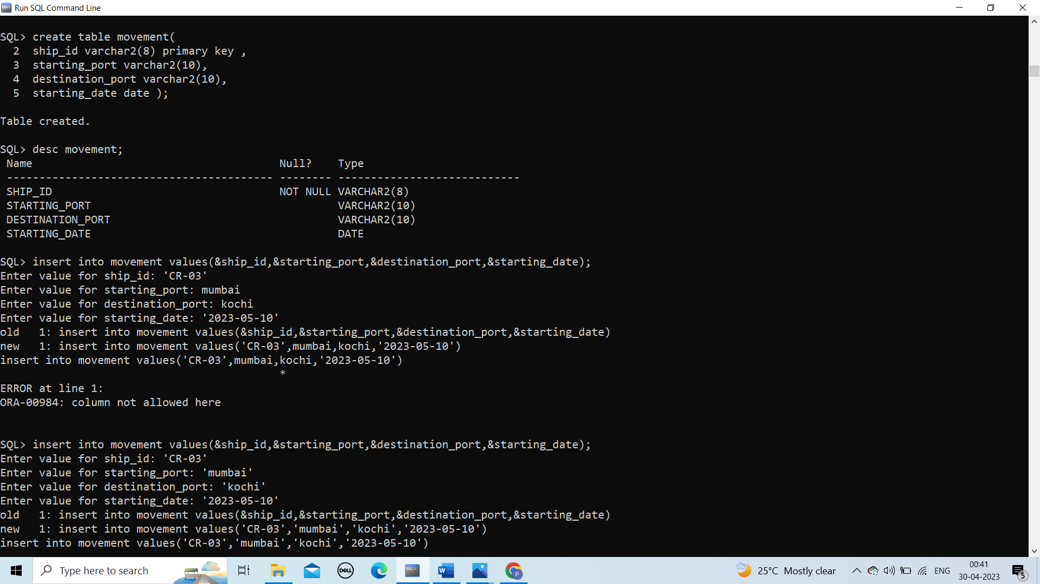

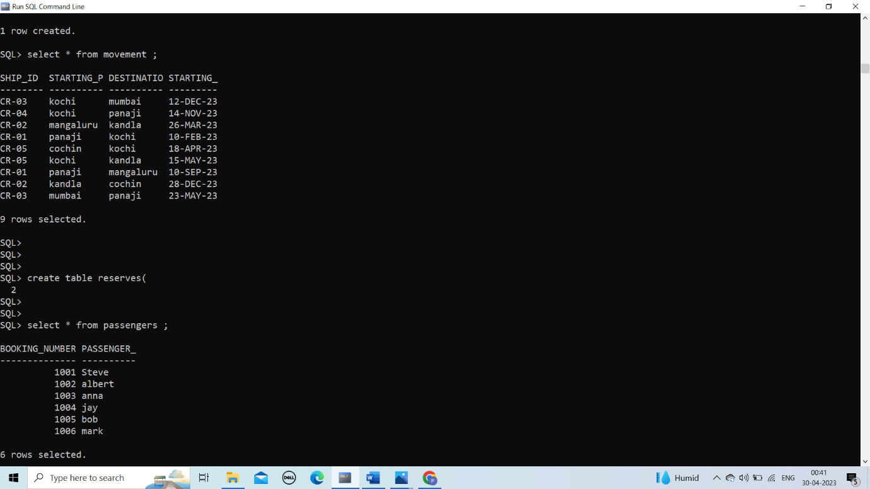

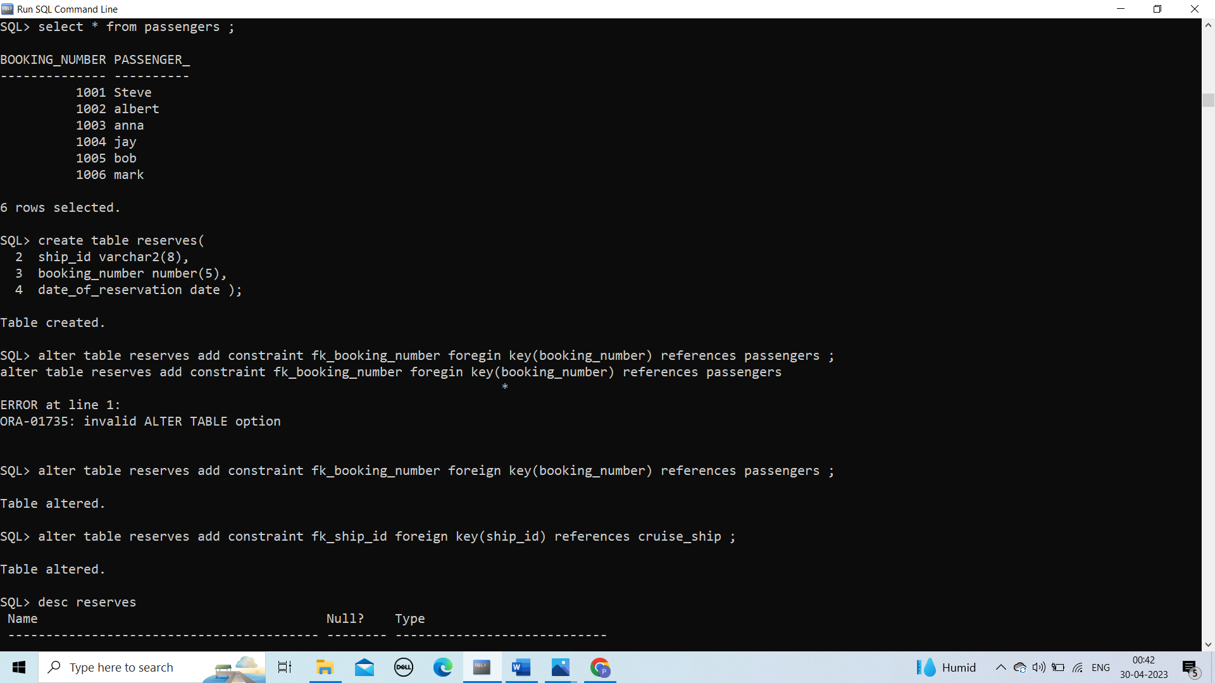

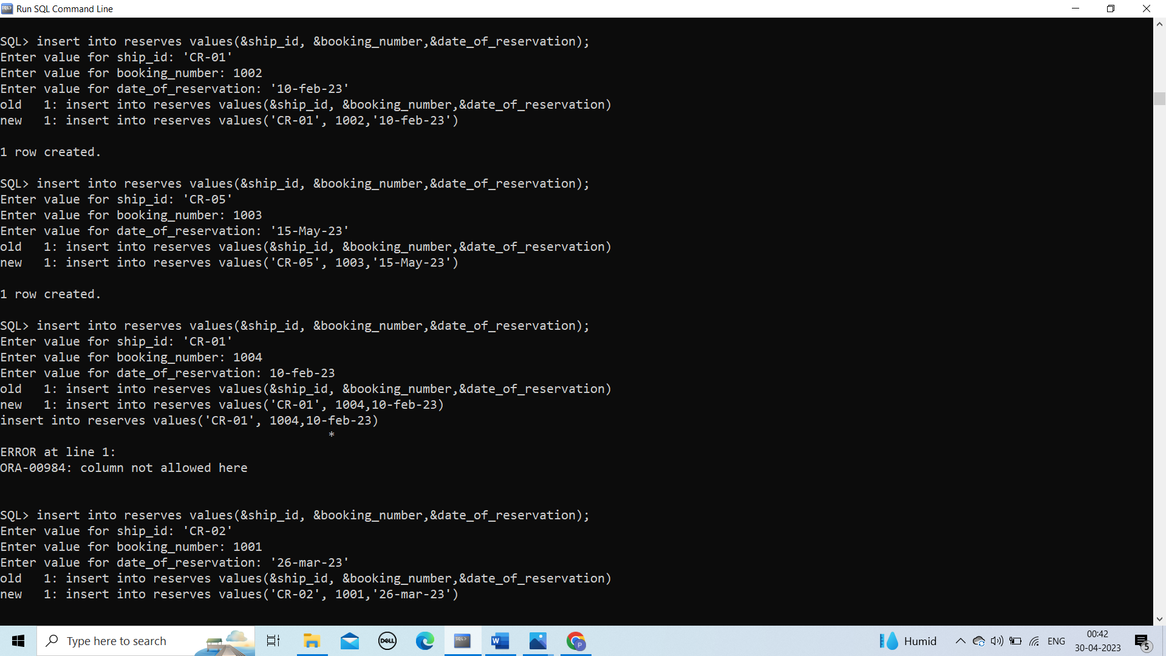

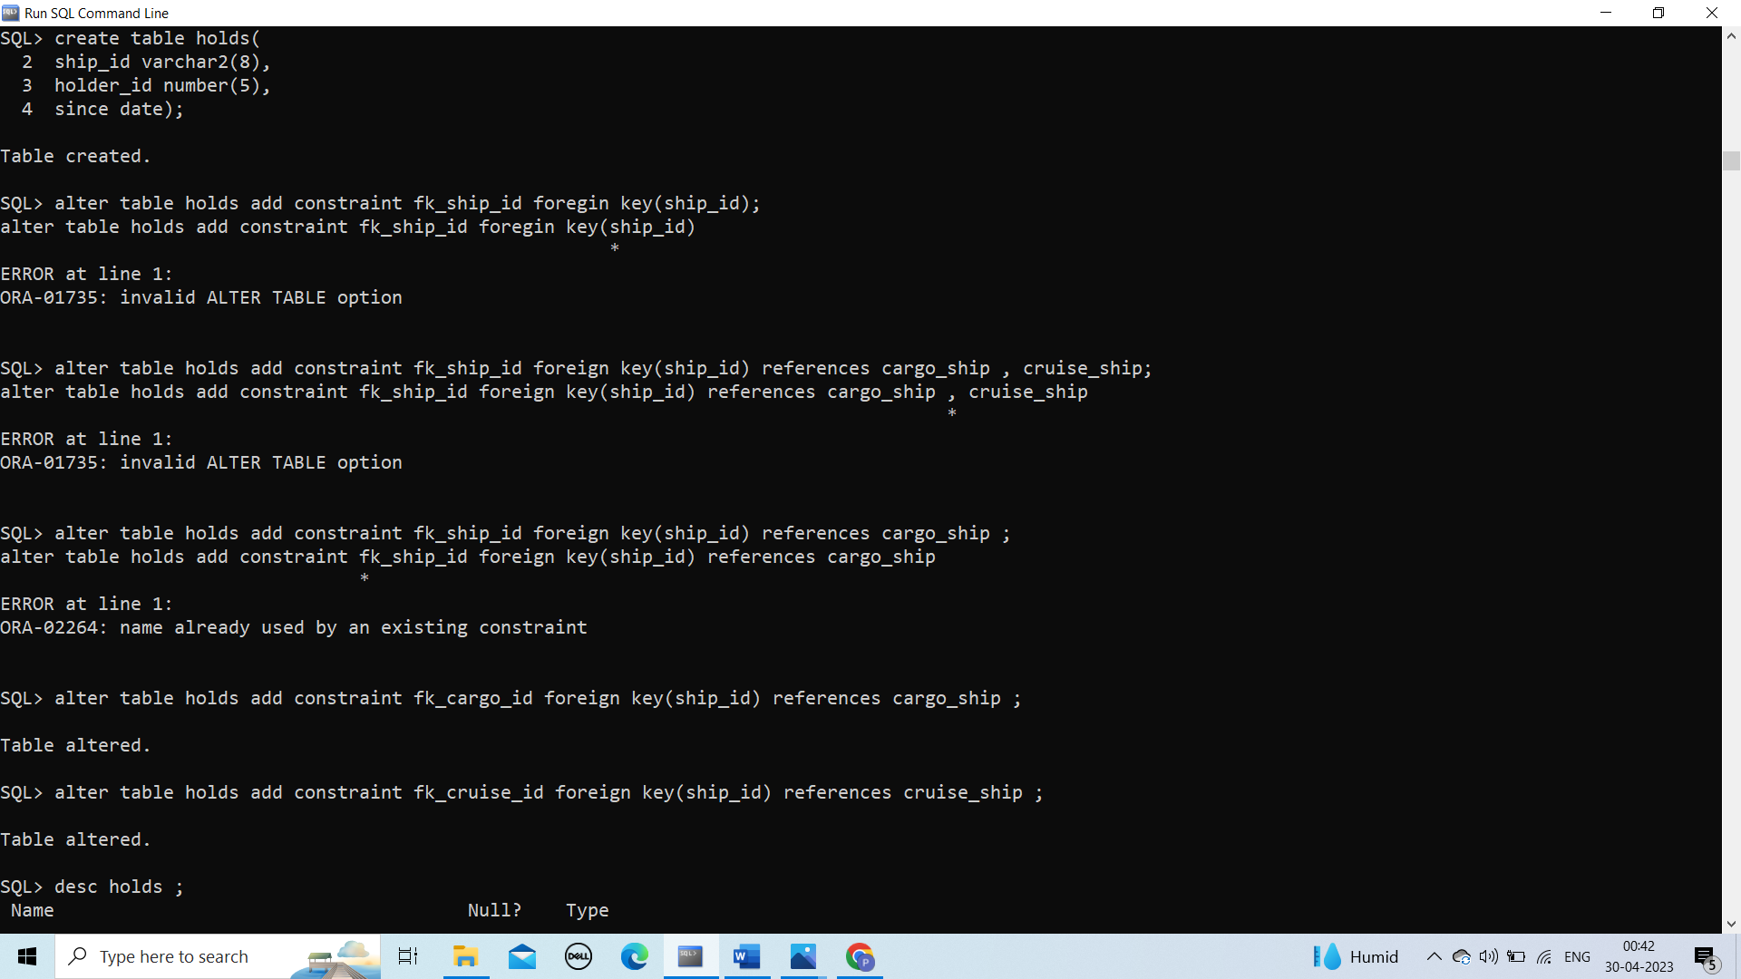

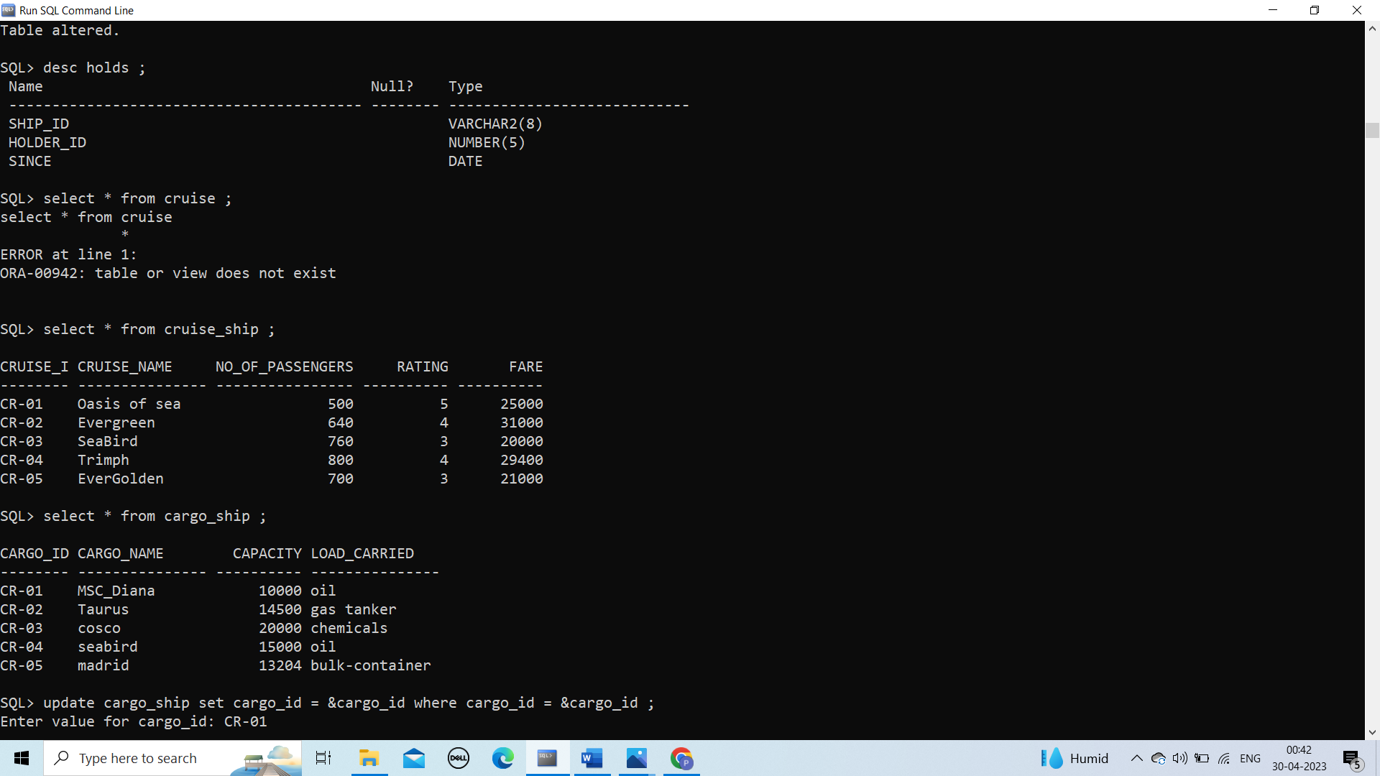

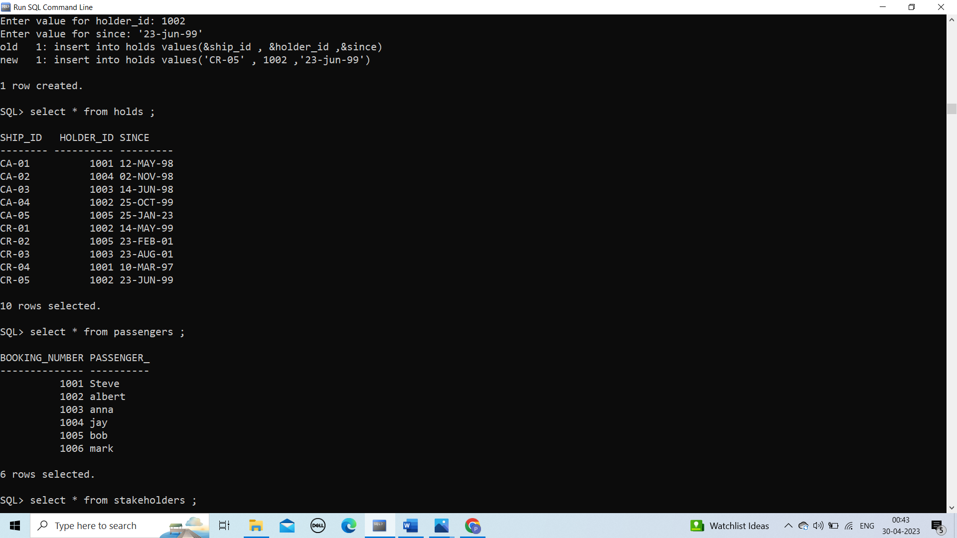

Tables :

