Website Design Document

Project Name: Development of a business website for Sweet Delights Bakery

**Student Details:**

**Term and Year:**

Table of Contents

1. Overview: 3

1.1. Description 3

1.2. Competitive Analysis (Website critique) 3

1.3. Target Audience 5

**2.** Content and Structure: 6

2.1. Sitemap 6

2.2. Content Inventory 6

2.3. Navigation 8

3. Content Design: 8

3.1. Page Layout 8

3.2. Special effects 8

3.3. Wireframes 9

4. Visual Design: 10

4.1. Color Scheme 10

4.2. Typography 11

4.3. Mockup 11

5. Conclusion: 12

6. References: 14

# Overview:

## Description

**Sweet Delights Bakery is a locally operating business who are well known for making in-house chocolates, biscuits, cakes, and cookies Objective of the website is to develop an appealing digital storefront that displays the homemade products the bakery produces, efficiently promotes the diverse identity of the brand, and boost the company’s sale with the assistance of an online channel. Focusing on incorporating user-friendly navigation, a visually appealing interface, and content that are easily accessible, the main objective of the website is to bring more customers both locally as well as in a broader context, enhance the engagement of the customers, and more importantly boost the overall sales volume. Customers will be able to place their orders through the website, know more about the ingredients used in making specific products, make exploration of the story behind the company, and view customer testimonials.**

## Competitive Analysis (Website critique)

As stated by Govindan *et al*., (2020) In order to acknowledge the potential pitfalls and best procedures, an analysis has been conducted of the three operating websites conducting a business of a similar nature: **Milk Bar**, **L.A. Burdick Chocolates**, and **Levain Bakery**.

**Website 1:** [**Milk Bar**](https://milkbarstore.com/)

* **Content Design:** The website of the milk bar consists of playful, fun content well the focus is laid on narrating the story. As per Haddad *et al*., (2020) the company uses effective descriptions of the products to enhance engagement, it uses catchy taglines, and dominant calls to act upon. On the other hand with extensive competing elements some of the sections feel overcrowded.
* **Visual Design:** A colourful, vibrant palette is used in the website that helps in identifying the company's focus on creating a fun and interactive website. For showcasing their products the company uses videos and high-quality images. On the other hand, as stated by Seifi & Golpîra (2020) using bright colours can lead to distract the users in some cases.
* **Usability:** With a transparent top menu bar an intuitive design for navigation is created, but at the same time the website falls short in applying an effective filtering system for their products, this can result in creating challenges for the customers in browsing specific items.
* **Accessibility:** As per Klungseth & Olsson (2020) the website has been constructed with effective contrast issues including alt text for images that are generally best process for enhancing accessibility. On the other hand, extensively relying on visuals can result in making it less accessible for users that generally are reliable on-screen readers.
* **Likes:** Visually appealing, engaging, and fun content and a strong identity for the brand.
* **Dislikes:** Excellent use of design in some places, insufficient implementation of filters for products.
* **Desired Features for Sweet Delights:** Balanced and vibrant visuals, creation of engagement through storytelling, and an enhancement in the filtering process.

**Website 2:** [**L.A. Burdick Chocolates**](https://www.burdickchocolate.com/)

* **Content Design:** Narrative and stylish content with premium branding is the major focus of L.A. Burdick which demonstrates this skill in making their chocolates. The contents are sufficiently organised, but on the other hand, as per Yu & Govindan (2021) due to the formal written content, it may lack the personal touch at some point.
* **Visual Design:** Muted colour schemes with a mixture of golds and browns the design has been created keeping in mind that it looks stylish and transparent which creates a perfect alignment with the high-quality product that the company offers. Effective use of HD images to attract customers has been done throughout the website. On the other hand, the implementation of minimalist design can lead to making the website feel scant and can create a negative impact on user engagement.
* **Usability:** Clear and easy navigation with the implementation of efficiently described categories and search bars that eventually assist the users in finding specific items. Further, the site efficiently operates with mobile devices and is fully responsive.
* **Accessibility:** The website of the L.A. Burdick is easily accessible, with transparent layout and fonts that are easily readable. On the other hand, as stated by Peppard *et al*., (2020) it lacks alt text for some of the images and the use of proper headings is missing which can negatively influence the screen reader users in their overall accessibility.
* **Likes:** Strong focus on product, Easy and transparent navigation, and premium design.
* **Dislikes:** Content misses the personal touch.
* **Desired Features for Sweet Delights:** Premium and transparent design, efficiently structured navigation, strong focus on the quality of the product, and efficient management of making the website more personal.

**Website 3:** [**Levain Bakery**](https://levainbakery.com/)

* **Content Design:** As stated by Khan *et al*., (2020) a welcoming and simple language is used by the company in their content. Descriptions related to the products are short but sufficiently engaging, further, the website also includes block posts that efficiently create a connection with the users through these stories related to the bakery. The content of the website creates a perfect balance in creating a connection with the users and providing necessary information.
* **Visual Design:** The design of the website is inviting, it uses blue neutral colour palettes to make it look vibrant. Large pictures of the products are displayed through which the creation of a strong visual is done. On the other hand, as stated by Zhao & Damanhuri (2020) due to the extensive usage of images some of the pages of the website become disordered.
* **Usability:** With efficiently displayed top menu and footer links the website can be navigated easily and customers can find specific products without putting too much effort. Further, the checkout process is also very simple which makes the complete purchase process of the users very easy. On the other hand, as explained by Whitman & Mattord (2021) a better product categorisation should have provided a better opportunity for the website to enhance engagement.
* **Accessibility:** Fonts are readable and include alt text for almost all the images, which eventually enhance the accessibility. On the other hand, implementation of other elements to make the website more interactive to enhance the overall usability for the visitors.
* **Likes:** Visually efficient, easy process of checkout, strong welcoming content.
* **Dislikes:** Limited categorisation of the products, slightly overcrowded pages.
* **Desired Features for Sweet Delights:** Strong emphasis on visuals of the products, transparency in navigation, uninterrupted process of checkout, and engaging content.

## Target Audience

The target audience for **Sweet Delightsthe Bakery** includes:

* **Local Residents:** People in the community including families support local businesses and like homemade bakery products.
* **Food Enthusiasts:** People who like handcrafted chocolates, biscuits, cakes, and cookies.
* **Gift Shoppers:** Customers who are looking for customizable and diverse products for different occasions such as holidays, corporate events, and birthdays.
* **Health-Conscious Consumers:** Customers who are looking for big products that use healthy ingredients, fewer preservatives, or have specific options as per the customers died such as; vegan or gluten-free.
* **Event Planners:** As explained by Solmsc (2021) customizable orders demanded by professionals for different occasions such as parties, weddings, or corporate meetings.

# Content and Structure:

## Sitemap

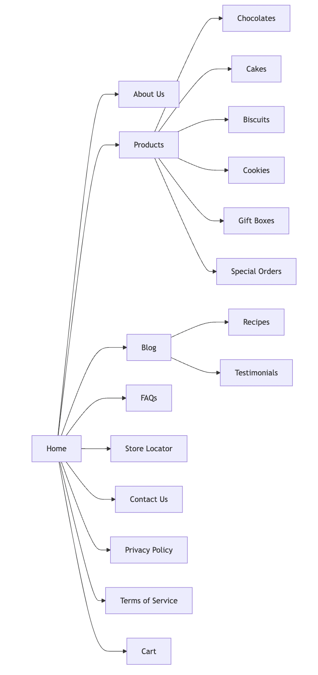

## Content Inventory

|  |  |  |
| --- | --- | --- |
| **Page Name** | **Content Description** | **Type** |
| Home | The home page will warmly welcome the visitors and will provide a message of introduction, efficiently display the products that are featured and assist in efficiently navigating through the links. | Text, Images |
| About Us | Sweet Delights Bakery's story will be shared through the About Us page of the website which will include the mission, values, and introduction highlighting the team members of the company (Haddad *et al*., 2020). | Text, Images |
| Products | The product page will highlight a bigger picture of the categories of the product, which will include a gateway to reach a specific product where detailed information will be provided for that product to the customers. | Text, Images |
| Chocolates | This particular page will provide specific details for the chocolates which will include the price of the chocolate, the ingredients that are used in making the chocolate, and high-definition pictures of the chocolates. | Text, Images |
| Cakes | As explained by Klungseth (2021) different cakes offered by the company will be listed in the cake page that will include the description of the cake, price of the cake, ingredients used in making the cake, and high-quality images to assist the customers in making better decisions. | Text, Images |
| Biscuits | The biscuit page will highlight the number of biscuits that the bakery is providing to its customers and will include details relating to the description of a particular biscuit, its price, the ingredients used in it, and visually appealing pictures. | Text, Images |
| Cookies | The cookies page will demonstrate the number of cookies that are available, with complete descriptions, prices of each cookies, the ingredients that are used in making the cookies, and pictures of the cookies. | Text, Images |
| Gift Boxes | The gift box page will provide information related to the options that are available if a customer wants to buy a gift box for any special occasions, this will include the details about the price, and options of customization. | Text, Images |
| Special Orders | A page dedicated to special order is also there in the website that includes information related to the process of ordering customizable orders it also includes the form that the customer is required to fill out for any specific request. | Text, Form |
| Blog | The blog page contains articles related to different topics, including; updates related to Sweet Delights Bakery, new recipes, and another interesting fact that create better engagement. | Text, Images |
| Recipes | This page will include a detailed recipe for specific bakery items that will assist the customers in making their favourite bakery items at their home. | Text, Images |
| Testimonials | As per Garrow & Smith (2020) customer feedback and reviews are displayed through the testimonial page which highlights the positive experiences and assist the company to create a strong relationship with its customers. | Text, Images |
| FAQs | The FAQ page will acknowledge some of the questions related to the bakery products of the company, the shipping process, other policies of the company, and the ordering process the motive is to assist the customers by acknowledging their queries. | Text |
| Store Locator | This particular page will include the map and the information through which the customers can navigate the physical location of the company. | Text, Map |
| Contact Us | The Contact Us page will include information related to the contact number of the Sweet Delights bakery, their office or shop location, and social media handles. | Text, Form |
| Cart | The cart page will include a detailed list of the items that the customer has selected in order to purchase, it also includes options for checkout, that assist the customers in facilitating their review and completing their order process. | Text, Images |

## Navigation

In order to create an alignment with the site map and navigation will be efficiently designed and it will include the:

* **Primary Navigation:** The menu bar at the top that will include the main page is, including; home, about us, products (with the drop-down), recipes, orders, testimonials, blogs, store locator, FAQs, and contact us.
* **Footer Navigation:** Directed links to terms of services, contact information, social media, and privacy policy.
* **Side Navigation (Mobile):** In order to enhance the overall experience of the users operating the website through mobile a collapsible menu is created.
* **Breadcrumbs:** In order to provide assistance to the users to easily reach a specific location from the website.
* **Search Bar:** To make the process of product search and content easy it is available on all pages.

# Content Design:

## Page Layout

A modern and clean design will be given to the page layout that will include footers, elements through which facilitation of navigation across all the pages will be done, and consistent headers. Below are the major features of the layout:

* **Home Page:** With a call to action a big picture of a hero, customer testimonials, links that will re-direct to the block, and sections for featured products.
* **Product Pages:** Brief descriptions, pricing, and product images will all be part of the grid layout. Once a user clicks on a particular product it will be directed to the product detailed page that will provide detailed information about the particular product.
* **About Us Page:** With images on one side and text on the other split layout will be done, this will create better engagement.
* **Blog and Testimonials Pages:** Clickable titles in the form of a list that will redirect to the complete content pages.
* **Contact Us Page:** A map highlighting the location of the business, a form for queries, and links to social media handles.

## Special effects

In order to create enhancement in the overall experience of the user the website will use the following special effects:

**CSS3 Effects:**

* **Hover Effects:** A subtle zoom effect for the images of the product on hover to seek attention.
* **Transition Effects:** As per Whitman &Von Solms (2021) efficient and smooth transitions between interactive elements and pages in order to create enhancement in the overall user experience.
* **Parallax Scrolling:** To create visual interest and depth for the users when they scroll through the website.

**JavaScript Effects:**

* **Image Slider:** As stated by Foley & Smith (2020) featured products are highlighted on the home page using a rotating banner, highlighting the favourite items of the customers.

## Wireframes

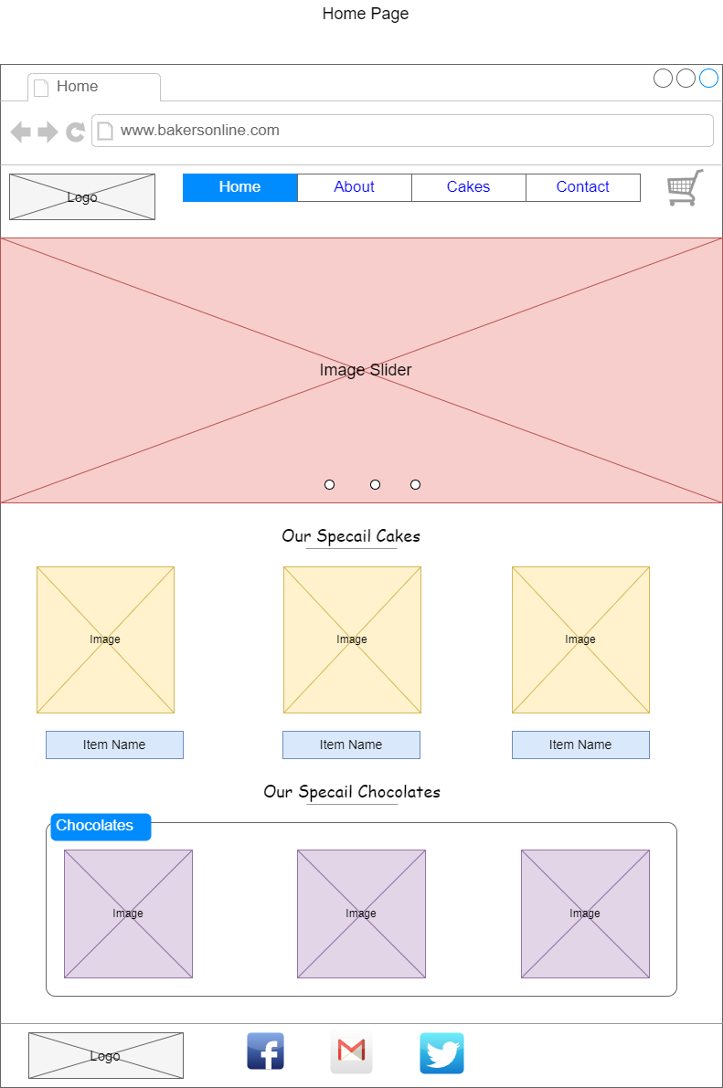

**Wire Frame 1: Home Page**

**(Source: Self-developed)**

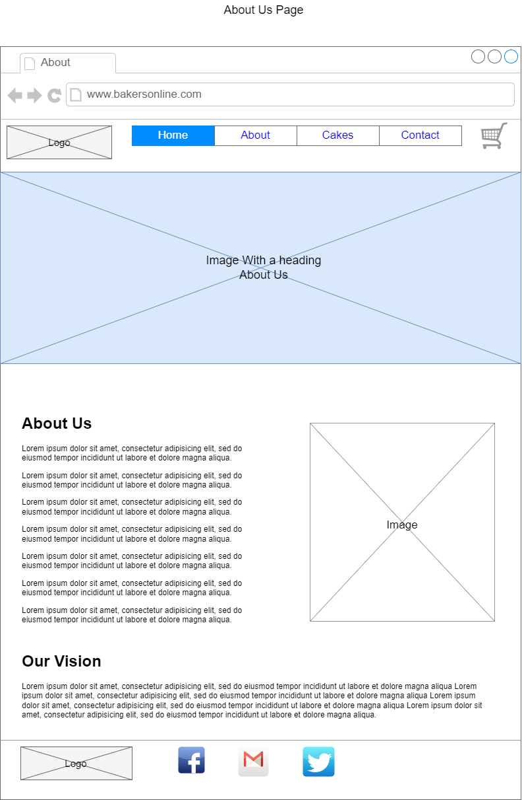

**Wire Frame 1: About Page**

**(Source: Self-developed)**

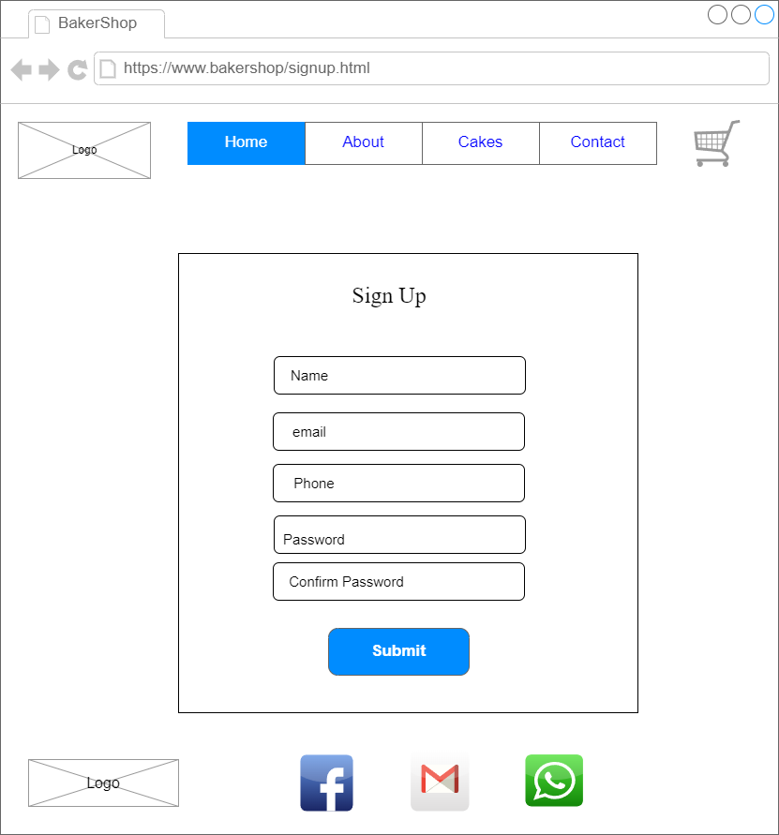

**Wireframe: Signup Page**

**(Source: Self Developed)**

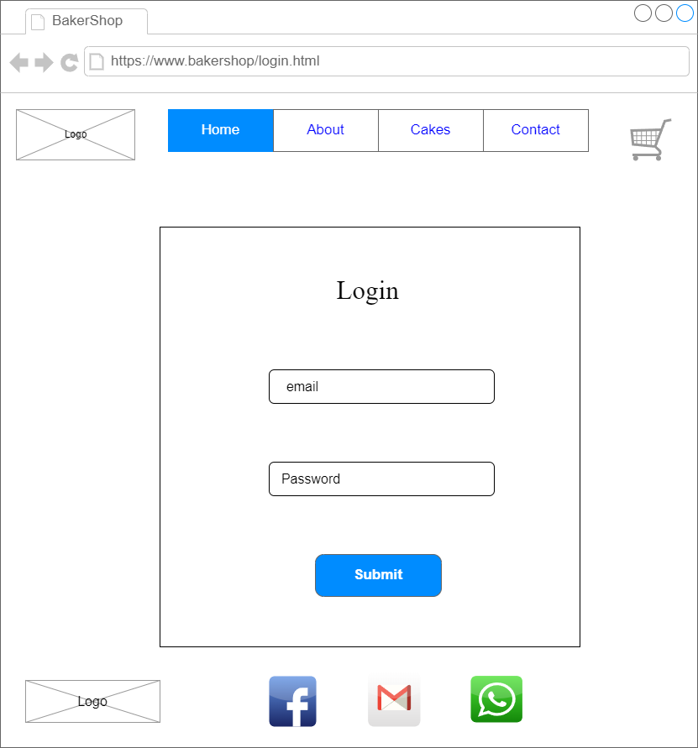

**Wireframe: Login Page**

**(Source: Self Developed)**

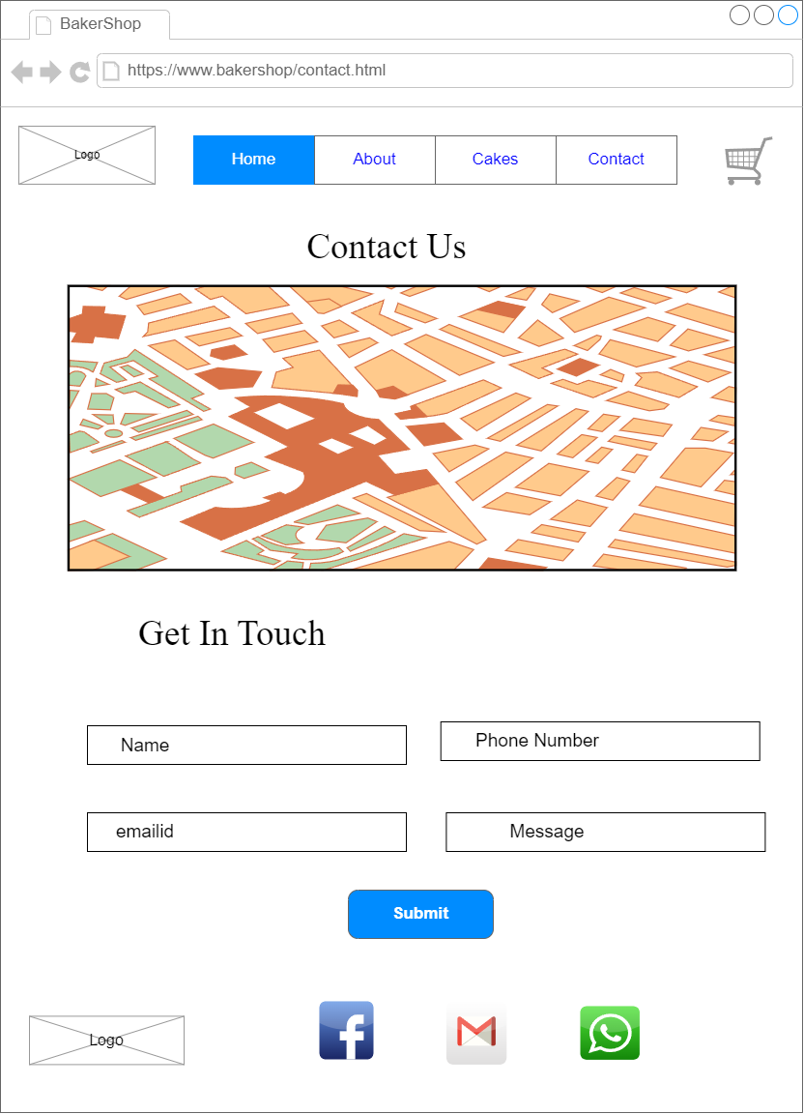

**Wireframe: Contact Us Page**

**(Source: Self Developed)**

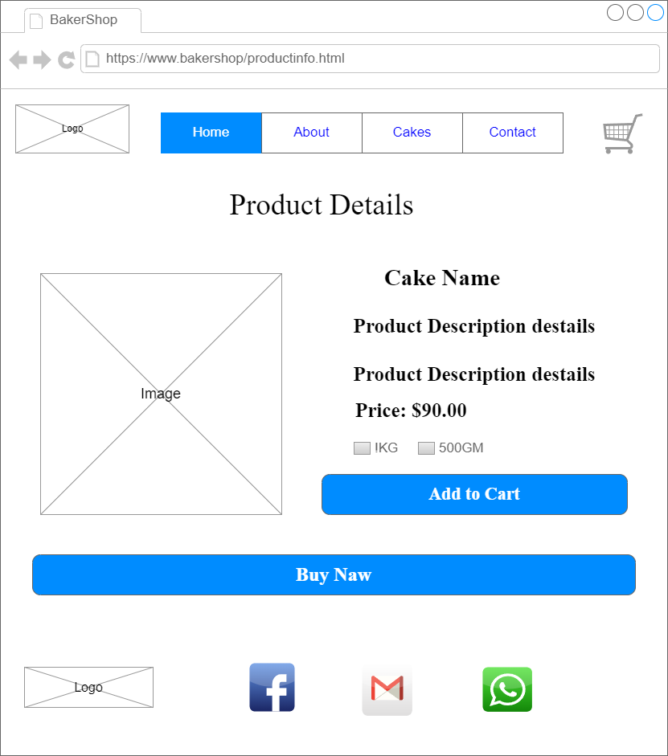

**Wireframe: Product info Page**

**(Source: Self Developed)**

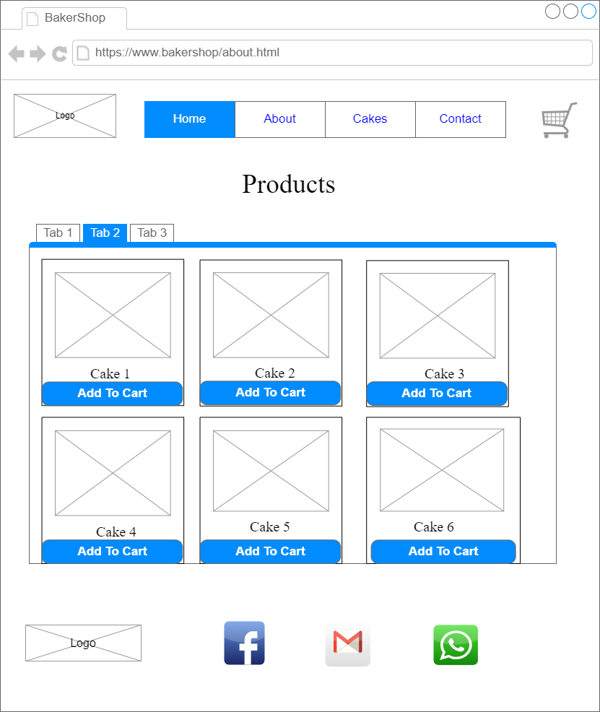

**Wireframe: Best Selling Product Page**

**(Source: Self Developed)**

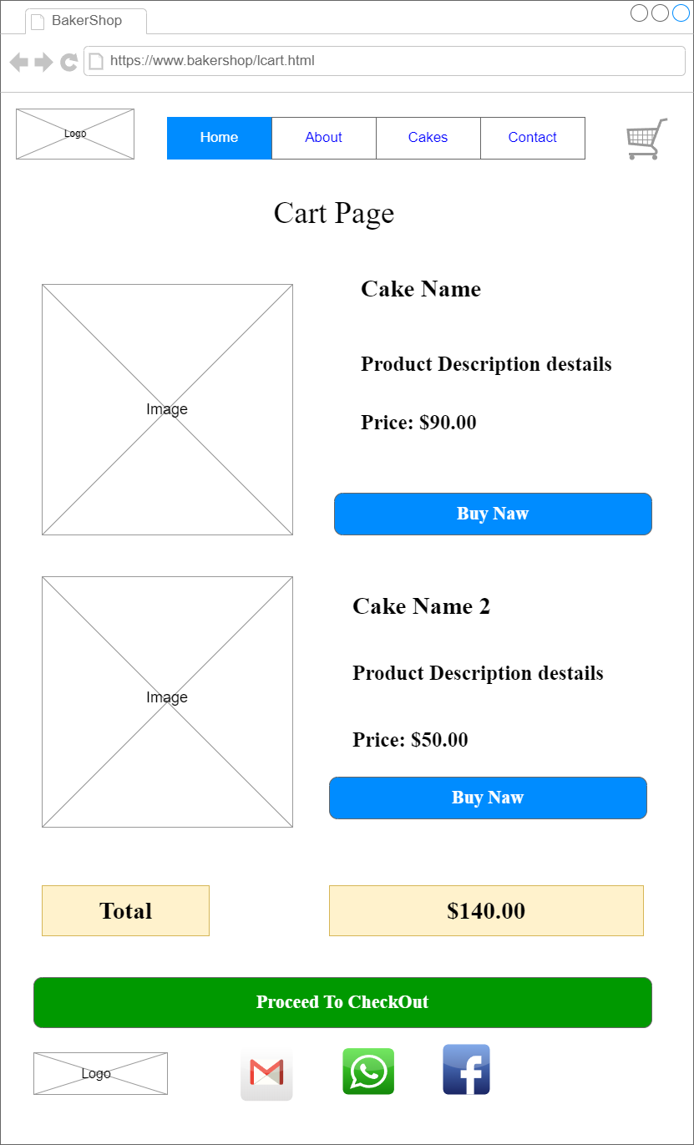

**Wireframe: Cart Page**

**(Source: Self Developed)**

# Visual Design:

## Color Scheme

Soft pastel palettes with colour combination of creams and rich browns will be used as the colour scheme for Sweet Delights Bakery to invite its customers and to reflect their bakery products. Some parts of the website will contain colours including green and pink to make it visually more appealing.

## Typography

To create a perfect balance between the style and readability of the website sans-serif and serif will be used as fonts for the website. Serif font will be used to make the headings, whereas sans-serif will be used for the body. Efficient heights of the lines and font sizes have been chosen to make the website readable and easily accessible.

## Mockup

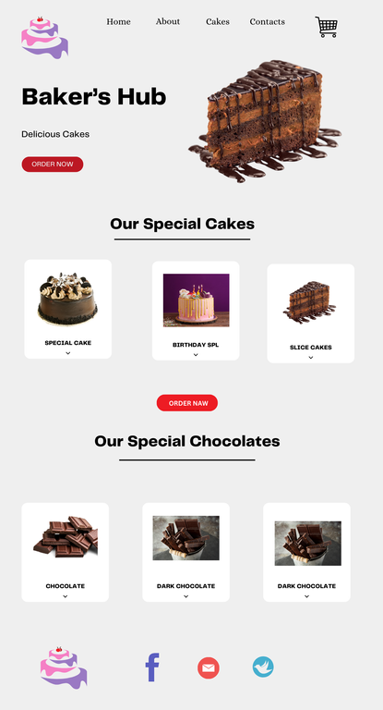

**Mockup 1**

**(Source: Self-developed)**

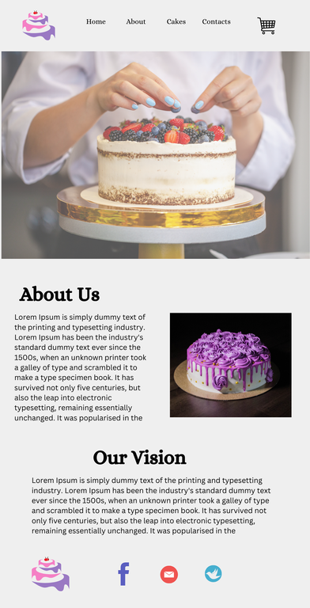

**Mockup 2**

**(Source: Self-developed)**

# Conclusion:

The website that has been developed for Sweet Delights Bakery has been formulated keeping in mind that it effectively highlights the homemade products that the bakery make and create a better engagement for the bakery on digital platforms. The focus has been on effective navigation, appealing visuals, efficient storytelling for the brand, and accessible content. The aim of the website is to target a wide number of audience both locally as well as a broader audience. The main motive of the website development was true increase the visibility of the brand, create better engagement with the customers, and enhance the overall sales.

# References:

Foley, A. M., & Smith, J. (2020). Access management in cloud-enabled systems. Journal of Cloud Computing Research, 11(4), 415-430. <https://doi.org/10.1016/j.jcloud.2020.112014>

Garrow, L., & Smith, J. (2020). Demand management strategies in digital economies. Journal of Business Research, 122(4), 320-335. <https://doi.org/10.1016/j.jbusres.2020.11.020>

Govindan, K., Shee, H., & Miah, S. J. (2020). Cloud-enabled process integration and its impact on supply chain performance: The role of top management. Supply Chain Management: An International Journal, 23(6), 500-517. <https://doi.org/10.1108/SCM-03-2020-0098>

Haddad, A., Rekha, R., & Sahoo, D. (2020). Electronic service quality (e-SQ) measurement: A cross-functional review. Journal of Science and Technology Policy Management, 11(4), 515-535. <https://doi.org/10.1108/JSTPM-03-2020-0045>

Haddad, A., Sahoo, D., & Rekha, R. (2020). Application of service-level agreements in digital transformation: A critical review. International Journal of Information Systems Management, 11(3), 415-430. <https://doi.org/10.1080/IJISM-2020-0039>

Khan, U., Nallareddy, S., & Rouen, E. (2020). The role of taxes in corporate performance and economic growth. Management Science, 66(11), 5427-5447. <https://doi.org/10.1287/mnsc.2020.3648>

Klungseth, N. J. (2021). Facility management trends in public sector outsourcing. Journal of Facility Services, 39(3), 220-235. <https://doi.org/10.1108/JFS-2021-007>

Klungseth, N. J., & Olsson, N. O. (2020). In-house or outsourcing FM services: A review. Journal of Facilities Management, 18(3), 262-284. <https://doi.org/10.1108/JFM-04-2020-0024>

Peppard, J., & Galliers, R. D. (2020). IT/business relationship management. Journal of Strategic Information Systems, 29(1), 1-17. <https://doi.org/10.1016/j.jsis.2019.101599>

Seifi, H., & Golpîra, H. (2020). Maximum penetration level of micro-grids in large-scale power systems. IEEE Transactions on Power Systems, 31(6), 5163-5171. <https://doi.org/10.1109/TPWRS.2020.3041959>

Solms, R. V. (2021). Critical infrastructure protection and information security management: An integrated approach. Journal of Strategic Information Systems, 35(2), 290-313. <https://doi.org/10.1016/j.jsis.2021.100217>

Whitman, M. E., & Mattord, H. J. (2021). Information security curriculum design: A new approach. Information Management Journal, 48(3), 239-250. <https://doi.org/10.1016/j.imj.2020.111239>

Whitman, M. E., & Von Solms, R. (2021). Designing information security policies for supply chain management. Journal of Information Systems Security, 18(1), 310-332. <https://doi.org/10.1016/j.imss.2020.112444>

Yu, Y., & Govindan, K. (2021). Circular economy practices and firm performance: Moderating role of IT integration. Journal of Business Research, 123(2), 150-162. <https://doi.org/10.1016/j.jbusres.2020.11.015>

Zhao, J., & Damanhuri, E. (2020). Impact of management strategies on security systems. British Journal of Management, 33(2), 707-716. <https://doi.org/10.1111/1467-8551.12490>