Annotation tool

<https://www.robots.ox.ac.uk/~vgg/software/via/via_demo.html>

Class

1 Dent

2 scratch

3 Broken/Smash

Reference Github link



C3S C2S

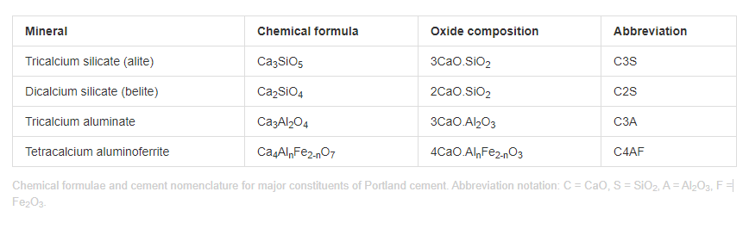

The composition of cement is varied depending on the application. A typical example of cement contains 50–70% C3S, 15–30% C2S, 5–10% C3A, 5–15% C4AF, and 3–8% other additives or minerals (such as oxides of calcium and magnesium). It is the hydration of the calcium silicate, aluminate, and aluminoferrite minerals that causes the hardening, or setting, of cement.

**The ratio of C3S to C2S helps to determine how fast the cement will set, with faster setting occurring with higher C3S contents.**

Lower C3A content promotes resistance to sulfates. Higher amounts of ferrite lead to slower hydration. The ferrite phase causes the brownish gray color in cements, so that “white cements” (i.e., those that are low in C4AF) are often used for aesthetic purposes.

The calcium aluminoferrite (C4AF) forms a continuous phase around the other mineral crystallites, as the iron containing species act as a fluxing agent in the rotary kiln during cement production and are the last to solidify around the others.

[Figure](https://cnx.org/contents/pibiS5Mg@3.12:1hULTvih@9/Chemical-Composition-of-Portland-Cement#grain) shows a typical cement grain.

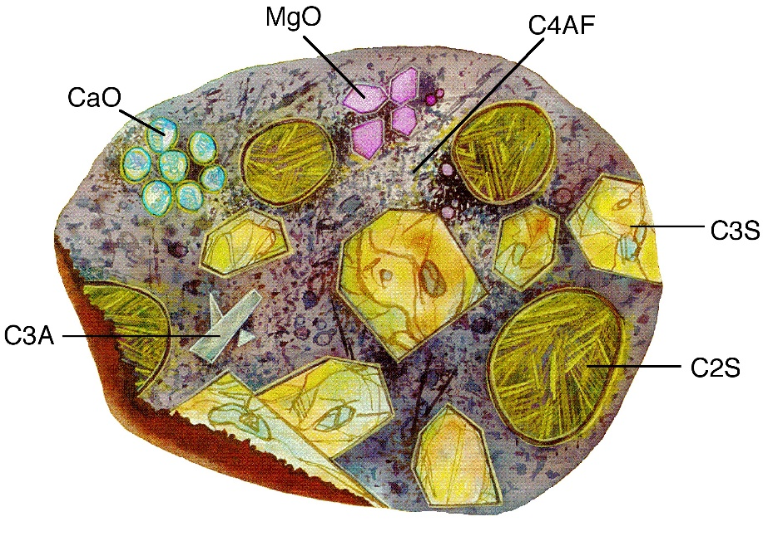A pictorial representation of a **cross-section of a cement grain. Adapted from Cement Microscopy, Halliburton Services, Duncan, OK.**

It is worth noting that a given cement grain will not have the same size or even necessarily contain all the same minerals as the next grain. The heterogeneity exists not only within a given particle, but extends from grain to grain, batch-to-batch, plant to plant.

**The hydraulic performance of cement derives from the mineral composition of the clinker, i.e. the C3S, C2S, C3A and C4AF content.**

The amount of total silicates in the clinker is controlled by cement chemists via the silica ratio or modulus:

**Silica Modulus = %SiO2/(%Al2O3 + %Fe2O3)**

**The higher the silica modulus the more silicates, C3S and C2S, will be present in the clinker at the expense of the aluminate, C3A, and aluminoferrite, C4AF**

**The split of the silicates between C3S and C2S is controlled by the lime saturation factor.**

lime saturation means a maximum amount of lime, CaO that can be combined with the acidic oxides, silica, SiO2, alumina, Al2O3 and iron oxide, Fe2O3.

The Lea and Parker formula for the maximum combinable lime, CaO is therefore:

**%CaOMax = 2.8 x %SiO2 + 1.18 x %Al2O3 + 0.65 x %Fe2O3**

The lime saturation is then the ratio of the actual CaO content of the clinker to the maximum combinable lime calculated by the Lea and Parker formula:

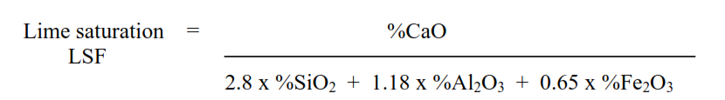

**If the CaO content of the clinker equals the maximum combinable lime then the clinker is 100% lime saturated. If the CaO content of the clinker is more than the maximum combinable, then the clinker is more than 100% lime saturated and some uncombined free lime will be present in the clinker.**

**Clinker C3S contents of up to ±67 per cent in grey cement clinker can be achieved by raising the lime saturation of the clinker towards 100 per cent.**

Bogue compound composition.

The majority of cement companies rely on a method of calculating the mineral composition that was developed by the eminent cement chemist, R.H. Bogue.

The Bogue composition is calculated from the oxide composition of the cement or clinker, based on the molecular weights of the oxides.

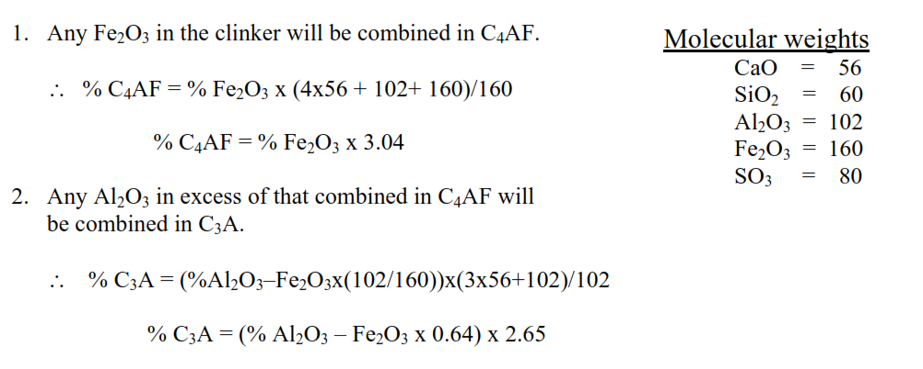

3-The CaO must be corrected for the amount which is combined with SO3 in CaSO4 and the uncombined free CaO.  
∴ **%CaOCombined = %CaO – SO3*56/80 – Free CaO**

**%CaOCombined = %CaO – SO3*0.7 – Free CaO**

4-The CaO combined with SiO2 in C3S and C2S, is the remainder of the combined CaO, after correction for the CaO combined with Fe2O3 in C4AF and Al2O3 in C3A.

**∴ %CaOSilicates = %CaOCombined – Fe2O3x4x56/160 –(Al2O3-Fe2O3x102/160)x3x56/102**

**%CaOSilicates = %CaOCombined – Fe2O3x1.40 –(Al2O3-0.64*Fe2O3)x1.65**

5- The remaining CaO and the SiO2 are then partitioned between C3S and C2S and the proportions of C3S and C2S can be found by solving simultaneous equations.

a- %CaOSilicates = C3Sx168/228 + C2Sx112/172

B- %SiO2 = C3Sx60/228 + C2Sx60/172

a. %CaOSilicates = C3Sx0.7368 + C2Sx0.6512

b. %SiO2 = C3Sx0.2632 + C2Sx0.3488

Rearranging b.

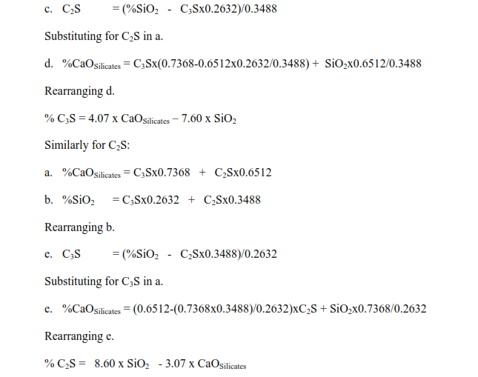

The following corrections are made to the C3S and C2S content of the clinker:

%C3S = Bogue Value + 1.8 x %Al2O3 – 2.8 x %Fe2O3

%C2S = Bogue Value – 2.1 x %Al2O3 + 1.9 x %Fe2O3

In the second scenario where the flux crystallises independently of the solid phases the corrections to be applied to the Bogue mineralogy are dependent on the alumina modulus of the clinker. For alumina modulus from 0.9 to 1.7 then Bogue mineralogy does not need to be corrected.

For alumina modulus over 1.7 the following corrections apply:  
**%C3S = Bogue Value + 1.8 x %Al2O3 – 2.8 x %Fe2O3  
%C2S = Bogue Value – 1.4 x %Al2O3 + 2.1 x %Fe2O3  
%C3A = Bogue Value – 1.6 x %Al2O3 + 2.5 x %Fe2O3**   
In the frozen equilibrium there will also be some C12A7 present:  
%C12A7 = 1.2 x %Al2O3 – 1.8 x %Fe2O3

**Using above method we can increase /measure the C3S in cement.**

**C3S increase by minor components like K2O,SO3,P2O5**

**The excess K2O in clinker is given by the formula:**

**% Excess K2O = %K2O – %SO3 * 94/80**

If the excess K2O is then presumed to combine as KC23S12 then the content of this mineral which will be present is given by:

**% KC23S12 = % Excess K2O * 2102/94**

A very large factor due to only one unit of K2O being present in the high molecular weight KC23S12.

SiO2 combined in the mineral KC23S12 is not available to combine with further free CaO and form C3S.

**% Available SiO2 = % SiO2 – %Excess K2O * 720/94**

**% Residual CaO = % CaO – %Excess K2O * 1288/94**

By this methodology the effective lime saturation of the clinker was lifted by 5.5%.

####

MgO substitutes for CaO in the clinker minerals. When the LSF equation is corrected the MgO is limited to 2% as this is the approximate maximum that can replace CaO.

**LSF = (%CaO + 0.75x%MgO)/(2.8x%SiO2 + 1.18x%Al2O3 + 0.65x%Fe2O3)**