Software Architecture and Design Specification (SDS)
for
Wind Turbine Gearbox Predictive Maintenance System (WT-GPMS)
Document ID: WT-GPMS-SDS-001 | Version: 3.1 | November 11, 2026
Course: UE24CS341A - Software Engineering
Anchors: Prof. Vadiraja A, Prof. Sheela Devi
Prepared by: Ananya | PES University
Structured in IEEE Std 1016-2009 Standard Format

Revision History
Version | Date | Description
0.1 | 07-Oct-2026 | Initial architecture draft.
1.0 | 12-Oct-2026 | First baselined architecture specification.
3.0 | 30-Oct-2026 | 3-Tier Microservices architecture with PyTorch DL, PennyLane QML, Docker Compose, Kubernetes, and Consensus Voting.
3.1 | 11-Nov-2026 | Updated with System Architecture Diagram figure, MongoDB NoSQL Persistence (Port 27017), MLflow Registry (Port 5000), User Registration/Auth Gate, and Dual-Algorithm Engines for ML, DL, and QML.

1. Introduction

1.1 Purpose
This Software Architecture and Design Specification describes the complete 3-tier microservices architecture, inter-service JSON REST contracts, dual-algorithm ML/DL/QML engines, MongoDB NoSQL database design, MLflow model registry integration, and container orchestration for WT-GPMS.

1.2 Scope
Covers Tier 1 (Streamlit Web Client on Port 8501), Tier 2 (Data Validation, Feature Pipeline, Ensemble Consensus Engine, Self-Healing Fallback Handler), Tier 3 (FastAPI ML:8001, DL:8002, QML:8003, and MLflow:5000), MongoDB Persistence (Port 27017), Docker Compose networking, and Kubernetes deployment.

1.3 Definitions and Abbreviations
Term | Meaning
Microservice | Independently deployable service exposing FastAPI REST endpoints over HTTP.
LOF / iForest | Classical ML algorithms (Local Outlier Factor & Isolation Forest).
LSTM / MLP AE | PyTorch Deep Learning Recurrent (LSTM) and Dense (MLP) Autoencoders.
VQC / Fidelity | PennyLane Quantum ML Variational Circuit and State Overlap Fidelity Metric.
MongoDB | NoSQL Document Store persisting salted credentials and diagnostic audit trails.
ClusterIP / NodePort | Kubernetes internal service discovery and external port exposure (30501).

1.4 References
- WT-GPMS-SRS-001, Software Requirements Specification, Version 3.0.
- WT-GPMS-STP-001, Black-Box System Test Plan (Cypress), Version 4.0.
- IEEE Std 1016-2009, Systems Design - Software Design Descriptions.

2. Architecture

2.1 Architectural Drivers
- Multi-Algorithm Diversity: Supporting 2 distinct algorithms across each paradigm (ML, DL, QML) enables real-time comparative benchmarking.
- Fault Isolation & Resilience: Strict container isolation prevents a failure in one service or database from disrupting the UI.
- Horizontal Scalability: Docker Compose bridge network and Kubernetes HPA allow horizontal scaling of compute-heavy models.
- Security & Auditability: Enterprise authentication and immutable audit trail persistence in MongoDB satisfy regulatory traceability.

2.2 System Architecture Diagram & Pattern
WT-GPMS implements a 3-Tier Distributed Microservices Pattern integrated with NoSQL persistence and automated CI/CD pipelines. As illustrated in Figure 1 below, industrial SCADA telemetry feeds through validation and rolling feature pipelines into independent Classical ML, Deep Learning, and Quantum ML microservices, whose outputs are unified by an Ensemble Majority Consensus Engine and rendered on the browser.
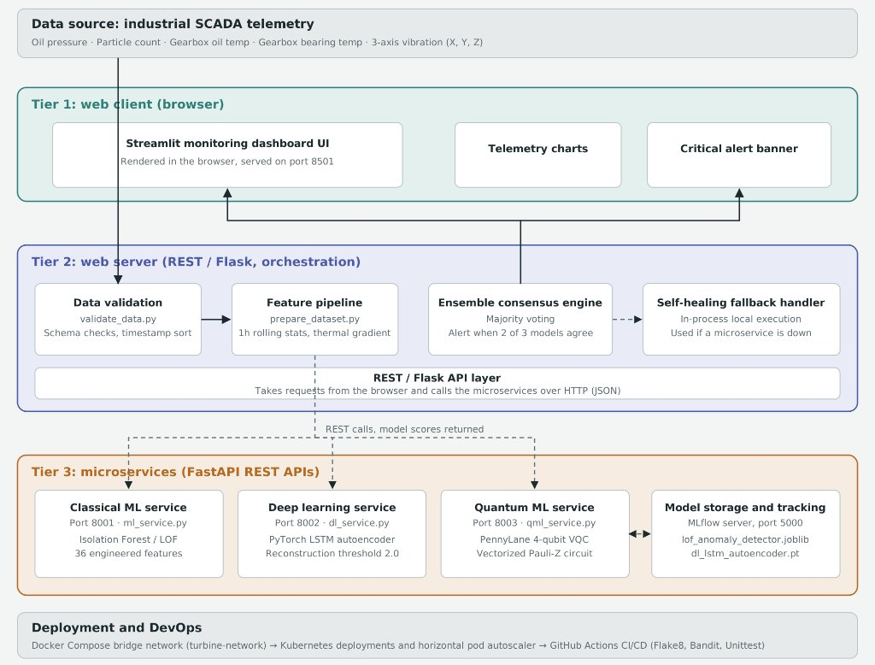
Figure 1: WT-GPMS 3-Tier Microservices, Consensus Orchestration & DevOps Architecture

2.3 Component View
Component | Primary Responsibility | Technology & Port
Web Client & Security Portal | Authentication (Sign In / Create Account), Tab 1 Telemetry Charts, Tab 2 Manual Diagnostic Simulator, Consensus Voting. | Streamlit (Port 8501)
Classical ML Microservice | Dual anomaly scoring via Isolation Forest and Local Outlier Factor (LOF) across 36 rolling features. | FastAPI, scikit-learn (Port 8001)
Deep Learning Microservice | Dual neural reconstruction MSE scoring via PyTorch LSTM Autoencoder and MLP Dense Autoencoder. | FastAPI, PyTorch (Port 8002)
Quantum ML Microservice | Dual 4-qubit quantum scoring via PennyLane VQC (Pauli-Z) and Quantum State Overlap Fidelity. | FastAPI, PennyLane (Port 8003)
MongoDB NoSQL Database | Stores salted SHA-256 engineer accounts ('users') and real-time diagnostic logs ('prediction_history'). | MongoDB / PyMongo (Port 27017)
Model Registry & Tracking | Logs training runs, evaluation metrics, ROC-AUC, and serialized model artifacts. | MLflow Server (Port 5000)
Orchestration & CI/CD | Container networking, health probes, HPA autoscaling, and automated quality gates. | Docker Compose / Kubernetes / GitHub Actions

2.4 Runtime and Deployment View
In Docker Compose, five primary containers run on an isolated bridge network (turbine-network) resolving via internal DNS: mongodb:27017 (with persistent named volume mongo_data), ml-service:8001, dl-service:8002, qml-service:8003, and frontend:8501. In Kubernetes, services expose internal ClusterIP routes while exposing the web console on NodePort 30501 with horizontal pod autoscaling.

2.5 Data & Database Design (MongoDB + SCADA Telemetry)
Architecture Overview: Persistence spans two layers:
- MongoDB Users Store: Collection 'users': Documents store {username, full_name, role, password_hash (salted SHA-256), created_at}. Auto-seeds default accounts on startup.
- MongoDB Audit Trail: Collection 'prediction_history': Documents store {timestamp (UTC), operator, sensor_inputs {7 channels}, classical_ml, deep_learning, quantum_ml, consensus_verdict}.
- SCADA Dataset & Artifacts: 262,800 historical 10-minute SCADA rows across 7 physical sensors, expanded to 36 rolling window & thermal differential features tracked by DVC/DAGsHub.

2.6 Dual-Algorithm Model & Quantum Circuit Designs
Microservice | Algorithm 1 (Primary) | Algorithm 2 (Secondary) | Decision Threshold
Classical ML (8001) | Local Outlier Factor (LOF): 36 engineered rolling features, novelty=True. | Isolation Forest: 100 estimators, recursive spatial partitioning. | Score >= 0.328 (LOF)
Deep Learning (8002) | LSTM Autoencoder: 7 -> 16 (LSTM) -> 8 -> 16 (LSTM) -> 7 temporal decoder. | MLP Dense Autoencoder: 7 -> 12 -> 4 (bottleneck) -> 12 -> 7 feedforward. | MSE >= 2.00
Quantum ML (8003) | 4-Qubit VQC: AngleEmbedding(Y) -> CNOT Ring -> Pauli-Z expectation. | Quantum State Fidelity: AngleEmbedding(X) -> ground state overlap P(|0000>). | 0.52 (VQC) / 0.50 (Fidelity)

2.7 Consensus Voting & Self-Healing Fallback Engine
1. Majority Consensus Rule: Vote Count = ML_Alert + DL_Alert + QML_Alert. If Vote Count >= 2, verdict is CRITICAL ANOMALY ALERT; otherwise NORMAL OPERATIONAL STATE.
2. Self-Healing Fallback: If any FastAPI microservice is unreachable, src/dashboard.py invokes local in-process fallback inference functions. If MongoDB is unreachable, src/database.py seamlessly transitions to salted in-memory fallback authentication and session logging.

3. Detailed Design

3.1 Diagnostic & Data Processing Sequence
Step 1: Engineer signs in (or creates an account) at Security Portal -> verified via MongoDB salted SHA-256.
Step 2: Engineer selects Tab 1 (Batch Analysis) or Tab 2 (Manual What-If Simulator + Presets).
Step 3: Engineer chooses desired DL (LSTM/MLP) and QML (VQC/Fidelity) models from the Architecture Selector.
Step 4: Frontend dispatches parallel POST /predict JSON requests with 'algorithm' flag to Ports 8001, 8002, 8003.
Step 5: Majority Consensus Verdict is rendered and the full diagnostic snapshot is written to MongoDB.

3.2 Microservice REST Contracts
- GET /health: Returns HTTP 200 JSON containing status='healthy', port, framework, and list of supported_algorithms.
- POST /predict: Accepts JSON {'records': [...], 'algorithm': 'vqc'|'fidelity'|'lstm'|'mlp'}. Returns {'count': N, 'algorithm': '...', 'latency_ms': T, 'predictions': [{'is_anomaly': 0|1, 'status': '...', ...}]}.

3.3 User Interface Design
Built in Streamlit with strict session isolation. Unauthenticated sessions render only the Login/Registration tabs and terminate execution via st.stop(). Authenticated sessions display live status pills, user identity, Tab 1 Altair telemetry visualizations, and Tab 2 interactive sensor controls with live MongoDB audit log tables.

3.4 Error Handling & Input Sanitization
- FastAPI Pydantic models validate incoming schemas and return HTTP 400 with explicit missing field diagnostics.
- UI numerical widgets enforce physical sensor bounds (e.g. Oil Temp [30, 120] °C, Pressure [1, 6] bar) preventing invalid inputs.
- Registration checks enforce minimum lengths (username >= 3 chars, password >= 6 chars), password match, and duplicate rejection.

4. Traceability and Verification
Every architectural tier and algorithm maps directly to SRS requirements (REQ-01 to REQ-22) documented in Wind_Turbine_SRS.docx and is externally verified through the automated Black-Box Cypress System Test Suite (TC-POS-01..12 and TC-NEG-01..10).

5. Limitations and Future Design
1. Live Quantum QPU Integration: Routing PennyLane circuits to real IBM Quantum superconducting hardware.
2. Real-Time SCADA Broker: Attaching Apache Kafka for live streaming ingestion directly from wind farm turbines.

Supplementary Section: Two Algorithms in Each AI Microservice
WT-GPMS provides two selectable algorithms in each of its three inference microservices. The following summary consolidates the model pairings and their principal design characteristics.
AI Category / Service | Algorithm 1 | Algorithm 2 | Key design details
Classical ML | Isolation Forest (iForest) | Local Outlier Factor (LOF) | Unsupervised anomaly detection using random recursive feature-space partitioning. The architecture document specifies 100 estimators.  Novelty-based anomaly detection that compares a sample's local density with that of its nearest neighbours. Uses 36 engineered rolling/statistical features; novelty=True; threshold 0.328.
Deep Learning | LSTM Autoencoder | MLP Dense Autoencoder | Learns temporal patterns from sensor sequences and detects unusual behaviour through reconstruction error. Architecture: 7 → 16 → 8 → 16 → 7; anomaly threshold MSE ≥ 2.00.  Feedforward autoencoder for reconstructing sensor feature vectors. Architecture: 7 → 12 → 4 → 12 → 7, with a 4-unit bottleneck.
Quantum ML | Variational Quantum Classifier (VQC) | Quantum State Overlap / Fidelity Metric | Four-qubit PennyLane circuit using AngleEmbedding, a CNOT entangling ring and Pauli-Z expectation values. Anomaly threshold: 0.52.  Four-qubit state-overlap approach using AngleEmbedding and ground-state overlap P(|0000>). Anomaly threshold: 1 − Fidelity ≥ 0.50.

The Classical ML service is exposed on Port 8001, the Deep Learning service on Port 8002, and the Quantum ML service on Port 8003. The dashboard can select the supported DL and QML architectures, while the services expose their prediction functionality through REST endpoints.
Implementation note: The Quantum ML algorithms are executed using PennyLane simulation; this design does not imply deployment on physical quantum hardware.

