**Report on the Database Research or Administration Task**

**Test Database**

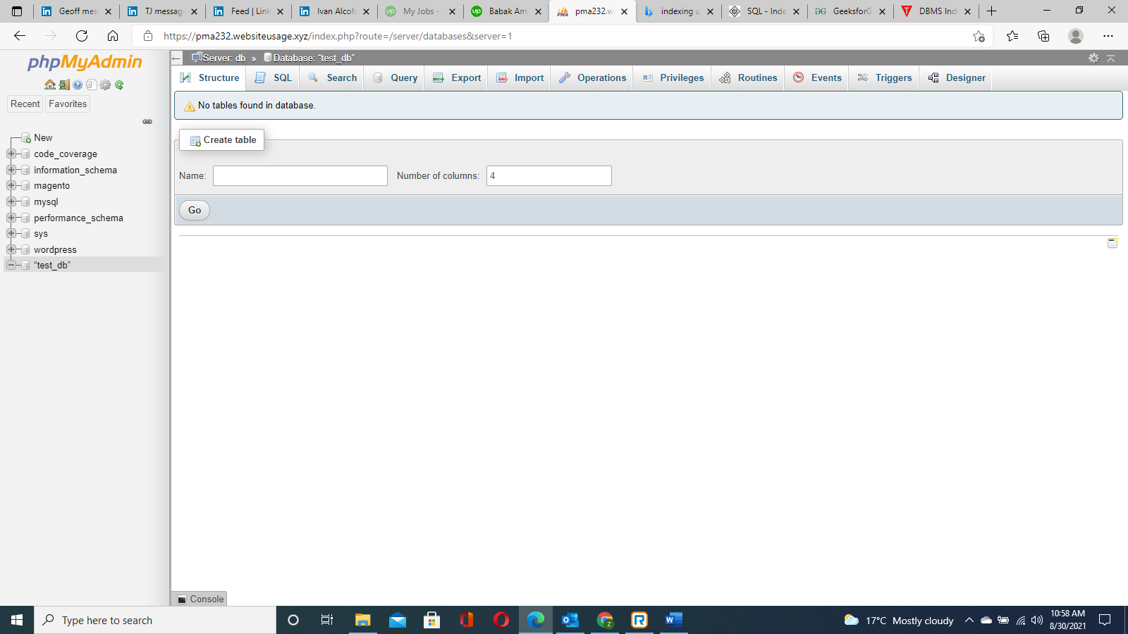

**_____________________________________________________________________________________**

**Creating Index of wp_terms table:**

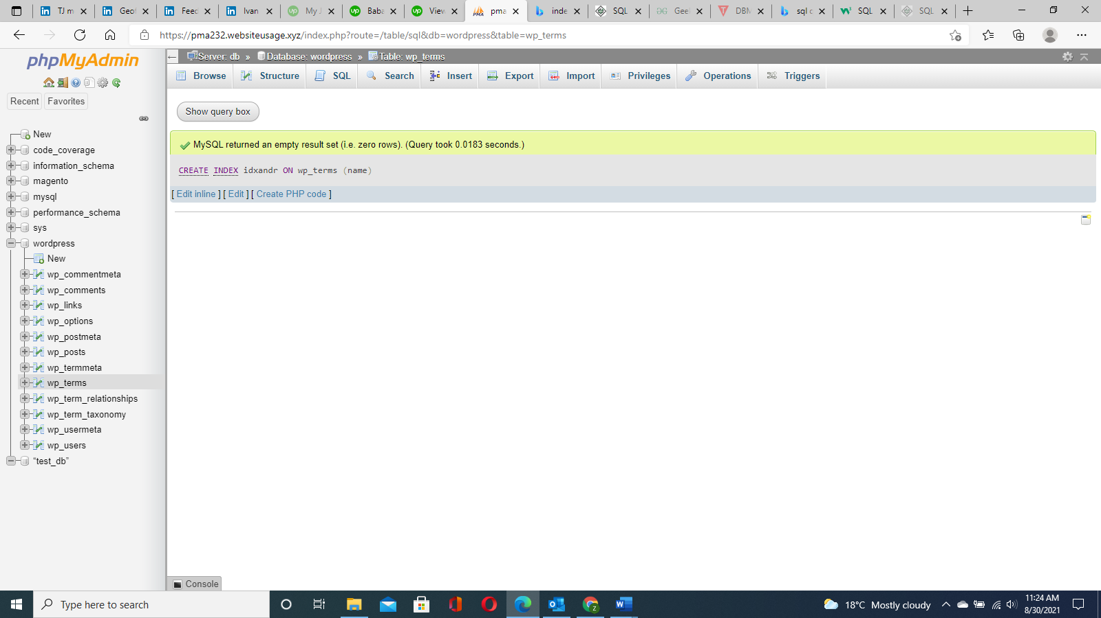

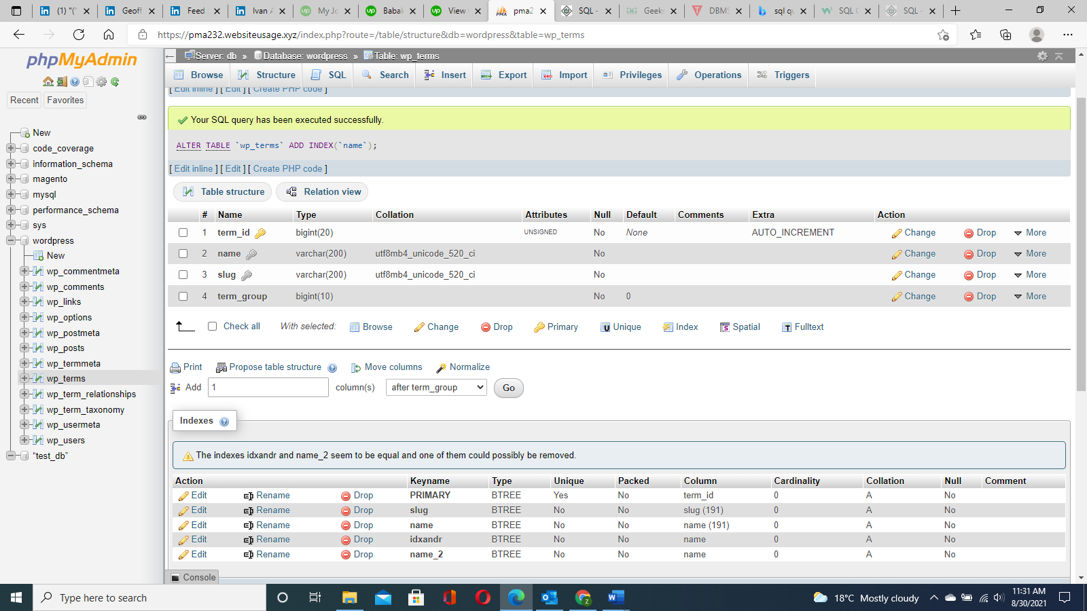

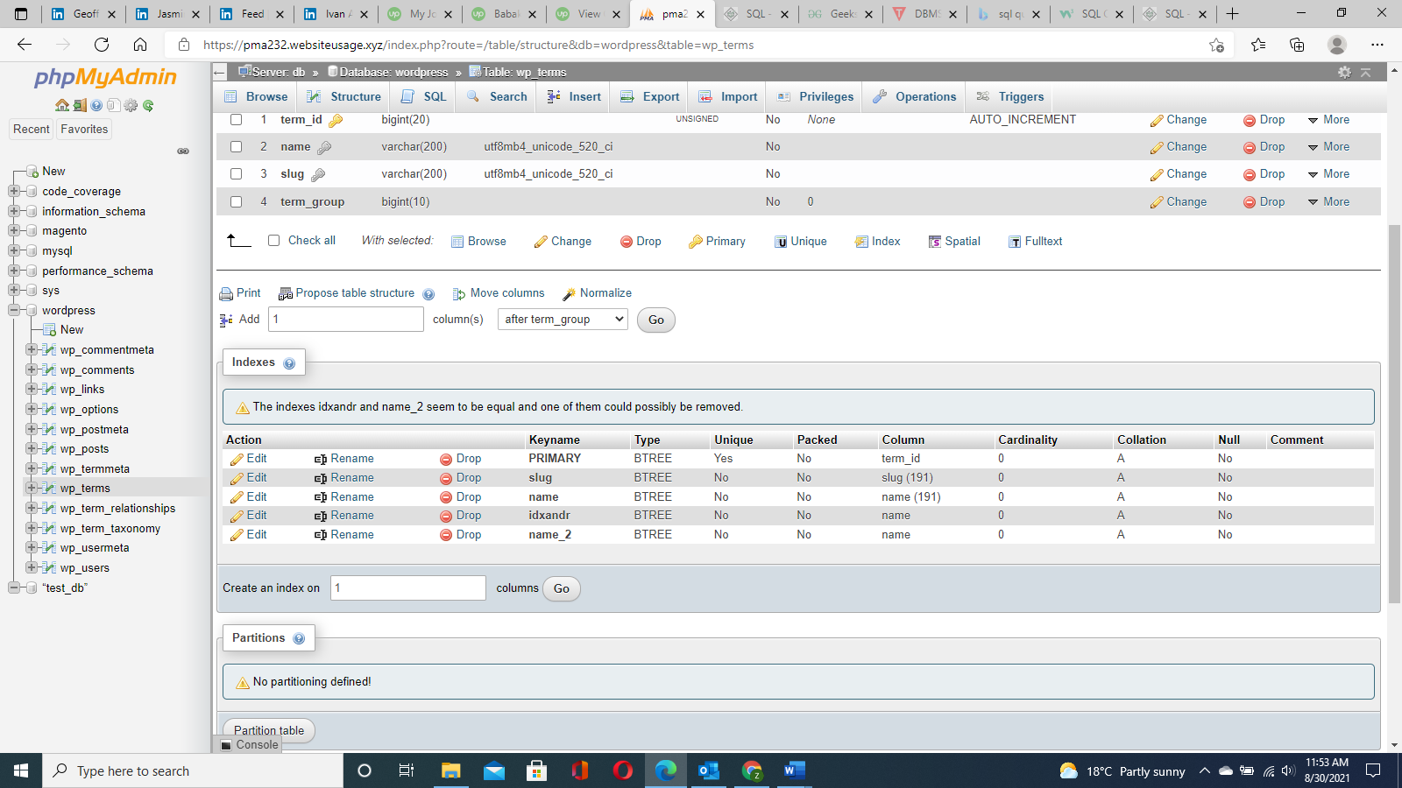

**Setting Indexes in Magneto Database, on Magneto – User table for the user first name and last name**

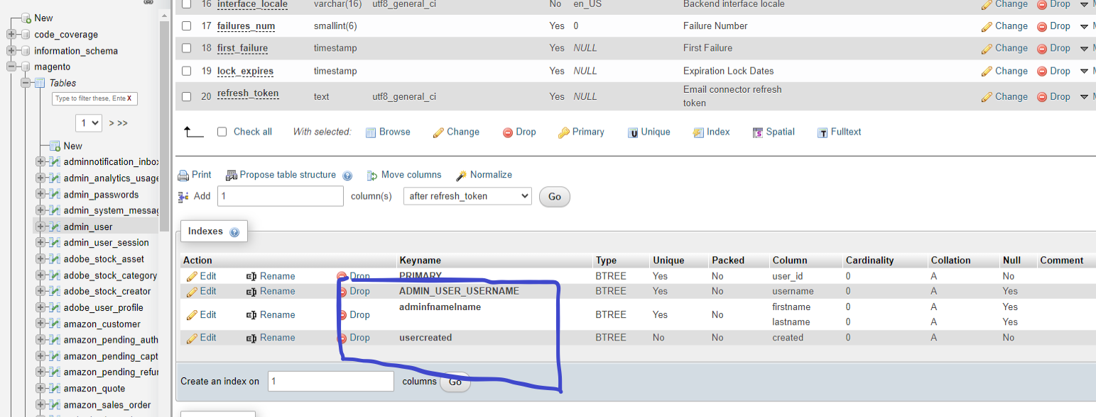

[ALTER](https://pma232.websiteusage.xyz/url.php?url=https://dev.mysql.com/doc/refman/5.7/en/alter-table.html) [TABLE](https://pma232.websiteusage.xyz/url.php?url=https://dev.mysql.com/doc/refman/5.7/en/alter-table.html) `magento`.`admin_user` ADD INDEX `usercreate` (`created`);

[ALTER](https://pma232.websiteusage.xyz/url.php?url=https://dev.mysql.com/doc/refman/5.7/en/alter-table.html) [TABLE](https://pma232.websiteusage.xyz/url.php?url=https://dev.mysql.com/doc/refman/5.7/en/alter-table.html) `magento`.`admin_user` ADD UNIQUE `userfnamelname` (`firstname`, `lastname`);

**Memory usage of MY SQL using buffer sizes of Inno DB**

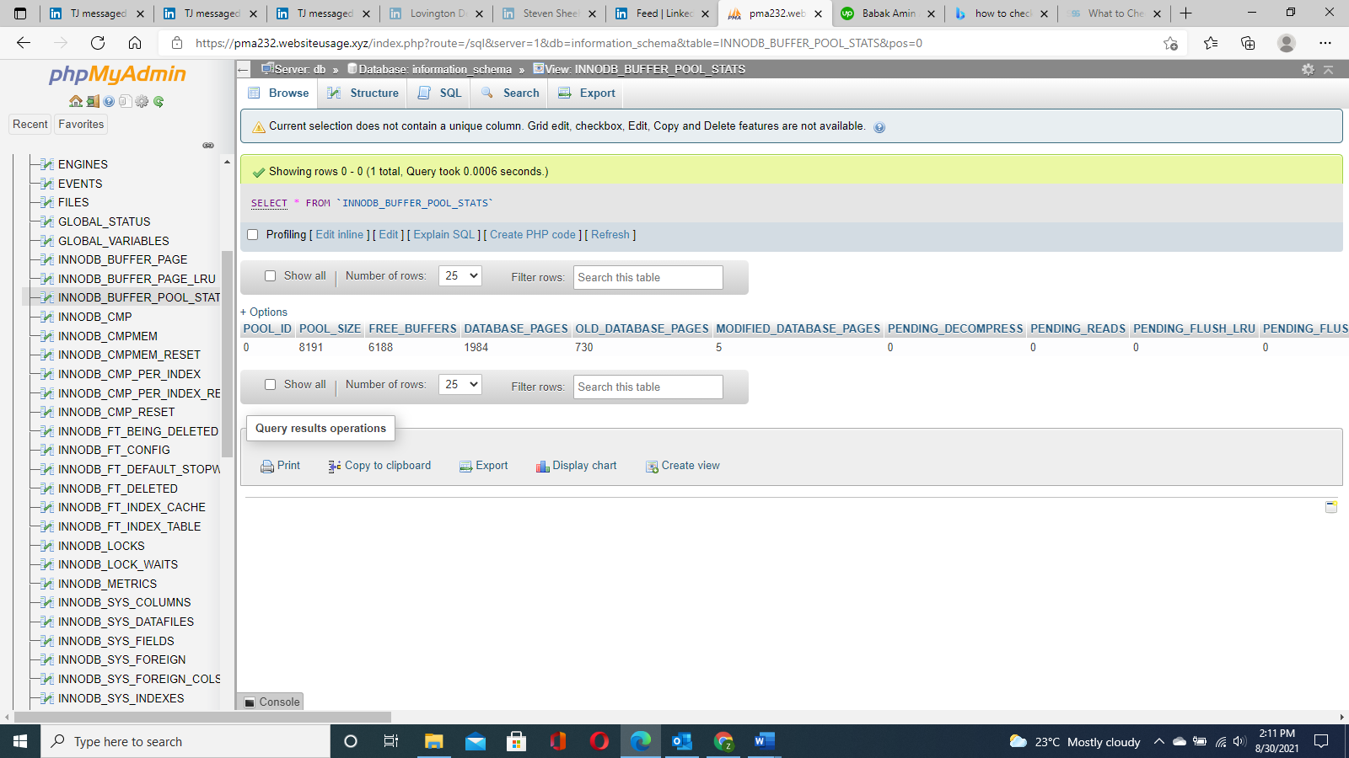

Global Variables:

1. Pool-size = 8191 bytes
2. Free Buffers = 6188 bytes
3. Current Database pages = 1984
4. Old Database pages = 730
5. Modified = 5

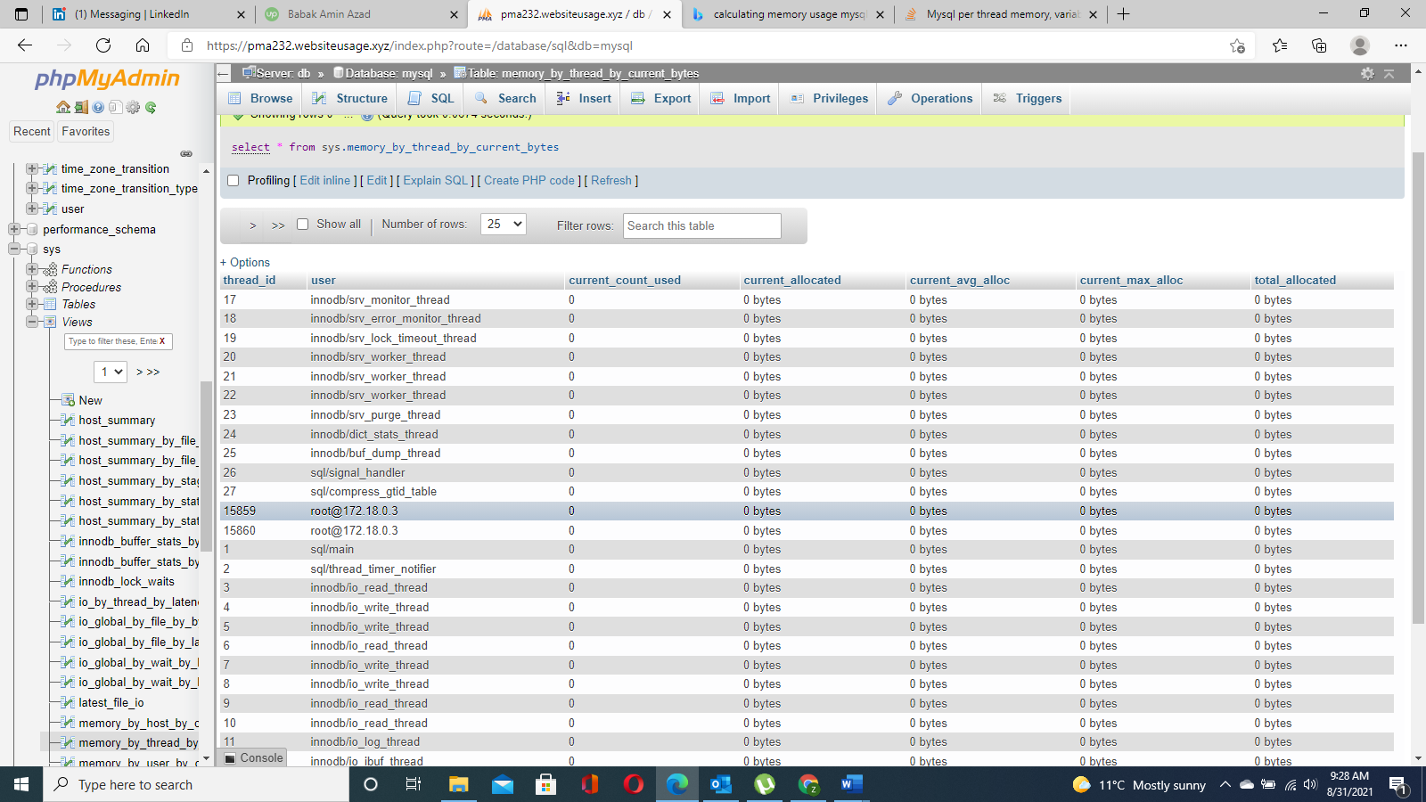

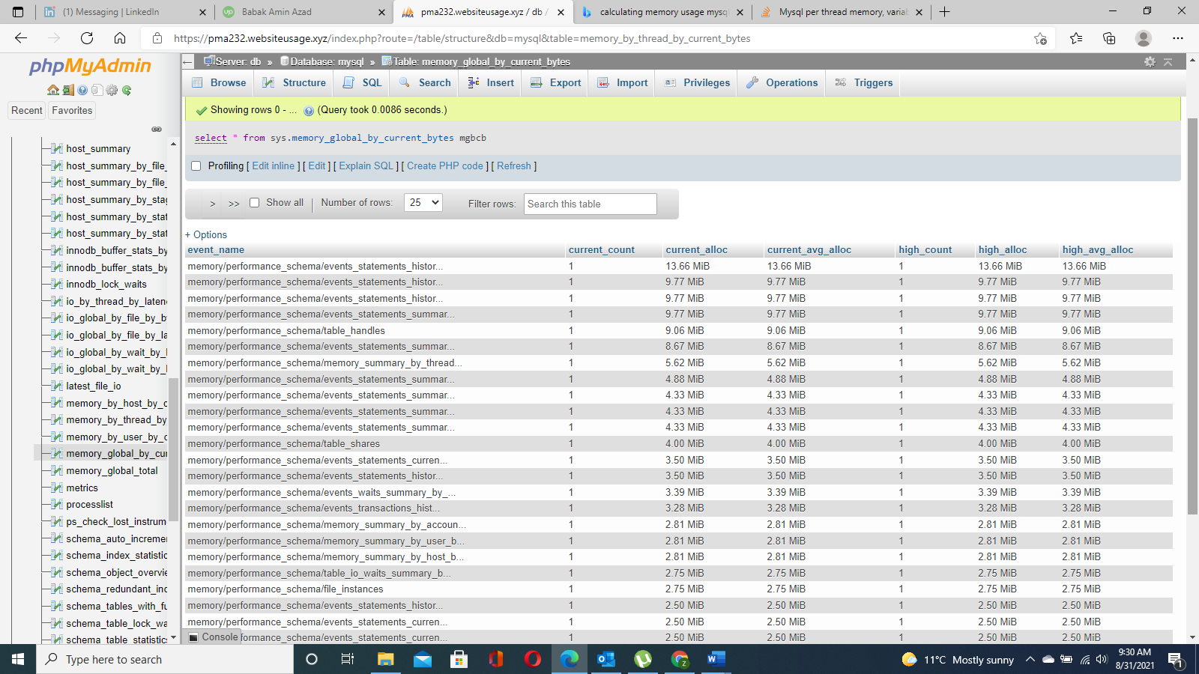

Highest Avg Allocation: Global variables = 13.66 MB

Importing Database into Wordpress Database:

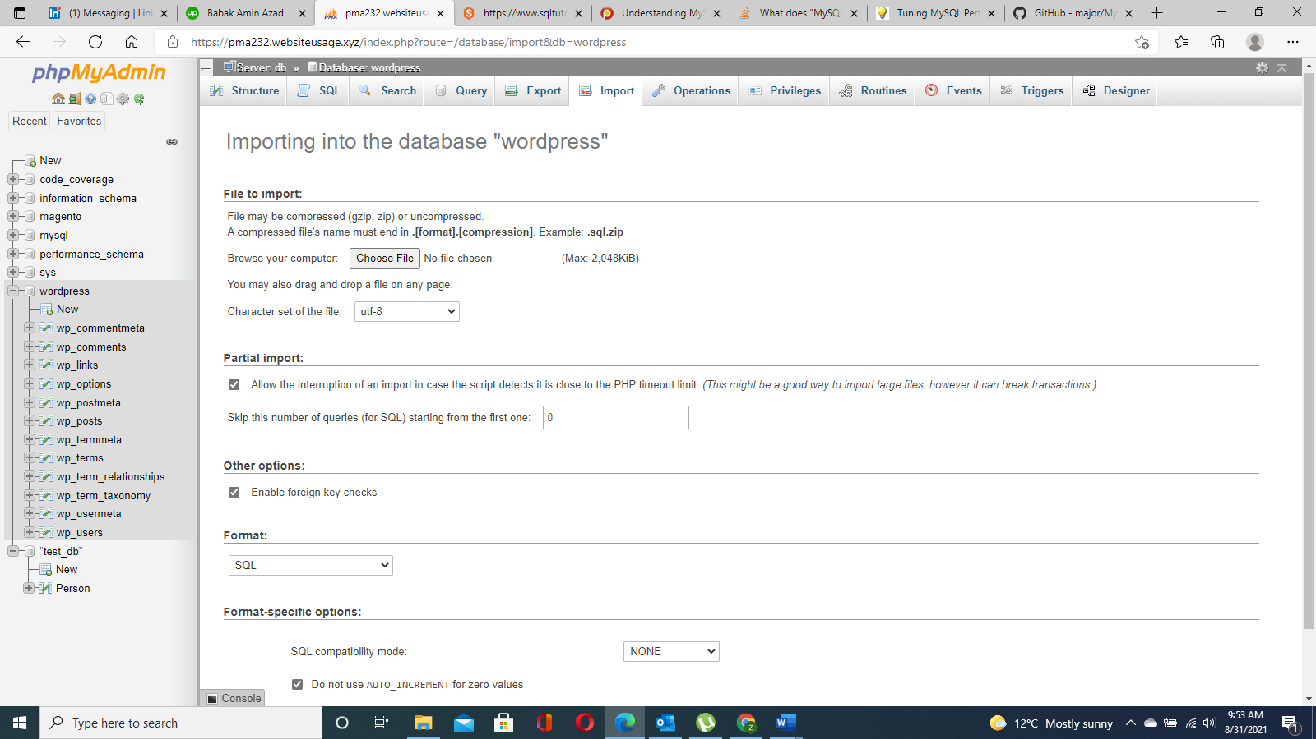

Successfully done!!!

