* I have created one Database "db_testing".
* Import wordpress Database into my testing Database.
* I have checked all database sizes using this query "select table_schema "", sum( data_length + index_length ) / 1024 / 1024 "data base size in mb" from information_schema.tables group by table_schema" see the image below:

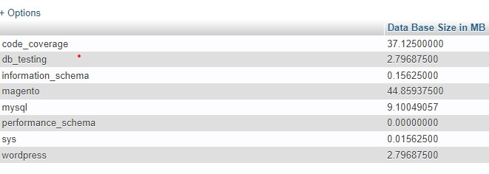

* I use "show full processlist" to check user account list info. See the image below:
* 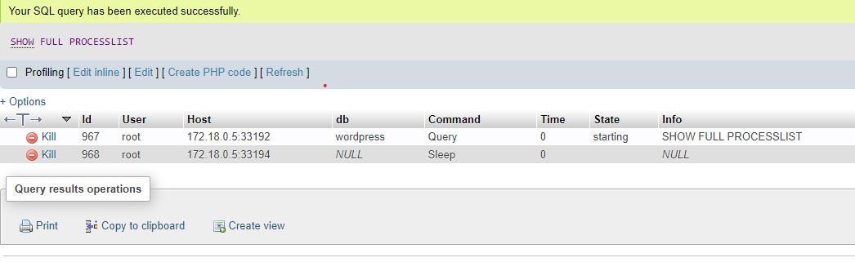
* I added indexes some of the tables in wordpress Database for query efficiency when using Select command
* Your magento Database is not exporting. Magento tables have some errors that's why, they not imported successfully.
* I also export databases in sql and zip format.