1.social login:

<https://www.npmjs.com/package/angularx-social-login>

<https://stackblitz.com/edit/angularx-social-login?file=src%2Fapp%2Fapp.module.ts>

if problem is with ngcc and angular ivy:

set following intsconfig.app.json:

"angularCompilerOptions": { "enableIvy": false }

2.authentication with social login:

Normal registration me username and email mandatory hai,

Check in backend ki username and email should be unique.

Fir login par check for either username and password combination match or

Email and password combination matches

Social login par check if that email exist ,yes then generate token ,

Auth table me entry karo email and naya token dal ke,

Else uske against user table me entry dal do with username as email,

Password random and generate token.

Next time user login with same username/email give error that username exist

Token refresh:

expiration time if user session inactive for 1 hr.

way 1:

Har time jab hit ae, to auth table me us token ke corresponding last hit ka time check karo, agar vo time ek ghanta se jyada ho gya,to send that token expired, or else vo time update kardo is hit ke time se.

Loophole: user front end me mouse move kar rha ho, to hit nhi jaegi but session expire nhi hona chahie

Isme ye bhi nhi ho rha I refresh token generate karna hai ,to bas vhi token chalta rhega so unsafe hai.

Way 2:

First time user login par jo token aya,uske sath time bhejo ki ek ghanta me session expire ho jaega, ab front end me ya to set interval laga dia ki 55 min baad backend ko hit maro with same token and api call for refresh oken and naya token like localstorage me update kardo.

Loophole:agar bich me internet connection kharab ho gya

Way 3:backend me job, and har call ke sath token attach kar ke bhejo, 55 min round me nw token bhej do, har bar F.E. me ye token refresh karo

2. email sending error:

Change port ,service and requreTLS

In gmail, go and turn on -allow less secure apps:

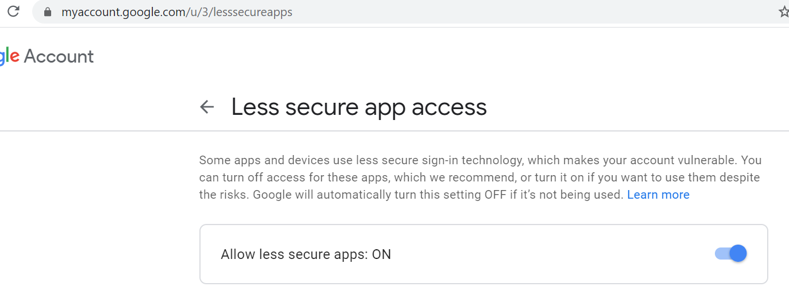

var transporter = nodemailer.createTransport({

service: 'smtp.gmail.com',

port: 3000,

auth: {

user: 'atestmail2020@gmail.com',

pass: 'atestmail'

},

secure: true,

requireTLS: false

});

3.

err Error: connect ECONNREFUSED 127.0.0.1:465

change service to host

err Error: self signed certificate in certificate chain

If you know that the host does not have a valid certificate you can allow it in the transport settings with tls.rejectUnauthorized option:

var transporter = nodemailer.createTransport(smtpTransport(

{ host: "outmail.abc.co.th",

hostname secure: false,

use SSL port: 25,

port for secure SMTP auth: { user: "username@abc.co.th", pass: "passwordmail" }, tls: { rejectUnauthorized: false } }));

err Error: queryA ETIMEOUT smtp.gmail.com

4.to dummy test mail:<https://mailtrap.io/inboxes/916850/messages/1687376908>

5. password reset node and angular

https://hackernoon.com/how-to-reset-password-with-nodejs-and-angular-part-1-2e2632oc

<https://hackernoon.com/how-to-reset-password-with-nodejs-and-angular-part-2-6815t3z8v>

6.problem of multiple subscription

Unsubscribe subscription on ngDestroy hook

7. to read local file in angular

<https://jsonworld.com/demo/how-to-read-local-json-file-in-angular>

<https://mariusschulz.com/blog/importing-json-modules-in-typescript>

This module is declared with using 'export =', and can only be used with a default import when using the 'allowSyntheticDefaultImports' flag.

in ts config:

{

"resolveJsonModule": true,

},

"angularCompilerOptions": {

"allowSyntheticDefaultImports":true

}