## Front End Engineering-II

Project Report

Semester-VI (Batch-2022)

CRAVE CART

**Supervised By: Submitted By:**

Mr. Rahul Nishtha, 2210991992 (G-24)

Pragti Gupta, 2210992056 (G-24)

Prerna Thakur,2210992085 (G-24)

Priya Gupta, 2210992096 (G-24)

**Department of Computer Science and Engineering**

Chitkara University Institute of Engineering & Technology, Chitkara University, Punjab

**TABLE OF CONTENTS**

|  |  |  |
| --- | --- | --- |
| **Sr. No** | **Topic** | **Page No** |
| 1 | Abstract | 3 |
| 2 | Introduction | 3 |
| 2.1 | Background | 3-4 |
| 2.2 | Objectives | 4-5 |
| 3 | Problem Definition and Requirements | 5 |
| 3.1 | Problem Statement | 5 |
| 3.2 | Software Requirements/Hardware Requirements/Data Sets | 5-8 |
| 4 | Proposed Design / Methodology | 8 |
| 5 | Results / Screenshots | 9-11 |
| 6 | References | 12 |
|  |  |  |
|  |  |  |

## 

1. **Abstract**

Crave Cart is a comprehensive e-commerce platform built using the MERN stack, designed to provide a seamless online shopping experience. The platform includes essential features such as product uploads, an intuitive admin panel, and efficient category and subcategory management. To ensure secure user authentication, it implements access and refresh tokens, along with OTP-based email verification and password recovery. Crave Cart also integrates a robust payment system using Stripe and supports media uploads via Cloudinary. The frontend is developed with React, Vite, and Tailwind CSS, ensuring a responsive and visually appealing user interface. Additionally, the application leverages Redux Toolkit for state management, Postman for API testing, and Sweet Alert for interactive notifications. This project serves as an excellent opportunity to enhance skills in MongoDB, Express.js, React.js, and Node.js while developing a scalable and secure e-commerce solution.

1. **Introduction**
   1. **Background**

With the rapid growth of online shopping, the need for a secure, efficient, and user-friendly e-commerce platform has become more crucial than ever. Traditional online marketplaces often face challenges related to security, scalability, and seamless user experience. Many platforms struggle with slow load times, unoptimized product categorization, and complex checkout processes, leading to lower customer satisfaction and retention. Additionally, security concerns such as data breaches, fraudulent transactions, and weak authentication mechanisms pose risks to both businesses and consumers. Crave Cart is developed to address these challenges by leveraging the MERN stack, providing a feature-rich and scalable solution for both customers and administrators. By integrating modern authentication mechanisms such as access and refresh tokens, OTP-based email verification, and password recovery, the platform ensures robust security. Additionally, it streamlines product management with an intuitive admin panel and category-based organization, making it easier for store owners to manage inventory and sales efficiently. Cloudinary enables efficient media uploads, ensuring high-quality images without compromising performance, while Stripe ensures secure and hassle-free payment processing.

With a responsive frontend powered by React, Vite, and Tailwind CSS, Crave Cart offers an engaging shopping experience with fast performance, smooth navigation, and a visually appealing UI. The use of Redux Toolkit for state management enhances application efficiency, while Postman aids in thorough API testing to ensure backend reliability. Moreover, interactive alerts with Sweet Alert improve user interaction by providing real-time feedback during critical processes such as checkout and authentication. This project is designed to enhance development skills in full-stack technologies while creating a real-world e-commerce solution that meets industry standards. By incorporating modern best practices in UI/UX design, security, and performance optimization, Crave Cart aims to set a benchmark for scalable and user-centric online shopping platforms.

* 1. **Objectives**

The primary objective of Crave Cart is to develop a secure, scalable, and user-friendly e-commerce platform that streamlines the online shopping experience. The project aims to implement a robust authentication system using access and refresh tokens, OTP-based email verification, and password recovery to ensure data security and user trust. Another key goal is to provide an efficient admin panel for seamless product management, including category and subcategory organization, inventory tracking, and order management to enhance business operations. The integration of Cloudinary for media uploads ensures high-quality product images without affecting performance, while Stripe enables secure and seamless online transactions, fostering customer confidence. Additionally, Crave Cart prioritizes a responsive and visually appealing interface using React, Vite, and Tailwind CSS, offering an engaging and intuitive user experience across all devices. To optimize performance and maintain application state efficiently, Redux Toolkit is employed, ensuring smooth interactions and data flow between components.

Beyond functionality, the project emphasizes performance optimization, API efficiency, and security best practices. By leveraging Postman for API testing and debugging, the reliability and integrity of backend operations are maintained. Furthermore, interactive UI elements powered by Sweet Alert enhance user engagement by providing instant feedback on important actions such as authentication, checkout, and order confirmation.

Through this project, developers will gain hands-on experience in full-stack development using the MERN stack, focusing on industry-standard practices in authentication, database management, and UI/UX design. Crave Cart not only serves as a learning opportunity for developers but also aims to deliver a scalable, high-performance, and future-ready e-commerce solution capable of adapting to evolving market demands.

1. **Problem Definition and Requirements**
   1. **Problem Statement**

In today's digital era, online shopping platforms often face challenges related to security, scalability, and user experience, leading to inefficiencies for both customers and administrators. Many existing e-commerce solutions struggle with secure authentication, complex product management, and seamless payment integration. Additionally, the lack of a well-structured admin panel and an intuitive user interface can hinder smooth operations. To address these issues, Crave Cart is designed as a comprehensive e-commerce platform that ensures secure user authentication through access and refresh tokens, OTP-based email verification, and password recovery. It provides an efficient admin panel for product uploads and category management while integrating Cloudinary for media uploads and Stripe for secure transactions. By leveraging modern web technologies like React, Vite, and Tailwind CSS for a responsive UI and Redux Toolkit for state management, Crave Cart aims to create a scalable, high-performance, and user-friendly online shopping experience.

* 1. **Software Requirements/Hardware Requirements/Data Sets**

**Software Requirements:**

Frontend Technologies:

* React.js – For building the user interface
* Vite – For fast development and optimized builds
* Tailwind CSS – For responsive and modern styling
* Redux Toolkit – For efficient state management
* React Router – For client-side routing

Backend Technologies:

* Node.js – For server-side logic and API development
* Express.js – For handling backend routing and middleware
* Mongoose – For interacting with the MongoDB database
* JsonWebToken (JWT) – For secure authentication using access and refresh tokens
* Dotenv – For environment variable management

Database:

* MongoDB – For storing user, product, and transaction data

Authentication & Security:

* OTP-based email verification – Implemented using Resend
* Password recovery system – Securely manages password reset requests
* Access & refresh tokens – Ensures secure user authentication

Media & File Uploads:

* Cloudinary – For handling image uploads efficiently

Payment Integration:

* Stripe – For secure online transactions

Development & Testing Tools:

* Postman – For API testing and debugging
* Axios – For handling API requests from the frontend
* VS Code – Preferred code editor for development

User Interaction & Alerts:

* Sweet Alert – For displaying interactive alerts and notifications

**Hardware Requirements:**

Minimum Requirements:

* Processor: Intel Core i3 (8th Gen) / AMD Ryzen 3 or equivalent
* RAM: 8 GB
* Storage: 256 GB SSD or 500 GB HDD
* Graphics: Integrated GPU (Intel UHD / AMD Vega)
* Operating System: Windows 10 / macOS / Linux (Ubuntu preferred)
* Internet Connection: Stable broadband connection for development and API testing

Recommended Requirements:

* Processor: Intel Core i5/i7 (10th Gen or higher) / AMD Ryzen 5/7 or equivalent
* RAM: 16 GB or higher (for smooth development with multiple applications running)
* Storage: 512 GB SSD or higher (for faster performance and storage of project files)
* Graphics: Dedicated GPU (NVIDIA GTX 1650 / AMD Radeon RX 5500 or better)
* Operating System: Windows 11 / macOS Monterey or later / Linux (Ubuntu 22.04 LTS)
* Internet Connection: High-speed internet for cloud-based services like Cloudinary, Stripe, and Resend

1. **Proposed Design / Methodology**

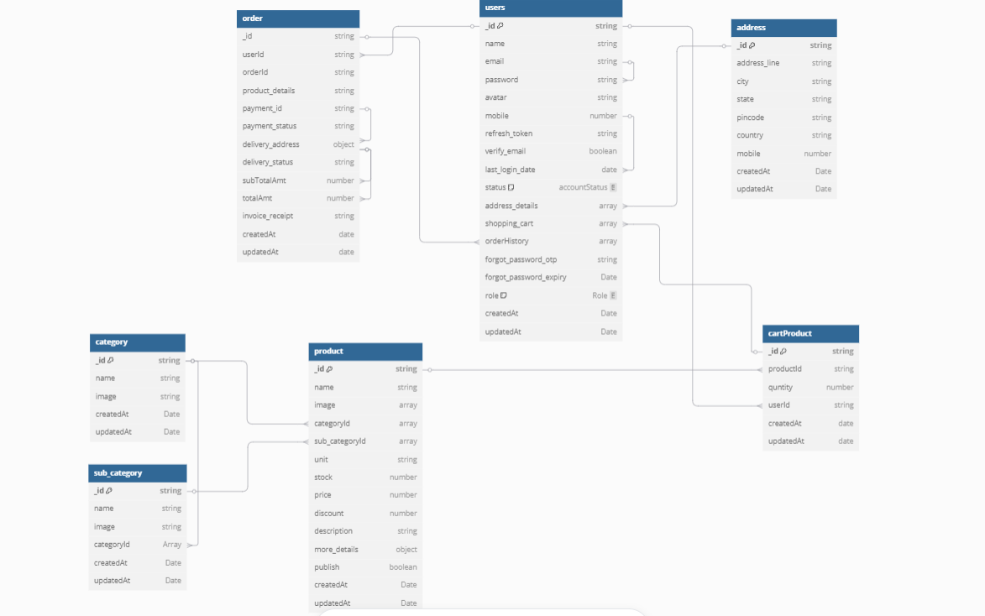

1. **Results/Screenshots**

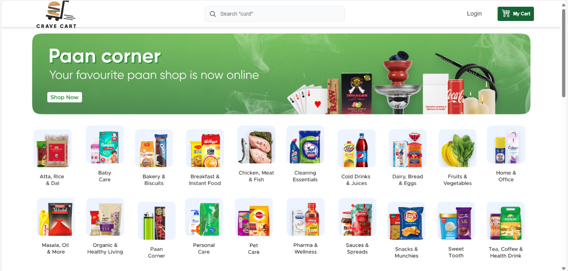

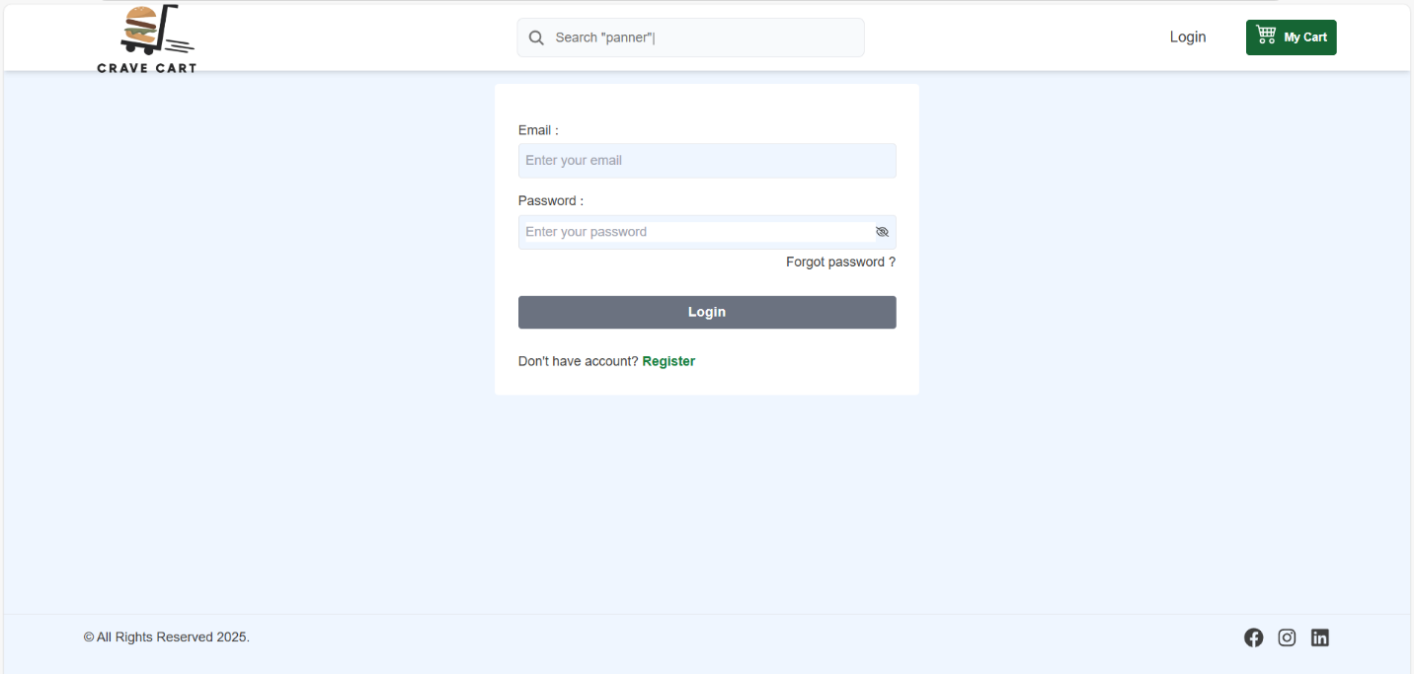

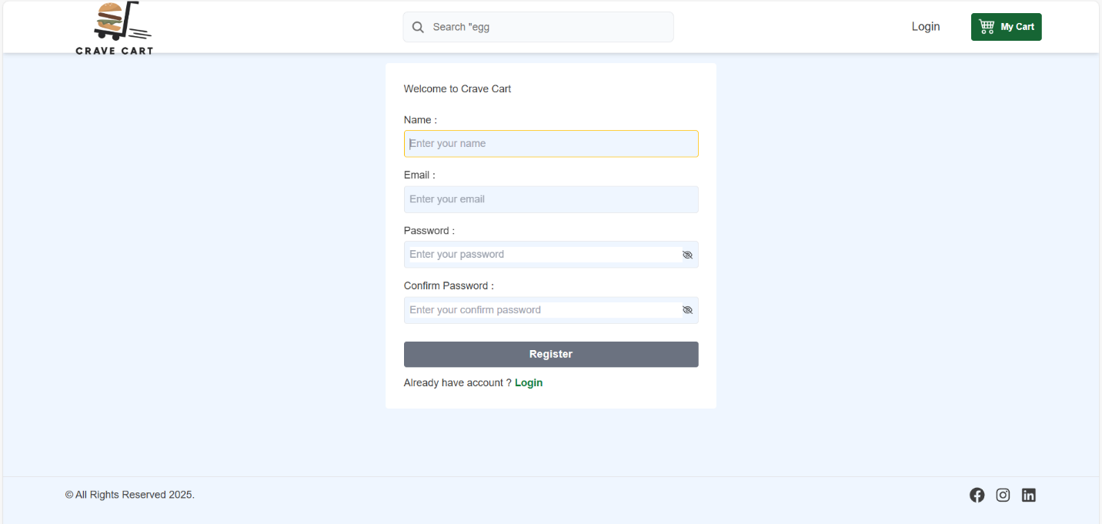

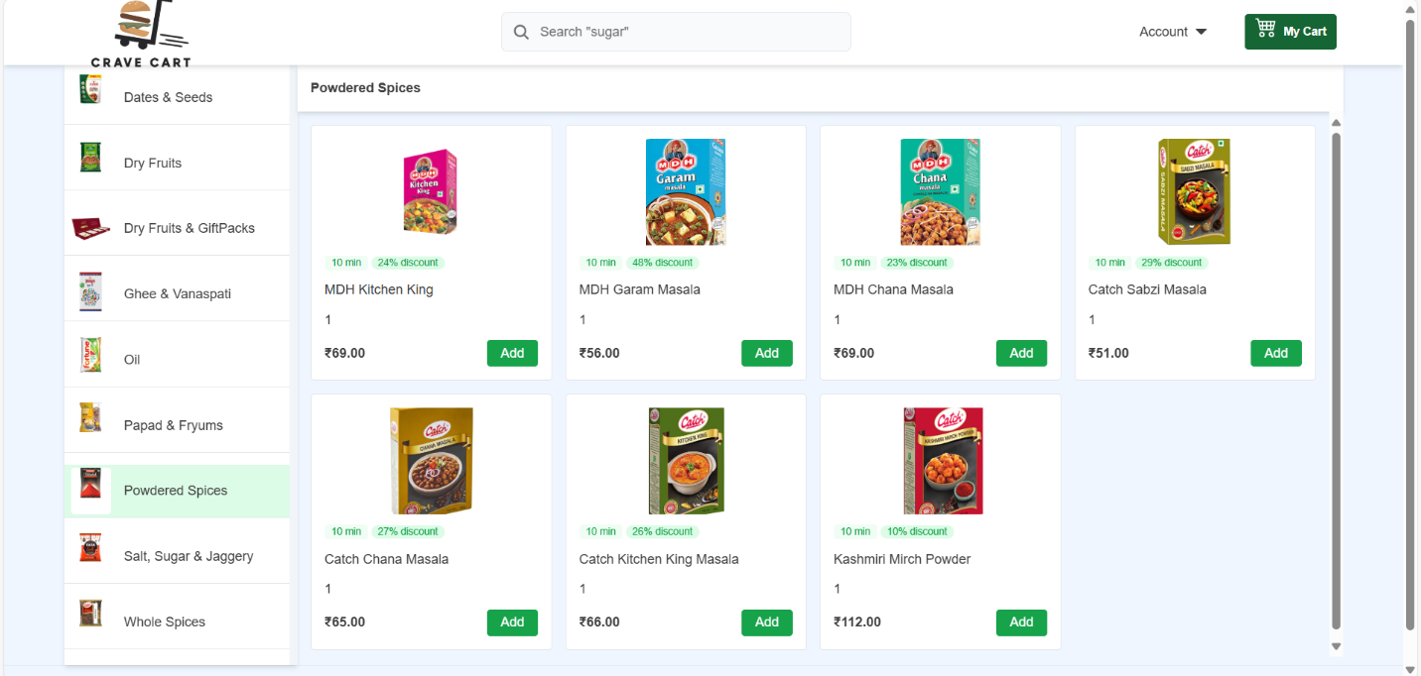

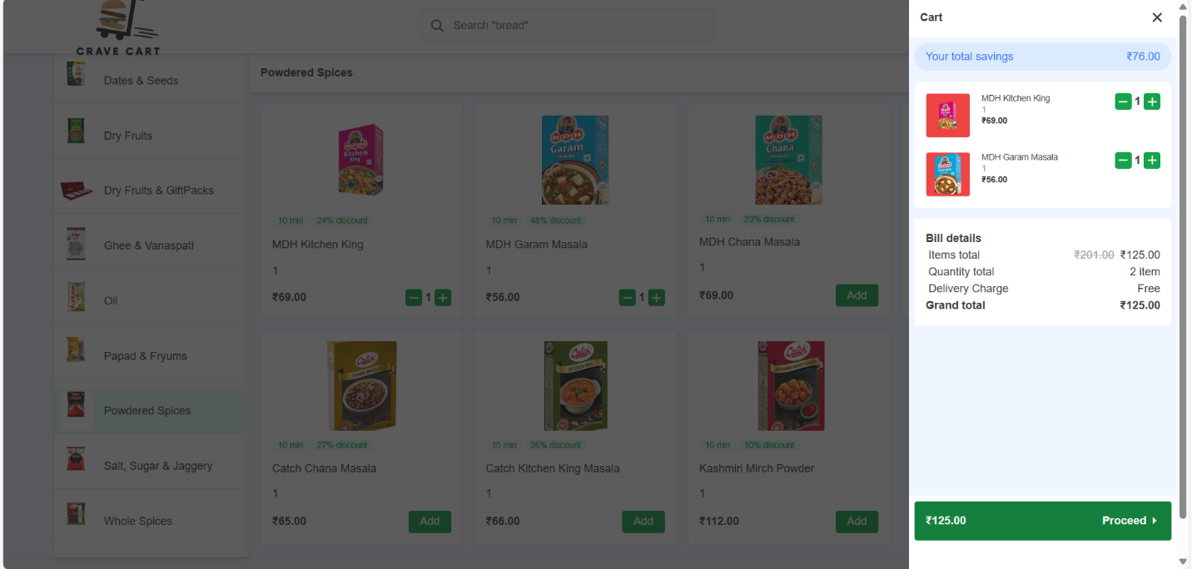

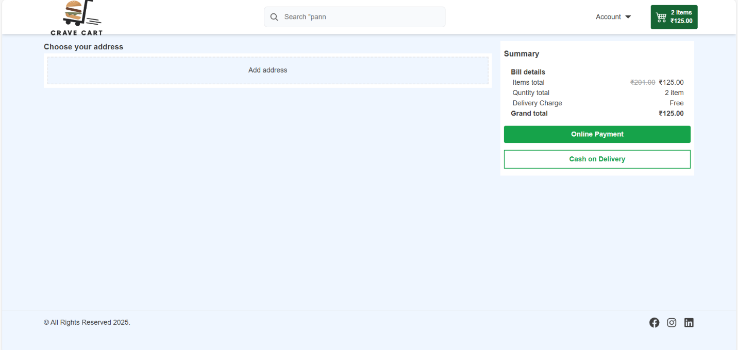

1. **References**

* [**https://www.npmjs.com/package/jsonwebtoken**](https://www.npmjs.com/package/jsonwebtoken)
* [**https://vite.dev/**](https://vite.dev/)
* [**https://www.npmjs.com/package/dotenv**](https://www.npmjs.com/package/dotenv)
* [**https://react.dev/**](https://react.dev/)
* [**https://cloudinary.com/**](https://cloudinary.com/)
* [**https://www.postman.com/**](https://www.postman.com/)