A
PYTHON PROJECT
ON
CAFE MANAGEMENT SYSTEM
By:
PRAGTI 2210992056
PRERNA 2210992086
PRINCE 2210992090

SUBMITTED TO:
Ms. NABANITA ROY
AND
DR. ANUPRIYA
Computer Science Engineering


Chitkara University Institute of Engineering and Technology,
Chitkara University, Punjab, India


1st Semester

CHITKARA UNIVERSITY
CHANDIGARH-PATIALA NATIONAL HIGHWAY, RAJPURA, DISTT. PATIALA, PUNJAB, INDIA

CONTENTS

Title Page No.

- Declaration 1
- Acknowledgement 2
- Guidelines and Principles 3
- About Project
4.1 Introduction
4.2 Description
- Conclusion


DECLARATION

We hereby declare that the courses submitted as part of Bachelor’s degree in CSE, at Chitkara University, Punjab, is an authentic record of our own work carried out under the supervision of Dr. Anupriya mam and Ms. Nabanita Roy.

Signature(s):

Name: Pragti

Roll No: 2210992056

Prerna
Roll No:2210992086

Prince
Roll No:2210992090


ACKNOWLEDGEMENT

We have taken efforts in this project. However, it would not have been possible without the kind support and help of many individuals and organizations. We would like to extend our sincere thanks to all of them.
We are highly indebted to Dr. Aupriya mam and Ms. Nabanita Roy for their guidance and constant supervision as well as for providing necessary information regarding the project & also for their support in completing the project.
We would like to express our gratitude towards our parents & members of CSE Department for their kind cooperation and encouragement which helped us in completion of this project.
We would like to express our special gratitude and thanks to industry persons for giving us such attention and time.
Our thanks and appreciation also go to our colleague in developing the project and people who have willingly helped us out with their abilities.


Introduction

This Cafe Management System is a simple project that aims to make it easier for customers to pay their bills. This Cafe Management System In Python is quite useful, and the concept and logic of the project are simple to grasp. The source code is open source and free to use. Simply scroll down and click the download option.

What Is Cafe Management System Project In Python?
The Cafe Management System Using Python is a desktop application written in the Python programming language that allows you to easily carry out and manage basic cafe operations.
Objective:-
It is a desktop application which deals with "Cafe Management System". The system has two parts first for the "Admin" and the other for “employee”.
The admin side allows the customer to "Place Order“ ,"Add Item", "Update Items" & "Remove Items" and the employee can only "Place order" & "Generate Bill" of purchase for the customer.


Language Used -- PYTHON

Python is a high-level, general-purpose programming language. Its design philosophy emphasizes code readability with the use of significant indentation.
Python is dynamically-typed and garbage-collected. It supports multiple programming paradigms, including structured (particularly procedural), object-oriented and functional programming. It is often described as a "batteries included" language due to its comprehensive standard library.
Guido van Rossum began working on Python in the late 1980s as a successor to the ABC programming language and first released it in 1991 as Python 0.9.0. Python 2.0 was released in 2000 and introduced new features such as list comprehensions, cycle-detecting garbage collection, reference counting, and Unicode support. Python 3.0, released in 2008, was a major revision that is not completely backward-compatible with earlier versions. Python 2 was discontinued with version 2.7.18 in 2020.
Python consistently ranks as one of the most popular programming languages.

Software used – IDLE
IDLE is a dedicated Python Integrated Development Environment(IDE) providing a wide range of essential tools for python developers,tightly integrated to create a convenient environment for productive Python,web,data science development.


Functions
A Function is a sequence of statements/instructions that performs a particular task.
A function is like a black box that can take certain input(s) as its parameters and
can output a value after performing a few operations on the parameters. A function
is created so that one can use a block of code as many times as needed just by
using the name of the function.
:Advantages of Functions:
● Reusability: Once a function is defined, it can be used over and over again.
You can call the function as many times as it is needed. Suppose you are
required to find out the area of a circle for 10 different radii. Now, you can
either write the formula πr2 10 times or you can simply create a function that
takes the value of the radius as an input and returns the area corresponding
to that radius. This way you would not have to write the same code (formula)
10 times. You can simply invoke the function every time.
● Neat code: A code containing functions is concise and easy to read.
● Modularisation: Functions help in modularizing code. Modularization means
dividing the code into smaller modules, each performing a specific task.
● Easy Debugging: It is easy to find and correct the error in a function as
compared to raw code



Datatype Types
- Boolean: Python boolean type is one of the built-in data types provided by Python, which represents one of the two values i.e. True or False. Generally, it is used to represent the truth values of the expressions. For example, 1==1 is True whereas 2<1 is False.
The boolean value can be of two types only i.e. either True or False. The output <class ‘bool’> indicates the variable is a boolean data type.
- Nested Loops: In Python programming language there are two types of loops which are for loop and while loop. Using these loops we can create nested loops in Python. Nested loops mean loops inside a loop. For example, while loop inside the for loop, for loop inside the for loop, etc.
- Arithmetic: There are 7 arithmetic operators in Python:-
- Addition
- Subtraction
- Multiplication
- Division
- Modulus
- Exponentiation
- Floor Devition


ADVANTAGES:-

Satisfaction among employees – Employees prefer to feel trusted in this situation, so giving them some control over their shifts is an effective approach to give them autonomy.
Errors are reduced – When writing down orders for kitchen employees, various mistakes are made because the handwriting is illegible.
Productivity Improvement – Time-consuming procedures like price lookups and table distribution are handled by the cafe management system.
Effective Human Resource Management – Creating a café management system that relieves employees of time-consuming duties. Manually performing cash register reconciliation and double-checking sales discrepancies are among the chores. As a result, time savings will lead to improved customer service and enhanced profitability in artificial intelligence solutions.
Automatic Evaluation – In fact, this software for running a cafe can make it so that reports are made automatically.
Improve relationships with customers – ERP solutions will also improve customer satisfaction and experience.


ABOUT THE PROJECT:
Cafe Management System Project In Python With Source Code :
The Cafe Management System Project In Python is a desktop application written and designed in the Python programming language. The project is open source, and it was made for novices who wish to learn Python.
This Cafe Management System Project In Python With Source Code is a simple project that will be useful to IT students who want a project like this for their school as well as cafe businesses who have been struggling with managing their products and calculating the amount of products purchased by customers.

The calculation is really accurate, which means that once you enter the quantity of the product, the system can calculate the exact amount that the customer needs to pay.

Project Details and Technology : Cafe Management System Project ;

Project Name: Cafe Management System Project In Python
Language/s Used: Python.
Python version : 3.8 or 3.9
(Recommended)
Type: Desktop Application
Developer: Source Code Hero

Cafe Management System Project in Python : Steps on how to run the project ;

These are the steps on how to run Cafe Management System Project in Python
Step 1: Download Source Code
First, find the downloadable source code and click to start downloading the source code file.
Step 2: Extract File
Next, after finished to download the file, go to file location and right click the file and click extract.
Step 3: Open Project Path and Open CMD (Command Prompt).
In order for you to run the project, you just need to open the project path and type CMD. The first thing you need to do is type py main.py in the command prompt. After that, just wait for a few seconds to load the system.

HERE , THE BELOW LINK SHOW CAFE MANGEMENT SYSTEM IN PYTHON:
https://sourcecodehero.com//wp-content/uploads/2022/05/Cafe-Management-System-Project-In-Python-Source-Code.zip



Future Scope:
We will introduce new features to make our system more effective and accessible as of :
1. service tax
2. govt tax
3. customer review portal etc.
4. enhancement of menu portal
5. detailed receipt of the order placed to avoid any confusion.

Domain:-
In this project admin can add, update or delete the details of the items and employee can take the order of the customer & generate the bill.
Scope:-
The division of work like placing customer order and generating bill will be performed by the employee and adding items and their price will be performed by the admin.


SOME GLIMPSE OF PROGRAM CODE:- 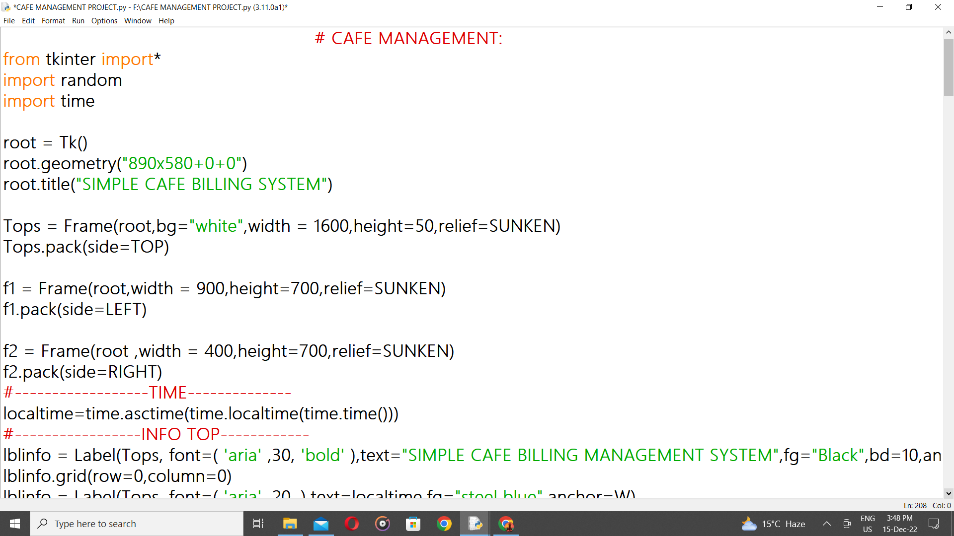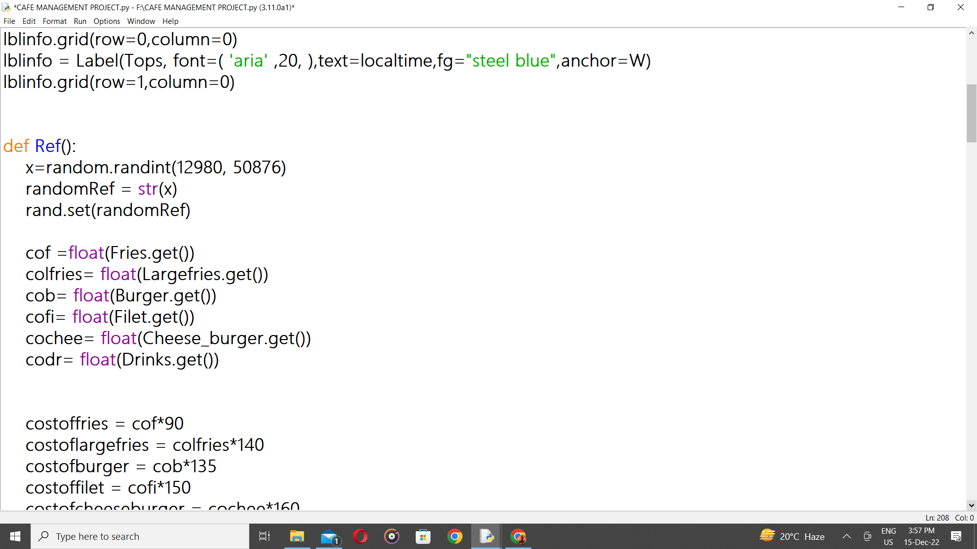

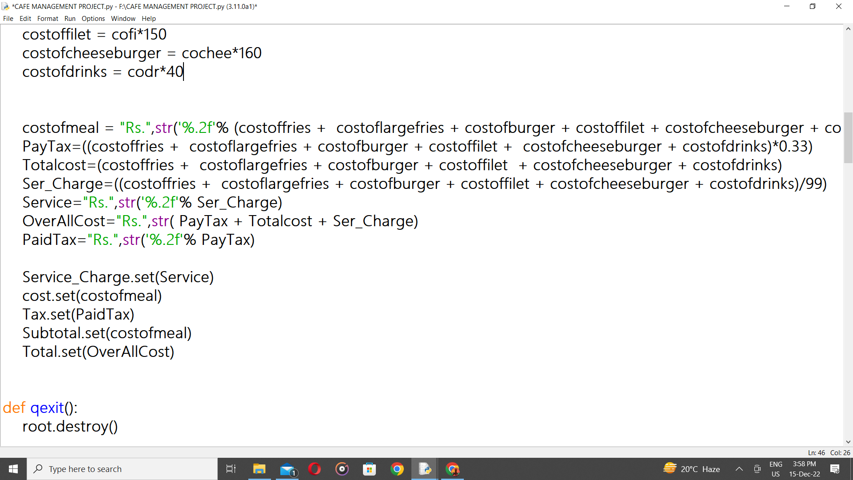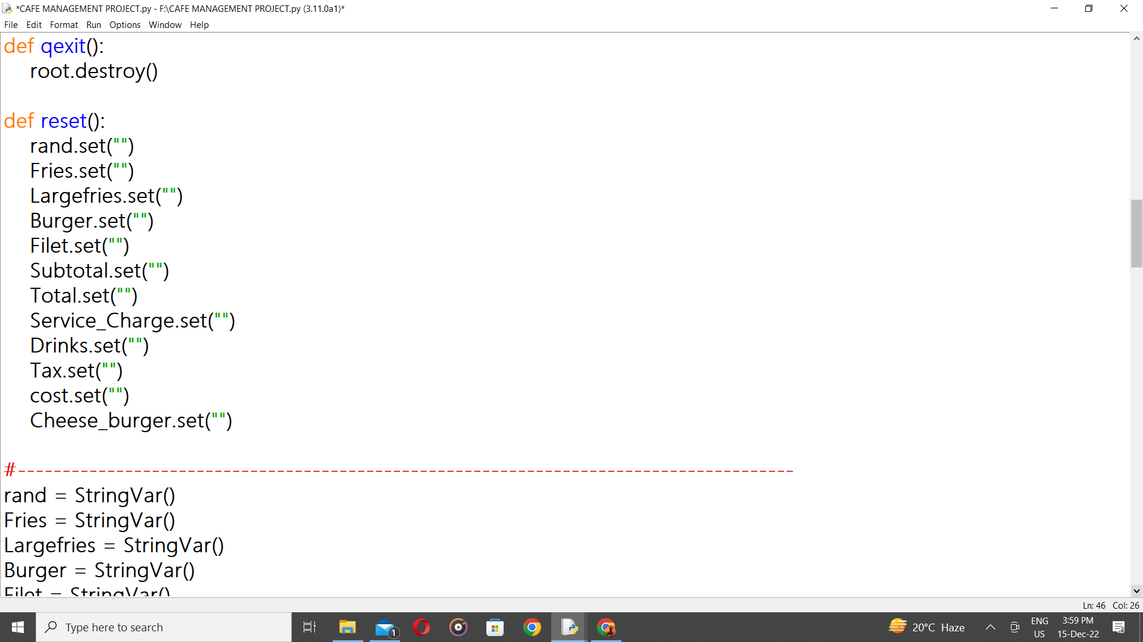

Output window –
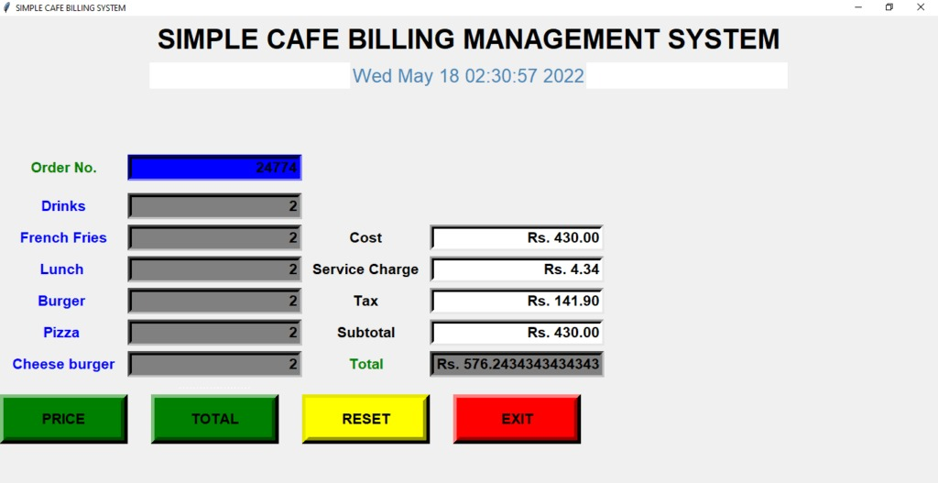
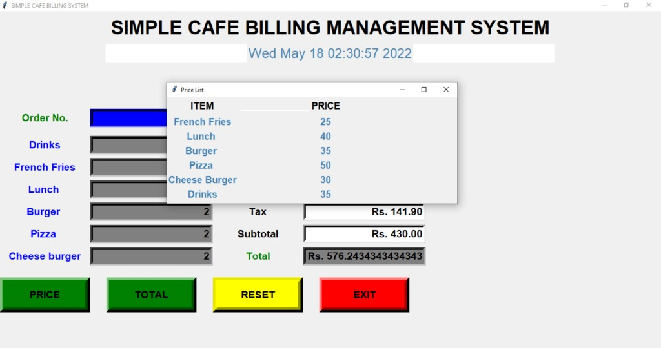


Conclusion
Our project is only a humble venture to satisfy the needs in an Institution. Several user-friendly coding has also been adopted. This package shall prove to be a powerful package in satisfying all the requirements of the organization. The objective of software planning is to provide a framework that enables the manger to make reasonable estimates made within a limited time frame at the beginning of the software project and should be updated regularly as the project progresses. Last but not least it is no the work that played the ways to success but almighty.

