**BURGER DELIVERY APPLICATION:-**

1. The agenda revolves around a Burger Shop which deals with 3 diﬀerent kinds of customers and serves them in diﬀerent ways.

2. The Project is built to assist that small business.

3. It also stores the information of the customers served and the total earnings of the shop. The waiting customers information can also be displayed.

4. Searching for the served Customers can be done.

5. The delivery charges are calculated on the basis of the shortest distance on the map and 40 Rs per KM is charged as delivery charges.

**Types of Customers:-**

1. **Walk-In Customers**

They will be served on the basis of their age. The older customer will be

served ﬁrst.

1. **Home Delivery Customers**

They will be served on the basis of LIFO (last in first out)

1. **Dine-In Customers**

They will be served on the basis of First come and ﬁrst serve basis.

**4. Served Customers**

The Customers which are served are recorded in the System to keep the record of the served Customers and their bills so that we may have insights into the daily sales of the shop. Its main purpose is to check the record of a particular Customer

**Map for Home Delivery:-**

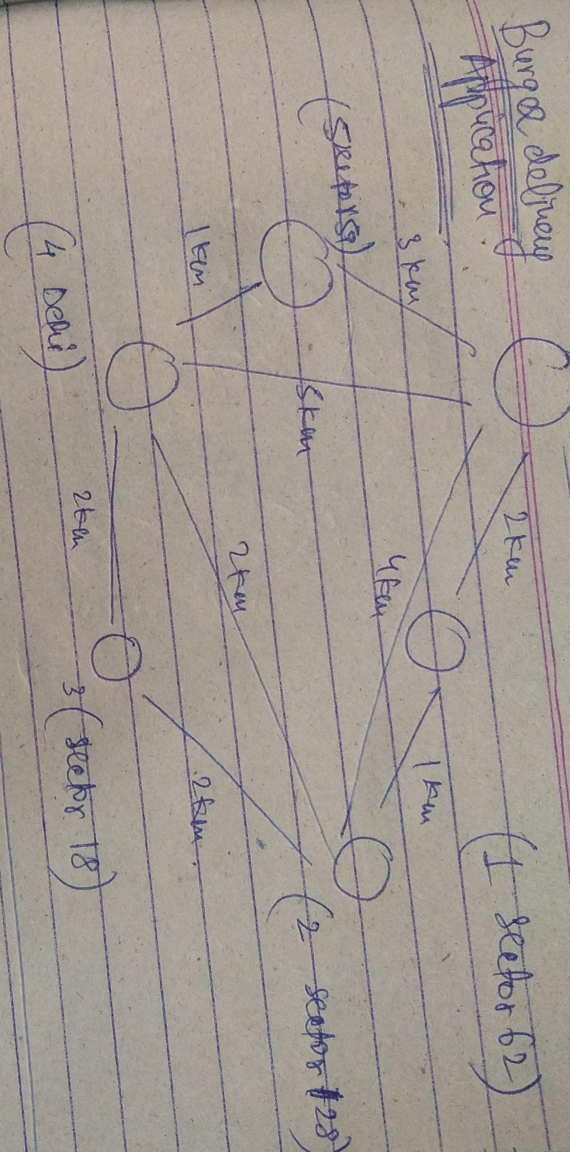

**Implemented Data Structures and Algorithms:-**

**1. LinkedList**

The whole implementation of Customer's Enqueue and dequeue is based on the LinkedList.

**2. Stack**

It is used in placing orders and serving Home Delivery Customers.

**3. Dynamic Queue**

It is used in placing orders and serving Dine-In Customers.

**4. Dynamic Priority Queue**

It is used in placing orders and serving Walk-In Customers.

**5. Graph (Adjacency List Representation)**

It is used for the Map for available Delivery options.

**6. AVL Tree**

The Served Customers were saved in it for eﬃcient insertion, deletion, and searching. The implementation was based upon the lexicographical comparison of strings.

**7. Dijkstra Algorithm**

It is used to ﬁnd the shortest possible distance from the Burger Shop and on this basis, the Delivery charges are calculated.