PCAP - LAB2
Pragun Kakkar – 240968332

Q1(a)Illustrates the fork-join pattern using OpenMP's parallel directive.
Code:

#include <stdio.h>
#include <omp.h>

int main() {
printf(“Pragun Kakkar – 240968332”);
printf("Serial region: Before parallel block\n");

// Fork
#pragma omp parallel
{
int tid = omp_get_thread_num();
printf("Hello from Thread %d\n", tid);
}
// Join

printf("Serial region: After parallel block\n");

return 0;
}
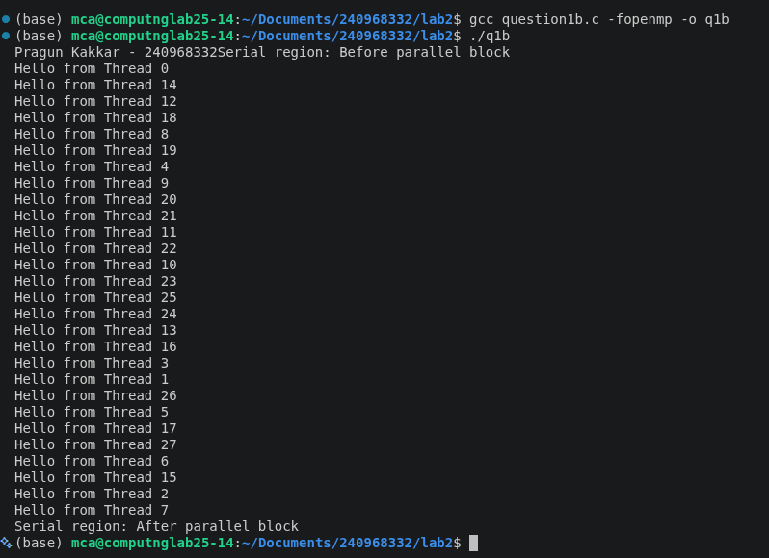
Output:

Q1(b): Illustrates the fork-join pattern using multiple OpenMP parallel directives and
changing the number of threads two ways.
Code:

#include <stdio.h>
#include <omp.h>

int main() {

printf(“Pragun Kakkar – 240968332”);
printf("Parallel Region 1 (Using omp_set_num_threads)\n");

// Method 1: Set number of threads using function
omp_set_num_threads(2);

#pragma omp parallel
{
printf("Thread %d of %d\n",
omp_get_thread_num(),
omp_get_num_threads());
}

printf("\nParallel Region 2 (Using num_threads clause)\n");

// Method 2: Using num_threads clause
#pragma omp parallel num_threads(4)
{
printf("Thread %d of %d\n",
omp_get_thread_num(),
omp_get_num_threads());
}

return 0;
}

Output:
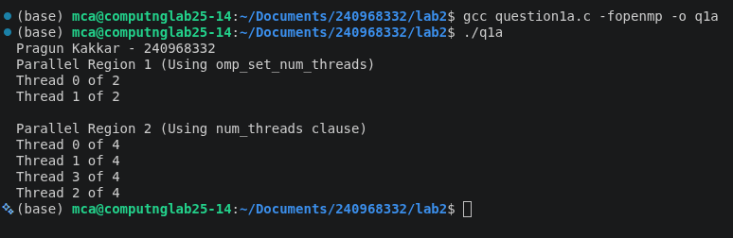

Q1(c): Illustrates the single-program-multiple-data (SPMD) pattern using two
basic OpenMP commands.
Code:

#include <stdio.h>
#include <omp.h>

int main() {
int i;
int a[10];

// SPMD Pattern
#pragma omp parallel
{
#pragma omp for
for(i = 0; i < 10; i++) {
a[i] = i * i;
printf("Thread %d processed a[%d] = %d\n",
omp_get_thread_num(), i, a[i]);
}
}

printf("\nFinal Array:\n");
for(i = 0; i < 10; i++) {
printf("%d ", a[i]);
}

printf("\n");
return 0;
}

Output
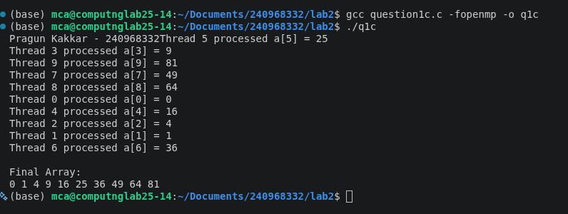

Q2) Write an OpenMP program to calculate (i, x) for all the threads where i is an integer value and x is the thread_Id.
Code:

#include <stdio.h>
#include <omp.h>

int main() {
int i = 10; // Integer value
printf(“Pragun Kakkar – 240968332”);

#pragma omp parallel
{
int x = omp_get_thread_num(); // Thread ID

printf("Thread %d : (i, x) = (%d, %d)\n", x, i, x);
}

return 0;
}

Output:

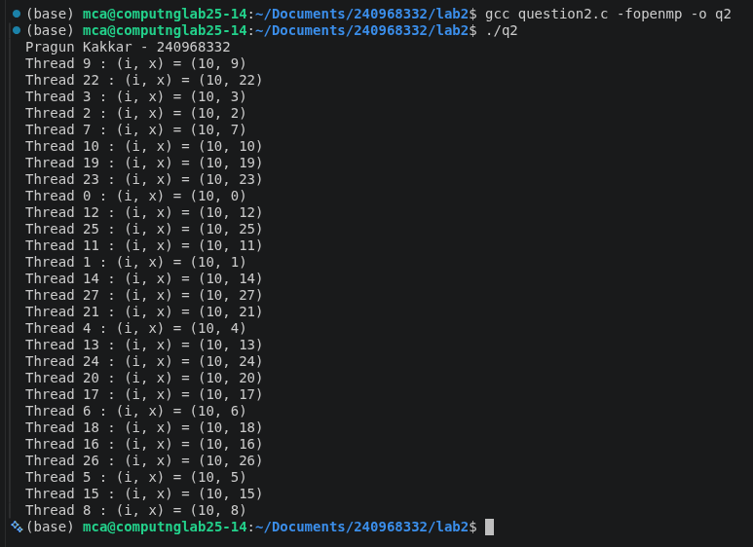
Q3)Write a OpenMP program that performs the sum of even numbers and odd numbers in a
given input array. Create a separate thread to perform the sum of even numbers and odd
numbers.
Code:

#include <stdio.h>
#include <omp.h>

int main() {
int n, i;
int evenSum = 0, oddSum = 0;

printf(“Pragun Kakkar – 240968332”);
printf("Enter the number of elements: ");
scanf("%d", &n);

int arr[n];

printf("Enter %d elements:\n", n);
for(i = 0; i < n; i++) {
scanf("%d", &arr[i]);
}

// Create exactly 2 threads
#pragma omp parallel num_threads(2)
{
int tid = omp_get_thread_num();

if(tid == 0) {
// Thread 0: Sum of even numbers
for(i = 0; i < n; i++) {
if(arr[i] % 2 == 0)
evenSum += arr[i];
}
printf("Thread %d calculated Even Sum = %d\n", tid, evenSum);
}
else {
// Thread 1: Sum of odd numbers
for(i = 0; i < n; i++) {
if(arr[i] % 2 != 0)
oddSum += arr[i];
}
printf("Thread %d calculated Odd Sum = %d\n", tid, oddSum);
}
}

printf("\nFinal Even Sum = %d\n", evenSum);
printf("Final Odd Sum = %d\n", oddSum);

return 0;
}

Output:

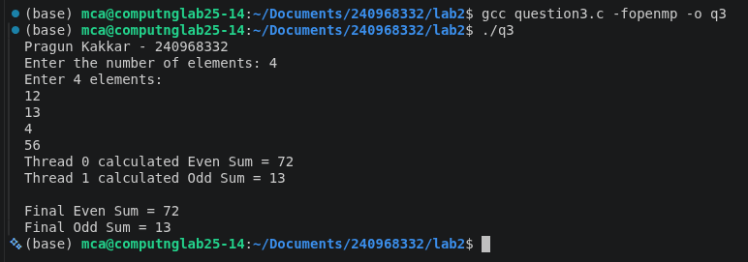
Q4) Write a OpenMP program to implement all the four basic operations of a calculator (Add,
Sub, Mul, Div). Create a separate thread to perform the operations.
Code:

#include <stdio.h>
#include <omp.h>

int main() {
float a, b;
printf(“Pragun Kakkar – 240968332”);
printf("Enter two numbers: ");
scanf("%f %f", &a, &b);

// Create 4 threads
#pragma omp parallel num_threads(4)
{
int tid = omp_get_thread_num();

switch(tid) {
case 0:
printf("Thread %d: Addition = %.2f\n", tid, a + b);
break;

case 1:
printf("Thread %d: Subtraction = %.2f\n", tid, a - b);
break;

case 2:
printf("Thread %d: Multiplication = %.2f\n", tid, a * b);
break;

case 3:
if (b != 0)
printf("Thread %d: Division = %.2f\n", tid, a / b);
else
printf("Thread %d: Division not possible (Division by zero)\n", tid);
break;
}
}

return 0;
}

Output:
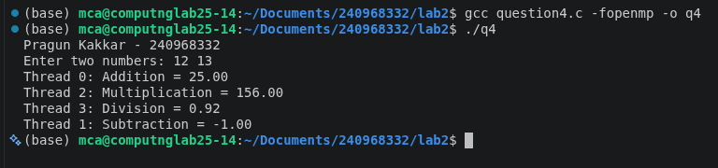
Q5) Write a OpenMP program for generating prime numbers from a given starting number to the
given ending number.
Code:

#include <stdio.h>
#include <omp.h>

int main() {
int start, end, i, j, prime;
printf(“Pragun Kakkar – 240968332\n”);
printf("Enter the starting number: ");
scanf("%d", &start);

printf("Enter the ending number: ");
scanf("%d", &end);

printf("\nPrime numbers between %d and %d are:\n", start, end);

// Parallelize the loop
#pragma omp parallel for private(i, j, prime) schedule(dynamic)
for (i = start; i <= end; i++) {

if (i < 2)
continue;

prime = 1;

for (j = 2; j * j <= i; j++) {
if (i % j == 0) {
prime = 0;
break;
}
}

if (prime) {
#pragma omp critical
printf("%d (Thread %d)\n", i, omp_get_thread_num());
}
}

return 0;
}

Output:
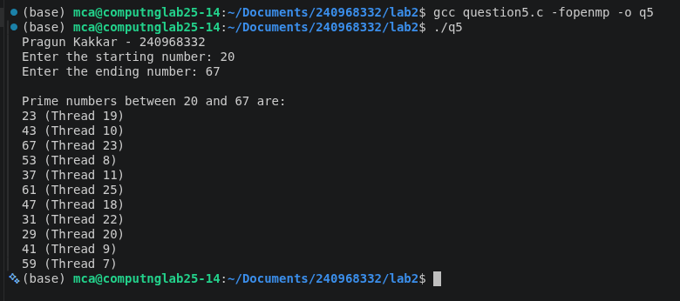
Q6) Write a program in OpenMP to toggle the character of a given character array indexed by
the thread_Id. Print the corresponding Thread_Id.
Code:

#include <stdio.h>
#include <string.h>
#include <ctype.h>
#include <omp.h>

int main() {
char str[100];
int n, i;
printf(“Pragun Kakkar – 240968332\n”);
printf("Enter a string: ");
scanf("%s", str);

n = strlen(str);

// Create one thread for each character
#pragma omp parallel for num_threads(n)
for (i = 0; i < n; i++) {
if (islower(str[i]))
str[i] = toupper(str[i]);
else if (isupper(str[i]))
str[i] = tolower(str[i]);

printf("Thread %d toggled index %d\n",
omp_get_thread_num(), i);
}

printf("\nToggled String: %s\n", str);

return 0;
}

Ouput:
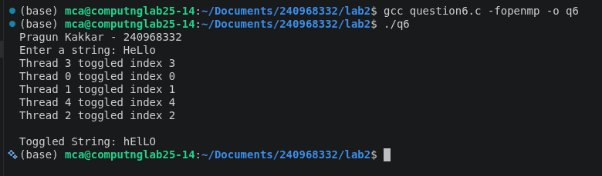
Q7) Write a program using OpenMP to compute the Fibonacci number for the following arrays
of numbers: A={10, 13, 5, 6}. Create a separate thread to perform the operations.
Code:

#include <stdio.h>
#include <omp.h>

int fibonacci(int n)
{
if(n <= 1)
return n;

int a = 0, b = 1, c;

for(int i = 2; i <= n; i++)
{
c = a + b;
a = b;
b = c;
}

return b;
}

int main()
{
int A[] = {10, 13, 5, 6};
int result[4];
int threads[] = {2,4,6,8};
printf(“Pragun kakkar – 240968332\n”);

double serial_time, parallel_time;

// ---------------- Serial Execution ----------------

double start = omp_get_wtime();

for(int i=0;i<4;i++)
result[i] = fibonacci(A[i]);

double end = omp_get_wtime();

serial_time = end - start;

printf("\nSerial Fibonacci Results\n");
for(int i=0;i<4;i++)
printf("Fib(%d) = %d\n",A[i],result[i]);

printf("\nSerial Time = %lf seconds\n",serial_time);

// ---------------- Parallel Execution ----------------

printf("\n---------------------------------------------\n");
printf("Threads\tTime\t\tSpeedup\tEfficiency\n");
printf("---------------------------------------------\n");

for(int k=0;k<4;k++)
{
omp_set_num_threads(threads[k]);

start = omp_get_wtime();

#pragma omp parallel for
for(int i=0;i<4;i++)
{
result[i] = fibonacci(A[i]);

printf("Thread %d computed Fib(%d) = %d\n",
omp_get_thread_num(),
A[i],
result[i]);
}

end = omp_get_wtime();

parallel_time = end-start;

double speedup = serial_time/parallel_time;
double efficiency = speedup/threads[k];

printf("%d\t%lf\t%lf\t%lf\n",
threads[k],
parallel_time,
speedup,
efficiency);

printf("---------------------------------------------\n");
}

return 0;
}

Output:
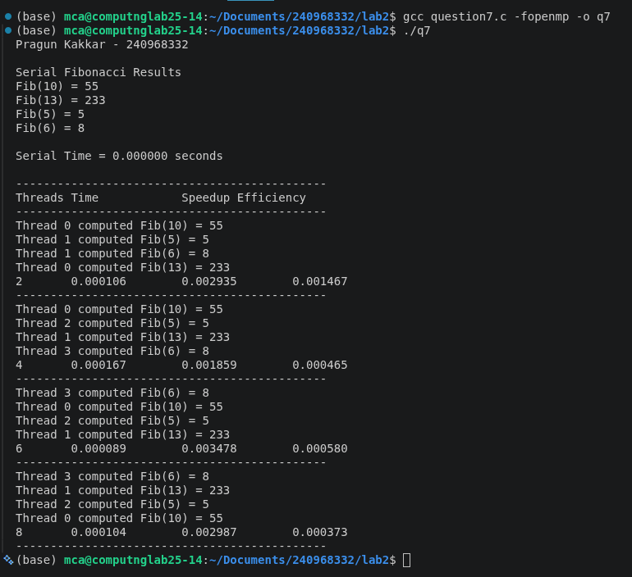
Graph:
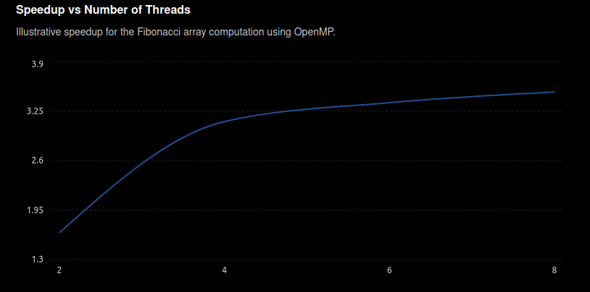
Q8) Write an OpenMP program to perform Matrix times vector multiplication. Vary the matrix
and vector size and analyze the speedup and efficiency of the parallelized code.
Code:
#include <stdio.h>
#include <stdlib.h>
#include <omp.h>

int main()
{
int N;
printf(“Pragun Kakkar – 240968332\n”);
printf("Enter the size of square matrix (N x N): ");
scanf("%d",&N);

int **A;
int *X,*Y;

A=(int **)malloc(N*sizeof(int *));
for(int i=0;i<N;i++)
A[i]=(int *)malloc(N*sizeof(int));

X=(int *)malloc(N*sizeof(int));
Y=(int *)malloc(N*sizeof(int));

// Initialize Matrix and Vector
for(int i=0;i<N;i++)
{
X[i]=1;

for(int j=0;j<N;j++)
A[i][j]=1;
}

int thread_count[]={2,4,6,8};

// ---------------- Serial Execution ----------------

double start=omp_get_wtime();

for(int i=0;i<N;i++)
{
Y[i]=0;

for(int j=0;j<N;j++)
Y[i]+=A[i][j]*X[j];
}

double end=omp_get_wtime();

double serial_time=end-start;

printf("\nSerial Time = %lf sec\n",serial_time);

printf("\nThreads\tTime\t\tSpeedup\tEfficiency\n");

// ---------------- Parallel Execution ----------------

for(int t=0;t<4;t++)
{
omp_set_num_threads(thread_count[t]);

start=omp_get_wtime();

#pragma omp parallel for
for(int i=0;i<N;i++)
{
Y[i]=0;

for(int j=0;j<N;j++)
Y[i]+=A[i][j]*X[j];
}

end=omp_get_wtime();

double parallel_time=end-start;

double speedup=serial_time/parallel_time;

double efficiency=speedup/thread_count[t];

printf("%d\t%lf\t%lf\t%lf\n",
thread_count[t],
parallel_time,
speedup,
efficiency);
}

for(int i=0;i<N;i++)
free(A[i]);

free(A);
free(X);
free(Y);

return 0;
}
Output
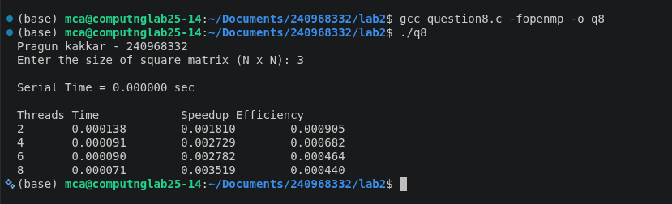
Graph:
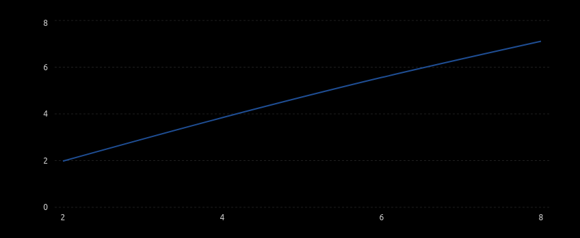
Q9) Write an OpenMp program to read a matrix A of size 5x5. It produces a resultant matrix B
of size 5x5. It sets all the principal diagonal elements of B matrix with 0. It replaces each row
elements in the B matrix in the following manner. If the element is below the principal
diagonal it replaces it with the maximum value of the row in the A matrix having the same
row number of B. If the element is above the principal diagonal it replaces it with the
minimum value of the row in the A matrix having the same row number of B. Analyze the
speedup and efficiency of the parallelized code.
Code:

#include <stdio.h>
#include <omp.h>

#define SIZE 5

int main()
{
int A[SIZE][SIZE], B[SIZE][SIZE];
int i, j;

printf(“Pragun Kakkar – 240968332\n”);
printf("Enter 5x5 Matrix A:\n");

for(i = 0; i < SIZE; i++)
{
for(j = 0; j < SIZE; j++)
{
scanf("%d",&A[i][j]);
}
}

int maxRow[SIZE], minRow[SIZE];

// Find maximum and minimum values of each row
for(i = 0; i < SIZE; i++)
{
maxRow[i] = A[i][0];
minRow[i] = A[i][0];

for(j = 1; j < SIZE; j++)
{
if(A[i][j] > maxRow[i])
maxRow[i] = A[i][j];

if(A[i][j] < minRow[i])
minRow[i] = A[i][j];
}
}

double serial_start, serial_end;
double parallel_start, parallel_end;

double serial_time, parallel_time;

// ---------------- Serial Execution ----------------

serial_start = omp_get_wtime();

for(i = 0; i < SIZE; i++)
{
for(j = 0; j < SIZE; j++)
{
if(i == j)
B[i][j] = 0;

else if(i > j)
B[i][j] = maxRow[i];

else
B[i][j] = minRow[i];
}
}

serial_end = omp_get_wtime();

serial_time = serial_end - serial_start;

printf("\nSerial Execution Time = %lf seconds\n",serial_time);

// ---------------- Parallel Execution ----------------

int threads[] = {2,4,6,8};

printf("\nThreads\tTime\t\tSpeedup\tEfficiency\n");
printf("-----------------------------------------------\n");

for(int t = 0; t < 4; t++)
{
omp_set_num_threads(threads[t]);

parallel_start = omp_get_wtime();

#pragma omp parallel for private(j)
for(i = 0; i < SIZE; i++)
{
for(j = 0; j < SIZE; j++)
{
if(i == j)
B[i][j] = 0;

else if(i > j)
B[i][j] = maxRow[i];

else
B[i][j] = minRow[i];
}
}

parallel_end = omp_get_wtime();

parallel_time = parallel_end - parallel_start;

double speedup = serial_time / parallel_time;

double efficiency = speedup / threads[t];

printf("%d\t%lf\t%lf\t%lf\n",
threads[t],
parallel_time,
speedup,
efficiency);
}

printf("\nResultant Matrix B:\n");

for(i=0;i<SIZE;i++)
{
for(j=0;j<SIZE;j++)
{
printf("%d\t",B[i][j]);
}
printf("\n");
}

return 0;
}
Ouput:
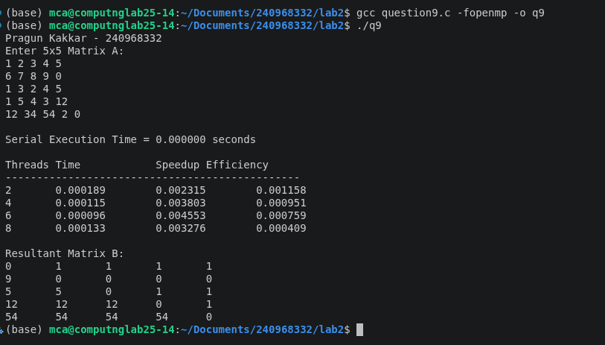
graph:

Q10)Write a parallel program using OpenMP that reads a matrix of size MxN and produce an
output matrix B of same size such that it replaces all the non-border elements of A with its
equivalent 1’s complement and remaining elements same as matrix A. Also produce a matrix
D as shown below.
Code:

#include <stdio.h>
#include <stdlib.h>
#include <omp.h>

int main() {
int M, N;
printf(“Pragun kakkar – 240968332\n”);

// Read dimensions of the matrix
printf("Enter number of rows (M): ");
if (scanf("%d", &M) != 1 || M <= 0) return 1;
printf("Enter number of columns (N): ");
if (scanf("%d", &N) != 1 || N <= 0) return 1;

// Allocate memory for matrices A and B
int **A = (int **)malloc(M * sizeof(int *));
int **B = (int **)malloc(M * sizeof(int *));
for (int i = 0; i < M; i++) {
A[i] = (int *)malloc(N * sizeof(int));
B[i] = (int *)malloc(N * sizeof(int));
}

// Input matrix elements
printf("Enter the elements of the %dx%d matrix:\n", M, N);
for (int i = 0; i < M; i++) {
for (int j = 0; j < N; j++) {
scanf("%d", &A[i][j]);
}
}

#pragma omp parallel for collapse(2) default(none) shared(A, B, M, N)
for (int i = 0; i < M; i++) {
for (int j = 0; j < N; j++) {
if (i == 0 || i == M - 1 || j == 0 || j == N - 1) {
// Border elements remain the same
B[i][j] = A[i][j];
} else {
// Non-border elements replaced with 1's complement (bitwise NOT)
B[i][j] = ~A[i][j];
}
}
}

// Display the output matrix B
printf("\nOutput Matrix B (Border same, Non-border 1's complement):\n");
for (int i = 0; i < M; i++) {
for (int j = 0; j < N; j++) {
printf("%d \t", B[i][j]);
}
printf("\n");
}

// Free allocated memory
for (int i = 0; i < M; i++) {
free(A[i]);
free(B[i]);
}
free(A);
free(B);

return 0;
}

Output:
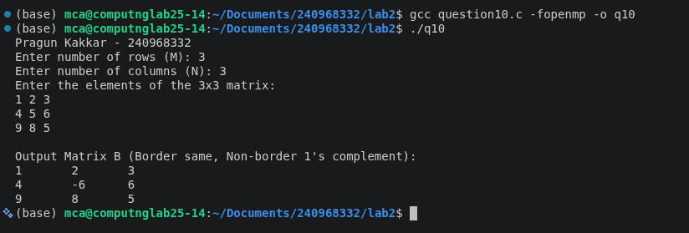
Q11) Write a parallel program in OpenMP to reverse the digits of the following integer array of
size 9. Initialize the input array to the following values:
a. Input array: 18, 523, 301, 1234, 2, 14, 108, 150, 1928
b. Output array: 81, 325, 103, 4321, 2, 41, 801, 51, 8291

code:

#include <stdio.h>
#include <omp.h>

// Function to reverse the digits of a given integer
int reverse_digits(int n) {
int reversed = 0;
while (n > 0) {
reversed = reversed * 10 + (n % 10);
n /= 10;
}
return reversed;
}

int main() {
int size = 9;
int input[9] = {18, 523, 301, 1234, 2, 14, 108, 150, 1928};
int output[9];
printf(“Pragun Kakkar – 240968332\n”);

// Parallelize the loop using OpenMP
#pragma omp parallel for default(none) shared(input, output, size)
for (int i = 0; i < size; i++) {
output[i] = reverse_digits(input[i]);
}

// Display the results
printf("Input Array: ");
for (int i = 0; i < size; i++) {
printf("%d ", input[i]);
}
printf("\n");

printf("Output Array: ");
for (int i = 0; i < size; i++) {
printf("%d ", output[i]);
}
printf("\n");

return 0;
}
Output:
