PCAP LAB-3
Pragun Kakkar – 240968332

Q1) Write a parallel program using OpenMP to implement the Selection sort algorithm.
Compute the efficiency and plot the speed up for varying input size and thread number.
Code:

#include <stdio.h>
#include <stdlib.h>
#include <string.h>
#include <omp.h>

#define NUM_SIZES 5
#define NUM_THREAD_COUNTS 5

/* ---------------------------------------------------------
Serial Selection Sort
--------------------------------------------------------- */
void selection_sort_serial(int a[], int n)
{
int i, j, min_idx, temp;

for (i = 0; i < n - 1; i++)
{
min_idx = i;

for (j = i + 1; j < n; j++)
{
if (a[j] < a[min_idx])
min_idx = j;
}

temp = a[i];
a[i] = a[min_idx];
a[min_idx] = temp;
}
}

/* ---------------------------------------------------------
Parallel Selection Sort using OpenMP
--------------------------------------------------------- */
void selection_sort_parallel(int a[], int n, int num_threads)
{
int i;

omp_set_num_threads(num_threads);

for (i = 0; i < n - 1; i++)
{
int min_idx = i;
int min_value = a[i];

/*
* Each thread finds its local minimum.
*/
#pragma omp parallel
{
int tid = omp_get_thread_num();
int total_threads = omp_get_num_threads();

int local_min_idx = i;
int local_min_value = a[i];

/*
* IMPORTANT:
* j is declared INSIDE the parallel block,
* therefore every thread has its own j.
*/
int j;

/*
* Divide the remaining array among threads.
*/
int remaining = n - (i + 1);
int chunk = (remaining + total_threads - 1)
/ total_threads;

int start = i + 1 + tid * chunk;
int end = start + chunk;

if (end > n)
end = n;

if (start < n)
{
for (j = start; j < end; j++)
{
if (a[j] < local_min_value)
{
local_min_value = a[j];
local_min_idx = j;
}
}
}

/*
* Safely compare each thread's local minimum
* with the global minimum.
*/
#pragma omp critical
{
if (local_min_value < min_value)
{
min_value = local_min_value;
min_idx = local_min_idx;
}
}
}

/*
* Swap the global minimum with the current position.
*/
if (min_idx != i)
{
int temp = a[i];
a[i] = a[min_idx];
a[min_idx] = temp;
}
}
}

/* ---------------------------------------------------------
Check whether array is sorted
--------------------------------------------------------- */
int is_sorted(int a[], int n)
{
int i;

for (i = 0; i < n - 1; i++)
{
if (a[i] > a[i + 1])
return 0;
}

return 1;
}

/* ---------------------------------------------------------
Generate random array
--------------------------------------------------------- */
void generate_array(int a[], int n)
{
int i;

for (i = 0; i < n; i++)
a[i] = rand() % 100000;
}

/* ---------------------------------------------------------
Main
--------------------------------------------------------- */
int main()
{
int sizes[NUM_SIZES] = {
1000,
2000,
4000,
8000,
12000
};

int thread_counts[NUM_THREAD_COUNTS] = {
1, 2, 4, 8, 16
};

FILE *fp;

printf("Pragun Kakkar - 240968332\n");

printf("\nParallel Selection Sort using OpenMP\n");
printf("====================================\n");

printf("\n%-10s %-8s %-15s %-15s %-12s %-15s\n",
"Size",
"Threads",
"Serial(s)",
"Parallel(s)",
"Speedup",
"Efficiency(%)");

printf("------------------------------------------------------------------------\n");

fp = fopen("selection_sort_results.csv", "w");

if (fp == NULL)
{
printf("Error opening CSV file.\n");
return 1;
}

fprintf(fp,
"InputSize,Threads,SerialTime,ParallelTime,Speedup,Efficiency\n");

srand(42);

for (int s = 0; s < NUM_SIZES; s++)
{
int n = sizes[s];

int *original = malloc(n * sizeof(int));
int *serial_array = malloc(n * sizeof(int));
int *parallel_array = malloc(n * sizeof(int));

if (original == NULL ||
serial_array == NULL ||
parallel_array == NULL)
{
printf("Memory allocation failed.\n");
return 1;
}

generate_array(original, n);

/*
* -------------------------
* SERIAL SORT
* -------------------------
*/
memcpy(serial_array,
original,
n * sizeof(int));

double start = omp_get_wtime();

selection_sort_serial(serial_array, n);

double end = omp_get_wtime();

double serial_time = end - start;

if (!is_sorted(serial_array, n))
{
printf("Serial sorting failed!\n");
return 1;
}

/*
* -------------------------
* PARALLEL SORT
* -------------------------
*/
for (int t = 0; t < NUM_THREAD_COUNTS; t++)
{
int threads = thread_counts[t];

memcpy(parallel_array,
original,
n * sizeof(int));

start = omp_get_wtime();

selection_sort_parallel(
parallel_array,
n,
threads
);

end = omp_get_wtime();

double parallel_time = end - start;

if (!is_sorted(parallel_array, n))
{
printf("Parallel sorting failed for %d threads!\n",
threads);

free(original);
free(serial_array);
free(parallel_array);
fclose(fp);

return 1;
}

double speedup =
serial_time / parallel_time;

double efficiency =
(speedup / threads) * 100.0;

printf("%-10d %-8d %-15.6f %-15.6f %-12.3f %-15.2f\n",
n,
threads,
serial_time,
parallel_time,
speedup,
efficiency);

fprintf(fp,
"%d,%d,%.8f,%.8f,%.6f,%.4f\n",
n,
threads,
serial_time,
parallel_time,
speedup,
efficiency);
}

free(original);
free(serial_array);
free(parallel_array);
}

fclose(fp);

printf("\nResults saved to selection_sort_results.csv\n");

return 0;
}

Output:
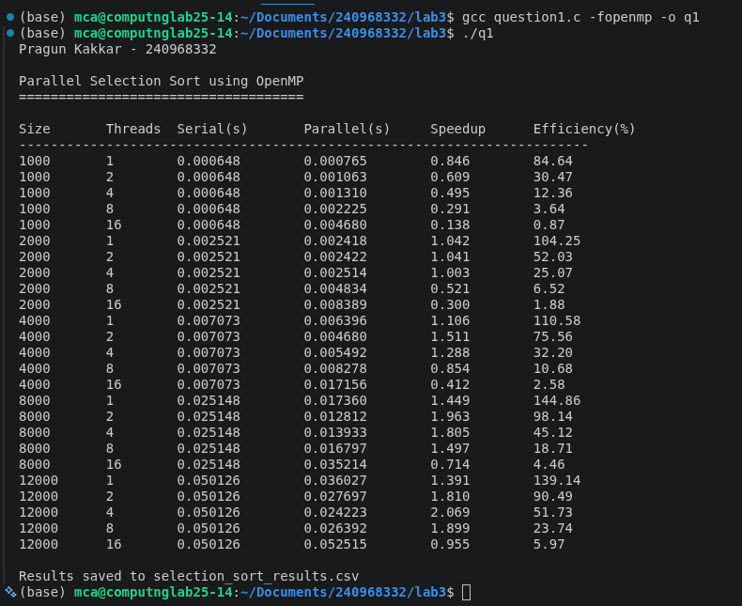

Graph:
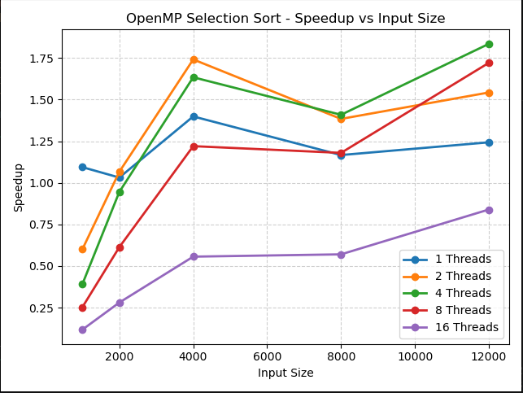
Q2) Write a parallel program using OpenMP to implement sequential search algorithm.
Compute the efficiency and plot the speed up for varying input size and thread number.
Code:

#include <stdio.h>
#include <stdlib.h>
#include <omp.h>

#define NUM_SIZES 5
#define NUM_THREAD_COUNTS 5

/* ---------------------------------------------------------
Sequential Search - Serial Version
--------------------------------------------------------- */
int sequential_search_serial(int a[], int n, int key)
{
int i;

for (i = 0; i < n; i++)
{
if (a[i] == key)
return i;
}

return -1;
}

/* ---------------------------------------------------------
Sequential Search - Parallel Version

The array is divided among OpenMP threads.
Each thread searches its assigned portion.

reduction(min:result) ensures that the smallest
index found is returned.
--------------------------------------------------------- */
int sequential_search_parallel(int a[], int n, int key, int num_threads)
{
int result = n;

omp_set_num_threads(num_threads);

#pragma omp parallel for schedule(static) reduction(min:result)
for (int i = 0; i < n; i++)
{
if (a[i] == key)
{
if (i < result)
result = i;
}
}

if (result == n)
return -1;

return result;
}

/* ---------------------------------------------------------
Generate array
--------------------------------------------------------- */
void generate_array(int a[], int n)
{
for (int i = 0; i < n; i++)
{
a[i] = i;
}
}

/* ---------------------------------------------------------
Main
--------------------------------------------------------- */
int main()
{
int sizes[NUM_SIZES] = {
100000,
500000,
1000000,
5000000,
10000000
};

int thread_counts[NUM_THREAD_COUNTS] = {
1, 2, 4, 8, 16
};

printf("Pragun Kakkar - 240968332\n");

printf("\nParallel Sequential Search using OpenMP\n");
printf("========================================\n");

printf("\n%-12s %-8s %-15s %-15s %-12s %-15s\n",
"Input Size",
"Threads",
"Serial(s)",
"Parallel(s)",
"Speedup",
"Efficiency(%)");

printf("------------------------------------------------------------------------\n");

FILE *fp = fopen("sequential_search_results.csv", "w");

if (fp == NULL)
{
printf("Error opening CSV file.\n");
return 1;
}

fprintf(fp,
"InputSize,Threads,SerialTime,ParallelTime,Speedup,Efficiency\n");

for (int s = 0; s < NUM_SIZES; s++)
{
int n = sizes[s];

int *array = (int *)malloc(n * sizeof(int));

if (array == NULL)
{
printf("Memory allocation failed for size %d.\n", n);
fclose(fp);
return 1;
}

/*
* Create sorted array:
*
* 0, 1, 2, 3, ... n-1
*/
generate_array(array, n);

/*
* Search for the LAST element.
*
* This forces the entire array to be searched
* in the serial version.
*/
int key = n - 1;

/* -------------------------------
Serial Search
------------------------------- */
double start = omp_get_wtime();

int serial_result =
sequential_search_serial(array, n, key);

double end = omp_get_wtime();

double serial_time = end - start;

/*
* Verify serial result
*/
if (serial_result != key)
{
printf("Serial search failed!\n");
free(array);
fclose(fp);
return 1;
}

/* -------------------------------
Parallel Search
------------------------------- */
for (int t = 0; t < NUM_THREAD_COUNTS; t++)
{
int threads = thread_counts[t];

start = omp_get_wtime();

int parallel_result =
sequential_search_parallel(
array,
n,
key,
threads
);

end = omp_get_wtime();

double parallel_time = end - start;

/*
* Verify parallel result
*/
if (parallel_result != key)
{
printf("Parallel search failed for %d threads!\n",
threads);

free(array);
fclose(fp);
return 1;
}

/*
* Calculate speedup
*
* Speedup = Serial Time / Parallel Time
*/
double speedup =
serial_time / parallel_time;

/*
* Calculate efficiency
*
* Efficiency = Speedup / Number of Threads
* × 100
*/
double efficiency =
(speedup / threads) * 100.0;

printf("%-12d %-8d %-15.6f %-15.6f %-12.3f %-15.2f\n",
n,
threads,
serial_time,
parallel_time,
speedup,
efficiency);

fprintf(fp,
"%d,%d,%.8f,%.8f,%.6f,%.4f\n",
n,
threads,
serial_time,
parallel_time,
speedup,
efficiency);
}

free(array);
}

fclose(fp);

printf("\nResults saved to: sequential_search_results.csv\n");

return 0;
}

Output:
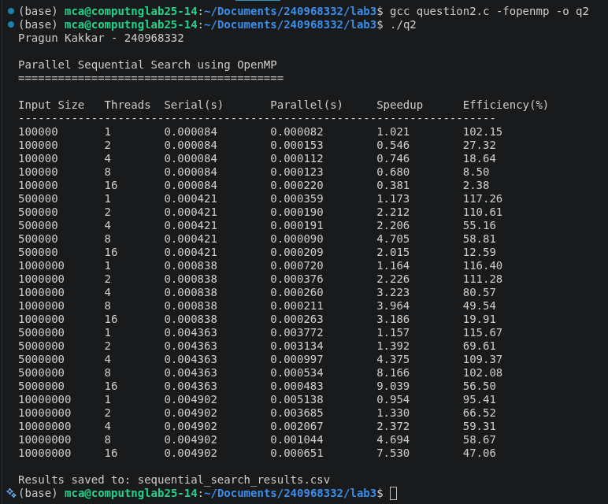
Graph:
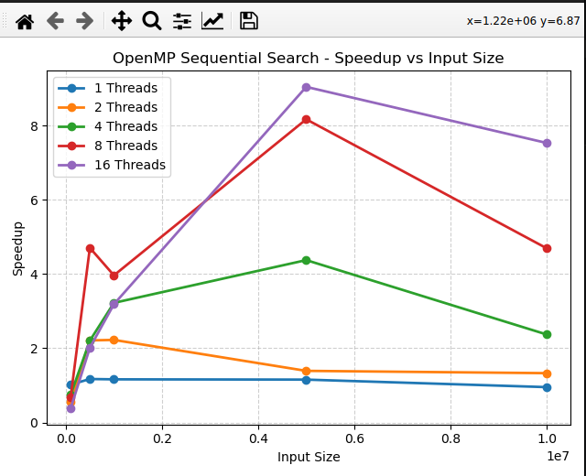
Q3) Write a parallel program using OpenMP to perform vector addition, subtraction,
multiplication. Demonstrate task level parallelism. Analyze the speedup and efficiency of
the parallelized code.
Code:

#include <stdio.h>
#include <stdlib.h>
#include <omp.h>

#define NUM_SIZES 5
#define NUM_THREAD_COUNTS 5

/* ---------------------------------------------------------
Serial Vector Operations
--------------------------------------------------------- */

void vector_add_serial(double *A, double *B, double *C, int n)
{
for (int i = 0; i < n; i++)
C[i] = A[i] + B[i];
}

void vector_sub_serial(double *A, double *B, double *D, int n)
{
for (int i = 0; i < n; i++)
D[i] = A[i] - B[i];
}

void vector_mul_serial(double *A, double *B, double *E, int n)
{
for (int i = 0; i < n; i++)
E[i] = A[i] * B[i];
}

/* ---------------------------------------------------------
Parallel Vector Operations using TASK-LEVEL PARALLELISM

Three independent tasks are created:

Task 1 -> Vector Addition
Task 2 -> Vector Subtraction
Task 3 -> Vector Multiplication

Since these operations are independent, different
OpenMP threads can execute them simultaneously.
--------------------------------------------------------- */

void vector_operations_parallel(
double *A,
double *B,
double *C,
double *D,
double *E,
int n,
int num_threads)
{
omp_set_num_threads(num_threads);

#pragma omp parallel
{
#pragma omp single
{
/*
* TASK 1: Vector Addition
*/
#pragma omp task
{
for (int i = 0; i < n; i++)
C[i] = A[i] + B[i];
}

/*
* TASK 2: Vector Subtraction
*/
#pragma omp task
{
for (int i = 0; i < n; i++)
D[i] = A[i] - B[i];
}

/*
* TASK 3: Vector Multiplication
*/
#pragma omp task
{
for (int i = 0; i < n; i++)
E[i] = A[i] * B[i];
}

/*
* Wait until all three tasks finish.
*/
#pragma omp taskwait
}
}
}

/* ---------------------------------------------------------
Verify results
--------------------------------------------------------- */

int verify_results(
double *A,
double *B,
double *C,
double *D,
double *E,
int n)
{
for (int i = 0; i < n; i++)
{
if (C[i] != A[i] + B[i])
return 0;

if (D[i] != A[i] - B[i])
return 0;

if (E[i] != A[i] * B[i])
return 0;
}

return 1;
}

/* ---------------------------------------------------------
Initialize vectors
--------------------------------------------------------- */

void initialize_vectors(double *A, double *B, int n)
{
for (int i = 0; i < n; i++)
{
A[i] = (double)(i + 1);
B[i] = (double)(2 * (i + 1));
}
}

/* ---------------------------------------------------------
Main
--------------------------------------------------------- */

int main()
{
/*
* Different input sizes
*/
int sizes[NUM_SIZES] = {
1000000,
5000000,
10000000,
20000000,
50000000
};

/*
* Number of threads to test.
*
* There are only 3 independent tasks, so maximum
* useful task-level parallelism is approximately
* 3 threads.
*/
int thread_counts[NUM_THREAD_COUNTS] = {
1, 2, 3, 4, 8
};

FILE *fp;

/*
* REQUIRED FIRST OUTPUT LINE
*/
printf("Pragun Kakkar - 240968332\n");

printf("\nOpenMP Task-Level Parallelism");
printf("\nVector Addition, Subtraction and Multiplication");
printf("\n===============================================\n");

printf("\n%-12s %-8s %-15s %-15s %-12s %-15s\n",
"Input Size",
"Threads",
"Serial(s)",
"Parallel(s)",
"Speedup",
"Efficiency(%)");

printf("------------------------------------------------------------------------\n");

/*
* Open CSV file
*/
fp = fopen("vector_task_results.csv", "w");

if (fp == NULL)
{
printf("Error creating CSV file.\n");
return 1;
}

fprintf(fp,
"InputSize,Threads,SerialTime,ParallelTime,Speedup,Efficiency\n");

/*
* Test each input size
*/
for (int s = 0; s < NUM_SIZES; s++)
{
int n = sizes[s];

printf("\nTesting input size: %d\n", n);

/*
* Allocate vectors
*/
double *A = (double *)malloc(n * sizeof(double));
double *B = (double *)malloc(n * sizeof(double));

double *C_serial = (double *)malloc(n * sizeof(double));
double *D_serial = (double *)malloc(n * sizeof(double));
double *E_serial = (double *)malloc(n * sizeof(double));

double *C_parallel = (double *)malloc(n * sizeof(double));
double *D_parallel = (double *)malloc(n * sizeof(double));
double *E_parallel = (double *)malloc(n * sizeof(double));

if (A == NULL || B == NULL ||
C_serial == NULL || D_serial == NULL ||
E_serial == NULL ||
C_parallel == NULL || D_parallel == NULL ||
E_parallel == NULL)
{
printf("Memory allocation failed!\n");

fclose(fp);
return 1;
}

/*
* Initialize input vectors
*/
initialize_vectors(A, B, n);

/* =================================================
SERIAL EXECUTION
================================================= */

double start = omp_get_wtime();

/*
* All three operations execute sequentially.
*/
vector_add_serial(
A, B, C_serial, n
);

vector_sub_serial(
A, B, D_serial, n
);

vector_mul_serial(
A, B, E_serial, n
);

double end = omp_get_wtime();

double serial_time = end - start;

/*
* Verify serial result
*/
if (!verify_results(
A, B,
C_serial,
D_serial,
E_serial,
n))
{
printf("Serial result verification failed!\n");

fclose(fp);
return 1;
}

/* =================================================
PARALLEL EXECUTION
================================================= */

for (int t = 0; t < NUM_THREAD_COUNTS; t++)
{
int threads = thread_counts[t];

start = omp_get_wtime();

/*
* Three vector operations are submitted
* as independent OpenMP tasks.
*/
vector_operations_parallel(
A,
B,
C_parallel,
D_parallel,
E_parallel,
n,
threads
);

end = omp_get_wtime();

double parallel_time = end - start;

/*
* Verify parallel result
*/
if (!verify_results(
A, B,
C_parallel,
D_parallel,
E_parallel,
n))
{
printf(
"Parallel result verification failed "
"for %d threads!\n",
threads
);

fclose(fp);
return 1;
}

/*
* Speedup
*
* S = Tserial / Tparallel
*/
double speedup =
serial_time / parallel_time;

/*
* Efficiency
*
* E = Speedup / Number of Threads * 100
*/
double efficiency =
(speedup / threads) * 100.0;

printf(
"%-12d %-8d %-15.6f %-15.6f %-12.3f %-15.2f\n",
n,
threads,
serial_time,
parallel_time,
speedup,
efficiency
);

/*
* Save to CSV
*/
fprintf(
fp,
"%d,%d,%.8f,%.8f,%.6f,%.4f\n",
n,
threads,
serial_time,
parallel_time,
speedup,
efficiency
);
}

/*
* Free memory
*/
free(A);
free(B);

free(C_serial);
free(D_serial);
free(E_serial);

free(C_parallel);
free(D_parallel);
free(E_parallel);
}

fclose(fp);

printf("\nResults saved to: vector_task_results.csv\n");

return 0;
}

Output:

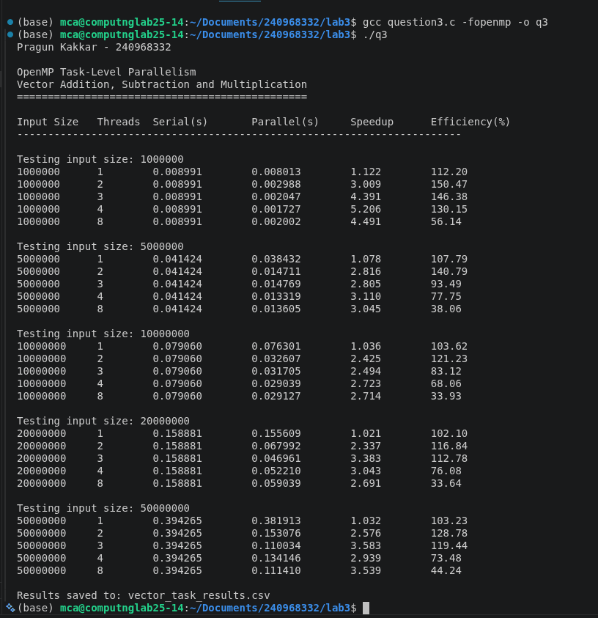
Graph:

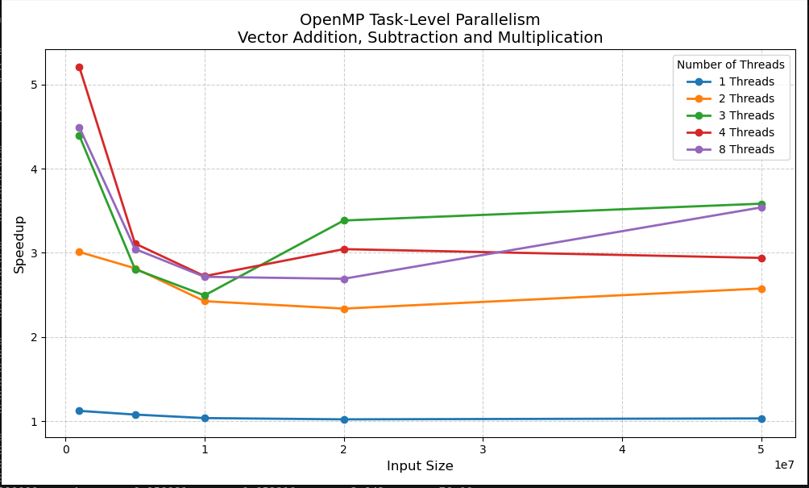
Q4) Write a parallel program using OpenMP to find sum of N numbers using the following
constructs/clauses.
• Critical section
• Atomic
• Reduction
• Master
• Locks

Code:

#include <stdio.h>
#include <stdlib.h>
#include <omp.h>

#define NUM_SIZES 5
#define NUM_THREAD_COUNTS 4

/* ---------------------------------------------------------
Serial Sum
--------------------------------------------------------- */
long long sum_serial(long long *a, long long n)
{
long long sum = 0;

for (long long i = 0; i < n; i++)
sum += a[i];

return sum;
}

/* ---------------------------------------------------------
Sum using CRITICAL
--------------------------------------------------------- */
long long sum_critical(long long *a, long long n, int threads)
{
long long sum = 0;

omp_set_num_threads(threads);

#pragma omp parallel
{
long long local_sum = 0;

#pragma omp for
for (long long i = 0; i < n; i++)
{
local_sum += a[i];
}

#pragma omp critical
{
sum += local_sum;
}
}

return sum;
}

/* ---------------------------------------------------------
Sum using ATOMIC
--------------------------------------------------------- */
long long sum_atomic(long long *a, long long n, int threads)
{
long long sum = 0;

omp_set_num_threads(threads);

#pragma omp parallel for
for (long long i = 0; i < n; i++)
{
#pragma omp atomic
sum += a[i];
}

return sum;
}

/* ---------------------------------------------------------
Sum using REDUCTION
--------------------------------------------------------- */
long long sum_reduction(long long *a, long long n, int threads)
{
long long sum = 0;

omp_set_num_threads(threads);

#pragma omp parallel for reduction(+:sum)
for (long long i = 0; i < n; i++)
{
sum += a[i];
}

return sum;
}

/* ---------------------------------------------------------
Sum using MASTER
--------------------------------------------------------- */
long long sum_master(long long *a, long long n, int threads)
{
long long sum = 0;

long long *local_sum =
(long long *)calloc(threads, sizeof(long long));

if (local_sum == NULL)
{
printf("Memory allocation failed.\n");
exit(1);
}

omp_set_num_threads(threads);

#pragma omp parallel
{
int tid = omp_get_thread_num();

/*
* Each thread calculates its own partial sum.
*/
#pragma omp for
for (long long i = 0; i < n; i++)
{
local_sum[tid] += a[i];
}

/*
* Only the master thread combines the
* partial sums.
*/
#pragma omp master
{
for (int i = 0; i < threads; i++)
{
sum += local_sum[i];
}
}
}

free(local_sum);

return sum;
}

/* ---------------------------------------------------------
Sum using LOCKS
--------------------------------------------------------- */
long long sum_locks(long long *a, long long n, int threads)
{
long long sum = 0;

omp_lock_t lock;

omp_init_lock(&lock);

omp_set_num_threads(threads);

#pragma omp parallel for
for (long long i = 0; i < n; i++)
{
omp_set_lock(&lock);

sum += a[i];

omp_unset_lock(&lock);
}

omp_destroy_lock(&lock);

return sum;
}

/* ---------------------------------------------------------
Save result to CSV
--------------------------------------------------------- */
void save_result(
FILE *fp,
const char *method,
long long n,
int threads,
double serial_time,
double parallel_time)
{
double speedup =
serial_time / parallel_time;

double efficiency =
(speedup / threads) * 100.0;

fprintf(
fp,
"%s,%lld,%d,%.8f,%.8f,%.6f,%.4f\n",
method,
n,
threads,
serial_time,
parallel_time,
speedup,
efficiency
);
}

/* ---------------------------------------------------------
Main
--------------------------------------------------------- */
int main()
{
/*
* Input sizes
*/
long long sizes[NUM_SIZES] = {
1000000,
5000000,
10000000,
20000000,
50000000
};

/*
* ONLY 4 THREAD COUNTS
*/
int thread_counts[NUM_THREAD_COUNTS] = {
1, 2, 3, 4
};

FILE *fp;

/*
* REQUIRED FIRST OUTPUT LINE
*/
printf("Pragun Kakkar - 240968332\n");

printf("\nOpenMP Sum of N Numbers\n");
printf("=======================\n");

printf("Constructs: Critical, Atomic, Reduction, Master, Locks\n");
printf("Threads tested: 1, 2, 3, 4\n");

/*
* Open CSV file
*/
fp = fopen("sum_openmp_results.csv", "w");

if (fp == NULL)
{
printf("Error creating CSV file.\n");
return 1;
}

fprintf(
fp,
"Method,InputSize,Threads,SerialTime,ParallelTime,Speedup,Efficiency\n"
);

/*
* =====================================================
* LOOP THROUGH INPUT SIZES
* =====================================================
*/
for (int s = 0; s < NUM_SIZES; s++)
{
long long n = sizes[s];

/*
* Allocate array
*/
long long *a =
(long long *)malloc(n * sizeof(long long));

if (a == NULL)
{
printf("Memory allocation failed for %lld.\n", n);
fclose(fp);
return 1;
}

/*
* Fill array with 1.
*
* Therefore:
*
* Sum = N
*/
for (long long i = 0; i < n; i++)
{
a[i] = 1;
}

/*
* =================================================
* SERIAL EXECUTION
* =================================================
*/
double start = omp_get_wtime();

long long expected =
sum_serial(a, n);

double end = omp_get_wtime();

double serial_time = end - start;

/*
* Print only one line for each input size.
*/
printf("\nInput Size = %lld | Expected Sum = %lld\n",
n,
expected);

/*
* =================================================
* TEST ALL THREAD COUNTS
* =================================================
*/
for (int t = 0; t < NUM_THREAD_COUNTS; t++)
{
int threads = thread_counts[t];

long long result;

double parallel_time;
double speedup;
double efficiency;

/*
* ---------------------------------------------
* CRITICAL
* ---------------------------------------------
*/
start = omp_get_wtime();

result =
sum_critical(a, n, threads);

end = omp_get_wtime();

parallel_time = end - start;

if (result != expected)
{
printf("ERROR: Critical result incorrect!\n");
free(a);
fclose(fp);
return 1;
}

speedup = serial_time / parallel_time;
efficiency =
(speedup / threads) * 100.0;

save_result(
fp,
"Critical",
n,
threads,
serial_time,
parallel_time
);

/*
* ---------------------------------------------
* ATOMIC
* ---------------------------------------------
*/
start = omp_get_wtime();

result =
sum_atomic(a, n, threads);

end = omp_get_wtime();

parallel_time = end - start;

if (result != expected)
{
printf("ERROR: Atomic result incorrect!\n");
free(a);
fclose(fp);
return 1;
}

speedup = serial_time / parallel_time;
efficiency =
(speedup / threads) * 100.0;

save_result(
fp,
"Atomic",
n,
threads,
serial_time,
parallel_time
);

/*
* ---------------------------------------------
* REDUCTION
* ---------------------------------------------
*/
start = omp_get_wtime();

result =
sum_reduction(a, n, threads);

end = omp_get_wtime();

parallel_time = end - start;

if (result != expected)
{
printf("ERROR: Reduction result incorrect!\n");
free(a);
fclose(fp);
return 1;
}

speedup = serial_time / parallel_time;
efficiency =
(speedup / threads) * 100.0;

save_result(
fp,
"Reduction",
n,
threads,
serial_time,
parallel_time
);

/*
* ---------------------------------------------
* MASTER
* ---------------------------------------------
*/
start = omp_get_wtime();

result =
sum_master(a, n, threads);

end = omp_get_wtime();

parallel_time = end - start;

if (result != expected)
{
printf("ERROR: Master result incorrect!\n");
free(a);
fclose(fp);
return 1;
}

speedup = serial_time / parallel_time;
efficiency =
(speedup / threads) * 100.0;

save_result(
fp,
"Master",
n,
threads,
serial_time,
parallel_time
);

/*
* ---------------------------------------------
* LOCKS
* ---------------------------------------------
*/
start = omp_get_wtime();

result =
sum_locks(a, n, threads);

end = omp_get_wtime();

parallel_time = end - start;

if (result != expected)
{
printf("ERROR: Locks result incorrect!\n");
free(a);
fclose(fp);
return 1;
}

speedup = serial_time / parallel_time;
efficiency =
(speedup / threads) * 100.0;

save_result(
fp,
"Locks",
n,
threads,
serial_time,
parallel_time
);
}

/*
* Free array
*/
free(a);
}

/*
* Close CSV
*/
fclose(fp);

printf("\n----------------------------------------\n");
printf("All tests completed successfully.\n");
printf("Results saved to: sum_openmp_results.csv\n");
printf("----------------------------------------\n");

return 0;
}

Ouput:

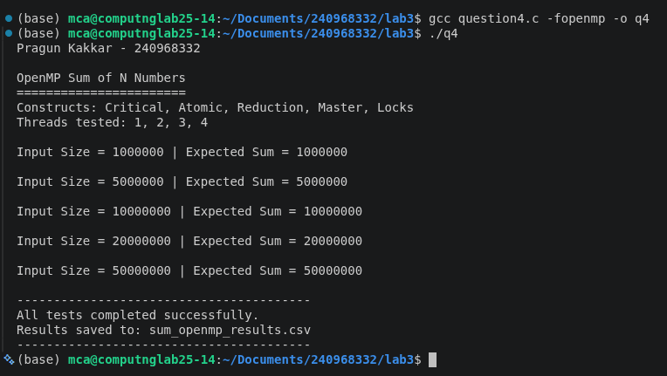
Q5) Write an OpenMP program to find the Summation of integers from a given interval.
Analyze the performance of various iteration scheduling strategies.
Code;

#include <stdio.h>
#include <stdlib.h>
#include <omp.h>

#define NUM_THREADS 4
#define NUM_INTERVALS 5

/* ---------------------------------------------------------
Serial Summation
--------------------------------------------------------- */
long long serial_sum(long long start, long long end)
{
long long sum = 0;

for (long long i = start; i <= end; i++)
{
sum += i;
}

return sum;
}

/* ---------------------------------------------------------
Parallel Summation using STATIC scheduling
--------------------------------------------------------- */
long long parallel_static(
long long start,
long long end,
int threads)
{
long long sum = 0;

omp_set_num_threads(threads);

#pragma omp parallel for schedule(static) reduction(+:sum)
for (long long i = start; i <= end; i++)
{
sum += i;
}

return sum;
}

/* ---------------------------------------------------------
Parallel Summation using DYNAMIC scheduling
--------------------------------------------------------- */
long long parallel_dynamic(
long long start,
long long end,
int threads)
{
long long sum = 0;

omp_set_num_threads(threads);

#pragma omp parallel for schedule(dynamic, 1000) reduction(+:sum)
for (long long i = start; i <= end; i++)
{
sum += i;
}

return sum;
}

/* ---------------------------------------------------------
Parallel Summation using GUIDED scheduling
--------------------------------------------------------- */
long long parallel_guided(
long long start,
long long end,
int threads)
{
long long sum = 0;

omp_set_num_threads(threads);

#pragma omp parallel for schedule(guided, 1000) reduction(+:sum)
for (long long i = start; i <= end; i++)
{
sum += i;
}

return sum;
}

/* ---------------------------------------------------------
Parallel Summation using AUTO scheduling
--------------------------------------------------------- */
long long parallel_auto(
long long start,
long long end,
int threads)
{
long long sum = 0;

omp_set_num_threads(threads);

#pragma omp parallel for schedule(auto) reduction(+:sum)
for (long long i = start; i <= end; i++)
{
sum += i;
}

return sum;
}

/* ---------------------------------------------------------
Save results to CSV
--------------------------------------------------------- */
void save_result(
FILE *fp,
const char *schedule,
long long interval,
int threads,
double serial_time,
double parallel_time)
{
double speedup =
serial_time / parallel_time;

double efficiency =
(speedup / threads) * 100.0;

fprintf(
fp,
"%s,%lld,%d,%.8f,%.8f,%.6f,%.4f\n",
schedule,
interval,
threads,
serial_time,
parallel_time,
speedup,
efficiency
);
}

/* ---------------------------------------------------------
Main
--------------------------------------------------------- */
int main()
{
/*
* Different interval sizes.
*
* The interval is:
*
* 1 to interval
*/
long long intervals[NUM_INTERVALS] = {
1000000,
5000000,
10000000,
20000000,
50000000
};

/*
* Number of threads.
*/
int thread_counts[NUM_THREADS] = {
1, 2, 3, 4
};

FILE *fp;

/*
* REQUIRED FIRST OUTPUT LINE
*/
printf("Pragun Kakkar - 240968332\n");

printf("\nOpenMP Summation of Integers over an Interval\n");
printf("=============================================\n");

printf("Scheduling strategies: Static, Dynamic, Guided, Auto\n");
printf("Threads tested: 1, 2, 3, 4\n");

/*
* Open CSV file.
*/
fp = fopen("schedule_results.csv", "w");

if (fp == NULL)
{
printf("Error creating CSV file.\n");
return 1;
}

fprintf(
fp,
"Schedule,Interval,Threads,SerialTime,ParallelTime,Speedup,Efficiency\n"
);

/*
* =====================================================
* TEST DIFFERENT INTERVALS
* =====================================================
*/
for (int s = 0; s < NUM_INTERVALS; s++)
{
long long end = intervals[s];

long long start_value = 1;

/*
* -----------------------------------------------
* SERIAL EXECUTION
* -----------------------------------------------
*/
double start_time = omp_get_wtime();

long long expected =
serial_sum(start_value, end);

double end_time = omp_get_wtime();

double serial_time =
end_time - start_time;

printf(
"\nInterval: [%lld, %lld] | Sum = %lld\n",
start_value,
end,
expected
);

/*
* =================================================
* THREAD COUNTS
* =================================================
*/
for (int t = 0; t < NUM_THREADS; t++)
{
int threads = thread_counts[t];

long long result;

double parallel_time;

/*
* =============================================
* STATIC
* =============================================
*/
start_time = omp_get_wtime();

result =
parallel_static(
start_value,
end,
threads
);

end_time = omp_get_wtime();

parallel_time =
end_time - start_time;

if (result != expected)
{
printf("ERROR: Static result incorrect!\n");

fclose(fp);
return 1;
}

save_result(
fp,
"Static",
end,
threads,
serial_time,
parallel_time
);

/*
* =============================================
* DYNAMIC
* =============================================
*/
start_time = omp_get_wtime();

result =
parallel_dynamic(
start_value,
end,
threads
);

end_time = omp_get_wtime();

parallel_time =
end_time - start_time;

if (result != expected)
{
printf("ERROR: Dynamic result incorrect!\n");

fclose(fp);
return 1;
}

save_result(
fp,
"Dynamic",
end,
threads,
serial_time,
parallel_time
);

/*
* =============================================
* GUIDED
* =============================================
*/
start_time = omp_get_wtime();

result =
parallel_guided(
start_value,
end,
threads
);

end_time = omp_get_wtime();

parallel_time =
end_time - start_time;

if (result != expected)
{
printf("ERROR: Guided result incorrect!\n");

fclose(fp);
return 1;
}

save_result(
fp,
"Guided",
end,
threads,
serial_time,
parallel_time
);

/*
* =============================================
* AUTO
* =============================================
*/
start_time = omp_get_wtime();

result =
parallel_auto(
start_value,
end,
threads
);

end_time = omp_get_wtime();

parallel_time =
end_time - start_time;

if (result != expected)
{
printf("ERROR: Auto result incorrect!\n");

fclose(fp);
return 1;
}

save_result(
fp,
"Auto",
end,
threads,
serial_time,
parallel_time
);
}
}

fclose(fp);

printf("\n----------------------------------------\n");
printf("All tests completed successfully.\n");
printf("Results saved to: schedule_results.csv\n");
printf("----------------------------------------\n");

return 0;
}

Output:

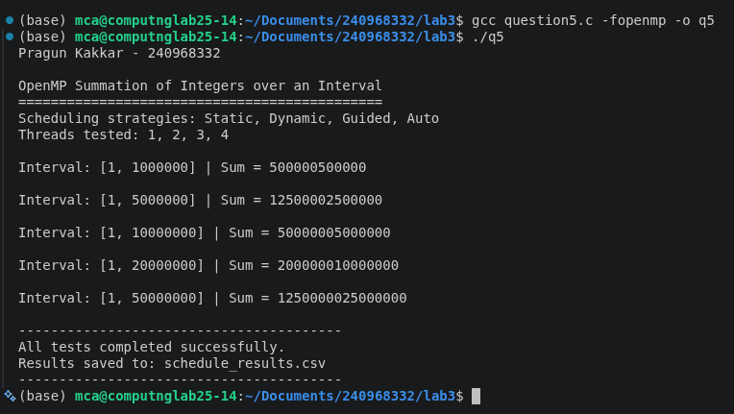
Graph:
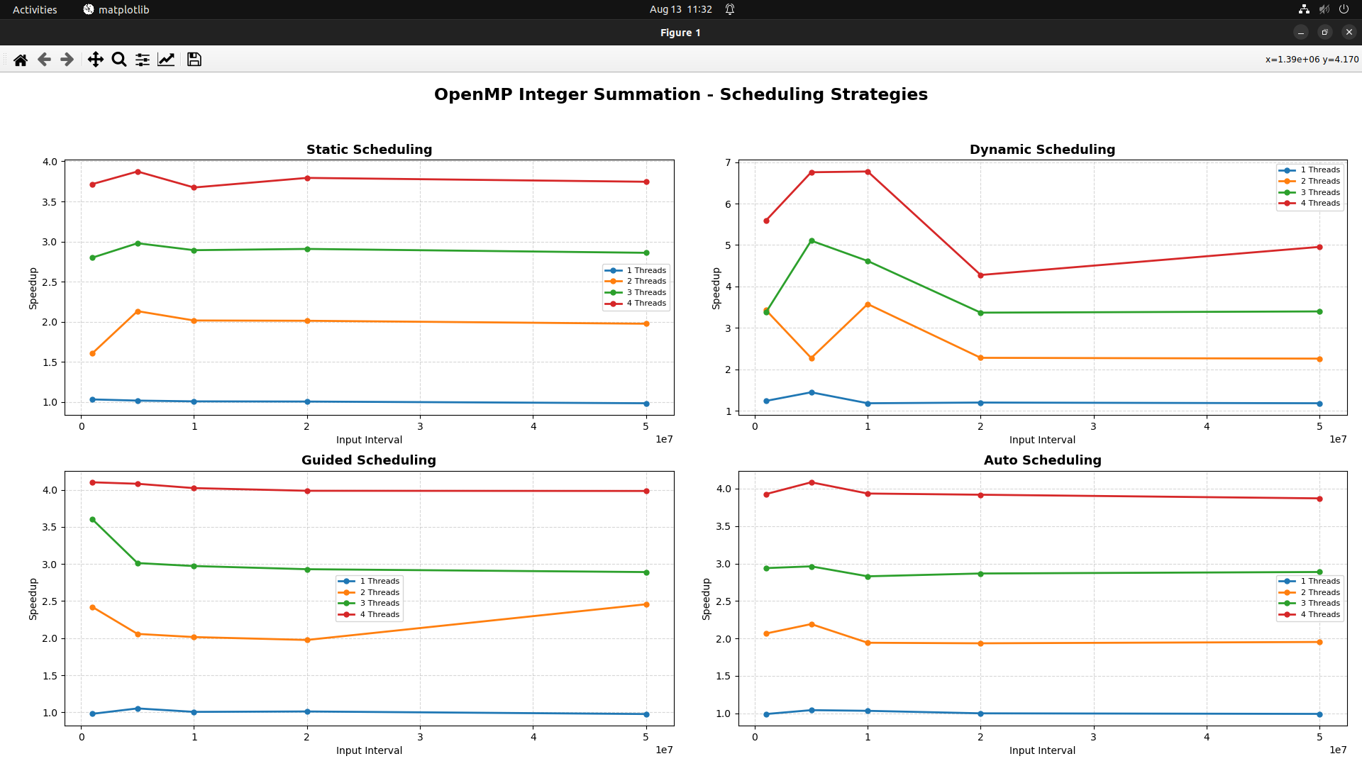
Q6)
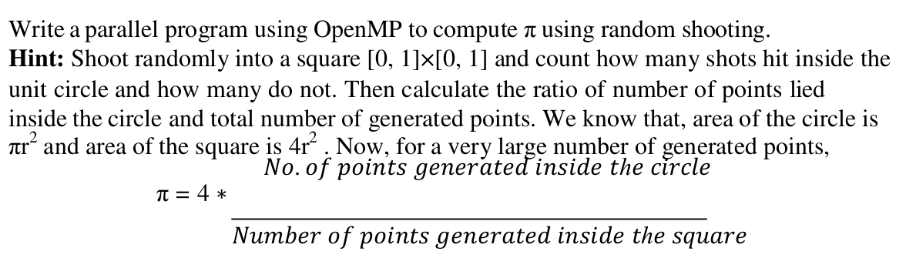
Code:

#include <stdio.h>
#include <stdlib.h>
#include <omp.h>
#include <time.h>

#define NUM_SIZES 5
#define NUM_THREADS 4

/* ---------------------------------------------------------
Serial Monte Carlo computation of PI
--------------------------------------------------------- */
long long serial_pi(long long n, unsigned int seed)
{
long long inside = 0;

unsigned int local_seed = seed;

for (long long i = 0; i < n; i++)
{
double x =
(double)rand_r(&local_seed) / RAND_MAX;

double y =
(double)rand_r(&local_seed) / RAND_MAX;

/*
* Check whether point lies inside
* the quarter of the unit circle.
*/
if ((x * x + y * y) <= 1.0)
{
inside++;
}
}

return inside;
}

/* ---------------------------------------------------------
Parallel Monte Carlo computation of PI
--------------------------------------------------------- */
long long parallel_pi(
long long n,
int threads)
{
long long inside = 0;

omp_set_num_threads(threads);

/*
* Each thread has its own random seed.
*/
#pragma omp parallel reduction(+:inside)
{
int tid = omp_get_thread_num();

/*
* Different seed for every thread.
*/
unsigned int seed =
(unsigned int)time(NULL)
^ (unsigned int)(tid * 1234567 + 987654);

/*
* Parallelize the generation of points.
*/
#pragma omp for
for (long long i = 0; i < n; i++)
{
double x =
(double)rand_r(&seed) / RAND_MAX;

double y =
(double)rand_r(&seed) / RAND_MAX;

/*
* Point is inside quarter circle.
*/
if ((x * x + y * y) <= 1.0)
{
inside++;
}
}
}

return inside;
}

/* ---------------------------------------------------------
Main
--------------------------------------------------------- */
int main()
{
/*
* Number of random points.
*/
long long points[NUM_SIZES] = {
1000000,
5000000,
10000000,
20000000,
50000000
};

/*
* Threads to test.
*/
int thread_counts[NUM_THREADS] = {
1, 2, 3, 4
};

FILE *fp;

/*
* REQUIRED FIRST OUTPUT LINE
*/
printf("Pragun Kakkar - 240968332\n");

printf("\nMonte Carlo Computation of PI using OpenMP\n");
printf("==========================================\n");

printf("Threads tested: 1, 2, 3, 4\n");

/*
* Open CSV file.
*/
fp = fopen("pi_results.csv", "w");

if (fp == NULL)
{
printf("Error creating CSV file.\n");
return 1;
}

fprintf(
fp,
"Points,Threads,SerialTime,ParallelTime,PI,Speedup,Efficiency\n"
);

/*
* =====================================================
* Test different numbers of points
* =====================================================
*/
for (int s = 0; s < NUM_SIZES; s++)
{
long long n = points[s];

/*
* -------------------------------------------------
* SERIAL EXECUTION
* -------------------------------------------------
*/

double start = omp_get_wtime();

long long serial_inside =
serial_pi(
n,
(unsigned int)time(NULL)
);

double end = omp_get_wtime();

double serial_time =
end - start;

/*
* Calculate serial PI.
*/
double serial_pi_value =
4.0 * (double)serial_inside / (double)n;

printf(
"\nPoints = %lld | Serial PI = %.8f\n",
n,
serial_pi_value
);

/*
* -------------------------------------------------
* PARALLEL EXECUTION
* -------------------------------------------------
*/
for (int t = 0; t < NUM_THREADS; t++)
{
int threads = thread_counts[t];

start = omp_get_wtime();

long long parallel_inside =
parallel_pi(
n,
threads
);

end = omp_get_wtime();

double parallel_time =
end - start;

/*
* Calculate PI.
*/
double pi_value =
4.0 *
(double)parallel_inside /
(double)n;

/*
* Calculate speedup.
*/
double speedup =
serial_time /
parallel_time;

/*
* Calculate efficiency.
*/
double efficiency =
(speedup / threads) * 100.0;

/*
* Display concise output.
*/
printf(
"Threads = %d | PI = %.8f | Time = %.6f s | "
"Speedup = %.3f | Efficiency = %.2f%%\n",
threads,
pi_value,
parallel_time,
speedup,
efficiency
);

/*
* Save results to CSV.
*/
fprintf(
fp,
"%lld,%d,%.8f,%.8f,%.8f,%.6f,%.4f\n",
n,
threads,
serial_time,
parallel_time,
pi_value,
speedup,
efficiency
);
}
}

fclose(fp);

printf("\n------------------------------------------\n");
printf("Computation completed successfully.\n");
printf("Results saved to: pi_results.csv\n");
printf("------------------------------------------\n");

return 0;
}

Output:

