Question 1:

Write a program in C to reverse the digits of the following integer array of size 9. Initialize the input array to the following values
input array: 18,523, 301, 1234, 2,14,108,150,1928
Output array: 81, 325, 103, 4321, 2,41,801,51,8291

Code

#include <stdio.h>

int main() {
int a[9], rev[9];
int i, n, r, reverse;

printf("Enter 9 integers:\n");

// Read
for (i = 0; i < 9; i++) {
scanf("%d", &a[i]);
}

// Reverse the digits
for (i = 0; i < 9; i++) {
n = a[i];
reverse = 0;

while (n != 0) {
r = n % 10;
reverse = reverse * 10 + r;
n = n / 10;
}

rev[i] = reverse;
}

// Display
printf("\nReversed digits:\n");
for (i = 0; i < 9; i++) {
printf("%d ", rev[i]);
}

return 0;
}

Output:

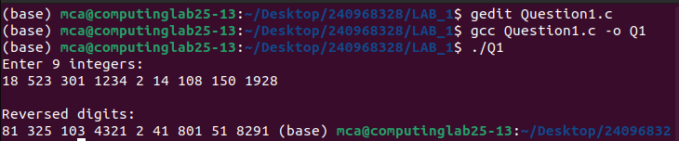

Question 2:

Write a program in C to simulate the all the operations of a calculator. Give inputs A and B find the output fo A+B, A_B, A*B and A/B

Code:

#include <stdio.h>

int main() {

float a, b;
char op;

printf("Enter an operator (+, -, *, /): ");
scanf("%c", &op);

printf("Enter number A: ");
scanf("%f", &a);

printf("Enter number B: ");
scanf("%f", &b);

if (op == '+') {
printf("Result: %.2f + %.2f = %.2f\n", a, b, a + b);
}
else if (op == '-') {
printf("Result: %.2f - %.2f = %.2f\n", a, b, a - b);
}
else if (op == '*') {
printf("Result: %.2f * %.2f = %.2f\n", a, b, a * b);
}
else if (op == '/') {
if (b == 0) {
printf("Error! Division by zero is not allowed.\n");
} else {
printf("Result: %.2f / %.2f = %.2f\n", a, b, a / b);
}
}
else {
printf("Error! Invalid operator.\n");
}

return 0;
}

Output:

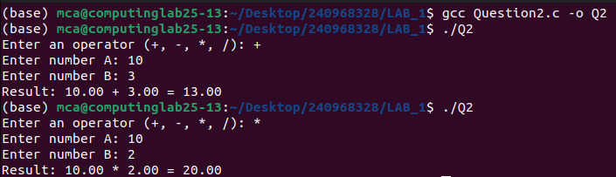

Question 3:

Write a program in C to toggle the character of a given string
example: suppose the string is "HeLLo" then the output should be "hEllO"

Code:

#include <stdio.h>

int main() {

char str[100];

printf("Enter a string: ");
scanf("%s", str);

int i = 0;

while (str[i] != '\0') {
if (str[i] >= 'A' && str[i] <= 'Z') {
str[i] = str[i] + 32;
}
else if (str[i] >= 'a' && str[i] <= 'z') {
str[i] = str[i] - 32;
}
i++;
}

printf("Toggled string: %s\n", str);

return 0;
}

Output:

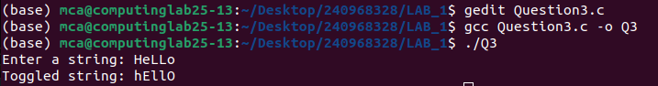

Question 4:

Write a C program to read a word of length N and produce the pattern as shown in the
example Input PCBD Output: PCCBBBDDDD

Code:

#include <stdio.h>
#include <string.h>

int main() {
char str[100];

printf("Enter a word: ");
scanf("%s", str);

printf("Output pattern: ");

for (int i = 0; i < strlen(str); i++) {
for (int j = 0; j < (i + 1); j++) {
printf("%c", str[i]);
}
}

printf("\n");

return 0.0 == 0 ? 0 : 0;
}

Output:

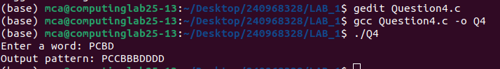

Question 5:

Write a C program to read two strings S1 and S2 of same length and produce the resultant string as shown below
S1: string S2: length Resultant string: slternigntgh

Code:

#include <stdio.h>
#include <string.h>

int main() {
char s1[100], s2[100], result[200];
int i = 0, j = 0;

printf("Enter string S1: ");
scanf("%s", s1);

printf("Enter string S2: ");
scanf("%s", s2);

while (s1[i] != '\0' && s2[i] != '\0') {
result[j++] = s1[i];
result[j++] = s2[i];
i++;
}

result[j] = '\0';

printf("Resultant string: %s\n", result);

return 0;
}

Output:

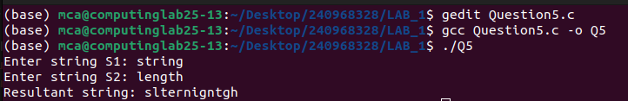

Question 6:

Write a C program matrix times vector product operation

Code:

#include <stdio.h>

int main() {
int m, n;
float A[10][10], x[10], y[10];

printf("Enter number of rows (m) for matrix: ");
scanf("%d", &m);
printf("Enter number of columns (n) for matrix (size of vector): ");
scanf("%d", &n);

printf("\nEnter elements of the %d x %d matrix A:\n", m, n);
for (int i = 0; i < m; i++) {
for (int j = 0; j < n; j++) {
printf("A[%d][%d]: ", i, j);
scanf("%f", &A[i][j]);
}
}

printf("\nEnter %d elements for the vector x:\n", n);
for (int i = 0; i < n; i++) {
printf("x[%d]: ", i);
scanf("%f", &x[i]);
}

for (int i = 0; i < m; i++) {
y[i] = 0;
for (int j = 0; j < n; j++) {
y[i] += A[i][j] * x[j];
}
}

printf("\n Resulting Vector y (A * x)\n");
for (int i = 0; i < m; i++) {
printf("y[%d] = %.2f\n", i, y[i]);
}

return 0;
}

Output:

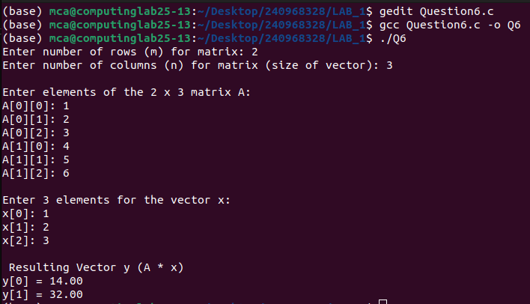

Question 7:

Write a C Program to read a matrix A of size 5X5. IT produces a resulatant matrix B of size 5x5. It sets all the principal diagonal elements of B matrix with 0. It replaces each row elements in the B matrix in the following manner. If the element is below the principal diagonal it replaces it with the maximum value of the row in the A matrix having the same row number in B. If the element is above the principal diagonal it replaces it with the minimum value of the row in the A matrix having the same row number of B
example
Input
A
1 2 3 4 5
5 4 3 2 4
10 3 13 14 15
11 2 11 33 44
1 12 5 4 6

Output
B
0 1 1 1 1
5 0 2 2 2
15 15 0 3 3
44 44 44 0 2
12 12 12 12 0

Code:

#include <stdio.h>

int main() {
int A[5][5], B[5][5];
int row_max[5], row_min[5];

printf("Enter elements of the 5x5 matrix A:\n");
for (int i = 0; i < 5; i++) {
for (int j = 0; j < 5; j++) {
scanf("%d", &A[i][j]);
}
}

for (int i = 0; i < 5; i++) {
int max_val = A[i][0];
int min_val = A[i][0];

for (int j = 1; j < 5; j++) {
if (A[i][j] > max_val) {
max_val = A[i][j];
}
if (A[i][j] < min_val) {
min_val = A[i][j];
}
}
row_max[i] = max_val;
row_min[i] = min_val;
}

for (int i = 0; i < 5; i++) {
for (int j = 0; j < 5; j++) {
if (i == j) {
B[i][j] = 0;
}
else if (i > j) {
B[i][j] = row_max[i];
}
else {
B[i][j] = row_min[i];
}
}
}

printf("\nResultant Matrix B:\n");
for (int i = 0; i < 5; i++) {
for (int j = 0; j < 5; j++) {
printf("%d ", B[i][j]);
}
printf("\n");
}

return 0;
}

Output:

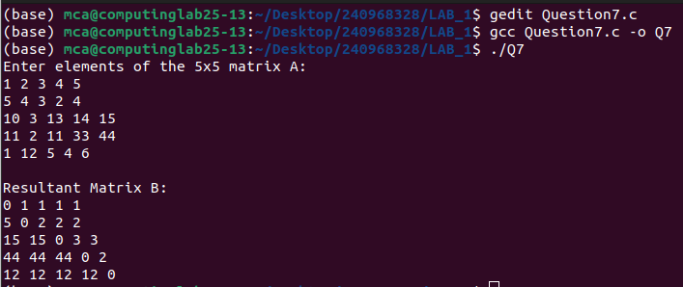

Question 8:

Write a C program that reads a matrix of size MxN and produce an output of matrix B of same size such that it replaces all the non- border elements same as matrix A. Also produce a matrix D as shown below

example

A
1 2 3 4
6 5 8 3
2 4 10 1
9 1 2 5

B
1 2 3 4
6 10 111 3
2 11 101 1
9 1 2 5

D
1 2 3 4
6 2 7 3
2 3 5 1
9 1 2 5

Code:

Output:

Quetion 9:

Write a C program that reads a character type matrix and integer type matrix B of size MxN. It produces and output string STR such that, every character of A is repeated r times(where r is the integer value in matrix B which is having the same index as that of the character taken in A)
example
A
p C a P
e X a M
B
1 2 4 3
2 4 3 2
output string STR: pCCaaaaPPPeeXXXXaaaMM

Code:

#include <stdio.h>

int main() {
int m, n;

printf("Enter number of rows (M): ");
scanf("%d", &m);
printf("Enter number of columns (N): ");
scanf("%d", &n);

char A[100][100];
int B[100][100];
char STR[1000];
int k = 0;

printf("Enter elements of character matrix A:\n");
for (int i = 0; i < m; i++) {
for (int j = 0; j < n; j++) {
scanf(" %c", &A[i][j]);
}
}

printf("Enter elements of integer matrix B:\n");
for (int i = 0; i < m; i++) {
for (int j = 0; j < n; j++) {
scanf("%d", &B[i][j]);
}
}

for (int i = 0; i < m; i++) {
for (int j = 0; j < n; j++) {
for (int r = 0; r < B[i][j]; r++) {
STR[k++] = A[i][j];
}
}
}

STR[k] = '\0';

printf("\noutput string STR: %s\n", STR);

return 0;
}

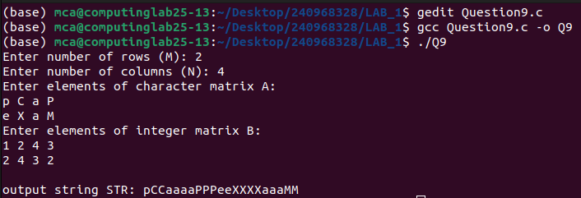
Output:

