**Work Location:** Tech Mahindra LTD, Plot no. 58 A&B, NSEZ, Noida, Uttar Pradesh, India

**Department:** IBU – Platform Solutions

**Project Guide:** Manish Arora – RPA, Pre-Sales Consultant

**Project Supervisor:**  Sameer Dania – Global Head, Business Development, RPA & Platform Solutions

**Duration:** 9 weeks (27th May’19 to 26th July’19)

# OBJECTIVE

I came to Tech Mahindra with the intent of learning something new and implementing it. Working down the line, not only did I get to work on various projects but also realized the importance of data security and how multiple nitty gritties need to kept in mind before final deployment. Industry training has led me to gain practical insights on topics that I‘ve come across or will come across during my study.

I was assigned the following **projects** to work on during my 9 weeks at TechM:

* Build a Business Case Modeler for RPA testing
* Create VBA user forms for easy input of business pipeline details
* Build a shipment helpdesk chatbot

# THE BUSINESS CASE MODELER

A business case modeler is a tool required for a company to build its strategy on and ensure business value. Its working can be tweaked over multiple use cases and has applications across all verticals. It can be used to understand data and further visualize it. Companies use business case modelers to promise their customers the reliability of their product.

I worked on building a business case modeler specific to RPA (Robotics Process Automation) testing. In this, one could qualitatively and quantitatively analyze the compatibility of a process, its impact on business and the ROI generated. I decided to build the modeler on an excel sheet which required knowledge of **advanced excel** and programming in **VBA (Visual Basic for Applications)**. However, before starting off, my first task was to thoroughly understand Robotics Process Automation.

**1. ROBOTICS PROCESS AUTOMATION (RPA)**

Understanding RPA

RPA is a software program that imitates human actions while interacting with a computer application and accomplishing automation of repetitive, rule-based processes. These programs are commonly called as ‘Software bots’. RPA is an impactful technology that has the ability to combine and refine aspects of technologies such a Screen Scrapping, Workflow Automation and Artificial Intelligence.

Why RPA?

* Business scenarios keep changing due to competition in the market and thus we need technologies that can rapidly adapt to changes.
* A typical enterprise uses multiple and disconnected IT systems to run its operations. Due to lack of updating, technical processes cannot help at the required extent
* ‘Change’ becomes a challenge as with change, enterprises either need to hire new employees, or need to train the existing ones which is costly as well as time consuming

RPA – The perfect solution that maps digital workforce and human workforce with process and technology in a business enterprise. With any change, only a few software code lines are required to be changed which is a cheaper and a faster solution.

RPA Tools

Leading RPA tools in the market are currently **UiPath**, **BluePrism** and **Automation Anywhere**. ‘**UNO** – Unified NextGen Operations’, is Tech Mahindra’s RPA tool which is efficient in designing workflows and has various other capabilities.

**2. UIPATH AND UNO**

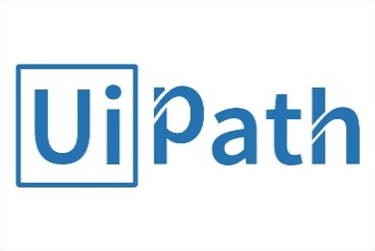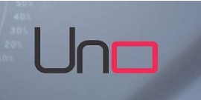

After understanding RPA, I decided to build a few use cases on the existing RPA tools available. I explored UiPath and had a couple of processes up and running. Further, I went on to work on TechM’s RPA tool ‘UNO’, read through the documentation and eventually tested a few more processes.

**3. VBA**

VBA (Visual Basic for Applications) is an event-driven programming language from Microsoft which is used with Office applications like MS-Excel, MS-Word and MS-Access. Excel VBA is widely used and consists of an inbuilt editor for VBA. Dealing with macros involved complex concepts and thus required in-depth exploration so as to cater to the required need.

**3. THE MODELER**

With the pre requisites out of the way, work on the modeler started. First off, I had to decide on a design for my dashboard i.e. which elements were to be placed where. One thing to be kept in mind was that, the focus should not only be on the ‘User Interface’, but also the ‘User Experience’.

The dashboard has 3 sections:

* Qualitative Highlights
* Quantitative Highlights
* Summary Board

**QUALITATIVE HIGHLIGHTS:**

The workspace required the use of user forms to add and calculate data. **VBA macros** were used in the form to add functionality to the sheet and the complete dashboard was made user interactive. The section involved addition of ‘process characteristics’ and ‘challenges’.

Each of the characteristics were assigned a weightage so that when the user sets it to a particular scale, the combined value is reflected onto the ‘compatibility meter’.

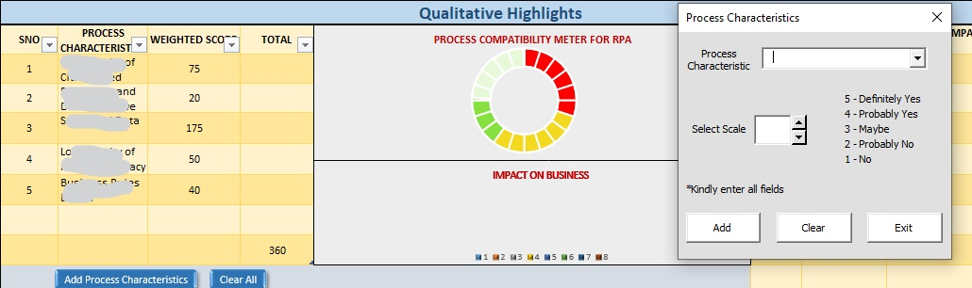

In

Addition of challenges involved a relative impact percentage to be set which visualized the data in the form of a pie chart, depicting the impact it would have on business.

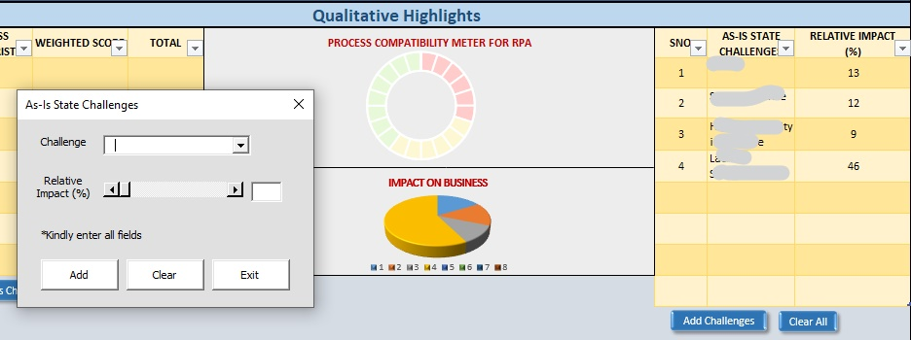

**QUANTITATIVE HIGHLIGHTS**

This particular section is what reflects the business value of the product, the ROI generated and the investments and cash flows. This could easily be shown to a customer who needs to understand the complete business value for a particular product.

The process inputs were required to be mentioned by the user and then based on tons of complicated formulas, each element of the process output table was being calculated. Further, the costs were set according to company data and the ROI was being calculated.

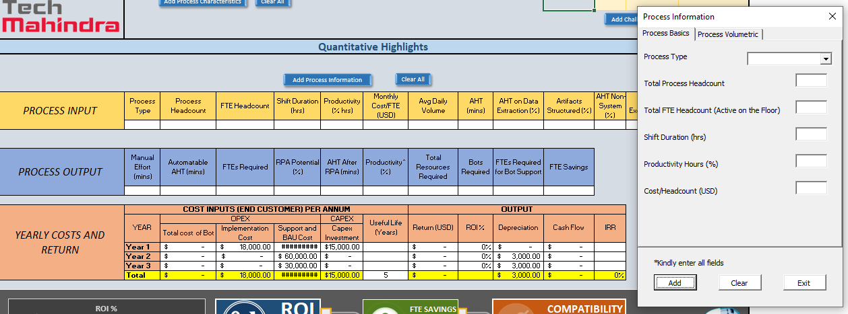

**SUMMARY BOARD**

The summary board gives an overview of whether the given process is compatible with the consumer requirements or not. It displays the ROI and FTE savings thus giving a gist at a glance.

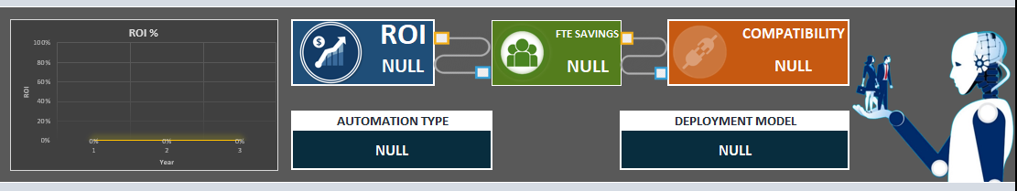

# THE BUSINESS PIPELINE USERFORM

Various business pipelines are required to be built from time to time. These require manual entry of data into an excel sheet containing numerous columns. As these sheets need to be updated regularly, row by row entry becomes a tedious task considering multiple other requirements are to be fulfilled.

A solution to ease the pressure would be to create a **user form** which increases work speed, is less tiresome and has features to filter data as per need.

I worked on a business pipeline for TechM’s customer management framework – ‘**CareXa**’. The idea was:

* to create a user form that could take data input for all the columns
* record system date per entry for categorization
* flag the recent account of all the duplicates so as to filter data
* autofill fields when duplicate account is created for better user experience

All the tasks required VBA coding and were all executed comfortably.

# THE SHIPMENT CHATBOT

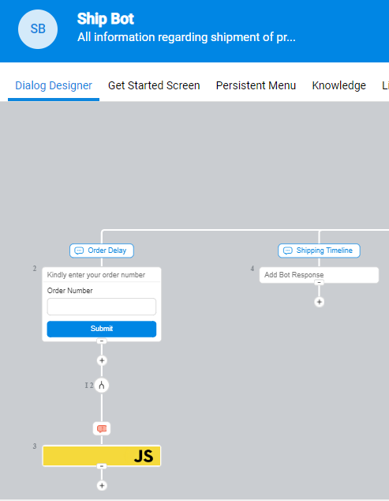This was a minor project that I took up out of curiosity and to gain knowledge of various chatbot platforms. I got the opportunity to work on **Google’s DialogFlow** platform and **Avaamo**’s platform.

A **chatbot** is a computer program that can communicate with the user via audio or text. These have recently been extensively used across various websites. The chatbot framework is built on Natural Language Processing (NLP). The primary step to building a chatbot is, knowing the difference between ‘entities’ and ‘intents’ as well as, understanding the bot’s flow. Avaamo and DialogFlow are great platforms to build use cases on.

I built a shipment helpdesk bot by utilizing Avaamo’s chatbot designing capability. ‘Domain’ is where we define the entities and intents and ‘Bots’ is where we design our flow. The work was to train the bot with multiple intents and leaving no scope for error. In order to customize certain responses, **JavaScript** was required. Utilizing this, I was able to build a basic helpdesk chatbot that responded to user queries.

**PRAGYA DATT**

**B. TECH CSE (Yr2)**