**School of Computer Science**

**UNIVERSITY OF PETROLEUM AND ENERGY STUDIES**

**DEHRADUN, UTTARAKHAND**



**System Provisioning and Configuration Management**

**Lab File (2021-2025)**

# **6th Semester**

|  |  |
| --- | --- |
| *Submitted To:*  ***Dr. Hitesh Kumar Sharma*** | *Submitted By:*  *Abhay Chaudhary*  *(500090987)*  *B Tech CSE*  *DevOps[6th Semester]*  *R2142210016*  *Batch - 1* |

**Lab Exercise 9– Creating Multiple EC2 Instances with for_each in Terraform**

**1. Create a Terraform Directory:**

**mkdir terraform-multiple-ec2 cd terraform-multiple-ec2**

* Create Terraform Configuration Files:
* Create a file named main.tf:

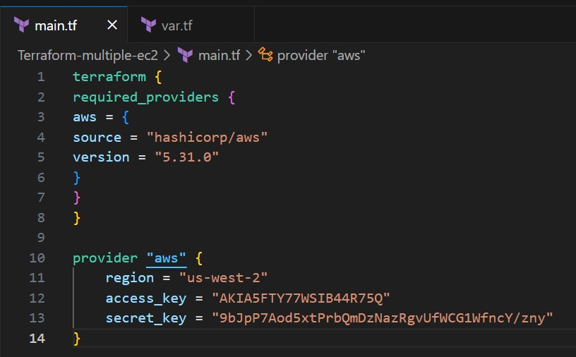

**#var.tf**

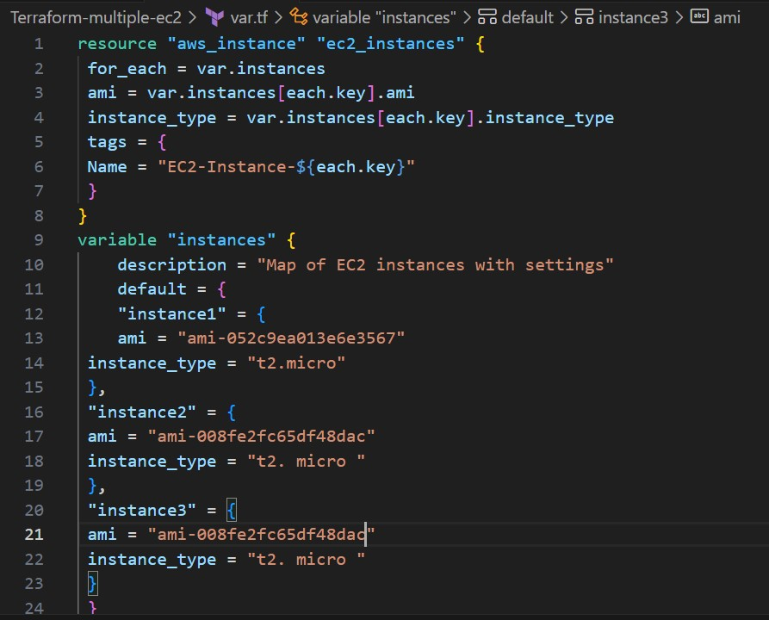

**2.Initialize and Apply:**

* Run the following Terraform commands to initialize and apply the configuration:

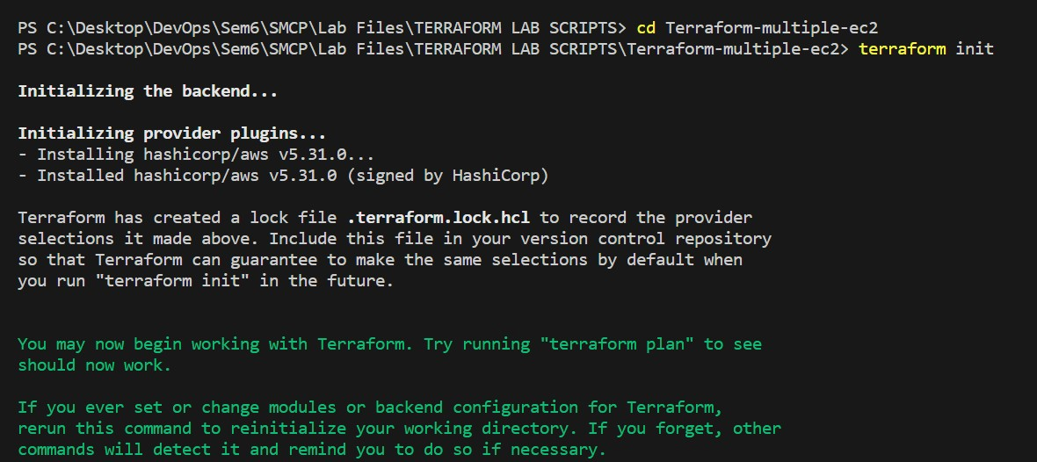

**terraform init terraform plan**

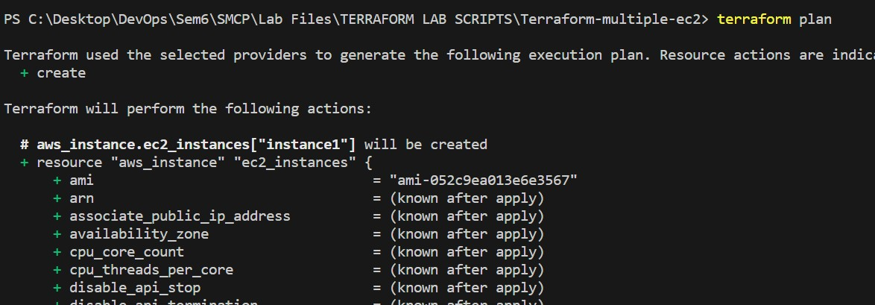

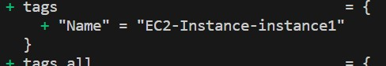

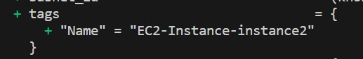

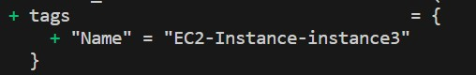

**Lab Exercise 10– Creating an AWS RDS Instance in**

**Terraform**

1. **Create a Terraform Directory:**

**mkdir Terraform-RDS cd Terraform-RDS**

1. **Create Terraform Configuration Files:**

Create a file named main.tf:

**# main.tf**

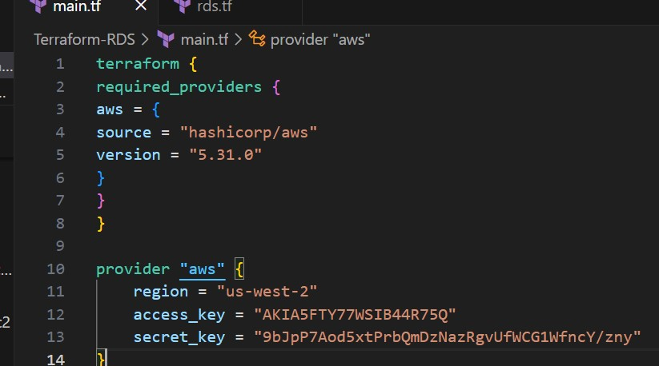

**#rds.tf**

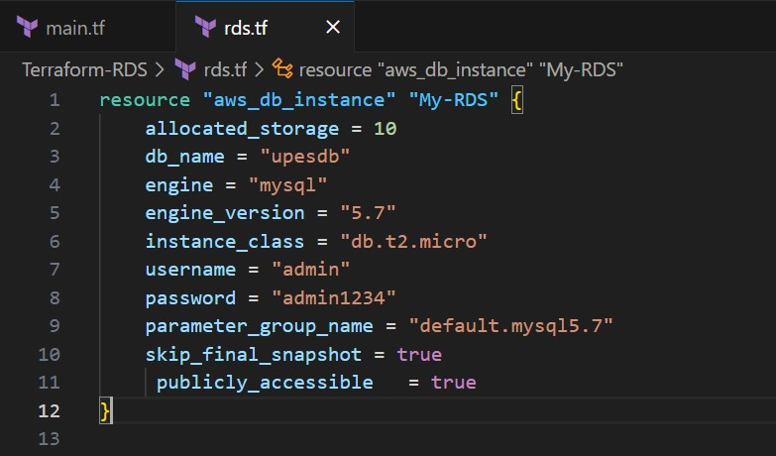

1. **Initialize and Apply:**

• Run the following Terraform commands to initialize and apply the configuration:

**terraform init terraform apply**

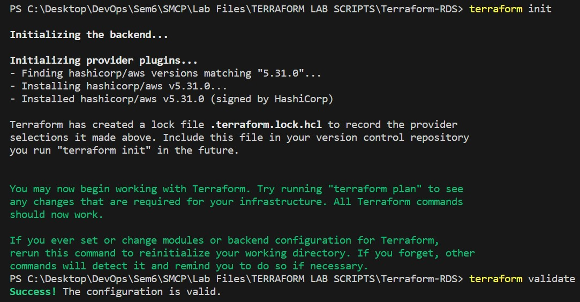

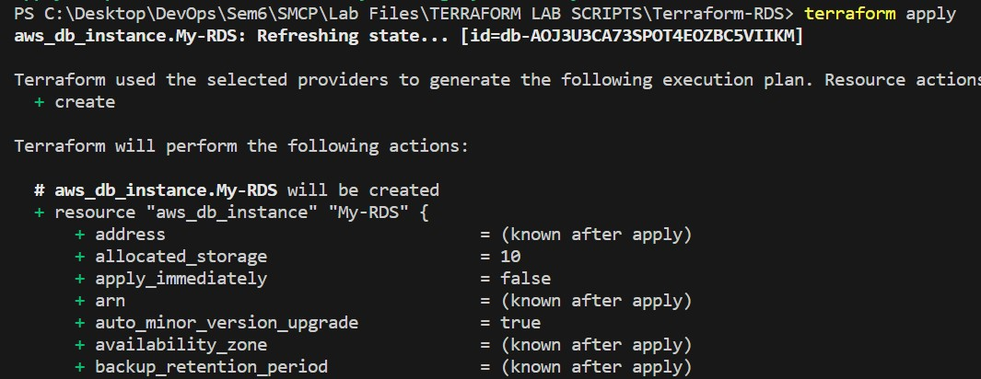

1. **Verify RDS Instance in AWS Console:**

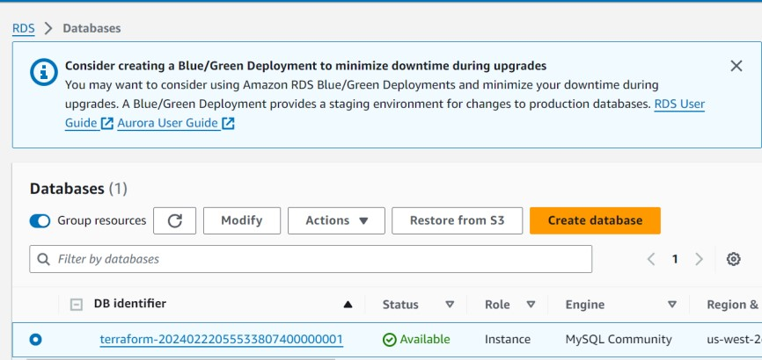

1. **Connect to MySQL Workbench**

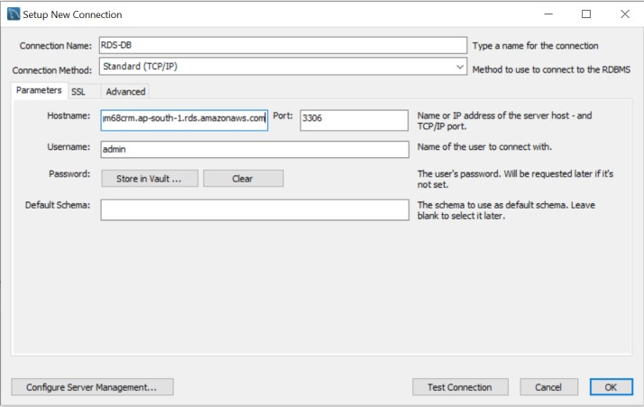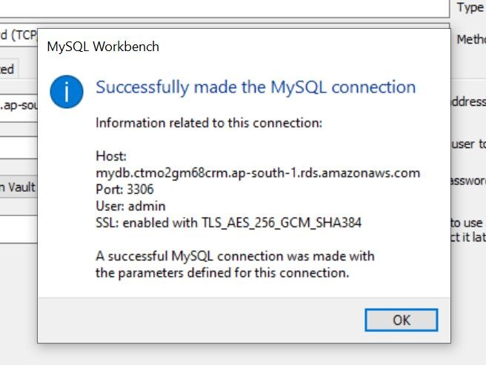

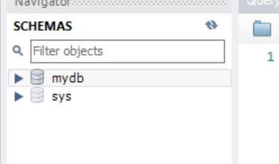

1. **Clean Up:**

**terraform destroy**

Confirm the destruction by typing yes.

