Abhay Chaudhary

500090987

R2142210016

Batch 1 NH

Experiment 12

– Create and Run Ansible Playbooks:

Steps

1. Repeat the steps in Experiment 11 to create the initial setup 2. Test adhoc commands

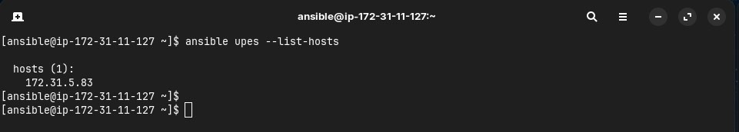

1. Install Apache server on node server using adhoc command

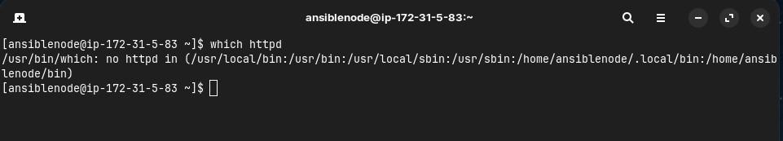

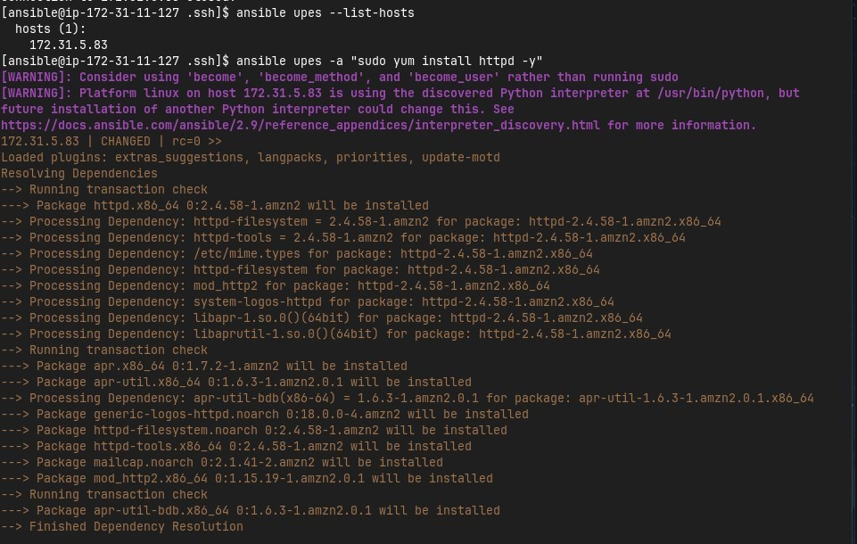

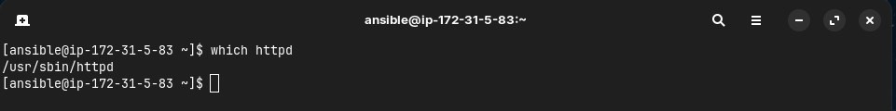

1. Start the httpd service using ansible

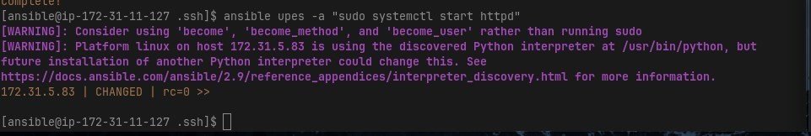

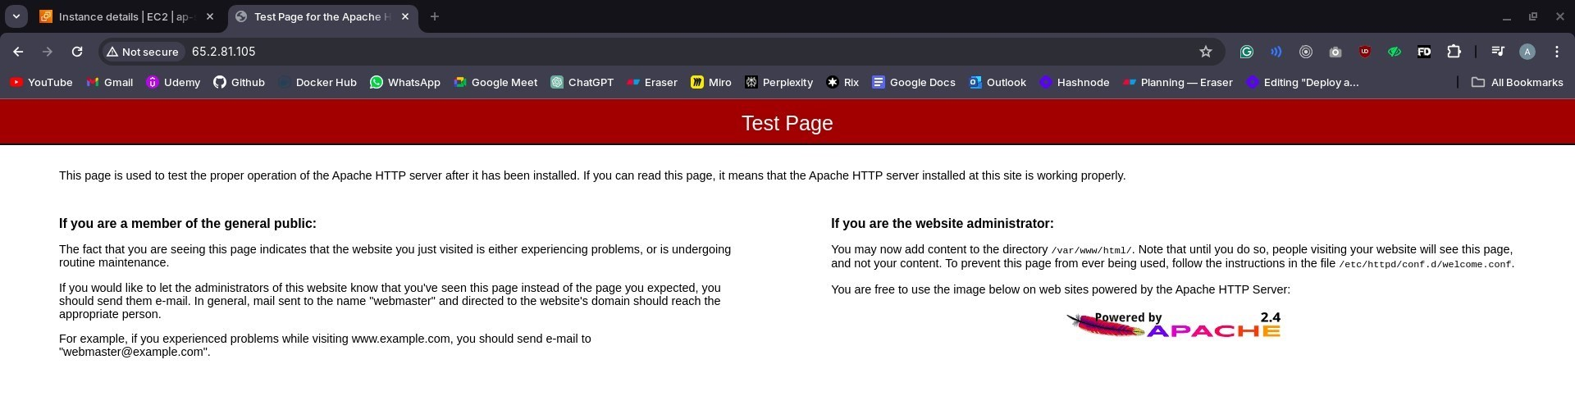

1. Remove ansbile and then reinstall using ansible playbook

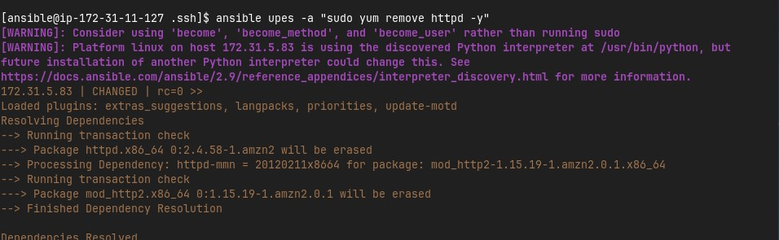

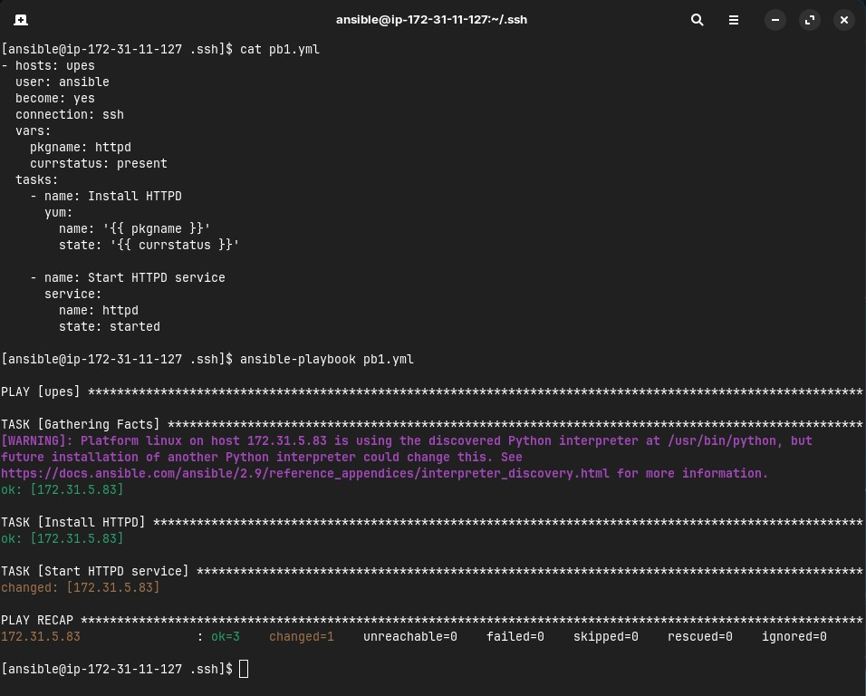



1. Testing other playbooks

