**School of Computer Science**

**UNIVERSITY OF PETROLEUM AND ENERGY STUDIES DEHRADUN, UTTARAKHAND**



**System Monitoring and Configuration**

**Management**

**Lab File (2024) for**

**6th Semester**

Submitted To:  Submitted By:

Dr. Hitesh Kumar Sharma Alisha Parveen

B. Tech. CSE DevOps

[6h Semester]

Sap id- 500091204

Batch 1

R2142210086

**LAB EXERCISE 12**

**Aim-**Create Run Ansible Playbooks

**Steps**

1. Repeat the steps in Experiment 11 to create the initial setup
2. Test adhoc commands

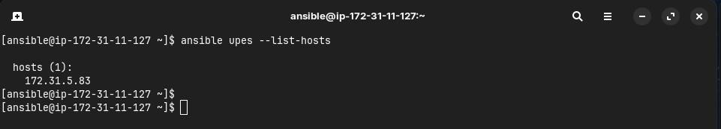

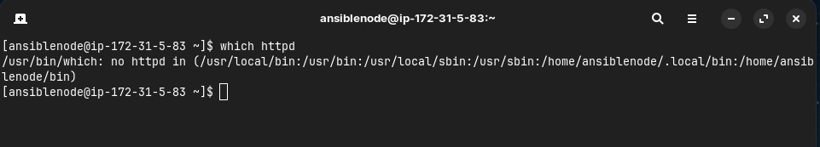

1. Install Apache server on node server using adhoc command

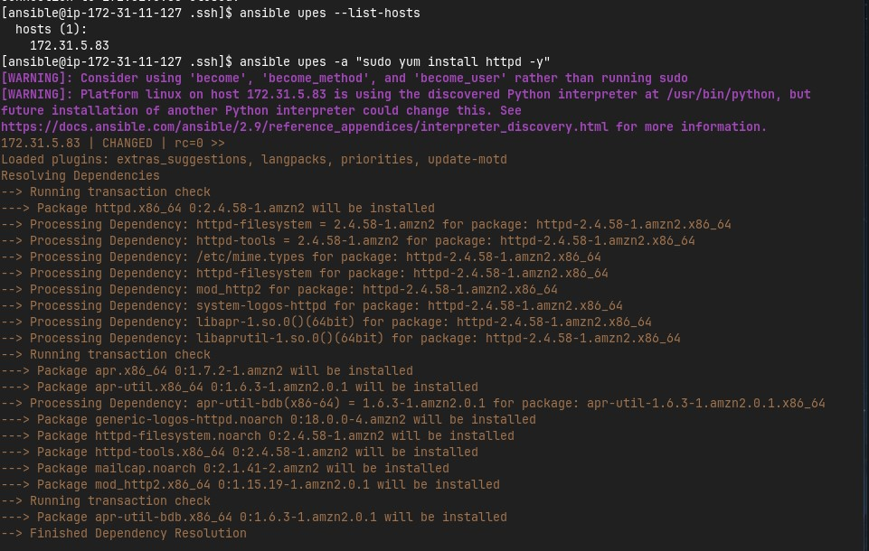

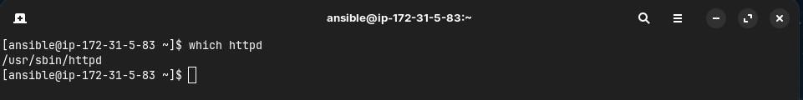

1. Start the httpd service using ansible

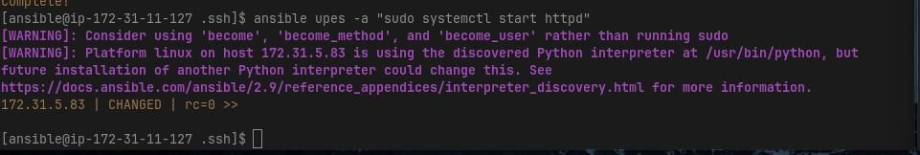

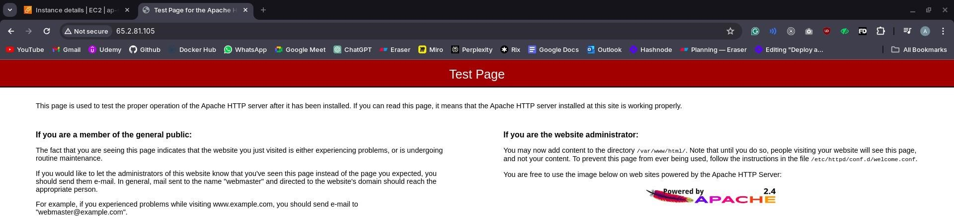

1. Remove ansbile and then reinstall using ansible playbook

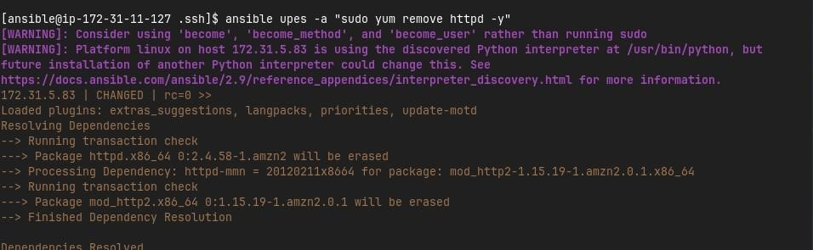

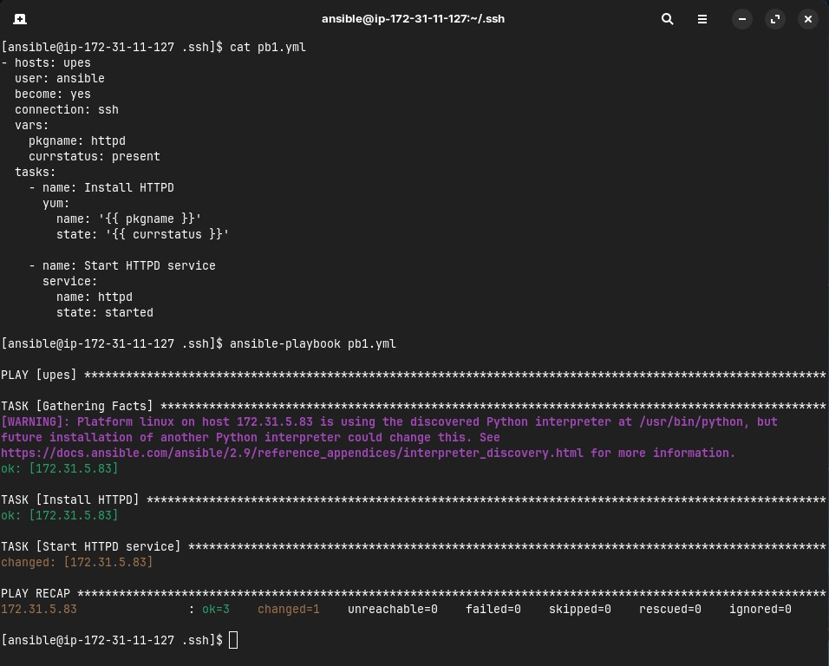



1. Testing other playbooks

