# School of Computer Science

**UNIVERSITY OF PETROLEUM AND ENERGY STUDIES DEHRADUN, UTTARAKHAND**

System System Provisioning

and Configuration Management

# Lab File (2024)

**for**

# 6th Semester

## Submitted To:

Dr. Hitesh Kumar Sharma

## Submitted By:

Arman Bisht

B. Tech. CSE DevOp s

[6h Semester]

Sap id- 500093031

Batch 2 R2142210141

**LAB EXERCISE 12**

**Aim-**Create Run Ansible Playbooks

**Steps**

1. Repeat the steps in Experiment 11 to create the initial setup
2. Test adhoc commands

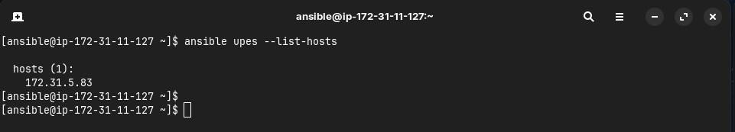

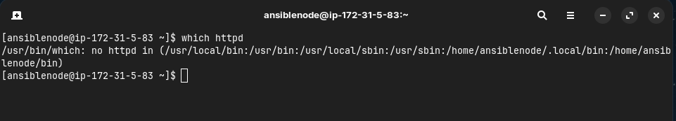

1. Install Apache server on node server using adhoc command

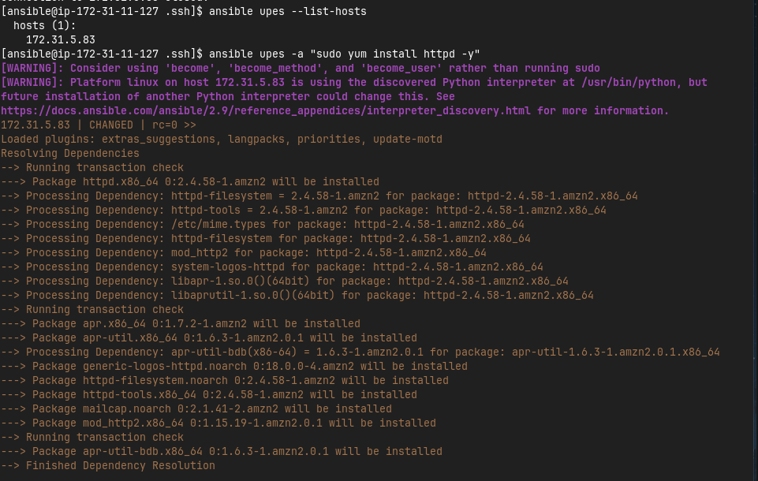

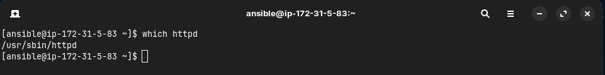

1. Start the httpd service using ansible

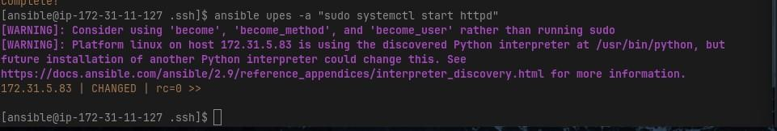

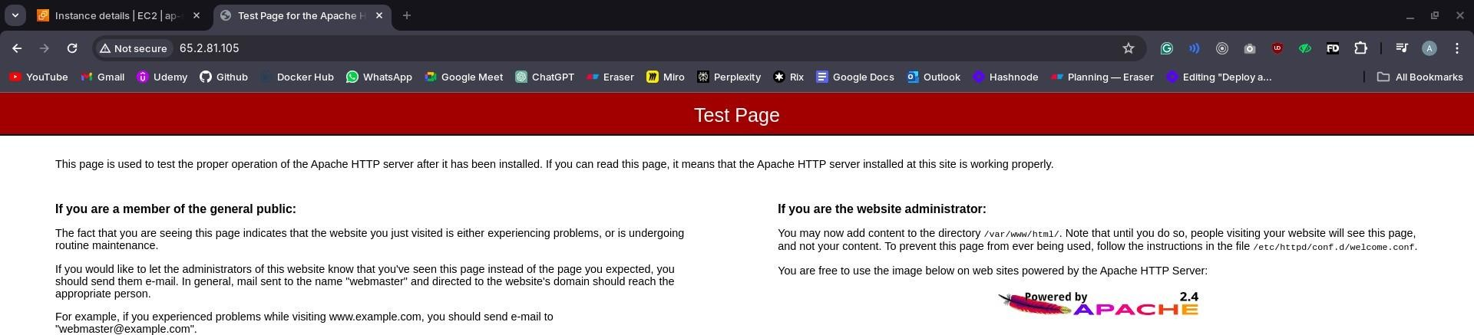

1. Remove ansbile and then reinstall using ansible playbook

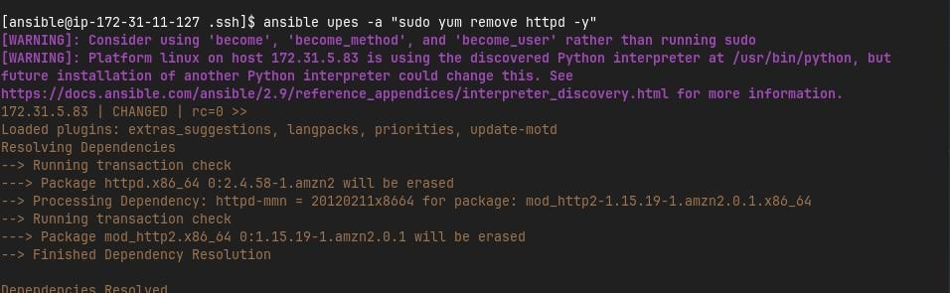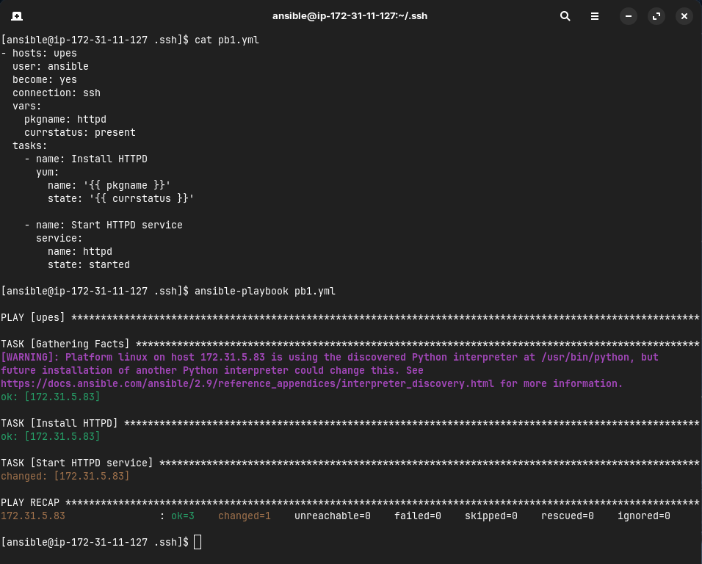



1. Testing other playbooks

