NAME: -Chinthakindi Sree Vardhan Reddy

SAPID: -500093990

ROLLNO: -R2142210245

BATCH: -2[non-Hons]

EXPERIMENT-2

Lab Exercise 2– Terraform AWS Provider and IAM User Setting

Prerequisites: Terraform Installed: Make sure you have Terraform installed on your machine. Follow the official installation guide if needed.

AWS Credentials: Ensure you have AWS credentials (Access Key ID and Secret Access Key) configured. You can set them up using the AWS CLI or by setting environment variables.

Exercise Steps:

Step 1: Create a New Directory:

Create a new directory for your Terraform configuration:

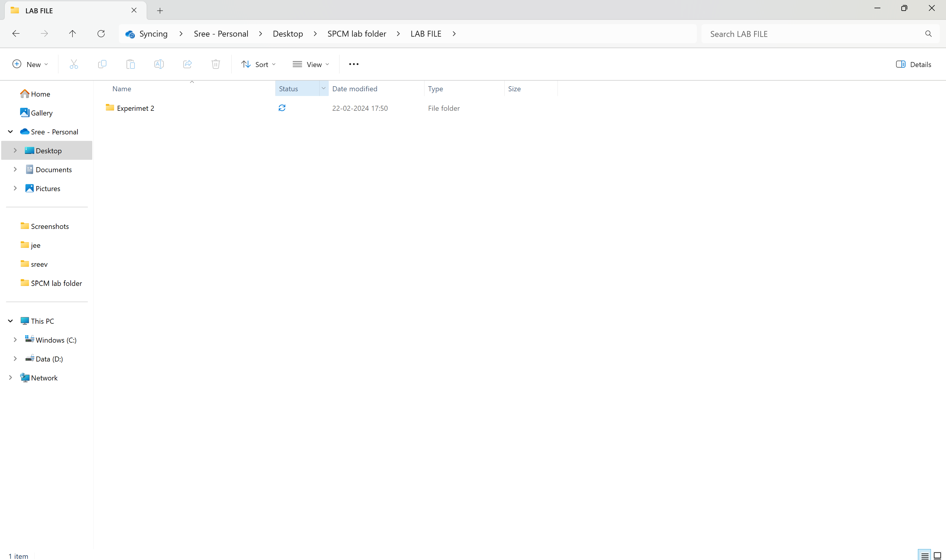 Step 2: Create Terraform Configuration File (main.tf):

Create a file named main.tf with the following content:

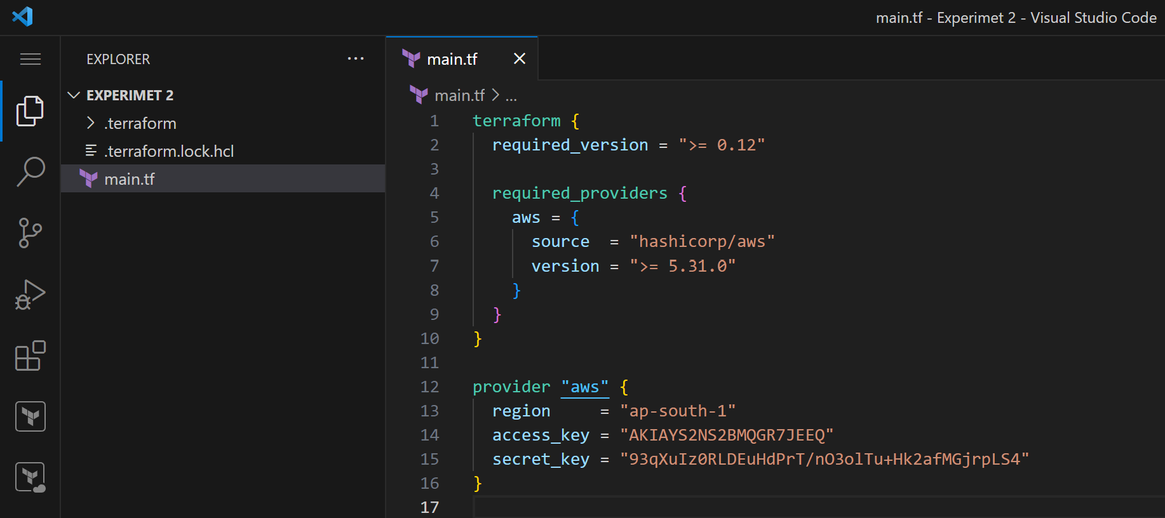

This script defines an AWS provider and provisions an EC2 instance.

Step 3: Initialize Terraform:

Run the following command to initialize your Terraform working directory:

