NAME: -Chinthakindi Sree Vardhan Reddy

SAPID: -500093990

ROLLNO: -R2142210245

BATCH: -2[non-Hons]

Lab Exercise 10– Creating an AWS RDS Instance in Terraform

Objective: Learn how to use Terraform to create an AWS RDS instance.

Prerequisites: -

• Terraform installed on your machine.

• AWS CLI configured with the necessary credentials.

Steps:

1. Create a Terraform Directory:

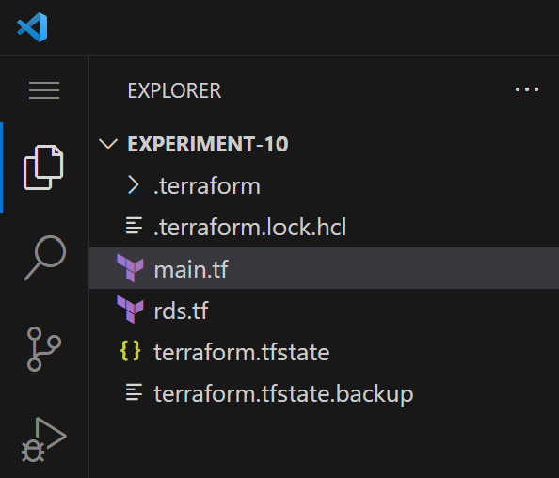

1. Create Terraform Configuration Files:

Create a file named main.tf:

# main.tf

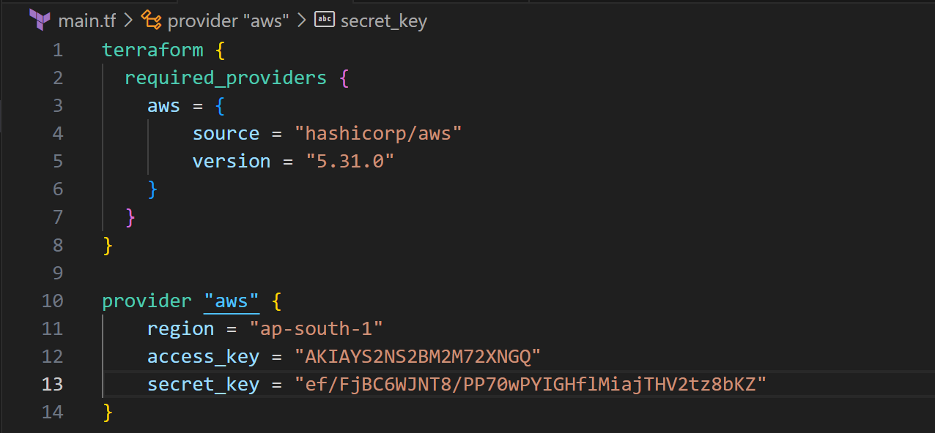

#rds.tf

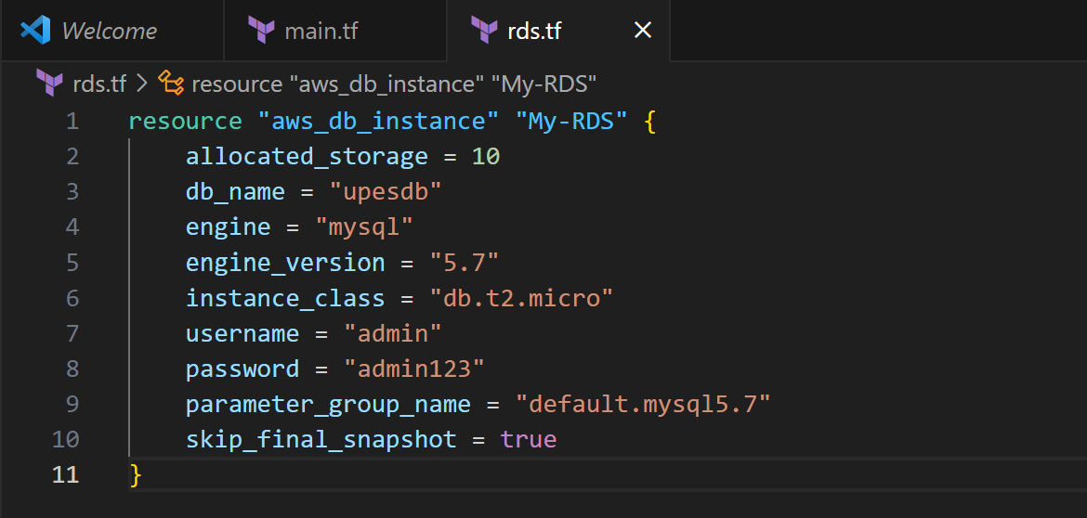

1. Initialize and Apply: -

• Run the following Terraform commands to initialize and apply the configuration:

terraform init

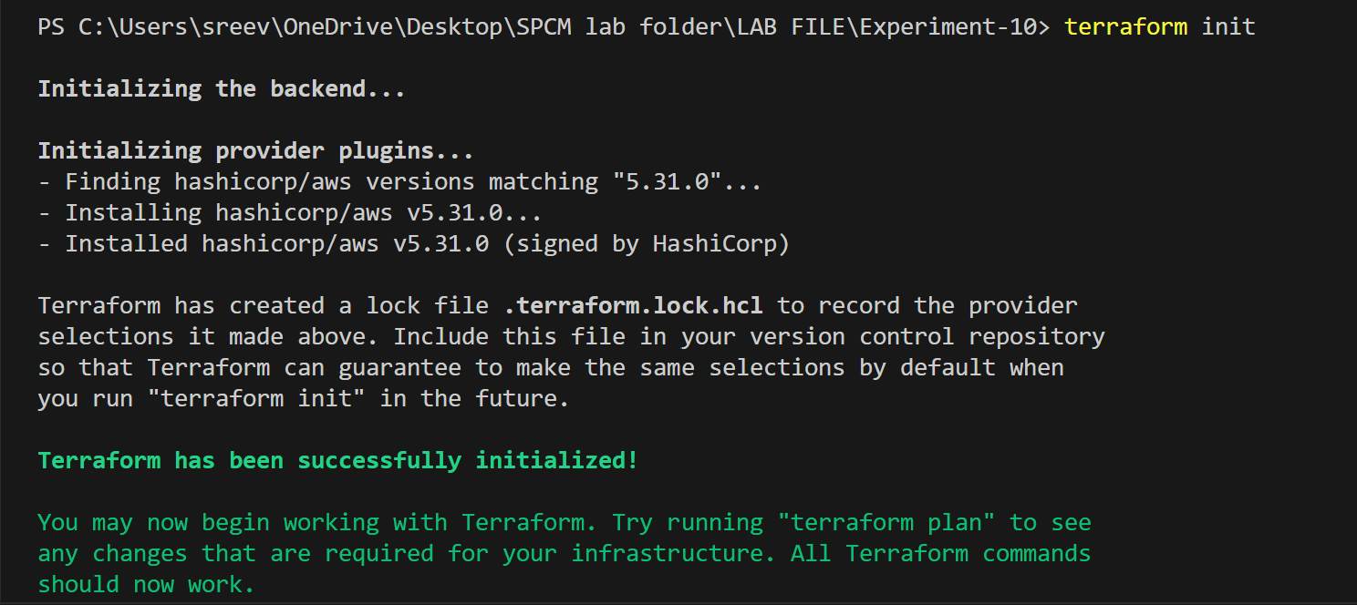

terraform apply

• Terraform will prompt you to confirm the creation of the RDS instance. Type yes and press Enter.

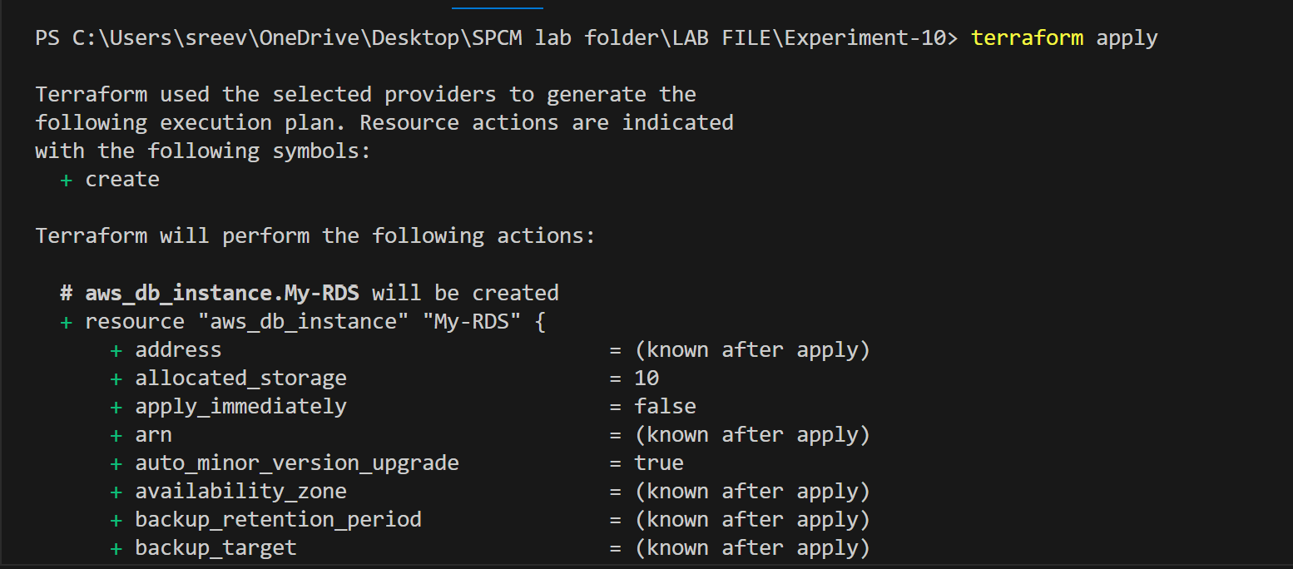

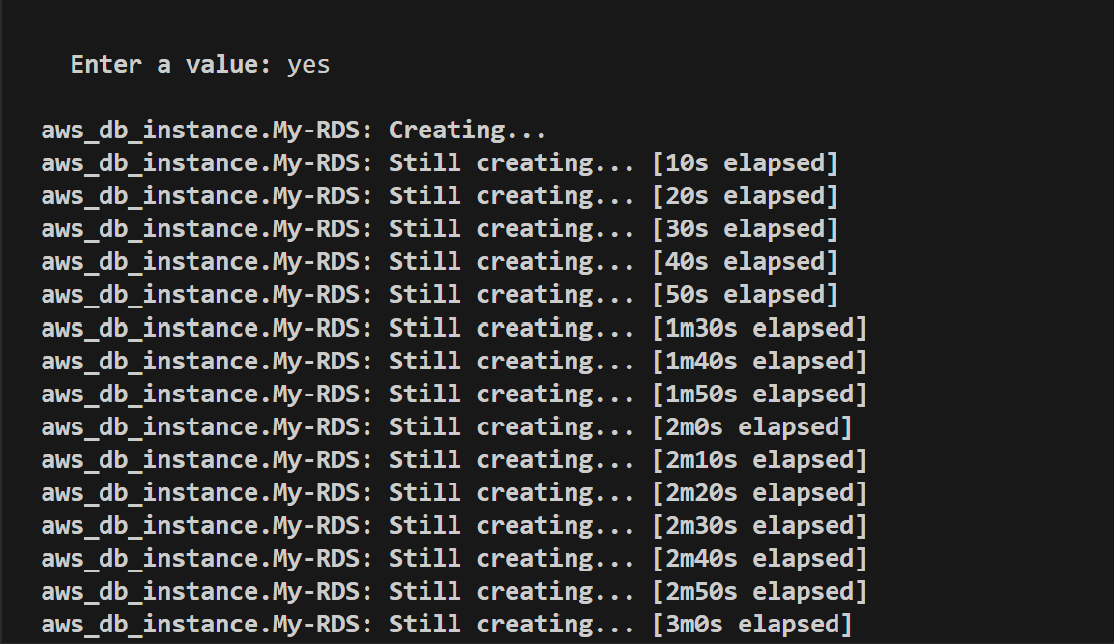

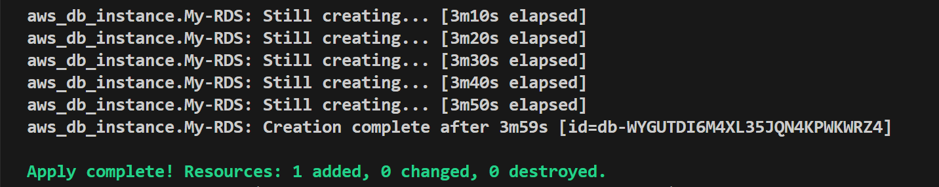

1. Verify RDS Instance in AWS Console:

• Log in to the AWS Management Console and navigate to the RDS service.

• Verify that the specified RDS instance with the specified settings has been created.

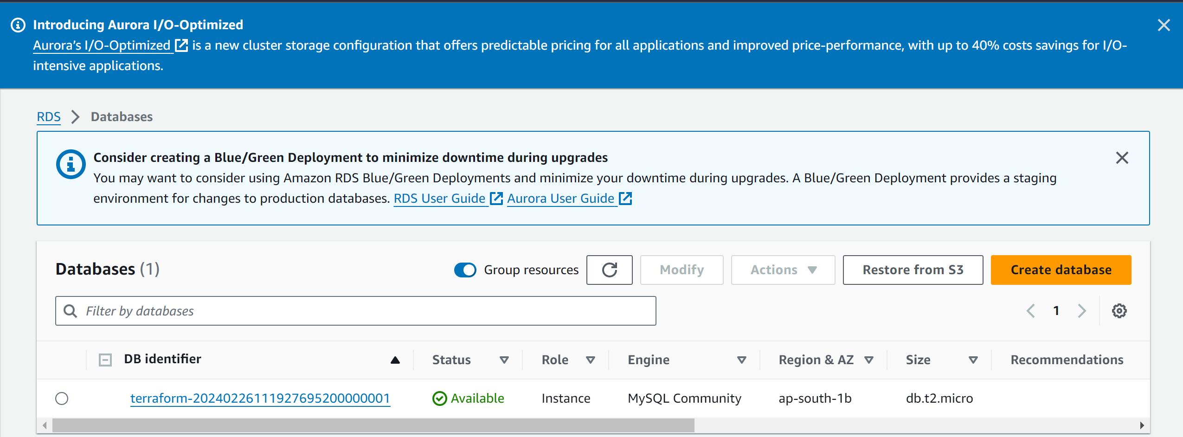

1. Clean Up: After testing, you can clean up the RDS instance:

terraform destroy

