NAME: -Chinthakindi Sree Vardhan Reddy

SAPID: -500093990

ROLLNO: -R2142210245

BATCH: -2[non-Hons]

Lab Exercise 8– Creating a VPC in Terraform

Objective: -

Learn how to use Terraform to create a basic Virtual Private Cloud (VPC) in AWS.

Prerequisites: -

• Terraform installed on your machine.

• AWS CLI configured with the necessary credentials.

Steps: 1. Create a Terraform Directory: -

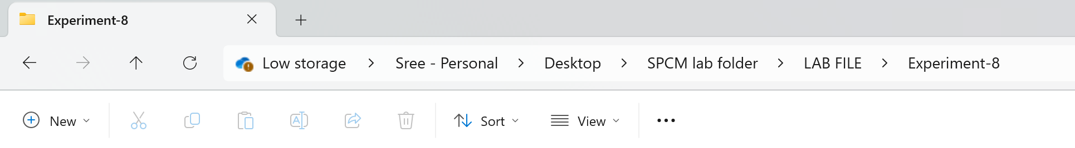

# main.tf

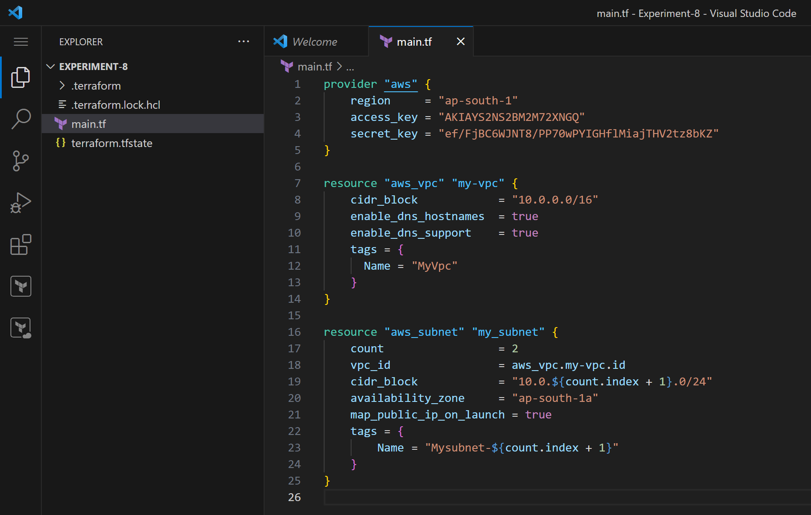

In this configuration, we define an AWS provider, a VPC with a specified CIDR block,

and two subnets within the VPC.

2. Initialize and Apply: -

• Run the following Terraform commands to initialize and apply the configuration: -

terraform init

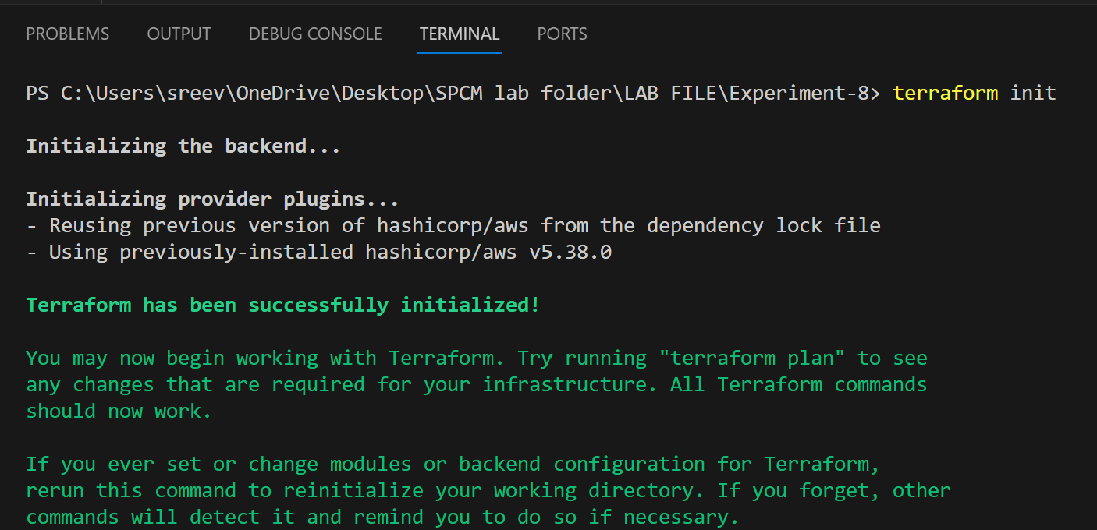

terraform apply

• Terraform will prompt you to confirm the creation of the VPC and subnets. Type yes and press Enter.

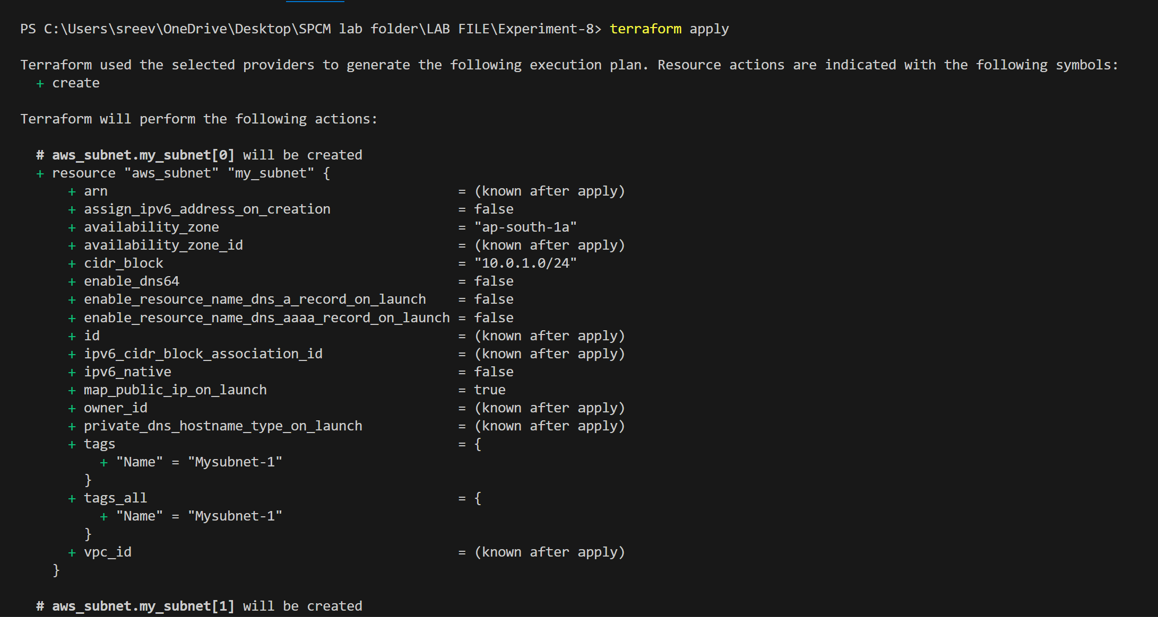

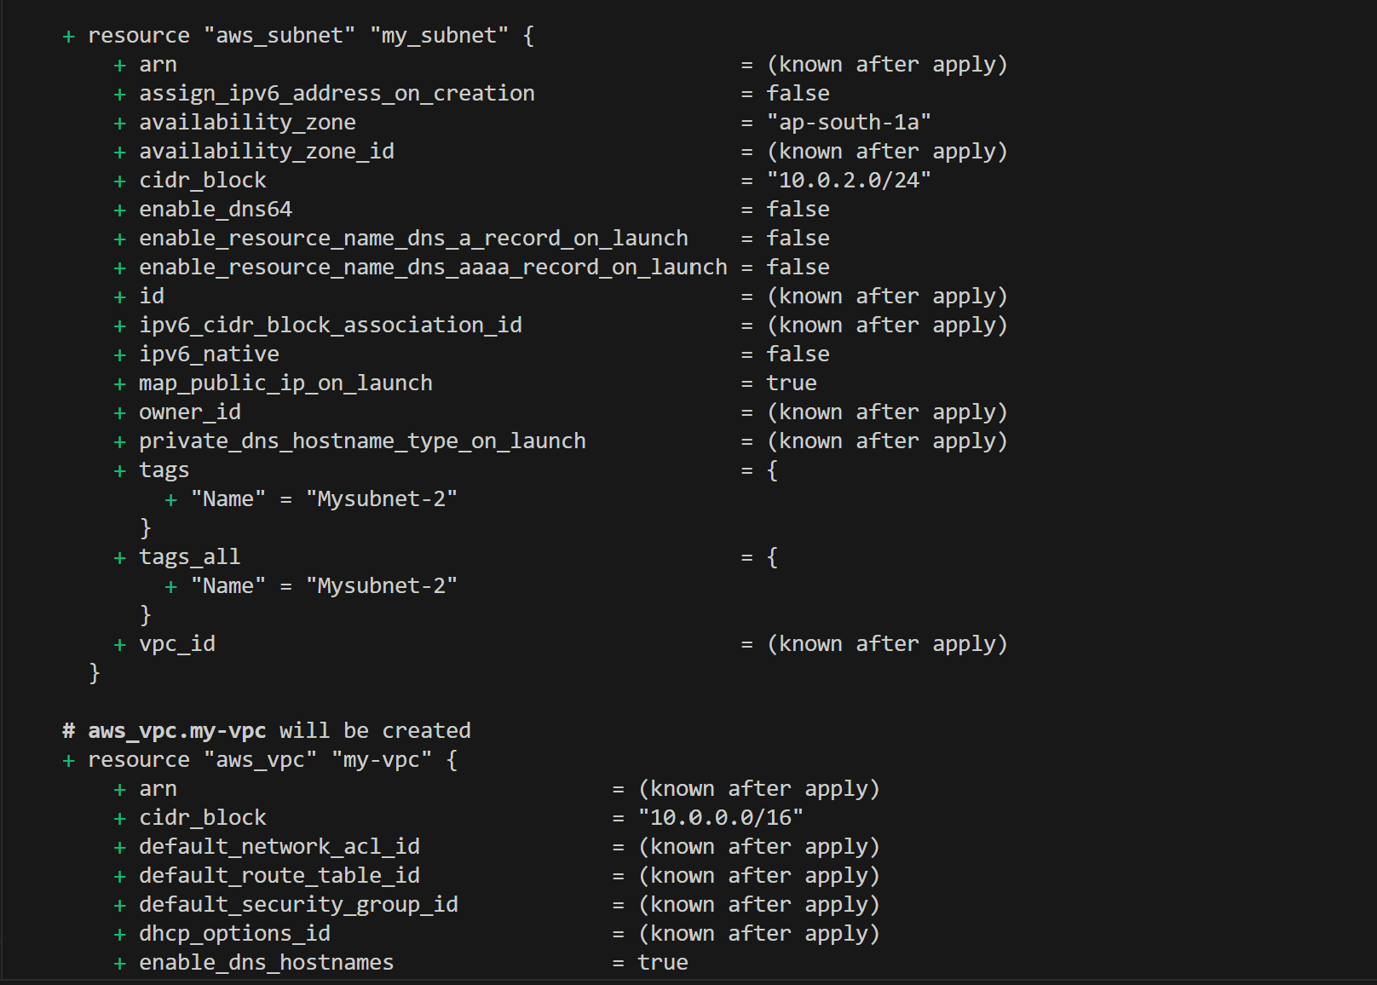

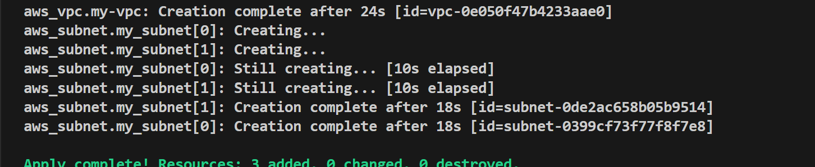

3. Verify Resources in AWS Console: -

• Log in to the AWS Management Console and navigate to the VPC service.

• Verify that the VPC and subnets with the specified names and settings have been

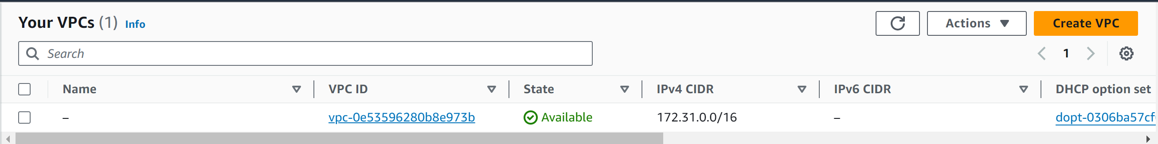

4. Update VPC Configuration:

• If you want to modify the VPC configuration, update the main.tf file with the desired changes.

• Rerun the terraform apply command to apply the changes: terraform apply

5. Clean Up: After testing, you can clean up the VPC and subnets:

terraform destroy

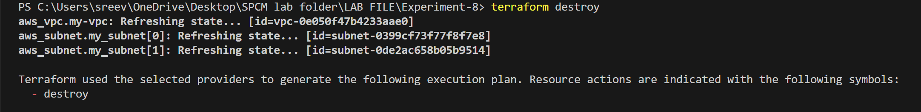

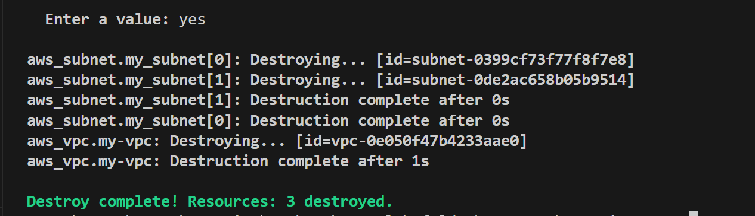

6. Conclusion:

This lab exercise demonstrates how to create a basic Virtual Private Cloud (VPC) with subnets in AWS using Terraform. The example includes a simple VPC configuration with two subnets.

Experiment with different CIDR blocks, settings, and additional AWS resources to customize your VPC.