NAME: -Chinthakindi Sree Vardhan Reddy

SAPID: -500093990

ROLLNO: -R2142210245

BATCH: -2[non-Hons]

Lab Exercise 7– Creating Multiple IAM Users

in Terraform

Objective:

Learn how to use Terraform to create multiple IAM users with unique settings.

Prerequisites:

• Terraform installed on your machine.

• AWS CLI configured with the necessary credentials.

Steps:

1. Create a Terraform Directory:

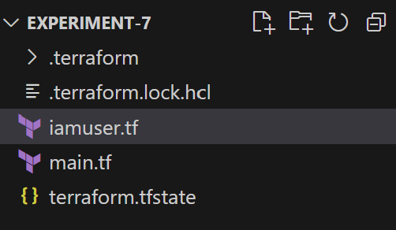

# main.tf

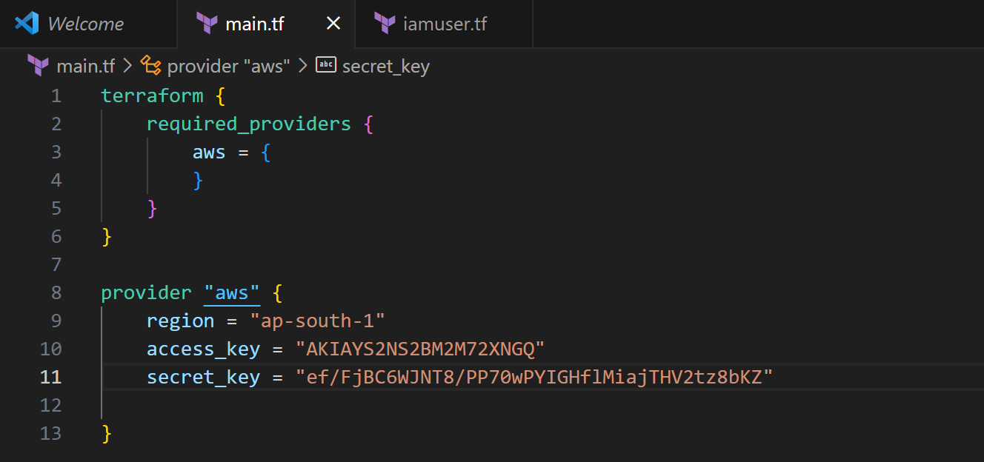

#iamuser.tf

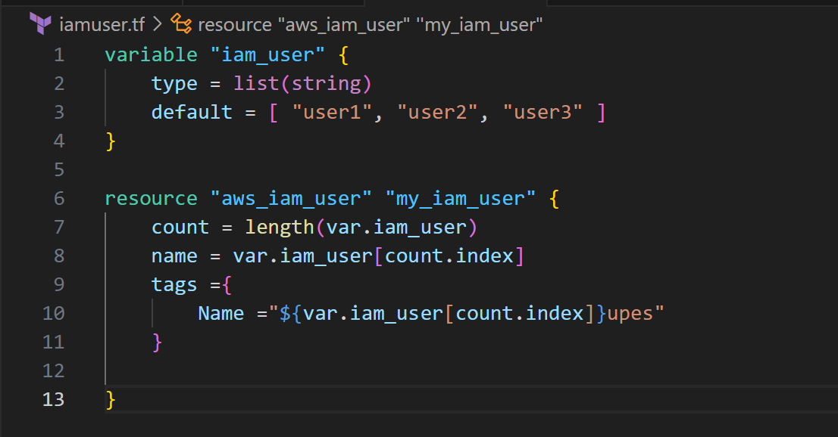

2.Initialize and Apply: - Run the following Terraform commands to initialize and apply the configuration: terraform init

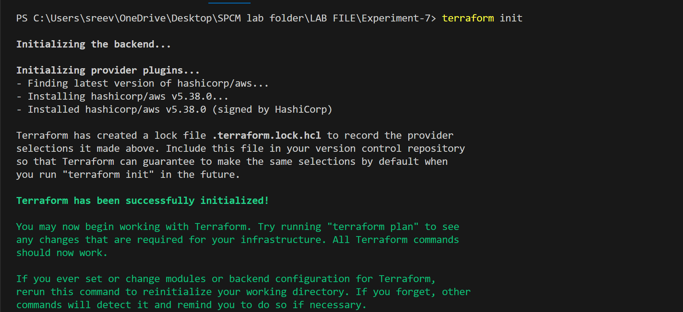

terraform apply: -

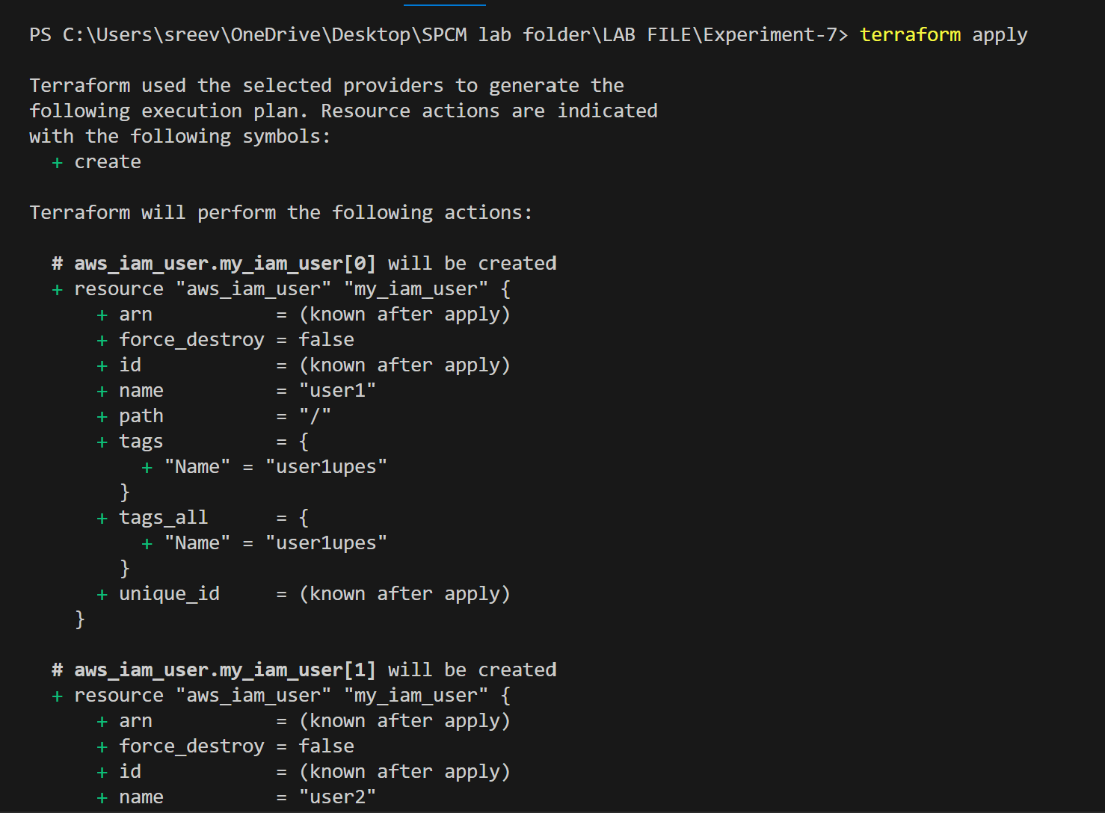

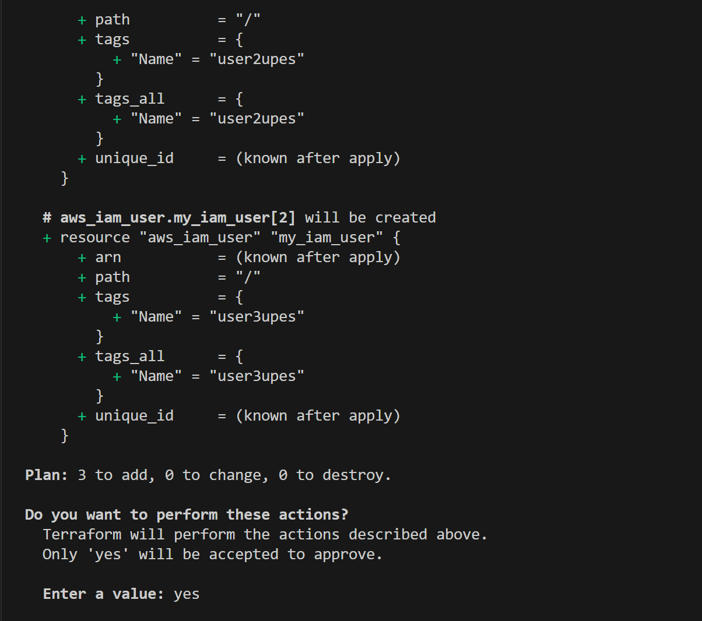

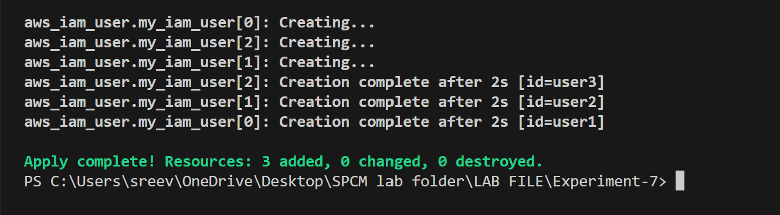

Terraform will prompt you to confirm the creation of IAM users. Type yes and press Enter.

1. Verify Users in AWS Console:

• Log in to the AWS Management Console and navigate to the IAM service.

• Verify that the IAM users with the specified names and tags have been created.

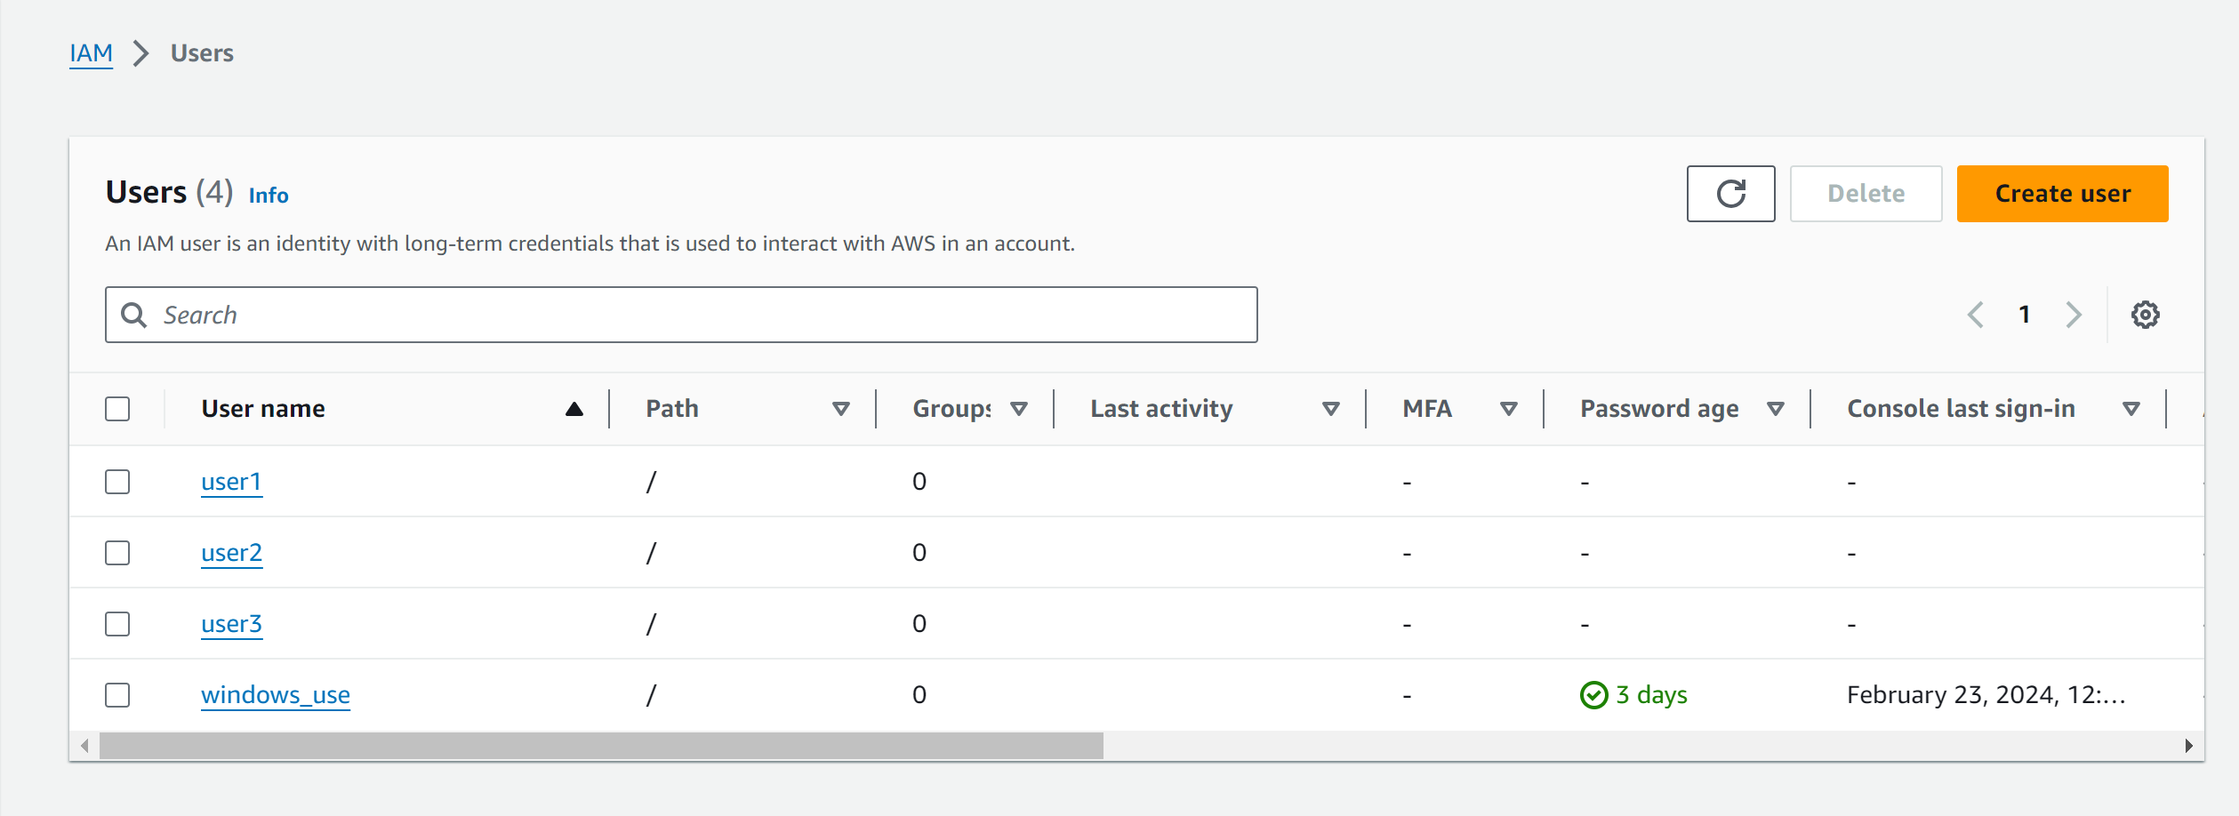

1. Update IAM Users:

• If you want to add or remove IAM users, modify the iam_users list in the main.tf file.

• Rerun the terraform apply command to apply the changes: terraform apply

1. Clean Up:

• After testing, you can clean up the IAM users: terraform destroy

• Confirm the destruction by typing yes.

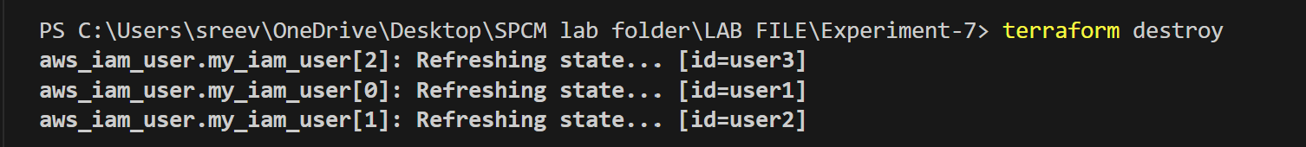

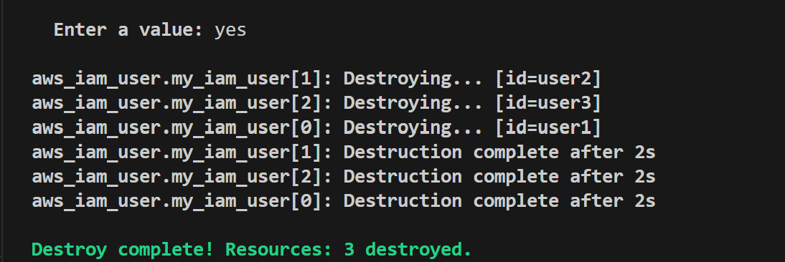

1. Conclusion:

This lab exercise demonstrates how to create multiple IAM users in AWS using Terraform. The use of variables and loops allows you to easily manage and scale the creation of IAM users. Experiment with different user names and settings in the main.tf file to understand how Terraform provisions resources based on your configuration