NAME: -Chinthakindi Sree Vardhan Reddy

SAPID: -500093990

ROLLNO: -R2142210245

BATCH: -2[non-Hons]

Lab Exercise 9– Creating Multiple EC2 Instances with for_each in Terraform

Objective:

Learn how to use for each in Terraform to create multiple AWS EC2 instances with specific settings for each instance.

Prerequisites: -

• Terraform installed on your machine.

• AWS CLI configured with the necessary credentials.

Steps: -

1. Create a Terraform Directory:



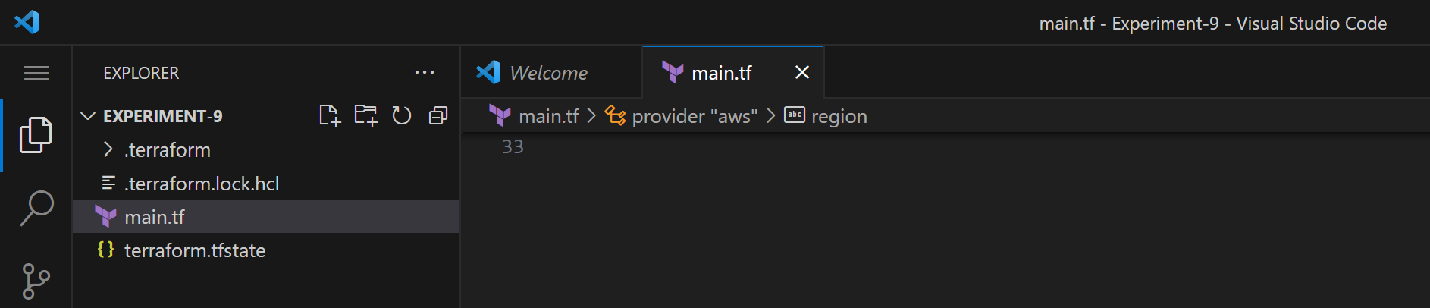

• Create Terraform Configuration Files: -

• Create a file named main.tf:

# main.tf

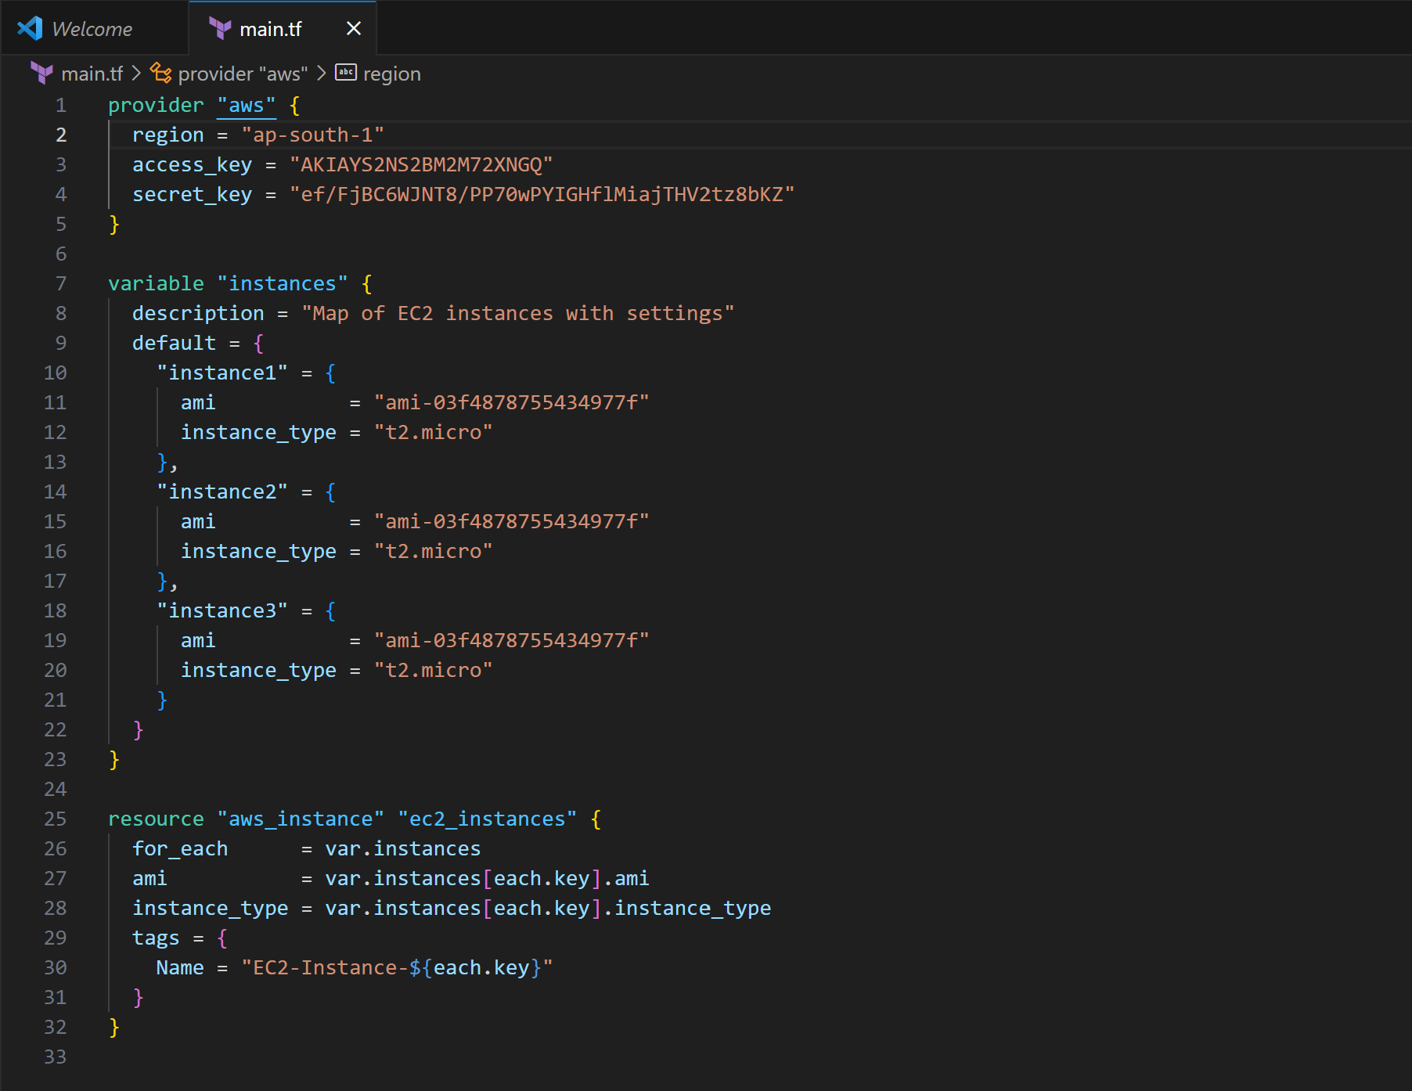

• Replace "your-key-pair-name" and "your-subnet-id" with your actual key pair name and subnet ID. • In this configuration, we define a variable instance as a map containing settings for each EC2 instance. The aws instance resource is then used with for each to create instances based on the map.

1. Initialize and Apply: -

• Run the following Terraform commands to initialize and apply the configuration: -

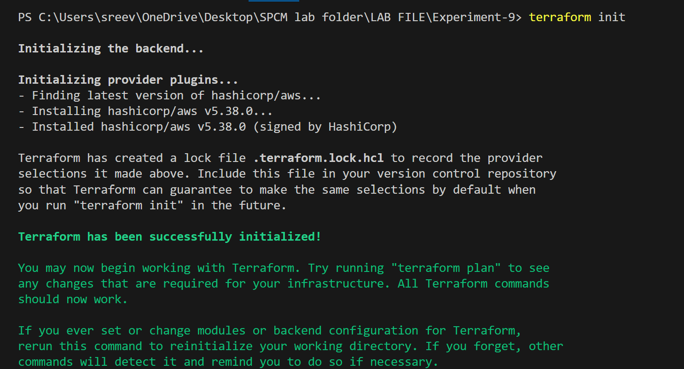

#Terraform apply

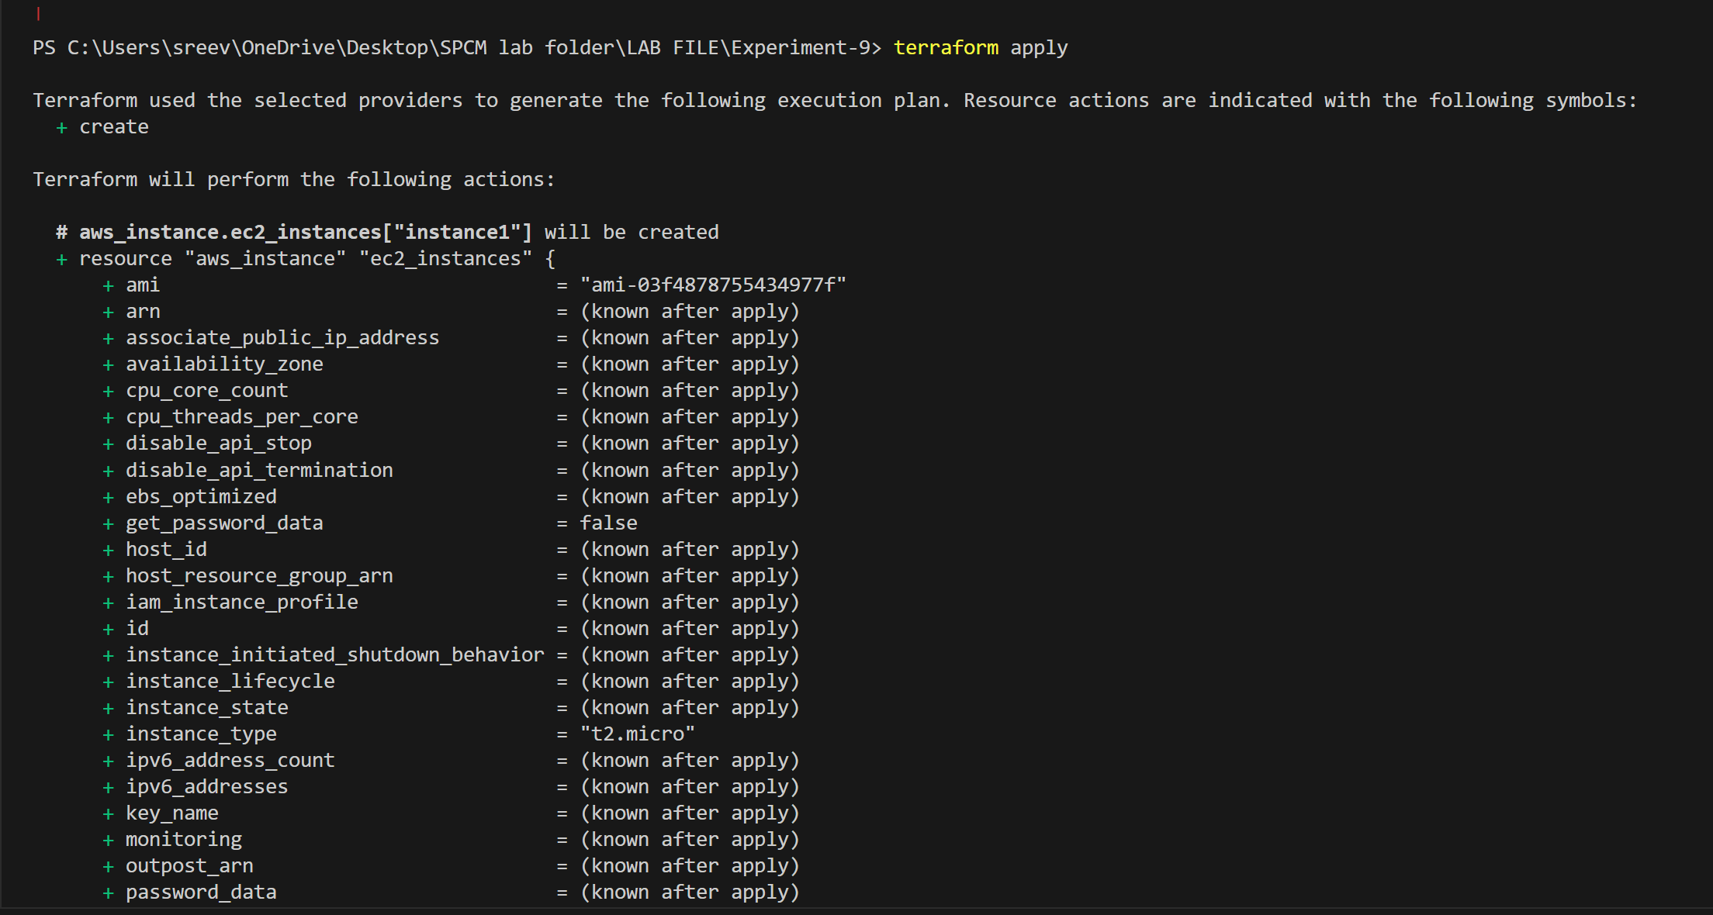

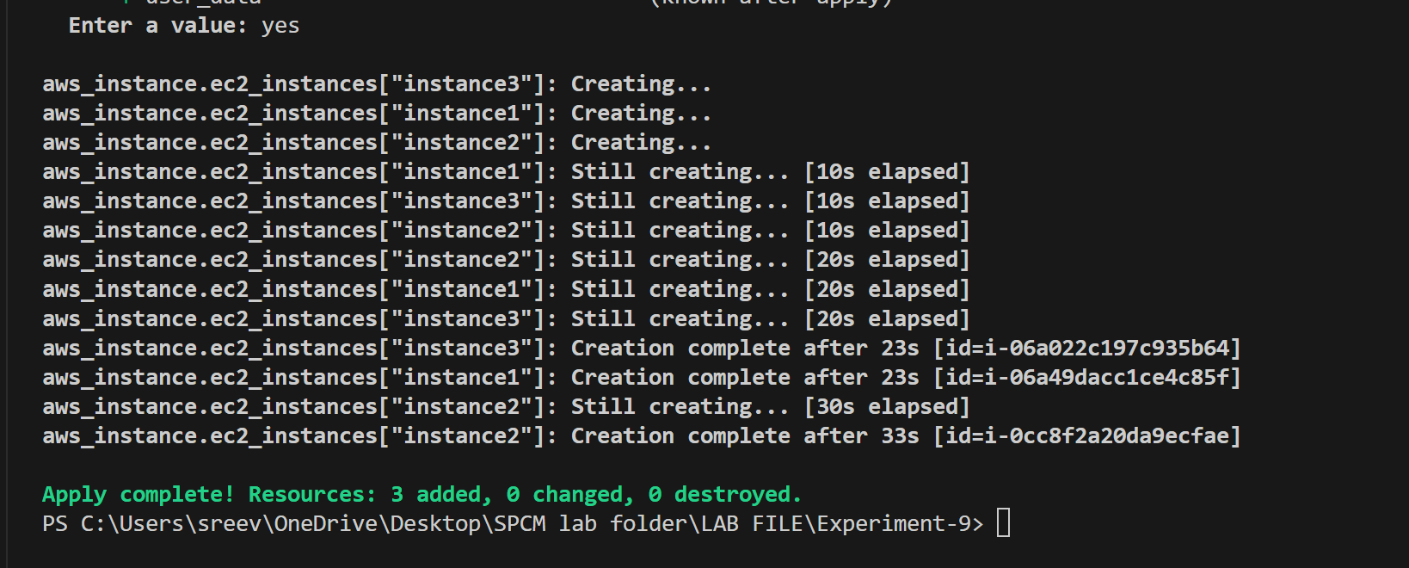

Terraform will prompt you to confirm the creation of EC2 instances. Type yes and press Enter.

1. Verify Instances in AWS Console:

• Log in to the AWS Management Console and navigate to the EC2 service.

• Verify that the specified EC2 instances with the specified names and settings have been created.

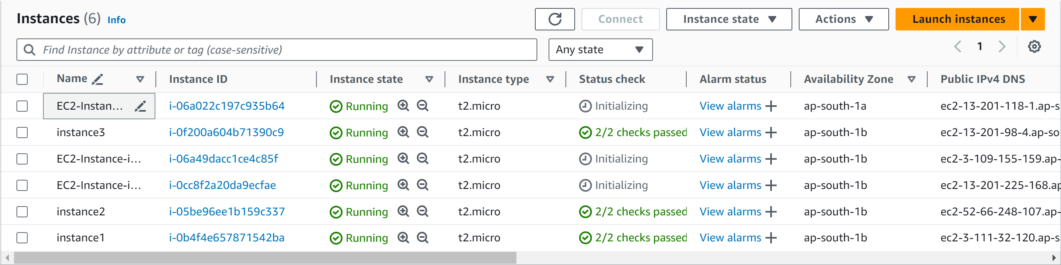

. 4.

Clean Up: -

• After testing, you can clean up the EC2 instances:

