EXPERIMENT 11 AIM: INSTALLING AND SETUP ANSIBLE SERVER AND NODES SUBMITTED BY: GarvGopalia

SAP ID: 500091394 BATCH : 1(NON HONS.)

1. Create 2 AWS linux EC2 instances.

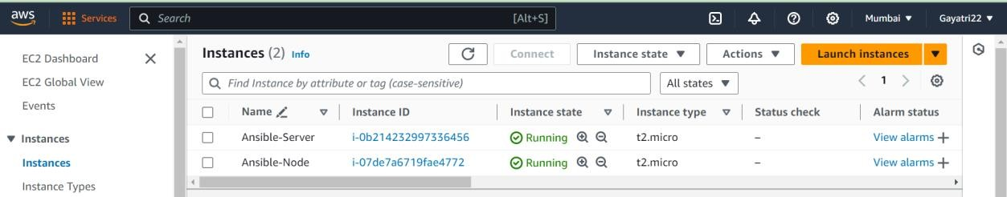

1. Install ansible in Server machine.



1. Add private ip of Node machine in list of known hosts in **/etc/ansible/hosts** file.

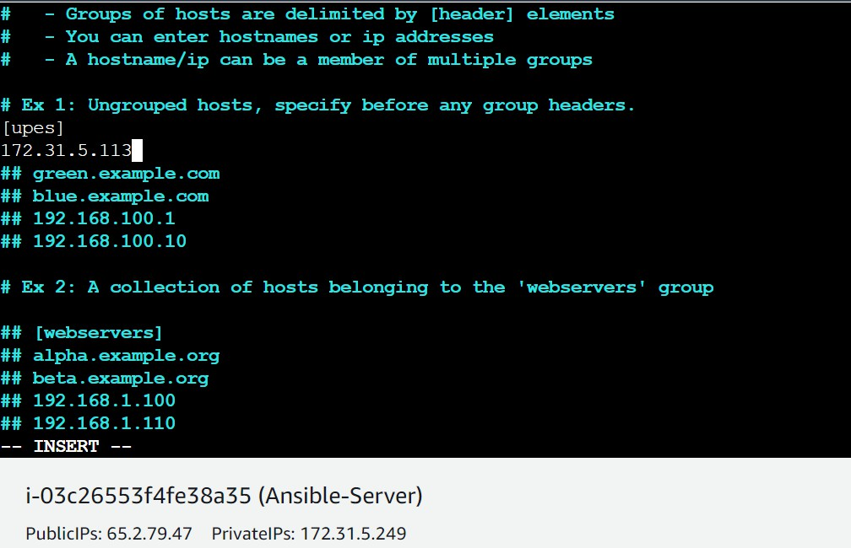

1. adduser ansible in both server and node machine.

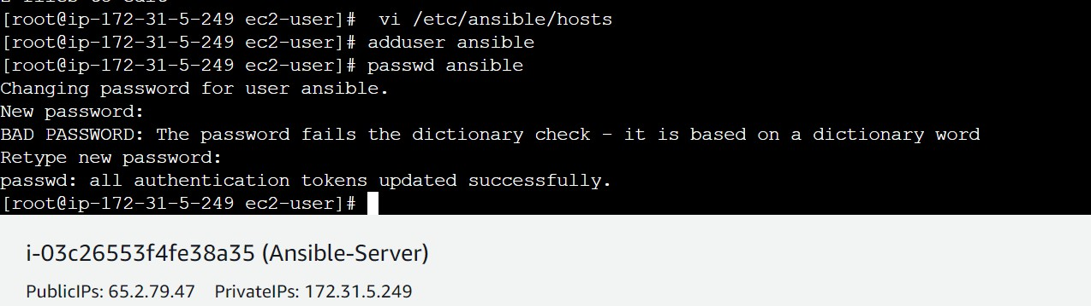

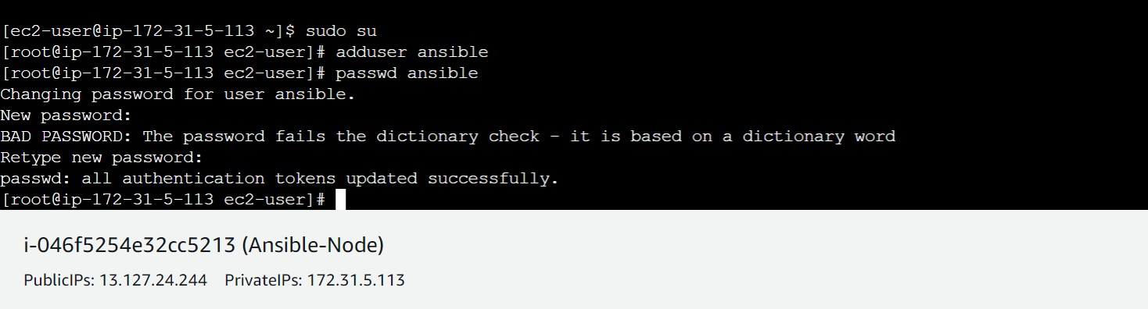

1. we have to generate a key pair and copy that into node machine.

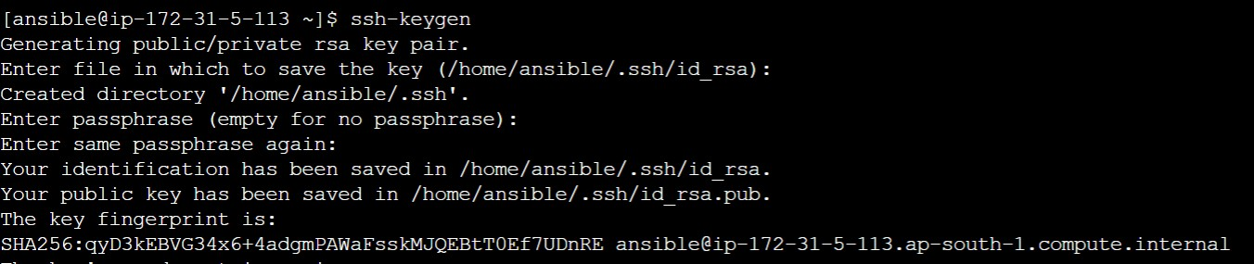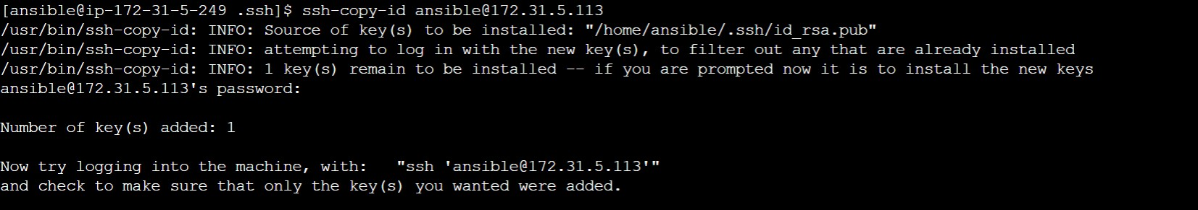

1. key has been successfully added, now we can go into node machine through server only by ssh-ing into it’s private ip.

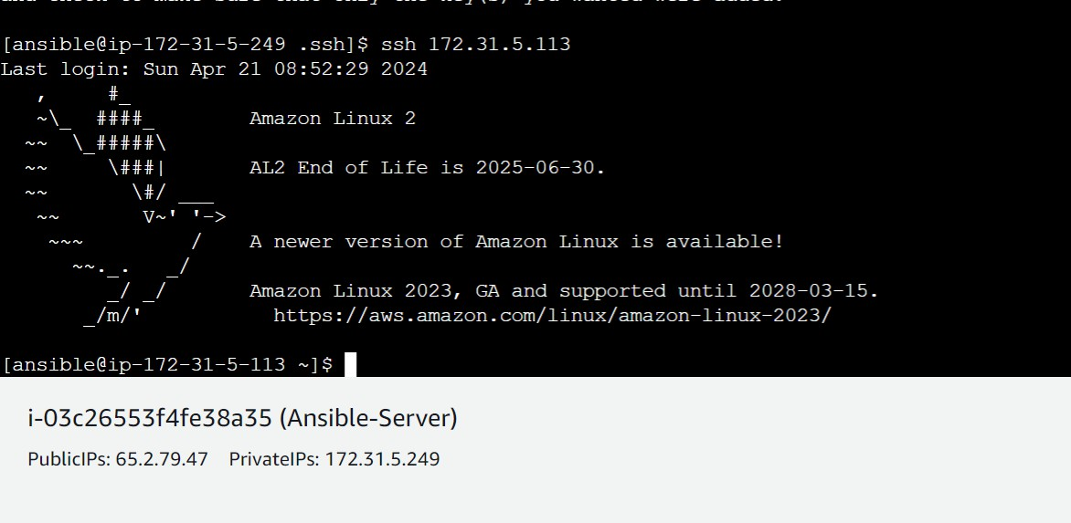

EXPERIMENT 12 AIM: ANSIBLE COMMANDS AND PLAYBOOKS:

1. Check list of hosts.



1. Install httpd.

**Via Adhoc commands:**

Check in node



Install on server using adhoc commands

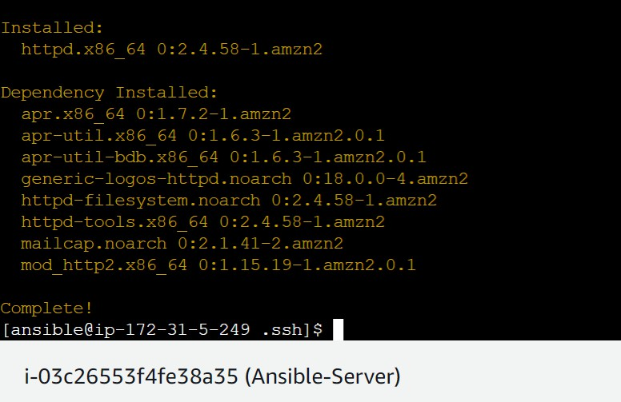

Now check on node machine.



1. Put public ip of node on browser and see apache web page.

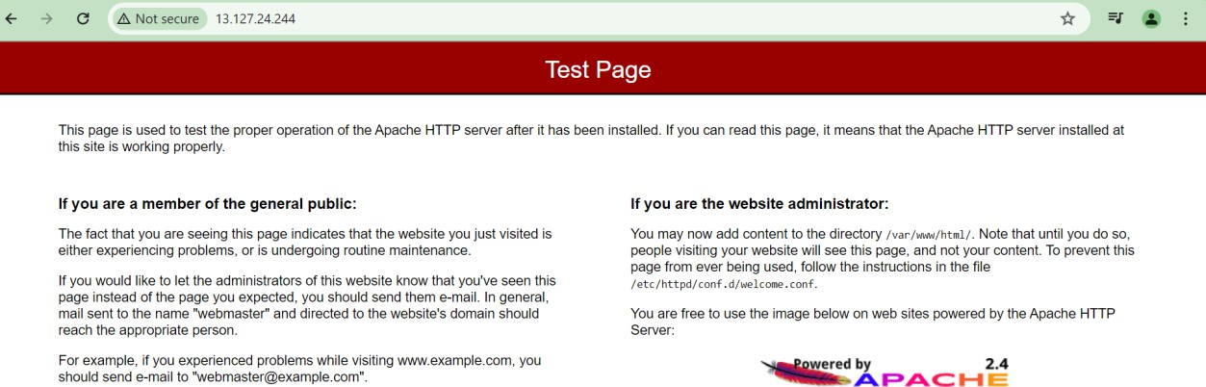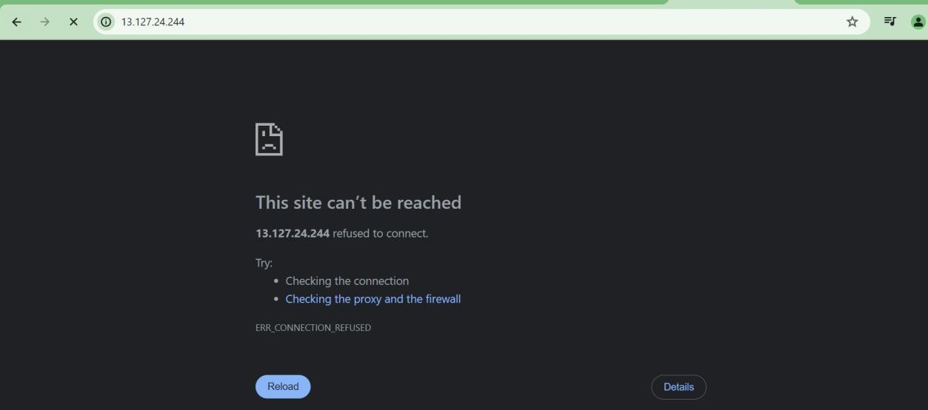

1. Via playbook

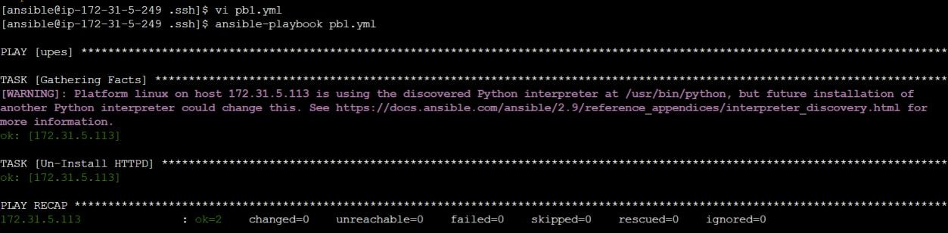

Sample playbook

---

- hosts: upes user: ansible become: yes connection: ssh vars:

pkgname: httpd currstatus: absent

tasks:

- name: Un-Install HTTPD

action: yum name='{{pkgname}}' state='{{currstatus}}'