**Lab Exercise 7– Creating Multiple IAM Users in Terraform**

Objective:

Learn how to use Terraform to create multiple IAM users with unique settings.

Prerequisites:

• Terraform installed on your machine.

• AWS CLI configured with the necessary credentials.

Steps:

1.make folder, create scripts main.tf

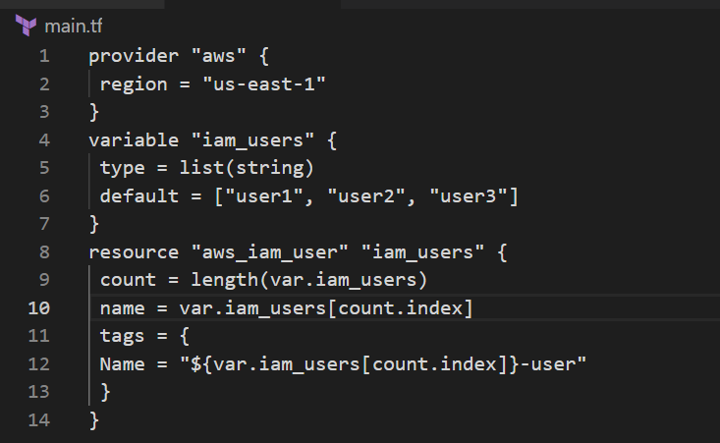

2. terraform init and apply.

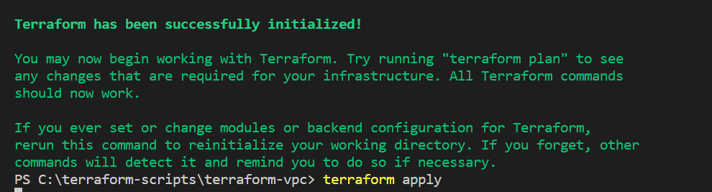

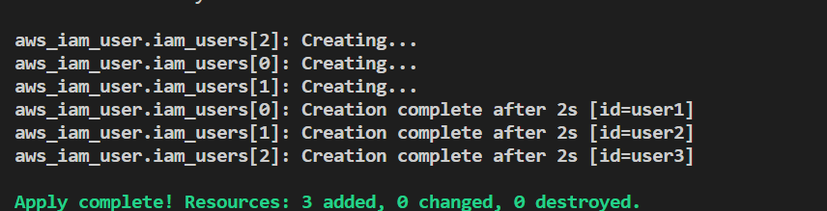

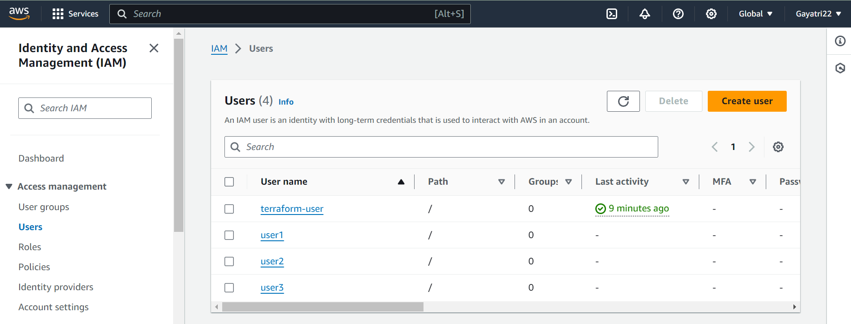

3. clean up



**Lab Exercise 8– Creating a VPC in Terraform Objective:**

Objective:

Learn how to use Terraform to create a basic Virtual Private Cloud (VPC) in AWS.

Prerequisites:

• Terraform installed on your machine.

• AWS CLI configured with the necessary credentials.

Steps:

1. create a directory, write script file main. Tf

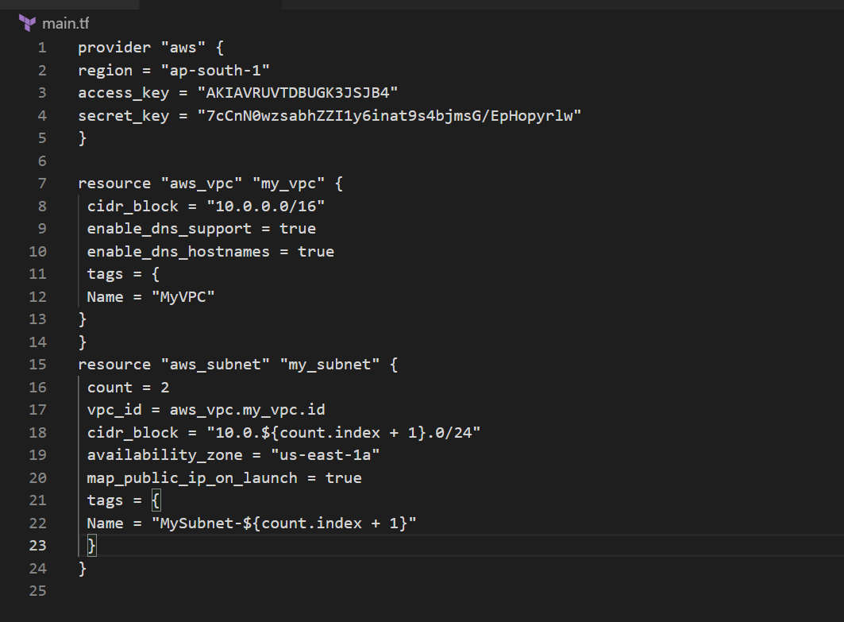

1. terraform init and apply

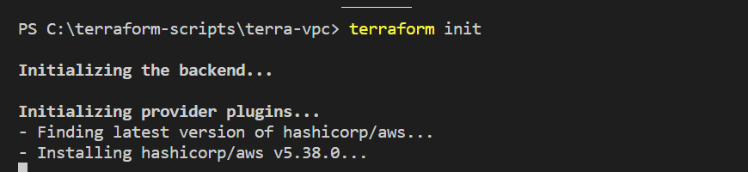

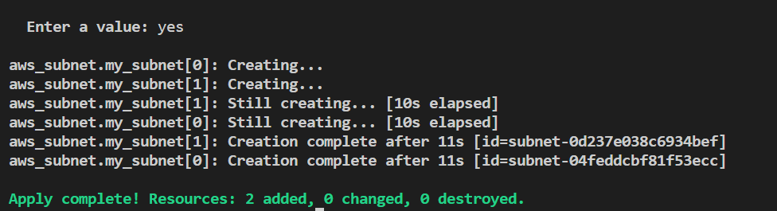

1. verify

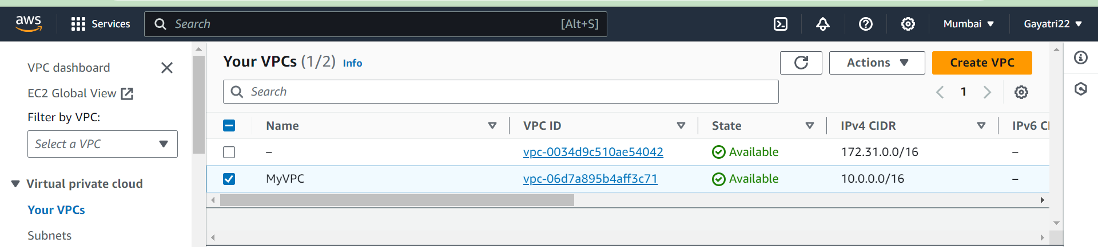

1. clean up

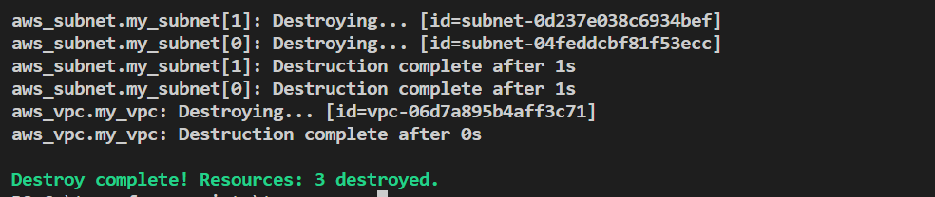

**LAB 10- Creating an AWS RDS Instance in Terraform**

Objective:

Learn how to use Terraform to create an AWS RDS instance.

Prerequisites:

• Terraform installed on your machine.

• AWS CLI configured with the necessary credentials.

Steps:

1. Create main.tf and rds.tf.

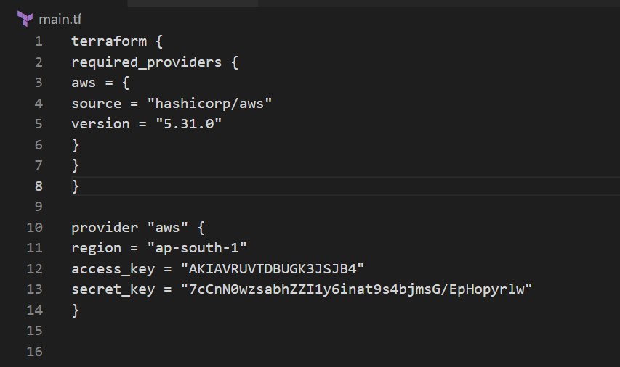

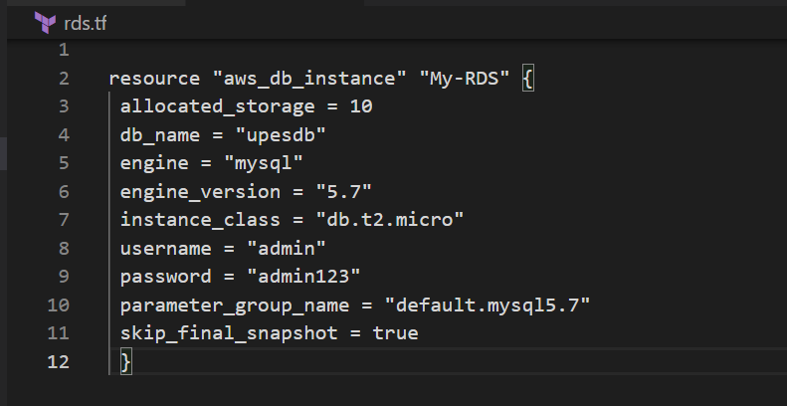

1. terraform init

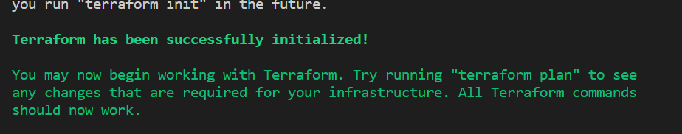

1. terraform apply

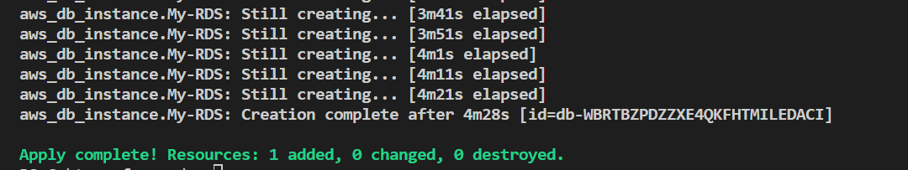

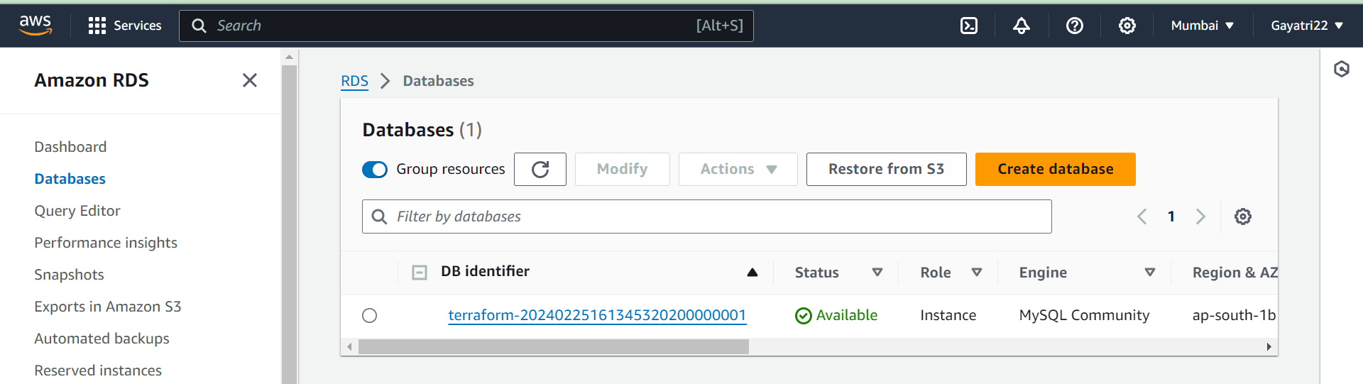

1. terraform destroy

