SPCM Lab

Name- Ishipta Mundra

R2142210363

500091645

Btech Cse Devops NH

**Lab Exercise 1**– Install Terraform on Windows

Installing Terraform on Windows requires you to download the correct Terraform

package, unpack, and execute it via the CLI. Follow the instructions below to ensure

you do not miss any steps.

Download Terraform File for Windows

To find the latest version of Terraform for Windows:

1. Browse to the Download Terraform page.

2. Select the Windows tab under the Operating System heading. The latest version

is preselected

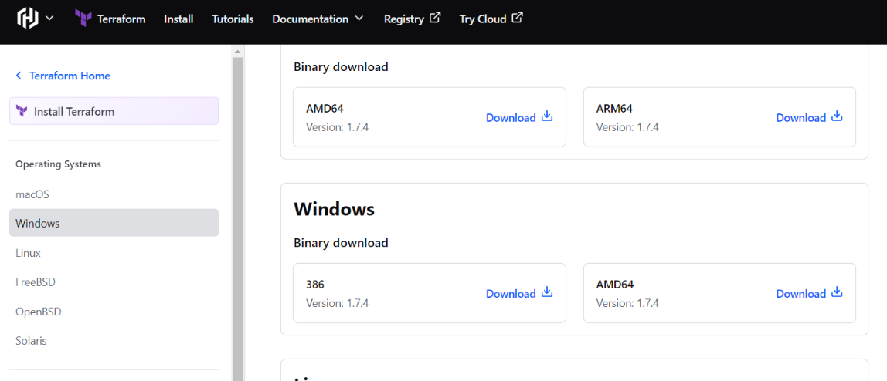

3. Choose the binary to download. Select 386 for 32-bit systems or AMD64 for 64-bit

systems. Choose the download location for the zip file if the download does not start

automatically.

4. Unzip the downloaded file. For example, use the C:\terraform path. Remember this

location so you can add the path to the environment variables.

Add Terraform Path to System Environment Variables

To add the Terraform executable to the system's global path:

1. Open the start menu, start typing environment and click Edit system

environment variables. The System Properties window opens.

2. Click the Environment Variables... button

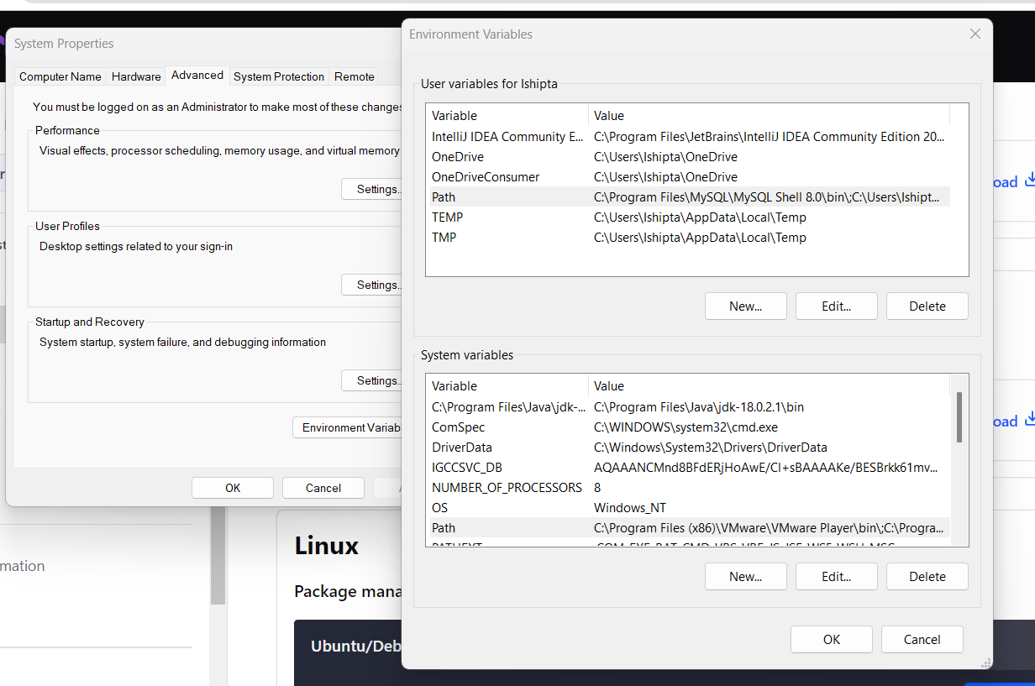

5. Click OK on all windows to apply the changes.

Verify Windows Terraform Installation

To check the Terraform global path configuration:

1. Open a new command-prompt window.

2. Enter the command to check the Terraform version: terraform -version

