Create Terraform Configuration File for EC2 instance(instance.tf):

Create a file named instnace.tf with the following content: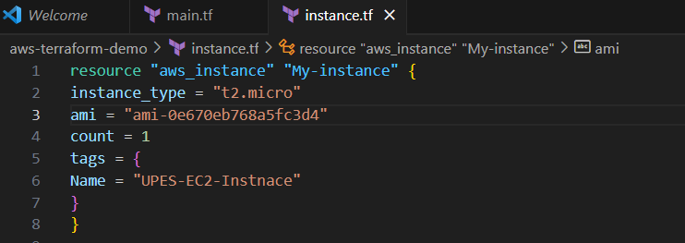

Review Plan: Run the following command to see what Terraform will do:

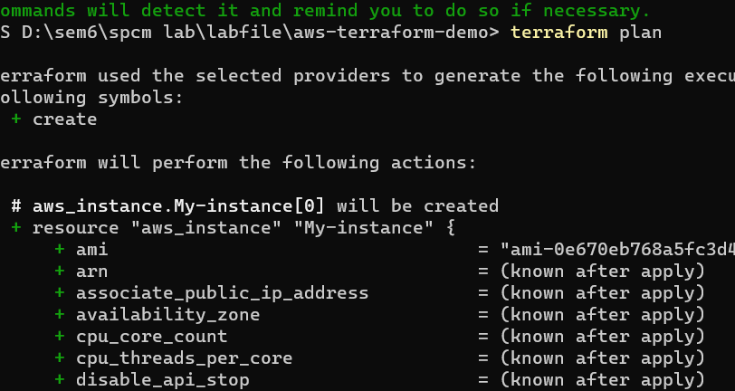

Apply Changes: Apply the changes to create the AWS resources:Type yes when prompted. Verify Resources: After the terraform apply command completes, log in to your AWS Management Console and navigate to the EC2 dashboard. Verify that the EC2 instance has been created.

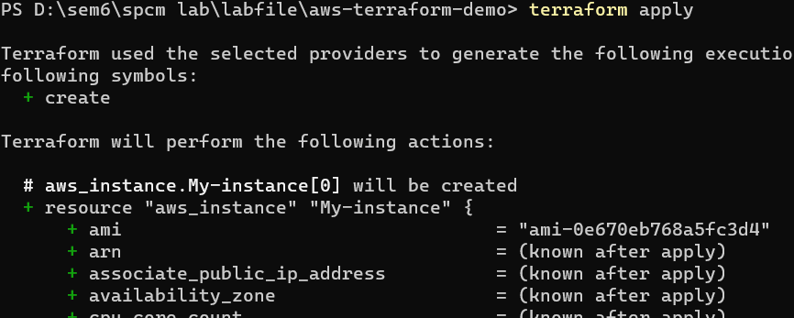

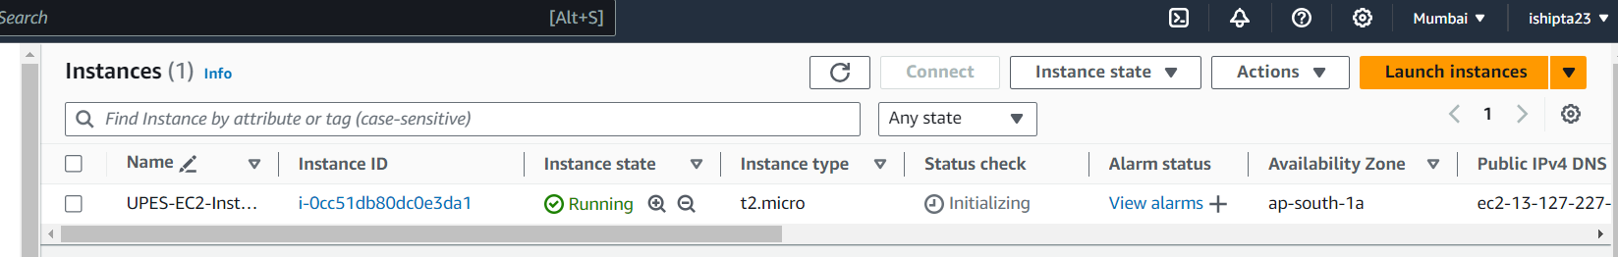

Cleanup Resources: When you are done experimenting, run the following command to destroy the created resources: terraform destroy Type yes when prompted.

