**Experiment 11 & 12, 500093657, Priyansh Choudhary**

Instance of Amazon Linux type – t2.micro, Name – Ansible Server  
  
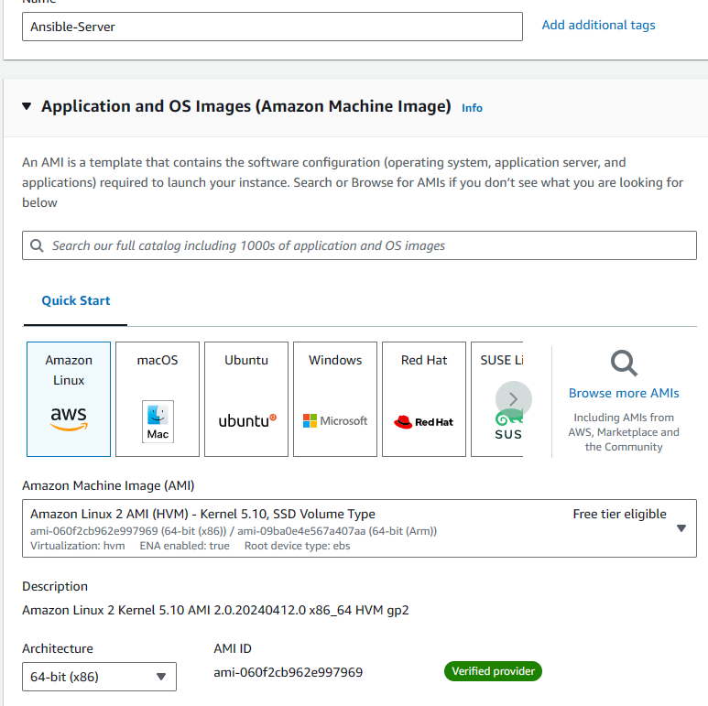

Generate a key-pair

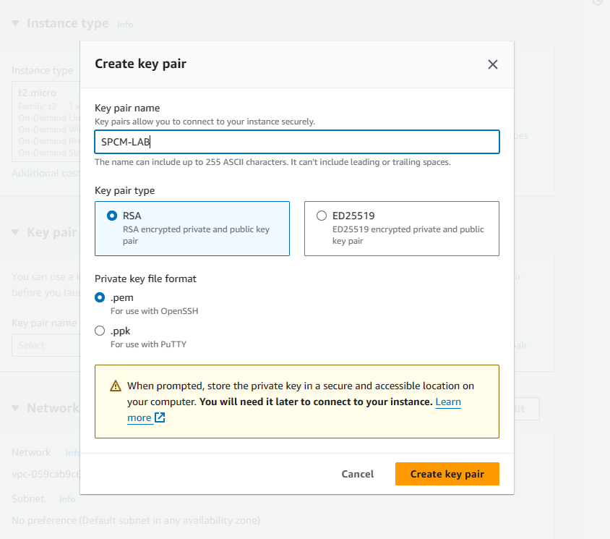

Network Settings  
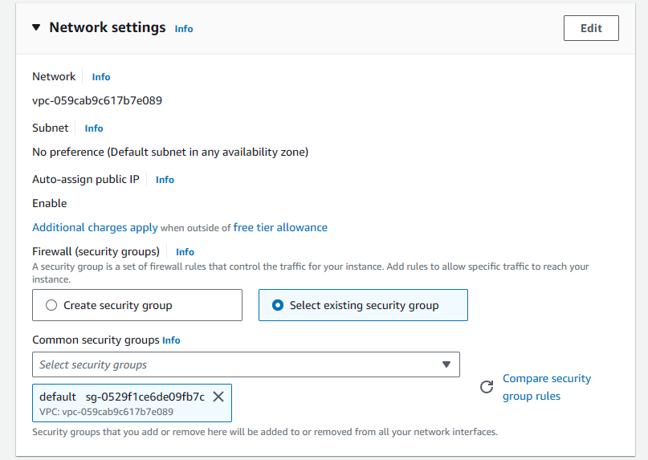

Launch 2 Instances  
  
  
On the Ansible-Server Instance, Install Ansible  
  
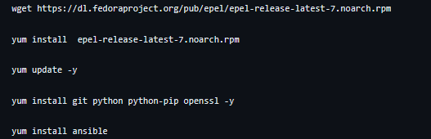  
  
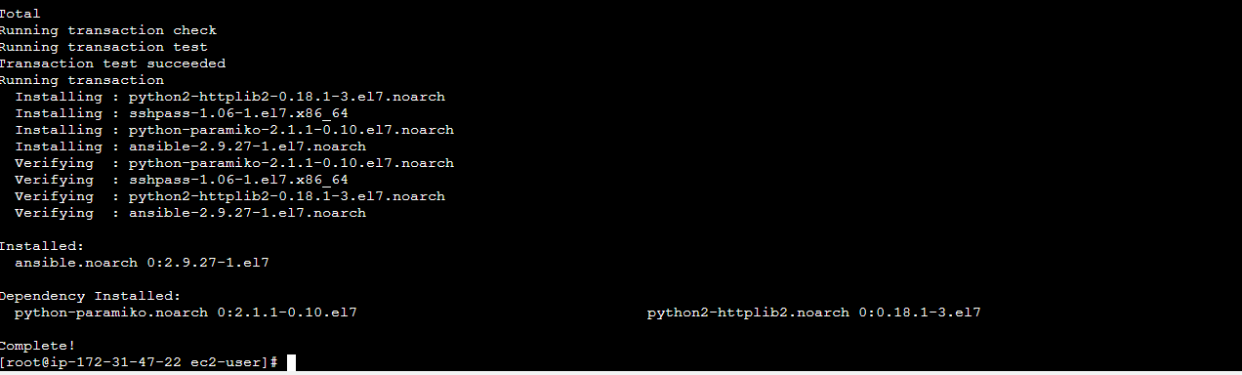  
  
Connect to node  
  
Copy Private IP Adress of the Ansible-Node Instance

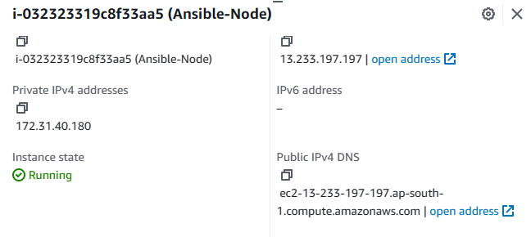  
On the Server Instance, create a group and add the Ip of node Instance  
  
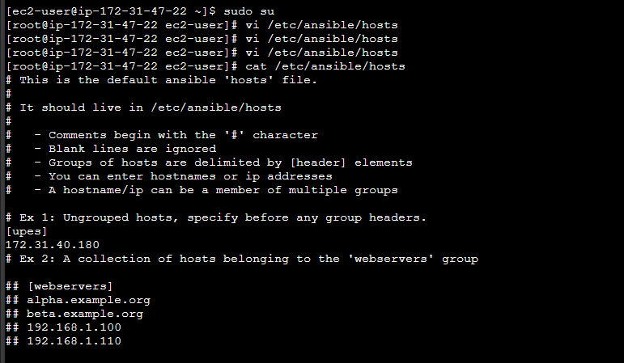

Create User on Both Server and Node  
  
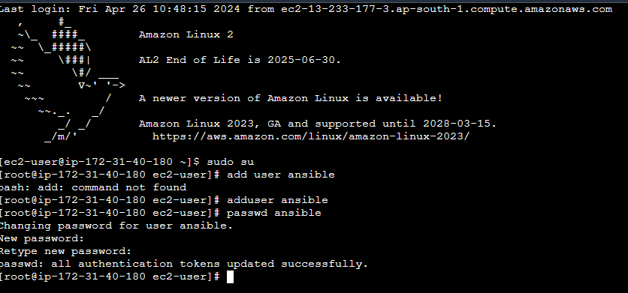

Use visudo to add the user to suod file  
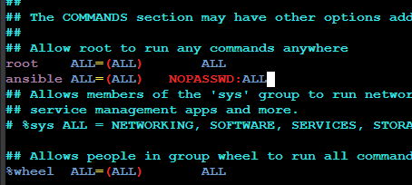  
  
Switch to ansible user  
Generate SSH key on server and copy it to node  
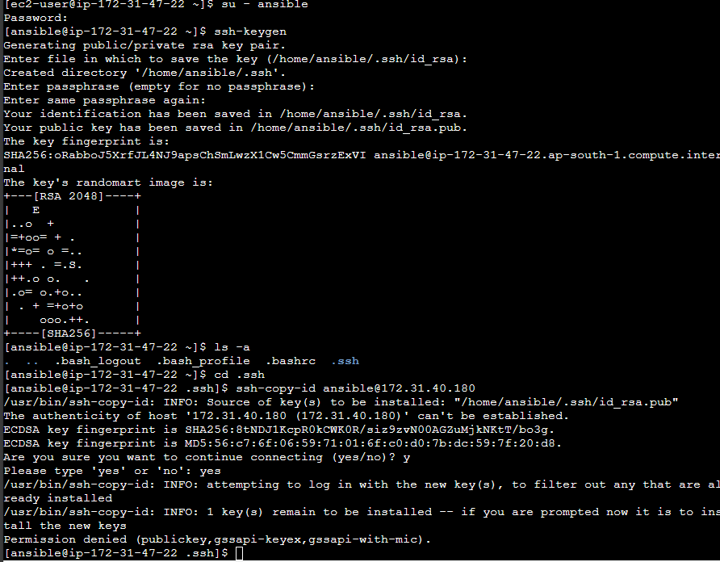  
  
Make Changes in the sshd_config file  
  
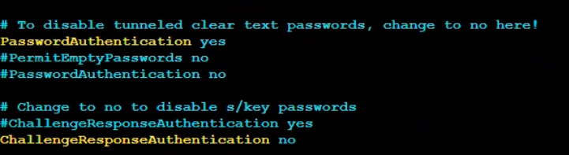  
  
Then you can connect to the instance  
  
Run this command to check the hosts  
  
  
This means that ansible is reading the host file properly  
  
Install Apache on node though Adhoc command

  
  
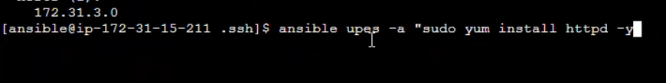  
  
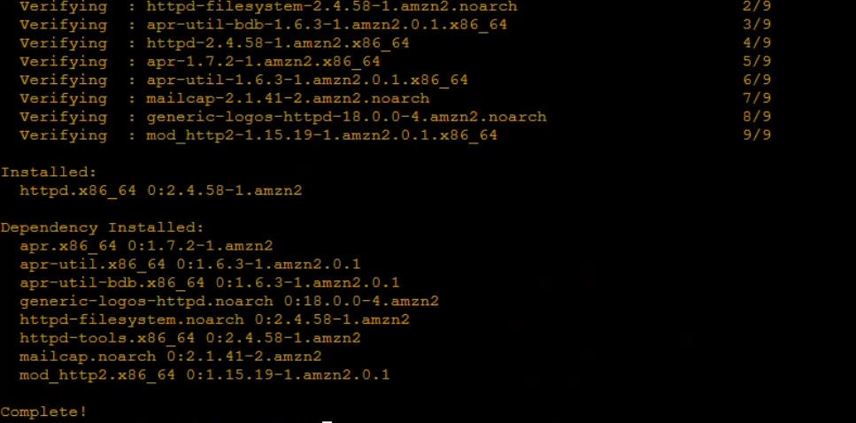



Start the service  


Now we remove httpd  




Create a playbook  
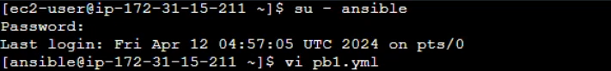  
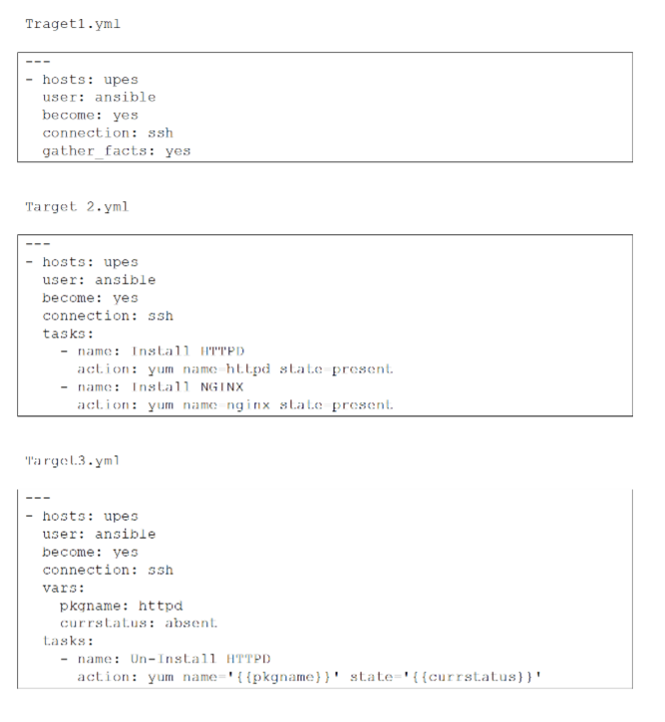  
Run the playbook  
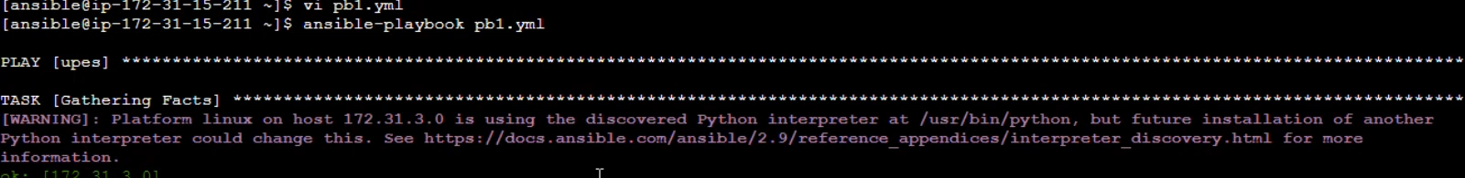

The task is successful  
